Caswell County Planning Board Meeting
January 21,2020
Members Present:
Chairman, Russell Johnston, Vice-Chairman, Michael Poteat, Ray Shaffner, Keith Blalock, Steve Harris, Ron Richmond, Jason Daniel, and Don Swann. Also present: Matthew Hoagland, Planner, and Ashley Kirby Powell, Administrative Assistant.
Members Absent:
Commissioner William Carter
Called to Order
Mr. Johnston called the meeting to order at 1:00 p.m.

Approval of the Agenda
Mr. Shaffner motioned to approve the agenda, seconded by Mr. Harris. The motion carried unanimously.

Election of Chair and Vice-Chairman
Mr. Blalock nominated Mr. Johnston as Chairman, seconded by Mr. Harris. The motion carried unanimously.
Mr. Harris nominated Mr. Poteat as Vice-Chairman, seconded by Mr. Daniel. The motion carried unanimously.

Public Comments
Phil Barfield, 910 Melvin Wrenn Road, Yanceyville NC 27379. I come before you this afternoon to voice my opposition to the construction and operation of the asphalt plant and quarry in our county. I oppose them because they are an environmental danger to humans, plants, and animals. I have numerous concerns about the projects which are shared by others. There are too many to read here today, so I am providing copies to the Board for inclusion into the record. They include concerns about pollution, fires, noise, smell, roads, traffic, wells, agriculture, wildlife, environment, zoning, and the enjoyment of one’s property. These are not just my concerns. These are concerns voiced by the citizens at the quarry mine hearing on November 4th of last year, at community meetings from Protect Caswell online group, and from the North Carolina Department of Environmental Quality. These lists can be found on the ProtectCaswell.org website. Without zoning, the public must rely on a notice in the local newspaper, social media, or word of mouth to know about an industry like this coming into our county. Then we must individually investigate to find out what this means, how it impacts us, and how to have our concerns addressed before permits are issued. This is clearly to the company’s advantage because they can have their permits processed out of our sight at the state level without review and determination by our local government or public comments from our citizens. In my opinion this is what happened with the approval of the asphalt plant on Wrenn Road. Until we have zoning, we need a better process. For now, that process is found on our Environmental Impact Ordinance. It mandates that an Environmental Impact Statement (EIS) be accomplished for the quarry. An EIS should provide a full and fair discussion of significant environmental impacts and include local and state review and a public hearing. For the reasons provided to you in the list of concerns, we should also have EISs accomplished for the asphalt plant sites since they are anticipated to have significant impacts. Please note that if the company is unwilling to provide EAs and EISs or does not provide complete EAs and EISs, our Environmental Impact Ordinance allows for enforcement.
Therefore, I stand before this Board and respectfully:
- Demand Environmental Assessments (EAs) and Environmental Impact Statements (EISs) be accomplished per the county’s Environmental Impact Ordinance.
- I request EISs be accomplished in addition to EAs for the asphalt plants.
- I request EISs to be complete and address all concerns of citizens.
- I request the Board to ensure public notices, state review, and public hearings are accomplished for the EISs.
- I request the Planning Department not process any county permits or allow construction at the quarry and asphalt plant sites per the moratorium and the ordinance.
- I request the Board require the County to file injunctions and seek equitable relief per the ordinance if the company is not meeting the EA and EIS requirements.
Vonda Oakley, 1425 Baynes Road Burlington, NC 27217. Thanked the Board for allowing her to speak today. The two facilities proposed to come to their area the asphalt plant and the cement plant they are located across from her home. I am not as close as some people but, my road along with others will see, smell and hear the effects from these two plants. I would like to say that there are a significant number of citizens in our community greatly opposed to any and all toxic industries that want to come into my community. We are a very small community way too small for a toxic industry, we want to breathe clean air, and drink clean water. I am opposed to SunRock and any type of company like them. I am here today to get answers and I would like the Planning Board to answer these questions today or in a timely manner.
- When did the Planning Board first become aware of the interest in the NC SunRock project on highway 62.
- Were there any efforts made to make the residents aware, if so, how were they made aware.
- Was the project evaluated with prospective of the increased road traffic, the cost to maintain roads.
- When will we know about the moratorium, and how will it affect SunRock. Also if a judge is to decide on the moratorium, who will it been and when.
- I want someone on the Board to explain the Pollution Impact Ordinance to her and how it applies to me.
- I request Environmental Assessments and Environmental Impact statements.
- I request EIs and EAs for the asphalt plant and concrete plant.
- I request that the Board insure public notices, State and Public review hearings are accomplished by the EIS.
- I require that you not process any county permits or allow any construction at any quarry, asphalt, and cement plant site pre the moratorium and inforce sections of the ordinance.
- I asked that all meetings be recorded and minutes posted from here on out.
Mrs. Oakley questioned the Board how they would feel if this was in their area, their neighborhood.
Susan Chandler, 1566 Alvis Boswell Road, Yanceyville NC 27379. Her and her husband Jack Chandler live on a 100 acre farm of pollution free land at this point. It is time to stop taking advantage of rural communities and the people by allowing these types of industries to come into our community. Once you present the facts and give people the truth we are very capable of making the decisions needed for the good of our community. There are many concerns that you all are aware of, this plant will release 44 air toxic pollutants, which include nickel, arsenic, benzene, and mercury. They will be admitted at higher concentrations that will not be healthy for humans. There are 3 asphalt plants that are being placed more than 10 miles apart and the State will be evaluating the pollutant effects at each site instead of cumulatively. If they were evaluated together the health pollutants would be extremely high. The Board is someone who we elect, trust and voted for. You are working for us. Looks like everyone here is working for you, but being optimistic, I do believe that together we can accomplish more. We want this for our children and your children. Again, I believe coming together we can do good for the community.
Caroline Laur, 12671 NC HWY 62, Burlington, NC 27217. I have been living in the county for 14 years now, and I have an organic farm. I have gone over and over what to say to this Board today, to try to get across my disappointment. My home is 190ft away from the proposed asphalt plant, and I have health issues. There are quite a few of us who have environmental diseases; I have a blood disease. Because of the pollutants that this plant will produce; I will not be able to live there anymore. It will affect my blood disease. I have been in contact with Alamance County with concerns of the water supply, because the creek that runs through my property runs into Alamance County and it could affect the County’s water supply. I feel like we should be having a disagreement with the company, but instead I am disagreeing with the County Officials to get help. After attending Board meetings no, one can give me answers and feels like she being treated like a child. This is devastating to me and I don’t understand why or how the Board treats people like this, this is wrong. I will use every piece of my breath to change this in my community and go door to door. We are asking you to stand on our side, and the ordinance states that you are to do these things for us. I don’t have to be an attorney to see that these EIAs are not done. Thank You.
George Daniel, 2685 HWY 62, Blanch NC 27212. I had the opportunity to watch the citizens come together for various causes. I saw this 28 years ago when there was an opportunity for the county to have a waste dump located in Pelham. The citizens took a stand to prevent this from coming to the County. There also was a transmission line that was going to run across this County and these citizens stood against this. Mr. Daniel thanked the Board for all they do because it’s not easy to be in the position that you all are in. Do not be offended if some of the citizens are coming in and being a little upset. This is a very emotional issue. These people came to the County to make a life here with their family. We understand that there is a need for asphalt and concrete but why here. Just like the citizens, you have a job and do not have all the time to devote to this but I know your heart is right. This involves not just these two communities it involves the whole County. This thing is going to go on but these citizens will not stop just at a county level, they will go on to a Federal Level. Thank you for the time you give every month and the service you give. Please, if someone comes off a little strong, please understand these people are hurting.
Lynn Pendergraft, 3131 Wrenn Road Prospect Hill, NC 27314. First of all, I am tired of the disgusted looks I receive every time I make a comment in this group. You people should be “looking out for us” isn’t that why you are chosen? If you would put yourself in our place you would be extremely outrageously upset as well. I grew up in Durham County. I lived in the Research Triangle Park where the county took peoples farms and land in the name of “progress”. Progress in that setting only means “dollars” to certain groups of people, not the land owners and no concern for the environment. Wow, does that sound familiar? Caswell County may not be “taking” my land but they are ruining it and its value. They are ruining the peaceful existence I have known for the 25 years I have lived here. I worked for the U.S. Environmental Protection Agency for 32 years with a group of engineers that studied air pollution and global warming. I typed many papers describing the effects of, what is emitted into our air does to our environment and our health. I never dreamed that I would be facing this right where I live. My husband and I sold everything we owned in Durham to find a peaceful place and enough land for our horses, to grow our own hay and to allow our daughter and her family to have a quiet, peaceful place to raise her family and where we could be involved with our grandchildren’s lives. We went into the chicken business so my husband could make a living on our farm. Our livelihood is in tremendous jeopardy. The quarry will drain all our 6 wells and cause us to lose our contract for our hatching eggs. Clean water and lots of it is necessary to keep our contract and have a successful business. I don’t understand why our “trusted servants” aren’t fighting with all they have to stop this raping of our land and our county. I go to sleep thinking about this horror and wake up with it slapping me in the face again. There has to be something that can be done to stop this nightmare.
Pat Warren, 36 Main Street, Prospect Hill, NC 27314 Thank you for having us today. I wasn’t planning on speaking today but I am going to go back over what I said at the last Planning Board Meeting. I don’t live right next to the quarry but my neighbors do. I have spent many times closing my eyes and imagining what that would be like coming beside my house it really is very disturbing. I want you all to do the same thing, close your eyes and imagine what it would do to you and your family. If you would work as hard as you would if it was next to you I want you to take this Environmental Impact Ordinance, read it and do everything in your power; If you do that then you will be our heroes. Thank you very much.
Sterling Carter, 222 Sunset Drive, Milton, NC 27305. “I just wanted to make a few statements both as citizens but, also to give you a prospective as one of the commissioners on the chain of the course of events on how this is transpired. We have the rock quarry situation that’s one thing, dealing with that you know separately. Then all the asphalt plant stuff comes up, it’s a very difficult being in a position as an elected official and having the task of having to know just about everything. The citizens expect that of us, we are supposed to have all the answers, all updates and everything. It was an embarrassment for me after dealing with a day of meetings regarding the quarry that I had a citizen come up to me on the town square and ask if I was aware of an asphalt plant coming to Anderson, my answer was no; this was September 2019. I recently had a citizen bring this to my attention and I’d like to read a few exerts to you of the watershed review that took place on March 2018. Ms. Denison was still the Planner this is a discussion that they were having regarding the asphalt plant and the hot mix concrete plant located on Wrenn Road, and it’s quoted a few years ago they came in and now they are ready to move forward with this and ya’ll proceeded to have a discussion about it. And towards the end is kinda what disturbed me it was asked of Mr. Bill Carter who’s the ex-officio on the Planning Board how the Commissioners felt about this type of business coming to the county; again this is March 2018 and me as in individual Commissioner didn’t know about this until September 2019. He said that the Commissioners were not aware and Ms. Denison the Planner said it was something that is not supposed to be brought to the Commissioners. So….it’s disturbing for me to hear that it’s an embarrassment that I wasn’t ready to answer a citizens inquiry. I feel like the Board of Commissioners as a whole should have known about this, we all are supposed to work together. I feel like moving forward we need to work on that relationship between the two Boards and I’m going to recommend as an individual Commissioner that we get regular updates on what’s going on and it’s my… I admit that we are supposed to read minutes of all Boards and there are dozens of them and I’ll say it up front we don’t have time to read all of those. It’s my ignorance that I didn’t read these minutes and I regret to inform the people, it slipped between my individual fingers. Just want to make it aware to the Planning Board that moving forward we don’t need to have these discrepancies because we could have worked on a moratorium a year ago and it might would have made a greater effect. That’s neither here or there I want to leave you with a positive note we need to work together moving forward on these because we are all here to help these guys and we need to be on top of our game. I appreciate you letting me speak.
Gaye Plesant 1268 Painter Road, Prospect Hill, NC 27314. After the zoning presentation that was put together for the Commissioners, I have come to realize there is a huge body of land use law that impacts all of this that is outside of how we feel or what we want. I think it would be very useful if there were public information setting all about zoning, rural agricultural, industrial zoning. After looking at the list that Mr. Hoagland gave us, it states that industries would not be allowed special use permits. Once you start to look at how a special use permit is approved and all the rules are grounded. I think the public needs to be educated on that process and what power the public has, the roles of the Public Officials. We need to talk about how to protect people so we all don’t wake up to a notice in the paper for a special use permit application to put another asphalt plant in the County. This would take a lot of the emotion out of this if we all had an understanding. Thank you very much.

Approval of Minutes
Mr. Harris made a motion to amend the November 26, 2019 minutes, correcting Mr. Poteat absent and correcting the year to 2019 under other business and that an administrative conflict being the reason the December meeting was rescheduled, seconded by Mr. Blalock. The motion carried unanimously.
.
New Business
Electronic Gaming Facility Regulations
Mr. Hoagland stated that last year they had a citizen voice their concerns on gaming facilities. Sheriff Durden stated at a previous Board meeting that these facilities always find a loop hole and manage to open back up and at that meeting the Board directed Mr. Hoagland to look into what neighboring County’s regulations are. Then Mr. Hoagland presented the Board with his findings, the City of Roxboro regulations are very similar to our UDO. Mr. Hoagland talked briefly about the regulations of Rockingham and Alamance counties as well and how they regulate electronic gaming locations.
Chairman Johnston questioned, has the State come up with any regulations, or is it just County level regulations. Mr. Hoagland replied the State explicitly outlaws them unless it’s on Tribal lands, however, Sheriff Durden believes they will find a loophole again in the future and try to reopen. Chairman Johnston questioned the Town of Yanceyville’s regulations. Mr. Hoagland replied he actually forgot to look at those; he was focused on other counties. Chairman Johnston suggested letting Sheriff Durden review these findings of other counties regulations and bring back to the Board what he suggests. There was no objection from the Board. Chairman Johnston stated, looking at the City of Roxboro they have hours, age, and alcohol restrictions. Mr. Hoagland replied, they limit the number of terminals to 20, they have parking requirements. Chairman Johnston questioned the current status of gaming facilities in the County. Mr. Hoagland replied they are all closed.
Mr. Daniel questioned, should there be a change in the Adult Gaming listing rules and regulations. Mr. Hoagland replied, that is another option, it could be added to that and rename the chapter. Chairman Johnston questioned Mr. Hoagland if he envisioned having to add another addendum to the UDO and then Public Hearings. Mr. Hoagland replied yes, if we change the UDO we will have to have a Public Hearing. It would also make just as much to amend the UDO. Chairman Johnston questioned Mr. Hoagland if he thought the City of Roxboro would be the best example for the County. Mr. Hoagland replied “yes, there ordinance is laid out the most similar to ours.”
Mr. Swann suggested putting some lighting restrictions in the ordinance. Mr. Hoagland replied, that would be something the Board could decide. He added they could add parking and location regulations as well. It would be totally up to the board.
Chairman Johnston questioned what was the pleasure of the Board, review this and speak with Sheriff Durden then bring back the modifications at the next meeting.
Mr. Blalock suggested that the Board do nothing, when a business starts up and is out of compliance the Sheriff should start the appeals process. We could also go ahead and have our rules in place when the time comes again.
Vice-Chairman Poteat stated, we need to have something in place and not wait until they start businesses up again.
Chairman Johnston requested that Mr. Hoagland schedule a time to meet with Sheriff Durden and put this item back on the agenda for the next Planning Board Meeting.
Mr. Hoagland questioned Chairman Johnston if the Board wanted him to draft any languages for a new ordinance, or draft any amendments to the UDO. Chairman Johnston replied let’s keep that option open and bring it back to the next meeting.

Other Business
Review of County’s Environmental Ordinance
Mr. Hoagland stated that this is an issue that was brought to our attention by a citizen at a previous Planning Board Meeting, that there were some disturbances on Pagetown Road by a company completing testing on gas tanks and other types of storage tanks. Since then, there have been a lot of request regarding part 3 of the Environmental Ordinance, which deals with the Environmental Assessment Application and the Environmental Impact Statement.
Chairman Johnston stated after reading the language, do we know if the federal or state government has approached this business. Mr. Hoagland replied that he didn’t know as of yet if a state of federal permit were required for them. “The name of the company is Arrow Head Industries. They are a licensed third party contractor with the Federal Department of Transportation, I have inquired with them in regards if they had to have an Environmental Permit from a State or Federal agency. If they had a state air quality or other before operating, then they may have to pause their operations and go through the Environmental Health Assessment process” Hoagland said.
Chairman Johnston questioned any businesses conducting these types of activities have to come through the Planning Department, correct? Mr. Hoagland replied, yes, they have to fill out an Environmental Assessment if they receive an air quality or mining permit from the State of North Carolina. Chairman Johnston questioned Mr. Hoagland have we received any notice from the quarry or asphalt plant. Mr. Hoagland replied yes, they have been informed that they need to fill them out but we have yet to receive them. Chairman Johnston stated that this is a lengthy detailed ordinance and it would take some time to research this and see how or complements or conflicts with Federal Statues. Mr. Hoagland stated that he believes the current Environmental Ordinance is the end result of the quarry that came to Pelham several years ago. In regards to the Pagetown road explosives issue, one of the criteria in the Environmental Ordinance is if they are storing 10,000 pounds of explosives on site then they have to comply with Part 1 of the Ordinance. But that company is not storing that much. Their headquarters is down in Graham, NC and they bring tanks and vessels on site to test but do not store them there. They mainly are testing tanks similar to the ones that hold nitrous oxide in dentist offices or natural gas for public transit buses. The Federal Government required that they test each tank to its maximum capacity before they are used. To make things more complicated, it is the Building Inspections Department that enforces Part 1of the ordinance.
Mr. Daniel questioned, how often they test. Mr. Hoagland replied, one or twice a week from what they’ve told him. Mr. Daniel questioned is that one test per day. Mr. Hoagland replied 2-3 tanks at a time and from what they told me they rarely ever have one explode, they only get an explosion if they have a faulty tank.
Mr. Blalock questioned, this is mainly a testing facility. Mr. Hoagland replied, yes.
Chairman Johnston questioned Building Inspections role. Mr. Hoagland replied, there is a requirement where they are responsible for enforcing the Explosives Ordinance which is Part 1 of the Environmental Ordinance.
Mr. Daniel questioned, are the bunkers up to standards, what are the height requirements. Mr. Hoagland replied he did not know the height requirements or the standards. Our main concern was the storage capacity and that they did not go over the 10,000-pound limit of explosives.
Chairman Johnston questioned there will be follow up inspections. Mr. Hoagland replied, yes, if necessary. He was still waiting to hear back from the company to know whether or not they had to receive a state permit before operating. If not, he can enforce the Environmental Assessment.
Mr. Daniels questioned if a Federal Agency comes in to the County to inspect this location or any location, do they have to notify the County? Mr. Hoagland replied, they may contact Emergency Management, or Building Inspections depending on what they are inspecting but he is not aware of a requirement where they have to notify the county.
Chairman Johnston told Mr. Hoagland to keep the Board updated on this issue if needed.
Mr. Shaffner stated, “Mr. Chairman I just want to say something here. We wait until after it is here to try to change something, just like with Adult Gaming suggesting to wait until someone comes, then you can’t do anything about it. Unless we have a Game Use Ordinance to resolve this matter. A few county commissioners and I went to one of the zoning information meetings that Matthew had early last year. You know how many people showed up to that zoning meeting other than county staff? Six people. When these things are addressed you don’t have any public feedback. But when it is next door to you or if it’s a Dollar General, rock quarry or an asphalt plant, you want to take all means necessary to stop it. At these meetings that are held these concerns need to be addressed and without zoning there is nothing you can do about it. We have a Land Use Ordinance yes, but there is no zoning to stop these things.”

Recess
At 2:09 p.m. the Board to a brief recess.
Called to Order
At 2:19 p.m. Chairman Johnston called the meeting back to order.

Zoning Presentation and Discussion
Mr. Hoagland stated that he and County Manager Bryan Miller had been asked by the county commissioners to draft a zoning proposal for the county and had given that presentation to them last week. Bryan and he thought the Planning Board should see the presentation. He then proceeded to give the following presentation:

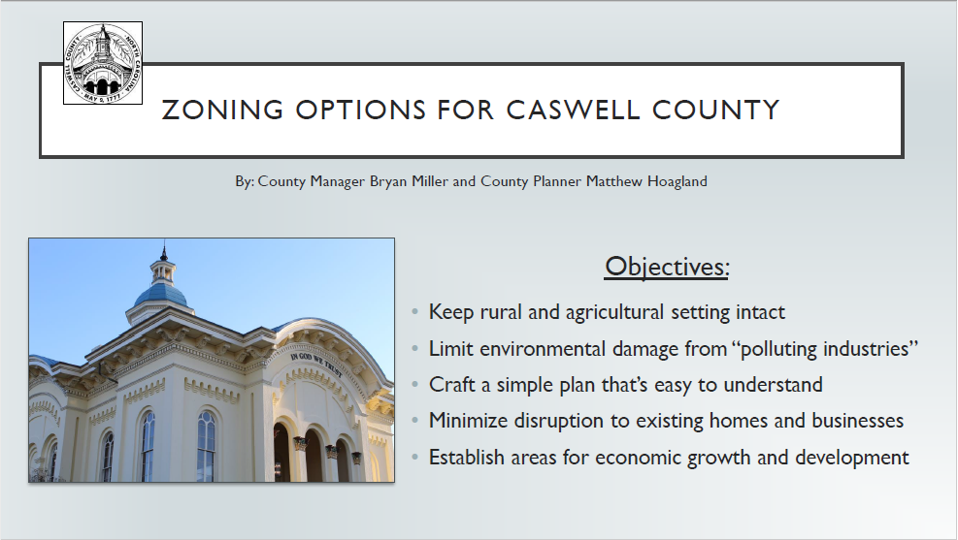
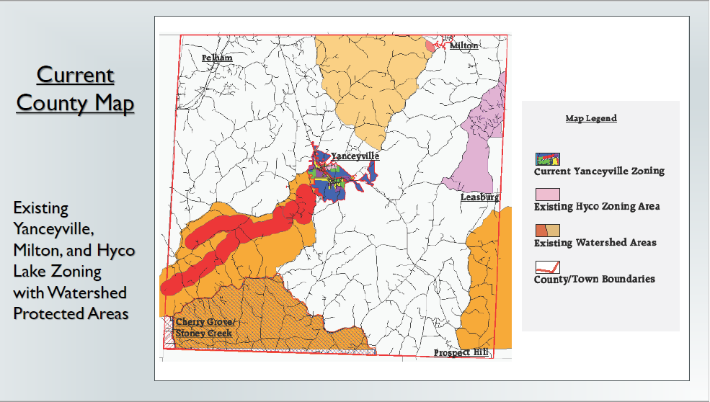

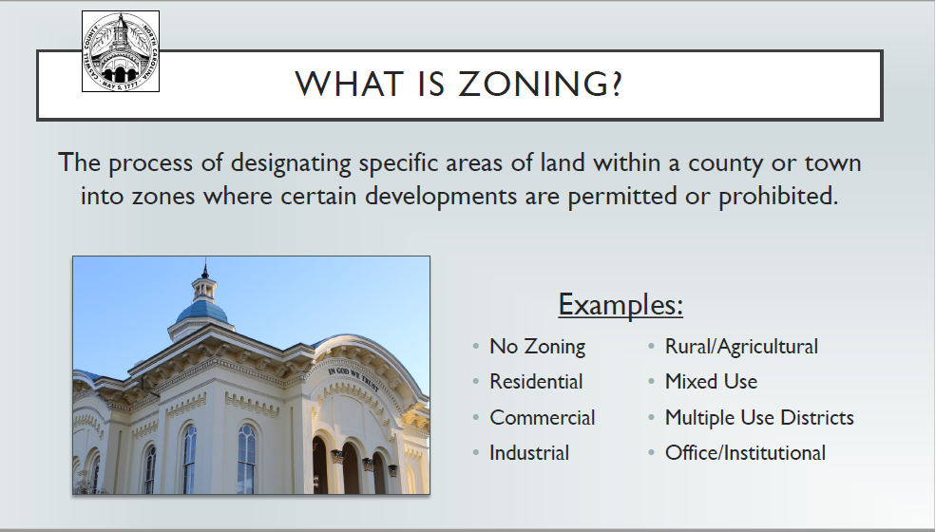

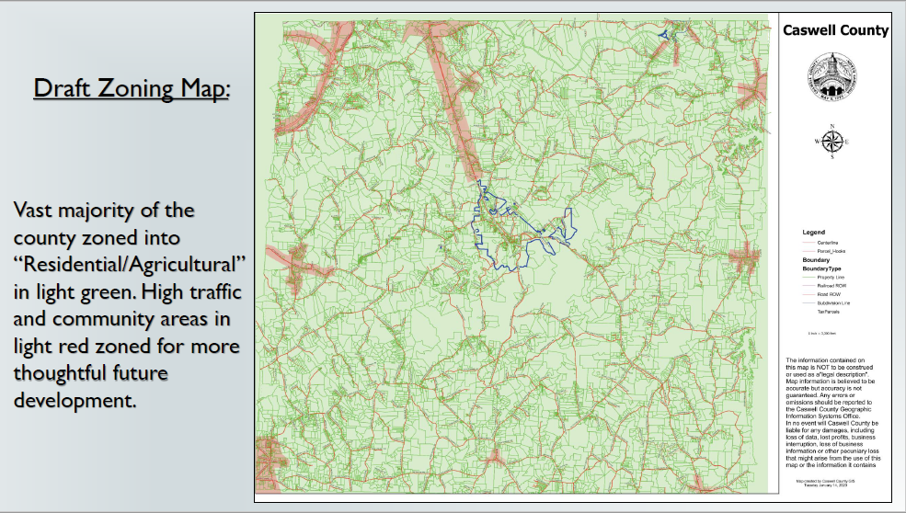

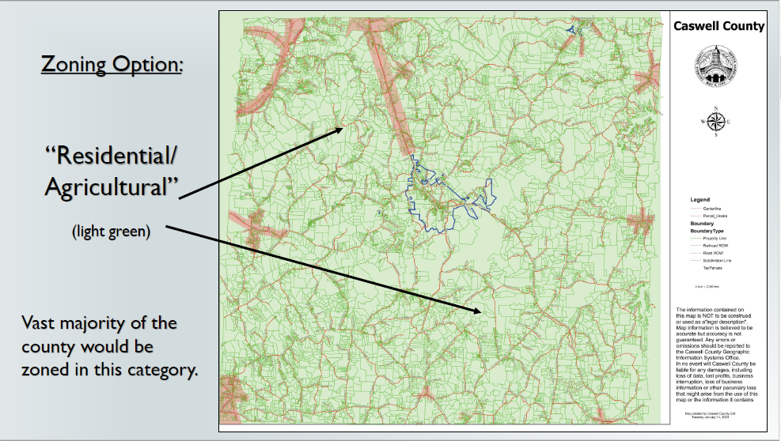

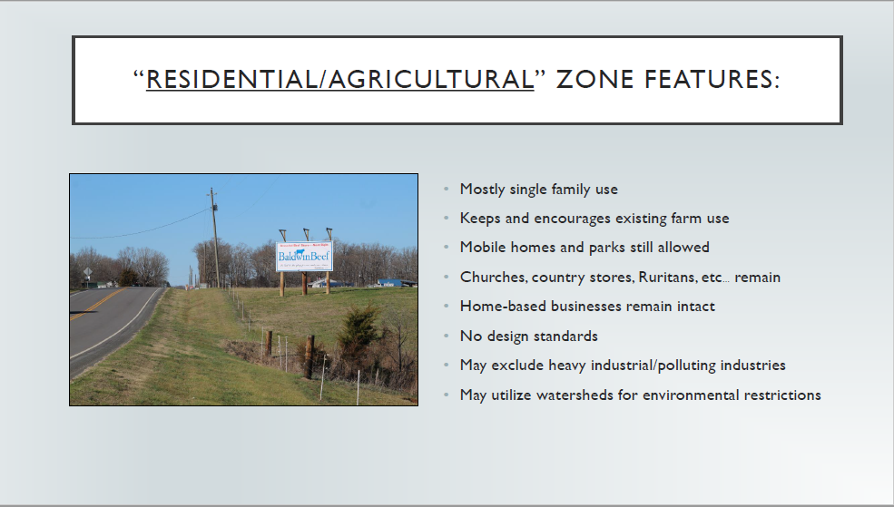

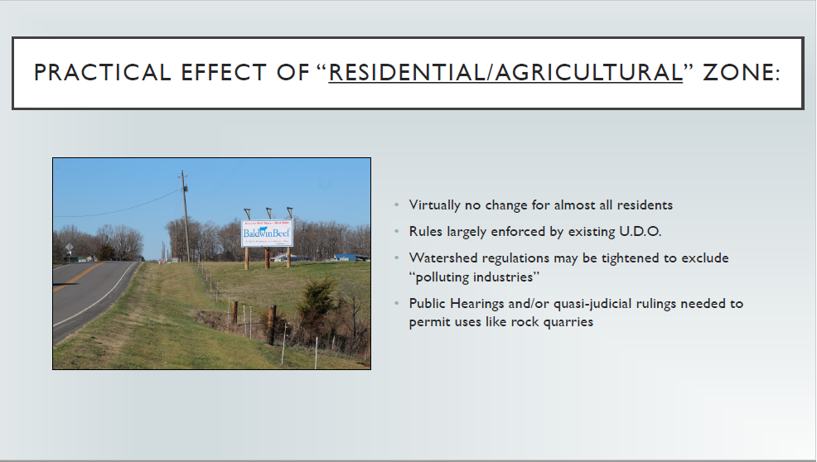

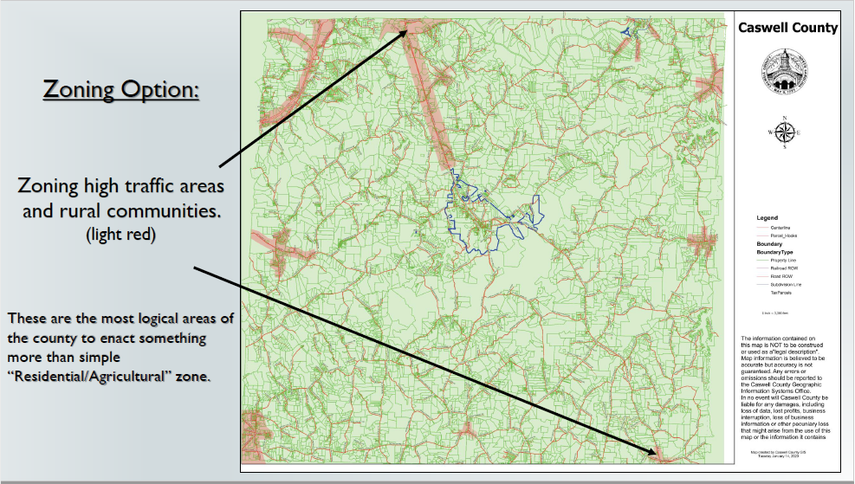

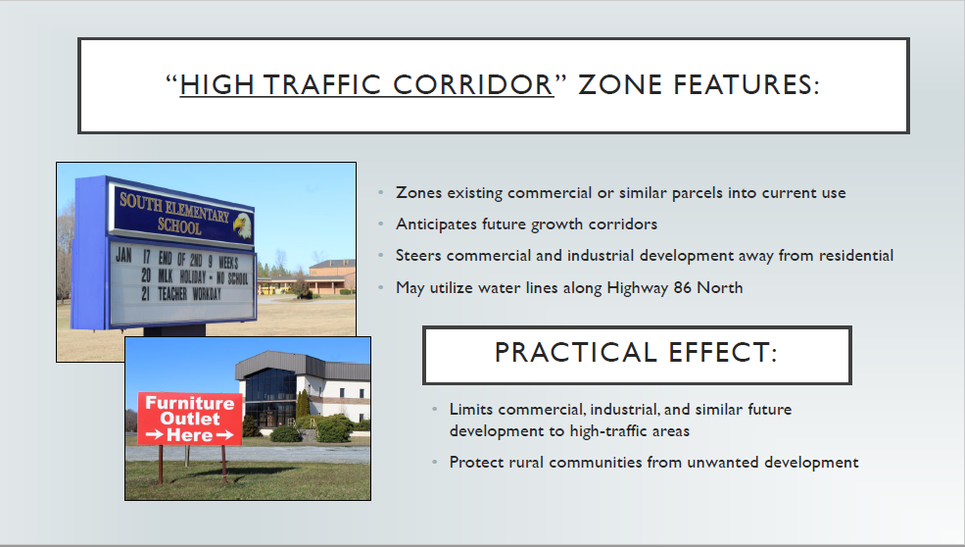

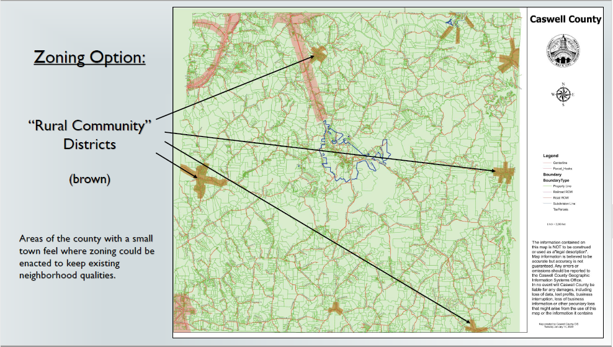

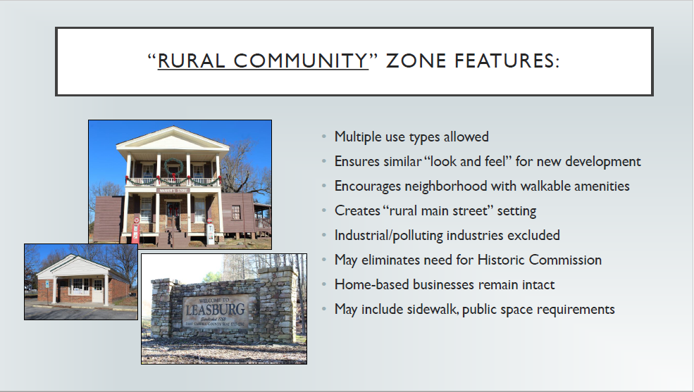

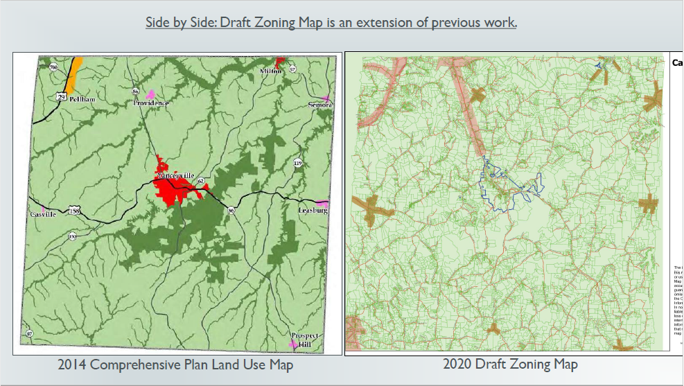

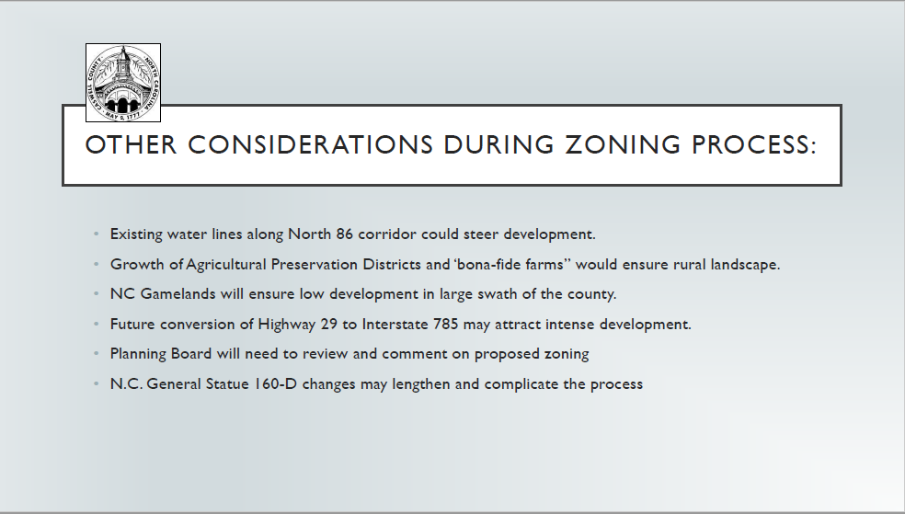

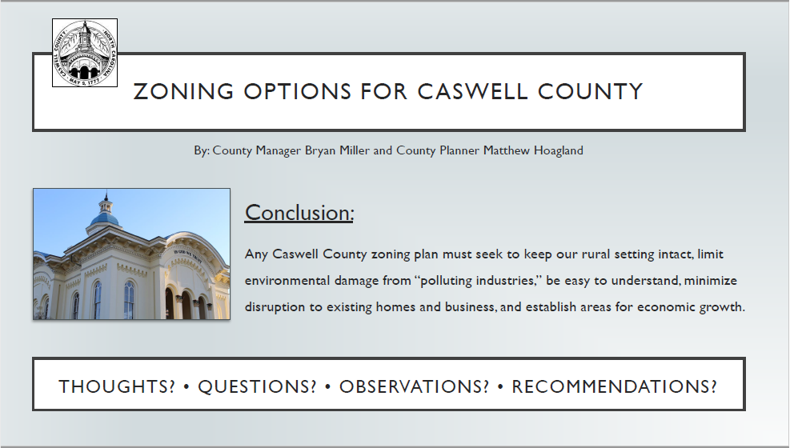

At 2:42 p.m. Mr. Blalock left the meeting.
Planning Department Updates
Mr. Hoagland presented the Board with a list of permits, forms, and applications needed for the proposed rock quarry and asphalt plant projects. This is the same itemized list he has sent to the company and wanted to share the list with the board mostly for informational purposes.
Prospect Hill Rock Quarry:
- Land Development Form
- Environmental Assessment Application
- Flood Hazard Acknowledgement Form (or) Floodplain Development Form
- Watershed Protection Permit (with site plan)
  - Site plan shall include:
- Stream buffer setbacks
- Impervious surface area calculation
- Setbacks
- Undisturbed vegetation
- Easements
- Any proposed new structures
- Spill Containment Plan
- Confirmation of a NCDEQ Mining Permit
- Confirmation of a NCDOT Driveway Permit
- S.N.I.A. Permit (if development exceeds 12% impervious surface)
- Environmental Impact Statement (if necessary)
- Watershed Occupancy Permit (upon completion)

South 62 Asphalt Mixing Facility:
- Land Development Form
- Environmental Assessment Application
- Flood Hazard Acknowledgement Form
- Watershed Protection Permit (with site plan)
  - Site plan shall include:
- Stream buffer setbacks
- Impervious surface area calculation
- Setbacks
- Undisturbed vegetation
- Easements
- Any proposed new structures
- Spill Containment Plan
- Confirmation of an applicable NCDEQ permit
- Confirmation of a NCDOT Driveway Permit
- NCDEQ determination regarding origination of on-site ponds
- S.N.I.A. Permit (if development exceeds 12% impervious surface)
- Environmental Impact Statement (if necessary)
- Watershed Occupancy Permit (upon completion)

Mr. Hoagland gave an update on internet connectivity. “We have been in touch with River Street Communications which has a partnership with Piedmont Electric Corporation. They plan to qualify for G.R.E.A.T. grant funding this year and, we will be sharing with them our survey results and any other information to help them receive this funding. With so much going on with zoning and 160D changes I will not be able to focus as much time on internet connectivity as last year but thankfully much of the work is already done. We’ll just have to get them a lot of that information from last year.”

Mr. Hoagland brought a new issue before the Board that has come up several times recently. Currently the UDO requires and owner’s certificate for virtually all new plats presented for recordation. However, The State of North Carolina does not require an owners certificate, but based on the local ordinances we do. This is something he wanted to make the Board aware of because this rule has not always been enforced in the past. Also, not all other counties require it. He told the Board this maybe something they want to address in the future. It would make recording plats a little easier for property owners throughout the county. Chairman Johnston questioned the owners certificate states that the owner owns the property. Mr. Hoagland replied, “it’s basically just their consent for the proposed plat and that it also has to be notarized. This is a bit of a redundancy since the surveyor’s seal is meant to guarantee the accuracy of the plat.”

Mr. Hoagland stated that after meeting he’d like to schedule a time with Chairman Johnston since the County Manager has requested that him, Mr. Hoagland, and Chairman Johnston schedule a meeting with the NC Wireless Association to continue looking at how we can ensure our wireless ordinance helps get more cell phone signal throughout the county.

Mr. Daniel questioned if the asphalt plant was going to be temporary. Mr. Hoagland replied that he was not sure.
Adjournment

Chairman Johnston made a motion at 2:49 p.m. to adjourn the meeting, seconded by Mr. Harris. The motion carried unanimously.
The minutes above were recorded by Ashley Kirby Powell, Administrative Assistant

