MINUTES – JANUARY 7, 2020

The Caswell County Board of Commissioners met in special session at the Caswell County Historic Courthouse, Yanceyville, North Carolina at 9:00 a.m. on Tuesday, January 7, 2020. Members present from the Board of Commissioners: Rick McVey, Chairman, David Owen, Vice Chairman, Nathaniel Hall, Jeremiah Jefferies, and Steve Oestreicher. Absent: Sterling Carter and William E. Carter. Also present: Bryan Miller, County Manager and Gwen Vaughn, Finance Director. Paula P. Seamster, Clerk to the Board, recorded the minutes.

MOMENT OF SILENT PRAYER

Chairman McVey opened the meeting with a moment of Silent Prayer.

ITEMS FOR DISCUSSION
Outside Consultant for Employees

Commissioner Jefferies stated that the Board discussed finding an outside consultant for the county employees and he thought Commissioner Hall was going to check with the PTRC and NCACC. Commissioner Hall responded that he had reported back to the Chairman with consultant information that was given to him by the PTRC and NCACC.

Chairman McVey stated that he never heard back that the Board wanted to proceed with this. Commissioner Jefferies responded that he would like to move forward with getting an outside consultant.

Mr. Miller stated that this should be discussed in a closed session.

Chairman McVey asked Commissioner Hall to get the names to him again.

Transparency/Honesty/Trust

Commissioner Jefferies stated that over the last year the Board has not worked together and no one trusts each other. He added that he needed things to be discussed with all the Board members and not just a few. Commissioner Jefferies stated that this is the worst Board he has ever worked with.

Commissioner McVey suggested a team building class for the Board.

Mr. Miller stated that there are some good team building classes out there and with these classes it does improve team work and trust as well as providing a common interest. He stated that he and the clerk could look into this for the Board.

Commissioner Jefferies stated that the Board has had team building in the past and it helped a lot.

Mr. Miller stated that several agencies in the county have done this type of activity and he would reach out to them to find out more information.

Zoning in Caswell County

Commissioner Oestreicher stated that zoning was discussed yesterday at the Board meeting as part of the moratorium. He added that there are things that have to be worked on throughout the year and zoning is in the top 3.

Chairman McVey stated that the first step would come from the Planning Department.

Mr. Miller stated that over the last couple of weeks the County Planner has looked at what zoning could look like in Caswell County. He suggested that the Board set a meeting date for a special meeting and the maps that the planner has been working would be presented in that meeting as well as what needs to be address to move forward with zoning such as public meeting.

Commissioner Oestreicher stated that some meetings have already been held. He asked for a review of the dates, places, and approximate county of how many were present at the meetings in Anderson and Pelham.

Chairman McVey asked if the county planner was looking at countywide zoning or spot zoning. Mr. Miller responded that he had asked the county planner to present a countywide zoning map and then a map with zoning in Anderson and Prospect Hill. He added that Pelham does not want zoning.

Commissioner Hall stated that zoning needed to be approached countywide. He added that the citizens do not know all the facts about zoning. Commissioner Hall stated that the Board cannot let the loudest citizen dictate what the Board does and the county cannot wait for the problems to come up and then address them. He added that there needs to be countywide zoning or no zoning.

Chairman McVey asked Commissioner Hall if he had heard the feeling of the citizens in Locust Hill. Commissioner Hall responded that he had not heard anything from the citizens in Locust Hill but citizens usually react when something affects them.

Commissioner Jefferies stated that the citizens in his district do not want zoning and he added that the taxpayers run Caswell County. He added that zoning needed to be put on the ballot.

Commissioner Oestreicher stated that 5% of the rock quarry property is in his district and heard them loud and clear yesterday that they did not want to fight another industry in their area and that they are in favor of zoning. He added that zoning is not decided by a ballot and that the ballot would just be done to get an opinion but he did not think there would be enough time to place it on the ballot in November since the moratorium ends in one year.

(At 9:30 a.m. Commissioner Owen entered the meeting.)

Chairman McVey asked if the Board needed to educate the citizens about zoning. Commissioner Hall responded that it is up to the citizens to educate themselves. Chairman McVey stated that the Board has some responsibility to educate the citizens.

Commissioner Oestreicher stated that education is the main task in the public meetings. He asked if there were consultants that could help the Board with the education because he felt that education is the key to zoning. Commissioner Oestreicher stated that the citizens needed to know what zoning does and does not do and added that zoning is a preventative measure.

Commissioner Owen stated that he agreed with Commissioner Hall. He added that when meetings are held the only people that show up are the ones against zoning. Commissioner Owen stated that this process needs to start with the county planner and the Planning Board. He stated that people want to see what zoning will look like specifically to their area. Commissioner Oestreicher added that this is one way to deal with the unknown. Commissioner Owen stated that the citizens need to understand residential zoning as well as the other types of zoning.

Commissioner Hall stated that zoning gives the county a management tool and added that the Board can zone areas with the input from the citizens.

Commissioner Oestreicher stated that the county cannot be rubber stamped residential and agricultural. Commissioner Owen responded that this is something the county planner can look into more in detail.

Mr. Miller stated that the Board could plan a joint meeting with the Planning Board and a countywide zoning map could be presented at this meeting. Commissioner Oestreicher responded that he would like to see a zoning map options. Mr. Miller stated that the countywide zoning map would have options.

Chairman McVey asked the Board to pick a date for this meeting because the Board needs to see what zoning would look like.

Mr. Miller stated that he instructed the planner to use 5 uses for zoning. He suggested scheduling a meeting for next week.

Commissioner Owen sated that there needs to be talk about mixed zoning.

Commissioner Oestreicher stated that there needs to be an exemption process with zoning.

The Board set the meeting for Thursday, January 16, 2020 at 1:00 p.m. at the 911 Center.

Commissioner Hall stated that the Board needed to be aware of the watershed areas in the county.

Commissioner Oestreicher asked if covenants would affect zoning. Mr. Miller responded that covenants can be more restrictive. Commissioner Oestreicher asked how the city’s zoning worked. Commissioner Hall responded that the city’s zoning takes priority. Mr. Miller stated that the county does not have jurisdiction over towns and cities.

RECESS

The Board took a brief recess.

County Advisory Boards and Committees

Commissioner Owen passed out the sheet below to the Board.
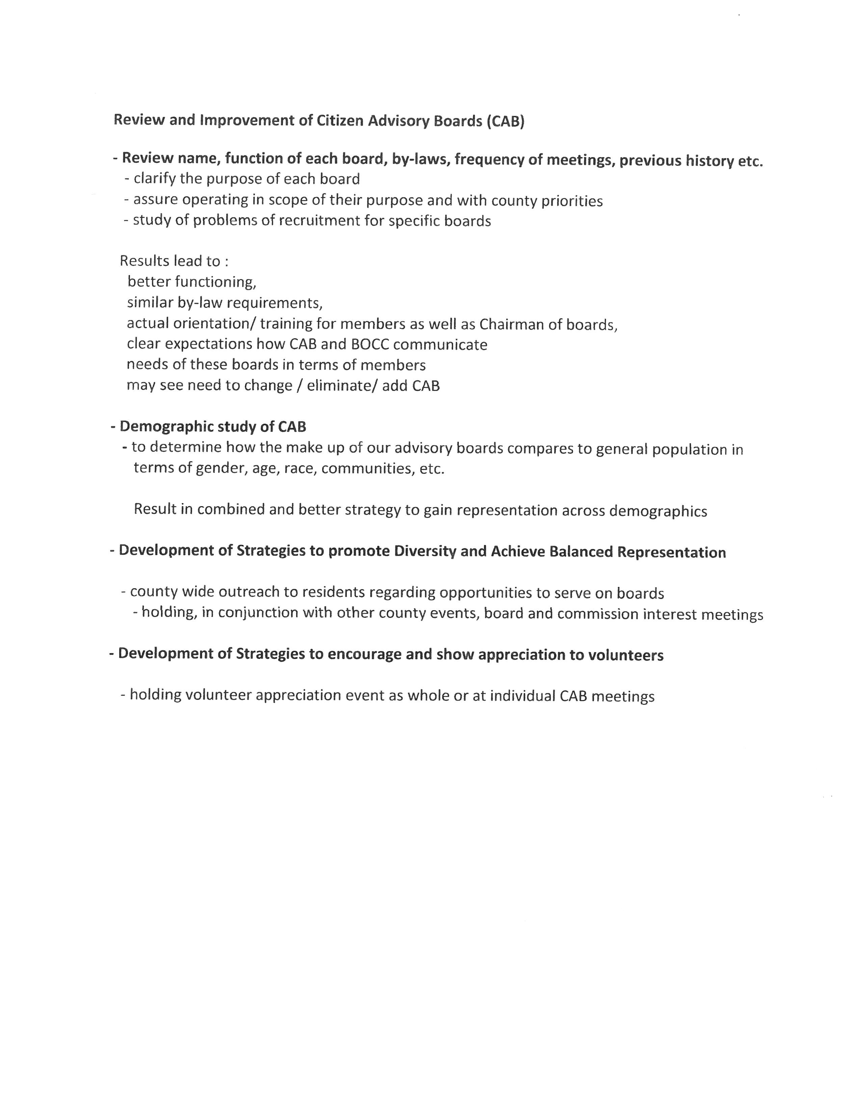
Commissioner Owen stated that he felt disconnected from the county boards and committees and he would like to pursue the above process. He suggested looking at the demographics of the boards first. Commissioner Owen stated that the application may need to be revamped. He suggested having a table set up at events with information available on county boards and committees so the public will be more aware of what each committee does. Commissioner Owen stated that the volunteers on these committees but in a lot of hours and the Board may need to consider some type of appreciation event. He went through the list that was handed out. Commissioner Owen asked the Board if it thought the information was beneficial. Chairman McVey responded yes.

Commissioner Hall stated that Commissioner Owen hit on a lot of issues and that the Board needed to start working on this list. He added that a lot of citizens don’t know what is going on with the boards and committees.

Commissioner Owen asked Commissioner Hall to help him with this process.

Commissioner Hall stated that there are several reasons why people do not serve on these committees.

Mr. Miller stated that this is a very complex issue that will take a lot of time and he offered to share some information from the meetings that he has been involved with.

Commissioner Oestreicher stated that the chairs of these committees need to participate in recruiting citizens for these boards and committees.

Commissioner Owen asked if anyone on the Board wants to help with he would welcome the help.

Co-Working Space on the Square

Mr. Miller stated that demolition has started in the old drug store. He expects the project to be complete in May. Mr. Miller stated that he plans to have a soft opening in May or June and then a larger opening later. He stated that the overall budget for this project is $1,276,600 and $1,303,525 has been received from funding sources as well $231,000 has been received for operational support so a total of $1,534,525 has been received.

Chairman McVey asked if a new roof would be put on the building. Mr. Miller responded yes.

Commissioner Oestreicher asked if the facade would be changed. Mr. Miller responded that this would probably not be changed a lot.

Commissioner Hall asked if policies and procedures regarding the uses of businesses and citizens have been developed. Mr. Miller responded that they have received the policies and procedures from HQ Greensboro and HQ Raleigh and they have helped a lot of develop the ones for Caswell. He added that Caswell’s will include a schedule for 501c3s whereas the others did not.

Commissioner Hall asked if there was a schedule of return on investment. Mr. Miller responded yes that he anticipates 12 co-working memberships and 70% of desk space to be used and the building will break even. He added that the economic developer has these numbers.

Commissioner Jefferies asked if county staff will have offices in this space. Mr. Miller responded that the economic development office will be in there as support for the center as well as the IT Department and fill ins of administrative assistants from different departments.

Commissioner Owen asked what the back part of the building will be used for. Mr. Miller responded that this will be a co-working office space.

Commissioner Hall asked for the capacity as it relates to office space. Mr. Miller responded that he could not answer this question because it is desk space. He added that there will be 4 to 6 desks per office. Commissioner Hall asked how many desks there will be. Mr. Miller responded that there maybe 50 desks. He added that the anchor tenant will rent a whole office space. Commissioner Hall asked if the desks will be rented for 24 hours. Mr. Miller responded that the facility will be a 24/7 facility. Commissioner Hall asked if individuals could rent a space for 4 to 6 hours. Mr. Miller responded that individuals can utilize a desk in the open space. He added that this space will have 1G of internet service.

Ms. Vaughn provided a handout and information requested from the Board.

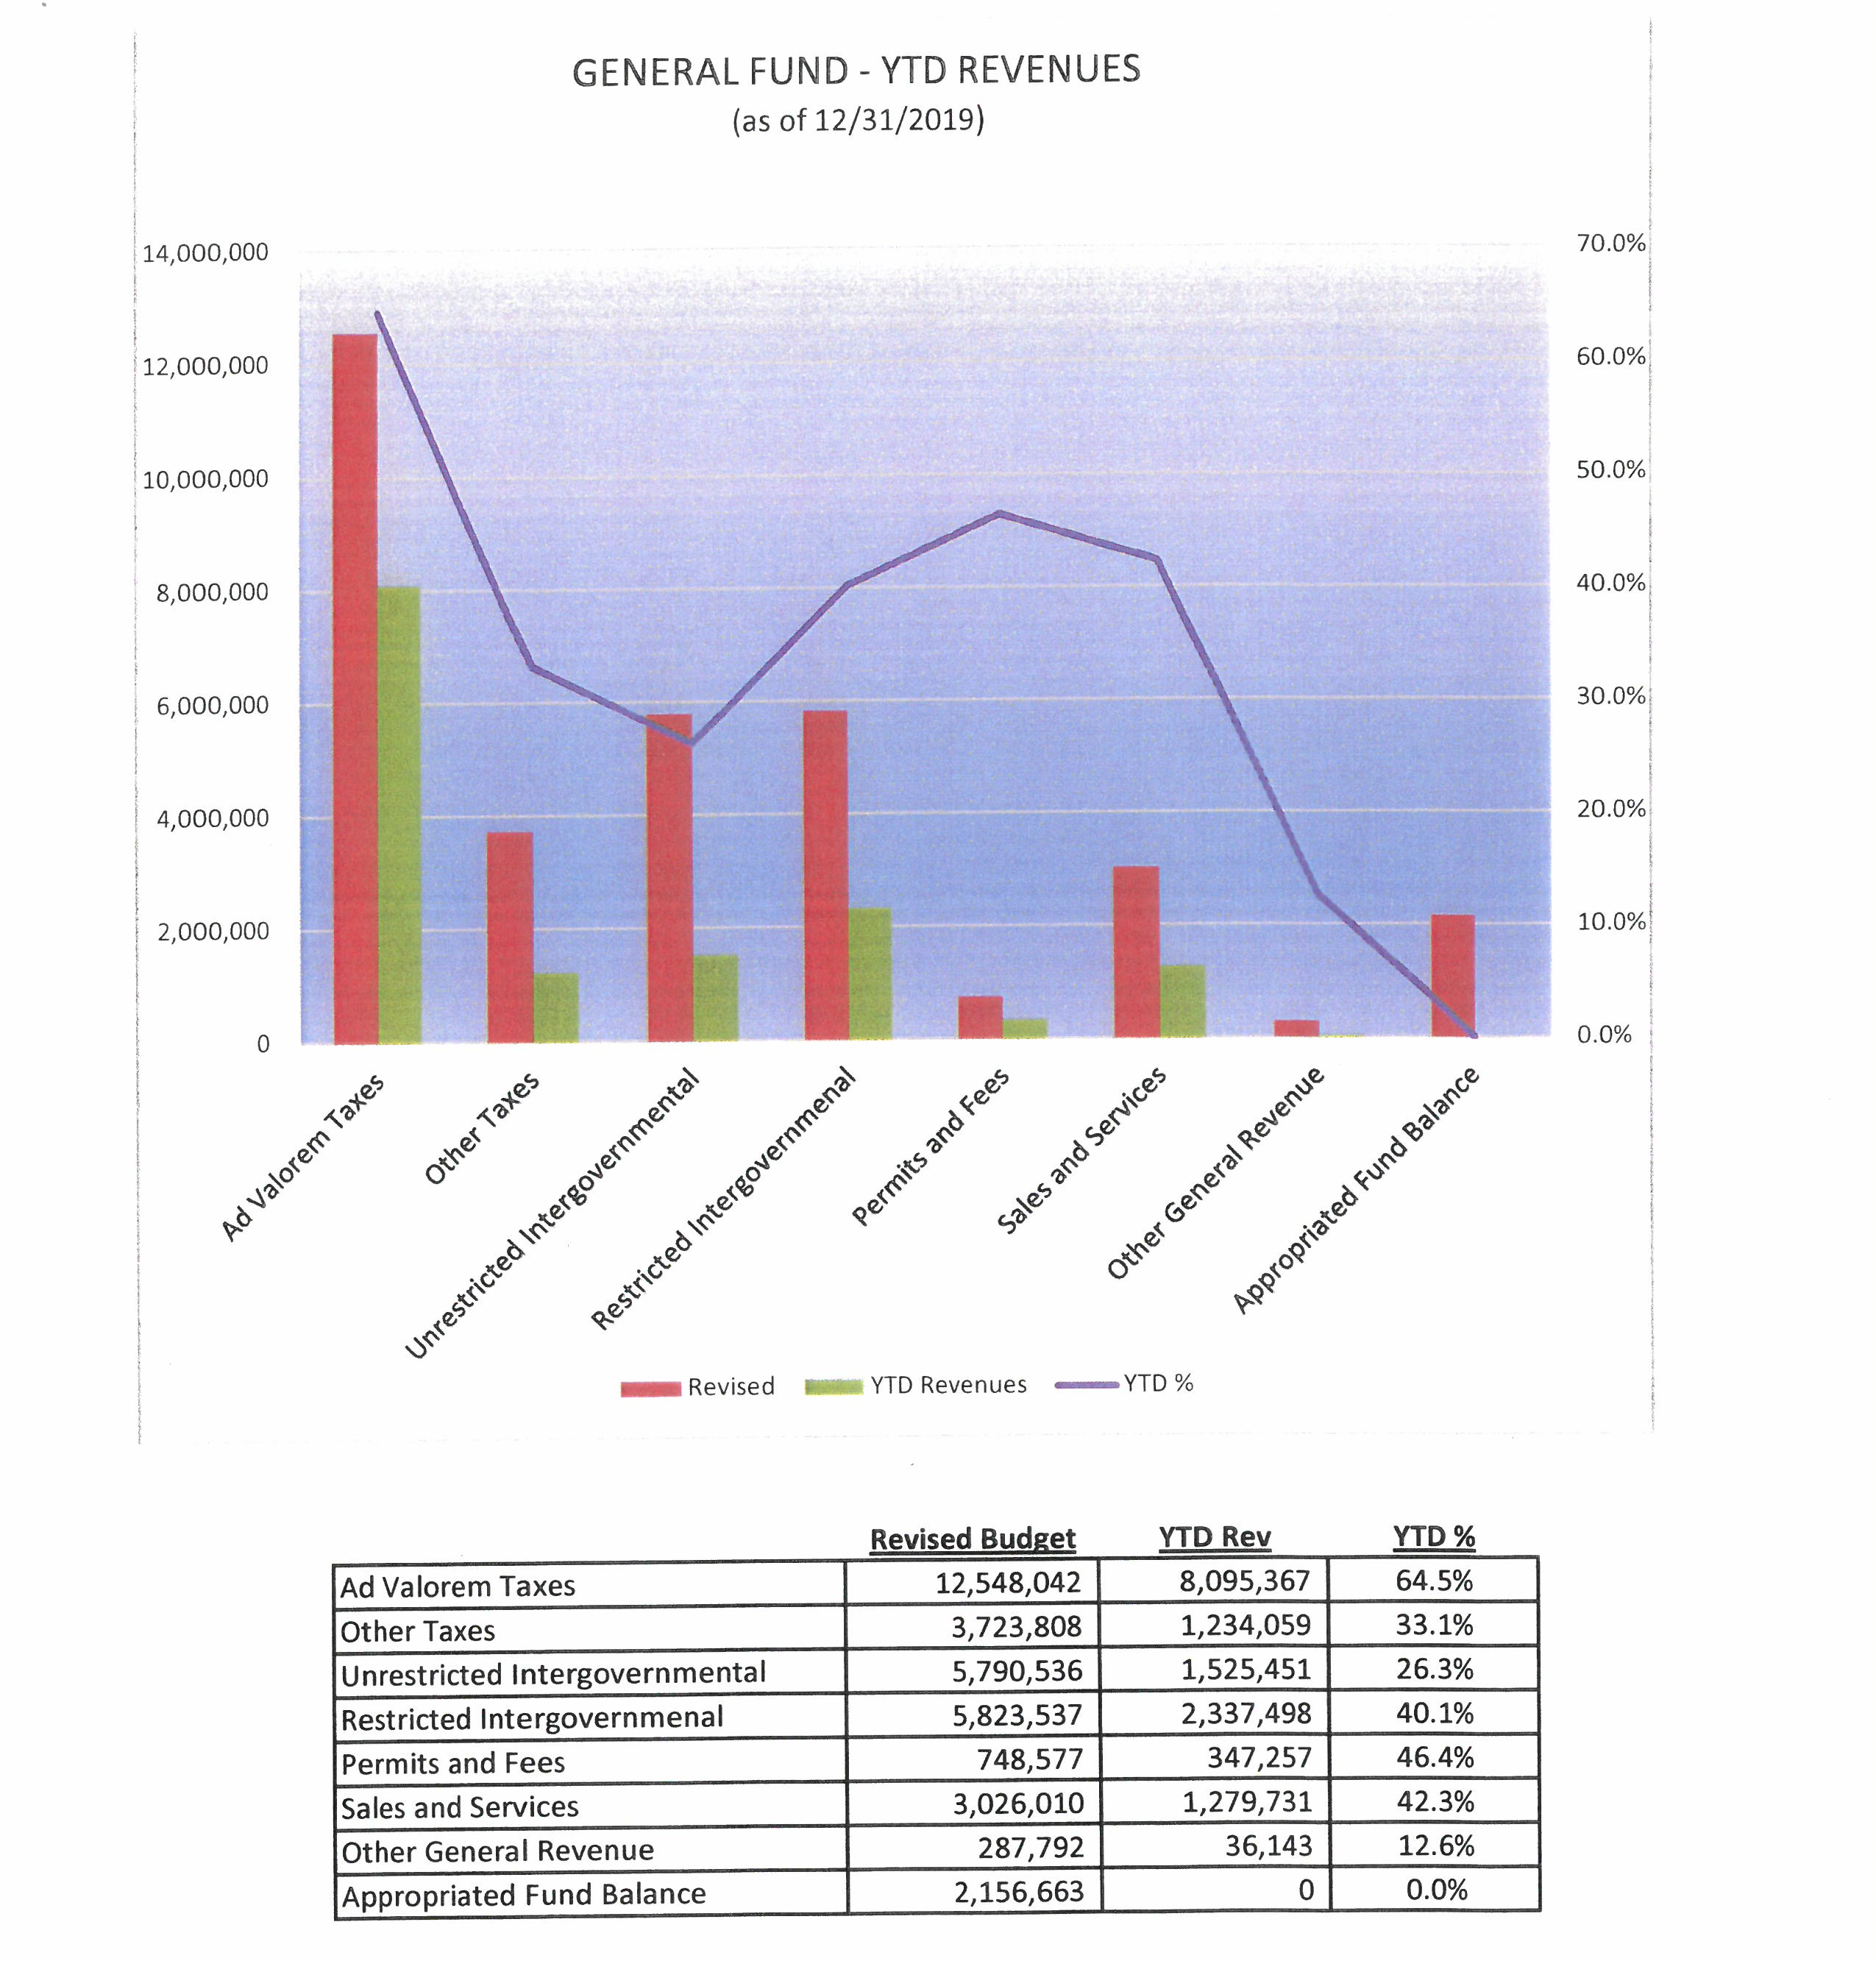

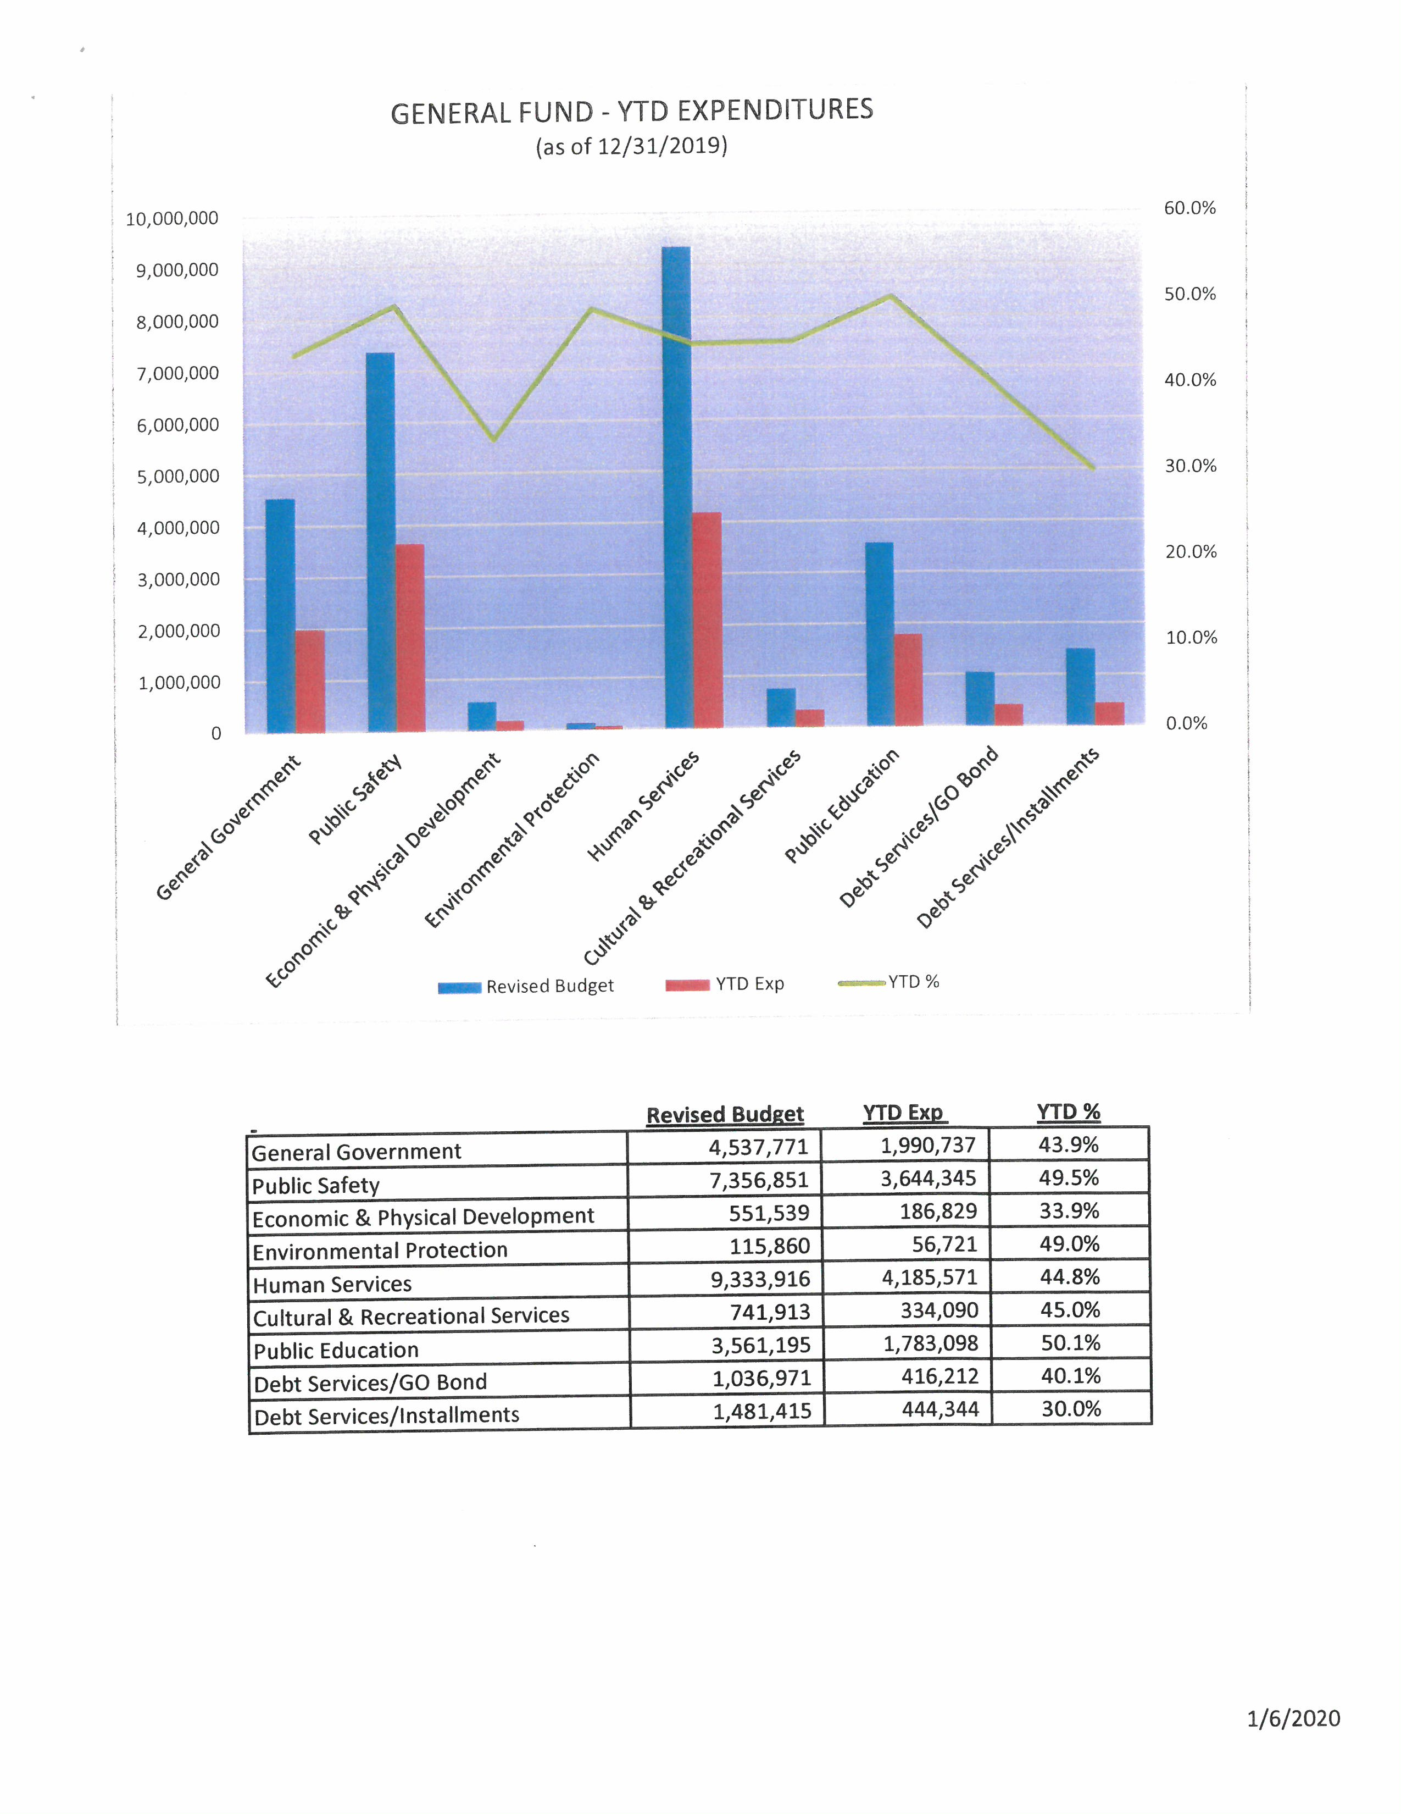

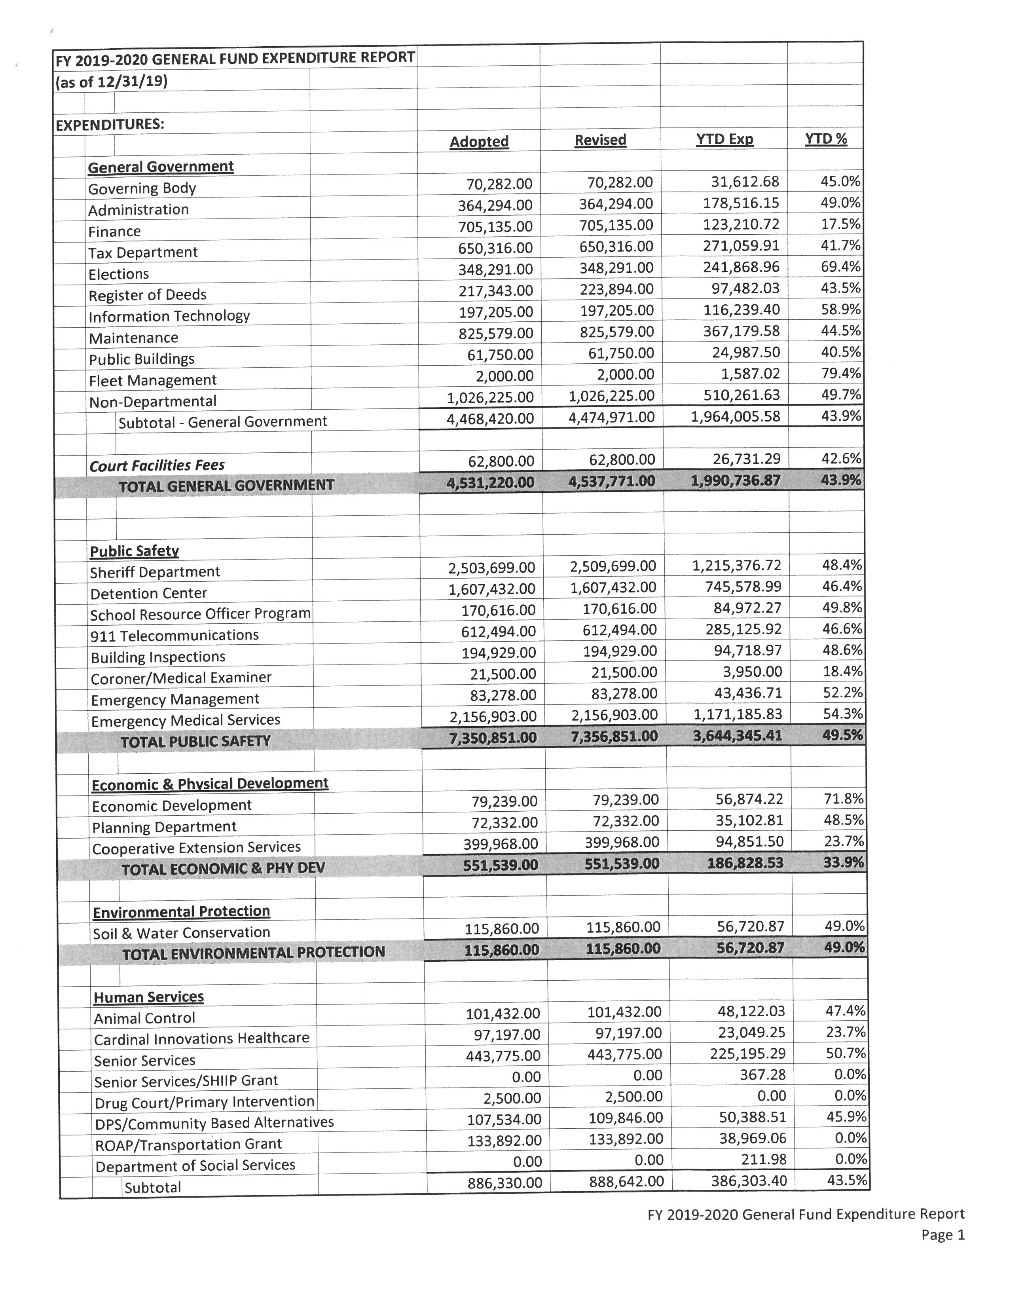

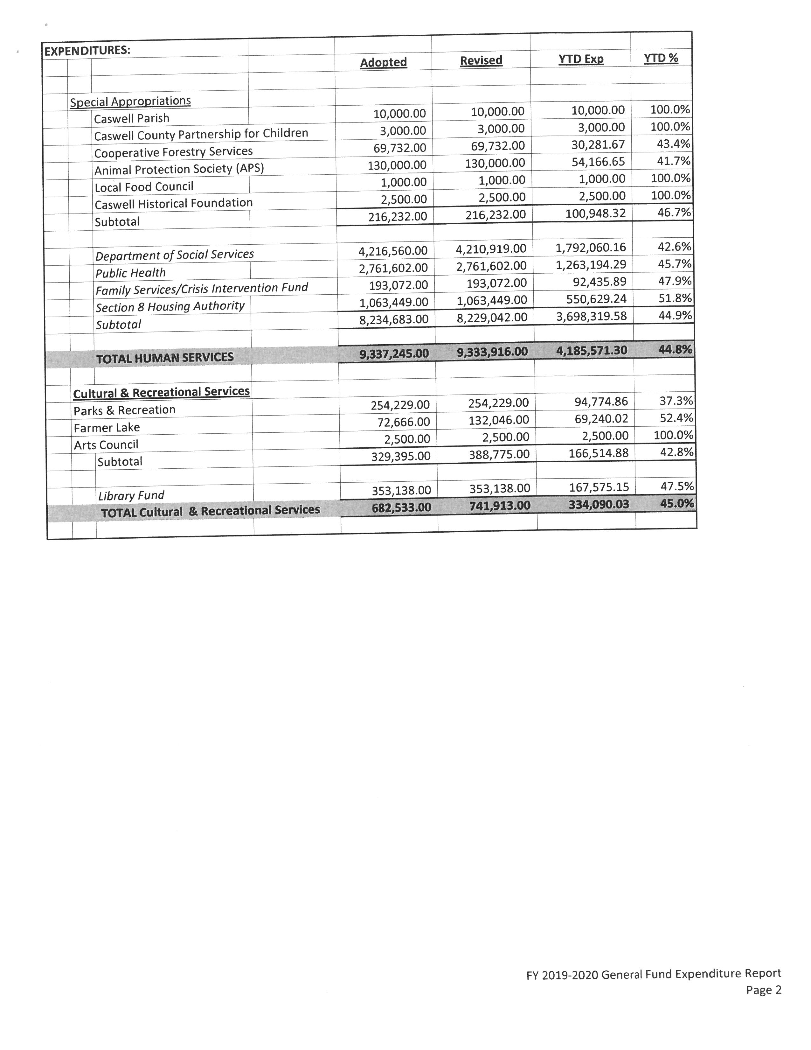
Ms. Vaughn went over the forms that were passed out. She stated that the peak for collecting taxes will be the ending of January. Ms. Vaughn stated that sales tax collections are always a month behind. She stated that the overall percentage for revenues is $8.7% and the overall percentage for expenditures is 46.4%. Ms. Vaughn stated that the county is running under budget on everything except for Public Education. She added that the Public Safety purchased an ambulance.

Commissioner Hall stated that he would like to see non-departmental expenditures appropriated to the true departments. He added that now is the time to do this since the county is looking at new software implementation. Ms. Vaughn responded that most things can be separated by departments but broadband and the webpage are in non-departmental. Mr. Miller stated that these can be gone through. Commissioner Hall stated that from a cost accounting standpoint these can be allocated to the difference departments.

Commissioner Owen asked when it is projected for the Board to get the budget. He added that he understands that Health and DSS will have to wait but he asked if the other departments’ budget could be received earlier than last year. Commissioner Owen asked if the Board could receive the budget by May. Mr. Miller responded that he and Ms. Vaughn have not sat down and discussed the budget yet. Commissioner Owen suggested using projections on revenue based on last year’s numbers. He added that he would like to see an operational budget first and he did not want to meet 8 times in June.

Commissioner Oestreicher stated that the Board needed to have the budget by the 1st meeting in May.

Ms. Vaughn stated that she would ask for the capital outlay items first. Commissioner Owen responded that the departments did not need to send in their wants because a lot of money was spent last year. Mr. Miller stated that the Board needed to see the list. Commissioner Owen stated that needs is different from wants.

Commissioner Oestreicher stated that he would like to see the capital item sooner than later.

Commissioner Hall stated that parameters needed to be set on what they do not need to ask for such a desktop computers. He added that a lot of the staff is afraid of technology and that they needed to move into the 21st century.

Commissioner Oestreicher stated that he would like to see a plan on the budget presentation and review process. He added that it was great last when the department heads presented their budgets. Commissioner Oestreicher requested more analytics such as projections, trends, and what has been done to reduce costs. He asked for a time line for the budget process and he wanted it to stay on track. Commissioner Oestreicher also asked for heavy participation from the tax department.

Commissioner Owen asked what is included in Other Taxes. Ms. Vaughn responded sales tax, Medicaid Hold Harmless, Franchise Fees.

RECESS

The Board took a brief recess.
Preparing for 5G Internet

Commissioner Hall stated that the Board has talked about internet a lot over the last couple of years. He added that 5G is done by Wi-Fi. Commissioner Hall asked that the Planning Department look into the areas in the county that need internet.

Mr. Miller stated that the NC Broadband Association meeting was on how to make towers more appealing to internet companies. He added that the tower at Stoney Creek will have 5G. Mr. Miller stated that the largest cost is running able to the towers. Commissioner Hall responded that there is a lot of fiber in the ground now. Mr. Miller stated that T-Mobile has erected a tower in the Yanceyville area.

Commissioner Hall asked about the status with River Street. Mr. Miller responded that River Street is already engaged with Piedmont Electric.

Mr. Miller informed the Board that Open Broadband LLC is going to be delayed by a month or so due to funding. He added that the grant requires Open Broadband to pay for the materials and then get reimbursed so they have applied for financing. He added that it is cheaper to erect straight towers rather than the traditional towers. Mr. Miller stated that these straight towers cost about $15,000 and if the Board wanted to discuss the possible it could be put on the agenda.

Census Complete County Committee

Commissioner Hall stated that this year is a census year and he thought the county should look into a complete county committee. Mr. Miller responded that the county has a Census Count Committee meeting scheduled for January 23rd at 1:00 p.m. at the library.

Commissioner Oestreicher asked when the census begins. Commissioner Hall responded that everyone should receive a packet in the mail and after the deadline individuals will be sent out to the houses that did not send anything in. He added that the county loses money if everyone is not counted.

Funds Budgeted for Professional Development

Commissioner Hall stated that something needed to be done to encourage staff to go to college and/or get more training. He added that money was budgeted for this. Ms. Vaughn responded that the $50,000 was for the schools. Chairman McVey added that the $50,000 was to help with college for future teachers.

Mr. Miller stated that Dr. Carter has reached out to him about this. He added that Commissioner Sterling Carter will also be included in this conversation but Dr. Carter is hoping to use these funds as a match for grants to get more money for this program.

Commissioner Hall stated that more professions needed to be focused on other than teaching such as nurses, etc. He added that the county needed to think broad and creatively and this program needed to get started. Mr. Miller responded that this was talked about during the budget meetings and it was just for teachers. Commissioner Hall stated that this needs to address the best interest for the county.

Commissioner Owen stated that this information needed to be relayed to Commissioner S. Carter that this money is to focus on the whole county.

Commissioner Hall stated that the county manager needed to have a conversation with Dr. Carter and added that input is needed from school professionals. Mr. Miller suggested having a partnership with UNC Pembroke and Western Carolina. Commissioner Oestreicher stated that Piedmont Community College needed to be talked to as well. Commissioner Hall stated that a sit down should be scheduled with school system, PCC and the County and there needs to be a commitment to the County.

Commissioner Owen asked the county manger to talk to Dr. Carter about this.

Commissioner Hall asked that this be put on the agenda to discuss further.

Commissioner Oestreicher asked if the Board would discuss this first or should the county manager talk to Dr. Carter first. Commissioner Hall responded that the county manager should talk to Dr. Carter before the meeting.

Automation Projects by Departments

Commissioner Hall stated that last year during the budget process the Board asked the departments to give their plans for automation.

Mr. Miller stated that the Tax Department has bought the new software and it is being installed. He added that the server has been purchased and installed as well. Mr. Miller stated that the system will be tested and then the data conversion will take place.

Commissioner Hall asked if the new tax software would be integrated with invoicing. Mr. Miller responded yes. Commissioner Hall stated that residents needed to be able to pay taxes online without a high fee. Commissioner Oestreicher responded that the credit and debit card companies charge these fees. Commissioner Hall stated that the fee should not be between $75 and $100 for a transaction.

Commissioner Oestreicher asked if the County could change and set this with another vendor. He added that it is easy to do a bank draft and there are no fees for this. Commissioner Hall responded that there is always a better way. Commissioner Oestreicher asked if the contract had a deadline or can the agreement be cancelled. He supported paying the taxes online.

Mr. Miller stated that he and Ms. Vaughn along with Mr. Bernard would look into this.

Mr. Miller stated that there will be a Finance software kickoff on January 14th and 15th.

Commissioner Oestreicher asked if the hardware was in place. Mr. Miller responded that the server that is in place now will support this software.

Commissioner Hall stated that he thought the finance software was going to be cloud based. Mr. Miller responded that it will be cloud based. Commissioner Hall asked if the finance software would be able to talk to other departments. Ms. Vaughn responded yes. Commissioner Oestreicher added that it was part of the specs.

Commissioner Oestreicher asked if it was still going to take 18 months to implement. Ms. Vaughn responded that it would take 12 to 18 months and that there is a step by step process that has to be followed. She added that she would have a better understanding of the process on January 14th.

Commissioner Hall asked how much more staff would this required over the next 2 years. Mr. Miller responded that finance is in the process of reallocating duties. He added that some of the finance duties and some of the HR duties will be going to the administrative assistant. Mr. Miller stated that member of these departments in involved in these discussions.

Mr. Miller stated that the Maintenance and IT’s system is operating. He added that not all of the functions are being used because there is not enough data yet. Mr. Miller stated that the space that PCC used to use at Guilford Mills is being used by the Sheriff’s Office. He added that the Work Order system is set up on email.

Commissioner Hall stated that the Board needed to talk about expanding the IT staff and they need to be trained and have skills.

Chairman McVey asked when the work order system would be on board to track time, parts, etc. so that he or other Board members could look at this. Mr. Miller responded that the Board has staff to do that and that he would be happy to provide that information.

Commissioner Oestreicher stated that a better question would be when Colon will be able to see this information. Mr. Miller responded that he could not answer this question. He added that the Tax software and Finance software have taken priority.

Chairman McVey asked if every department had assigned one person to handle all work orders. Mr. Miller responded that DSS and Health had done this. Chairman McVey asked when the Timekeeper system would come on board. Ms. Vaughn responded that she would know more on January 14th. Chairman McVey asked if the payroll staff would be able to do other things in the finance department once this is implemented. Ms. Vaughn responded yes. Mr. Miller added that Ms. Vaughn is already reallocating duties.

Work Closely with PCC on Agribusiness Center in Pelham Industrial Park

Commissioner Oestreicher asked about the status of this and asked for a timeline. Mr. Miller responded that there was been a downturn in the type of timber that is selling right now. He added that the property has been shown 3 times and that he hopes that the land will be timbered quickly. He added that PCC, the economic developer, and he have met several times with different agencies on funding. Mr. Miller stated that land transfer agreement is with PCC’s lawyer and once it is complete it will come before the Board for approval. Commissioner Oestreicher asked what the holdup was since the Board agreed to do this in the spring. Mr. Miller responded that the hold is the timbering of the land. He added that the State’s budget included $1.1 million in their budget for this project and $1.4 million with NC Connect and other funders are being talked to for the remainder of the money. Commissioner Oestreicher asked to see a timeline on this project.

Implement New Agenda Format to Improve Better Follow Up on Projects and Assigned Tasks

Commissioner Oestreicher handed out an example agenda from the Piedmont Triad Regional Council.

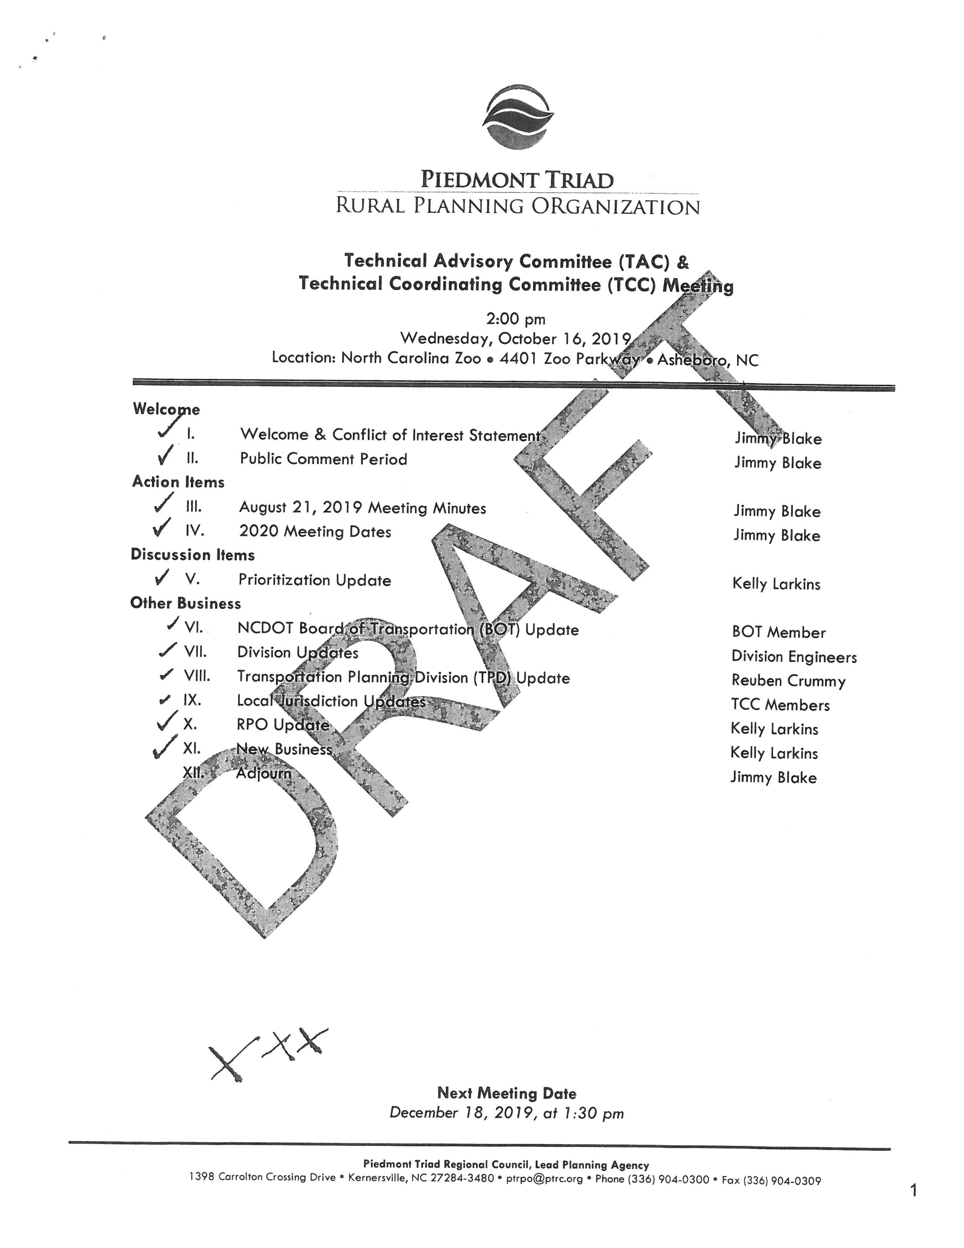
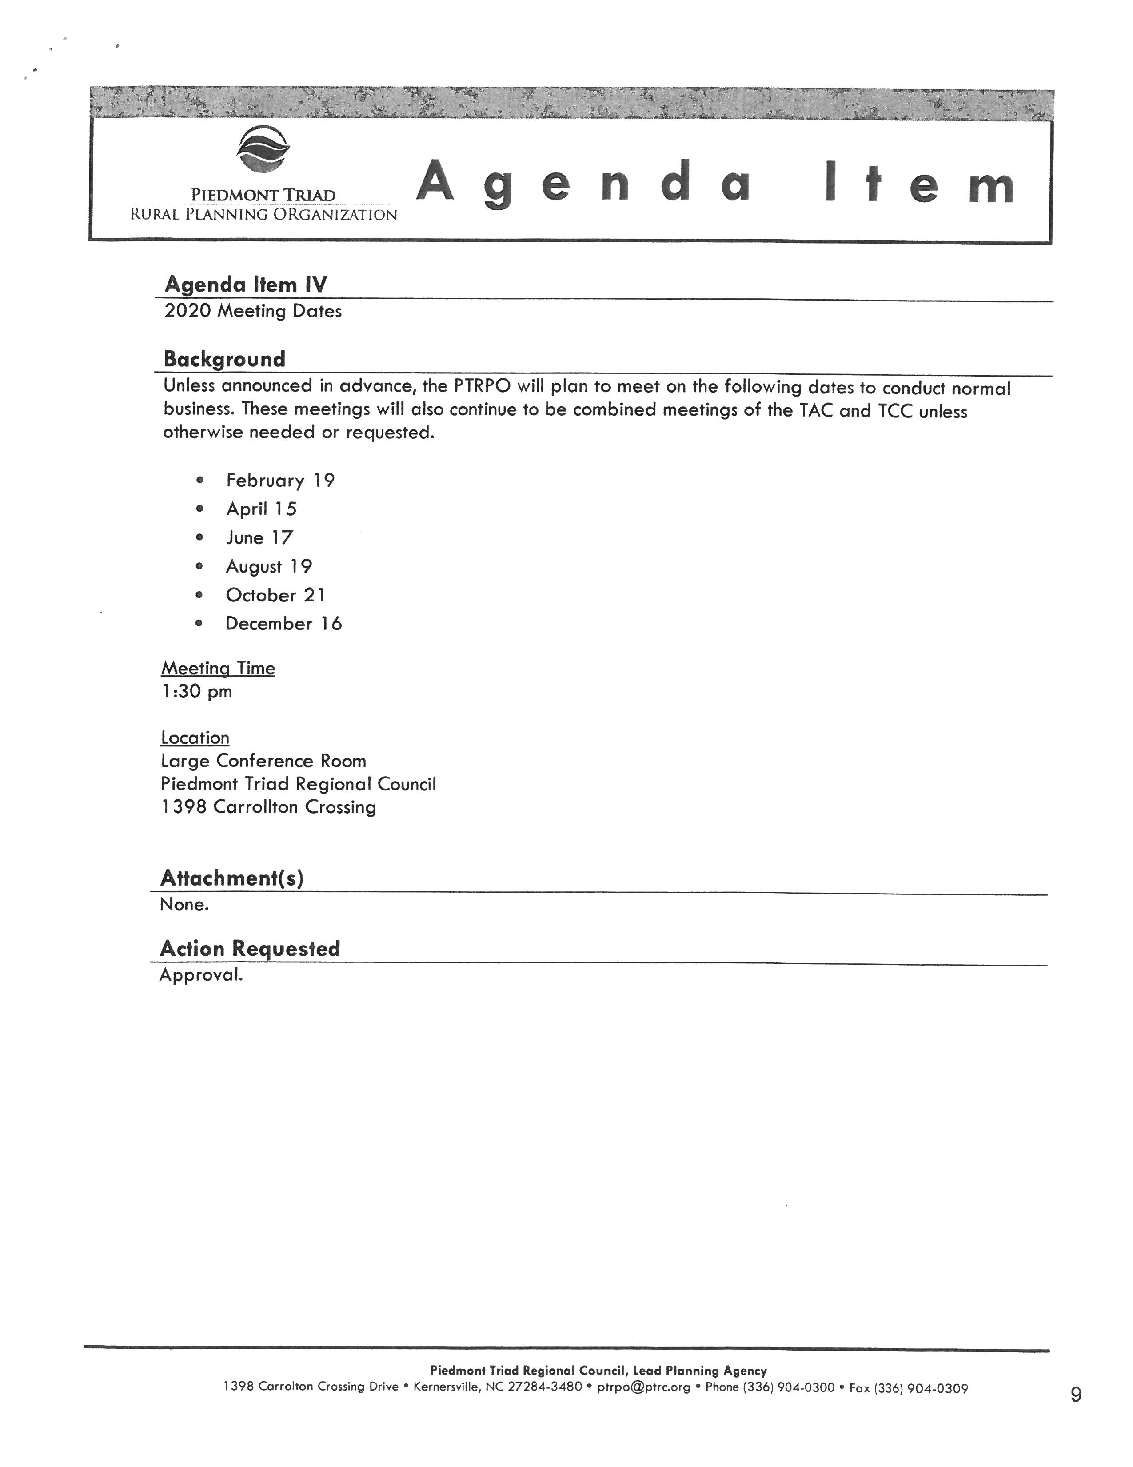
Commissioner Oestreicher stated that he likes the PTRC’s format and he likes to see old business and new business. He added that on this form the departments would give a description of what is being presented, have attachments and request action if needed. Commissioner Oestreicher asked is the Board would consider adopting something like this.

Commissioner Owen stated that he would like to see the action item on the agenda and added that this way the Board would know when to take action.

Commissioner Oestreicher stated that the action would the listed as well as a timeline and who is assigned the duty. He asked if the clerk would integrate this and come up with a proposal for the Board. The clerk asked if the Board wanted to see a proposal or to just start the new agenda for the next meeting. Commissioner Oestreicher stated to start the new agenda procedure at the next meeting.

WRAP UP & CLOSE OUT

Chairman McVey stated that it was brought up to get a timer for the meetings. He stated that the clerk had done some research and the ones she found cost $857 and $449. The clerk recommended authorizing her to get a cheaper one at the home store. Chairman McVey stated that this would be up to the Board and suggested put a limit of $20 to $25 on the timer.

Commissioner Jefferies stated that he and Chairman McVey had attended a seminar in Raleigh and it was recommended to have work sessions before the meetings to agree on items and then vote at the next Board meeting. There was a little discussion but no one agreed to this.

Commissioner Owen stated that the Board had agreed that it would not vote on new items the same night that it was presented. Commissioner Hall responded that this has been done. Commissioner Oestreicher stated that the new template would have on it whether or not an item would be voted on.

ADJOURNMENT

At 1:05 p.m. Commissioner Owen moved, seconded by Commissioner Hall to adjourn to work session. The motion carried unanimously.

________________________________ ___________________________
Paula P. Seamster Rick McVey
Clerk to the Board Chairman

******************************************************************************

