MINUTES – JUNE 8, 2020

The Caswell County Board of Commissioners reconvened in special session at 1:00 p.m. on Monday, June 8, 2020. The meeting was held electronically using Zoom Webinar software. Members present: Rick McVey, Chairman, David J. Owen, Vice Chairman, Sterling Carter, William E. Carter, Nathaniel Hall, Jeremiah Jefferies and Steve Oestreicher. Also present: Bryan Miller, County Manager and Gwen Vaughn, Finance Director. Paula P. Seamster, Clerk to the Board, recorded the minutes.

WELCOME

Chairman McVey opened the budget work session.

PROPOSED FY 2020-2021 BUDGET

Mr. Miller thanked Commissioner McVey and he also thanked Gwen Vaughn, Finance Director, for the information compiled as requested by the Board. He asked Ms. Vaughn to go over the data that she put together.

Ms. Gwen Vaughn stated that the information that the Board received is for 5 years of information as well as additional information requested from the commissioners. She stated that Commissioner S. Carter requested 5 years of fund balance information and this is located on page 1starting with 2014-2015 through 2019-2020.

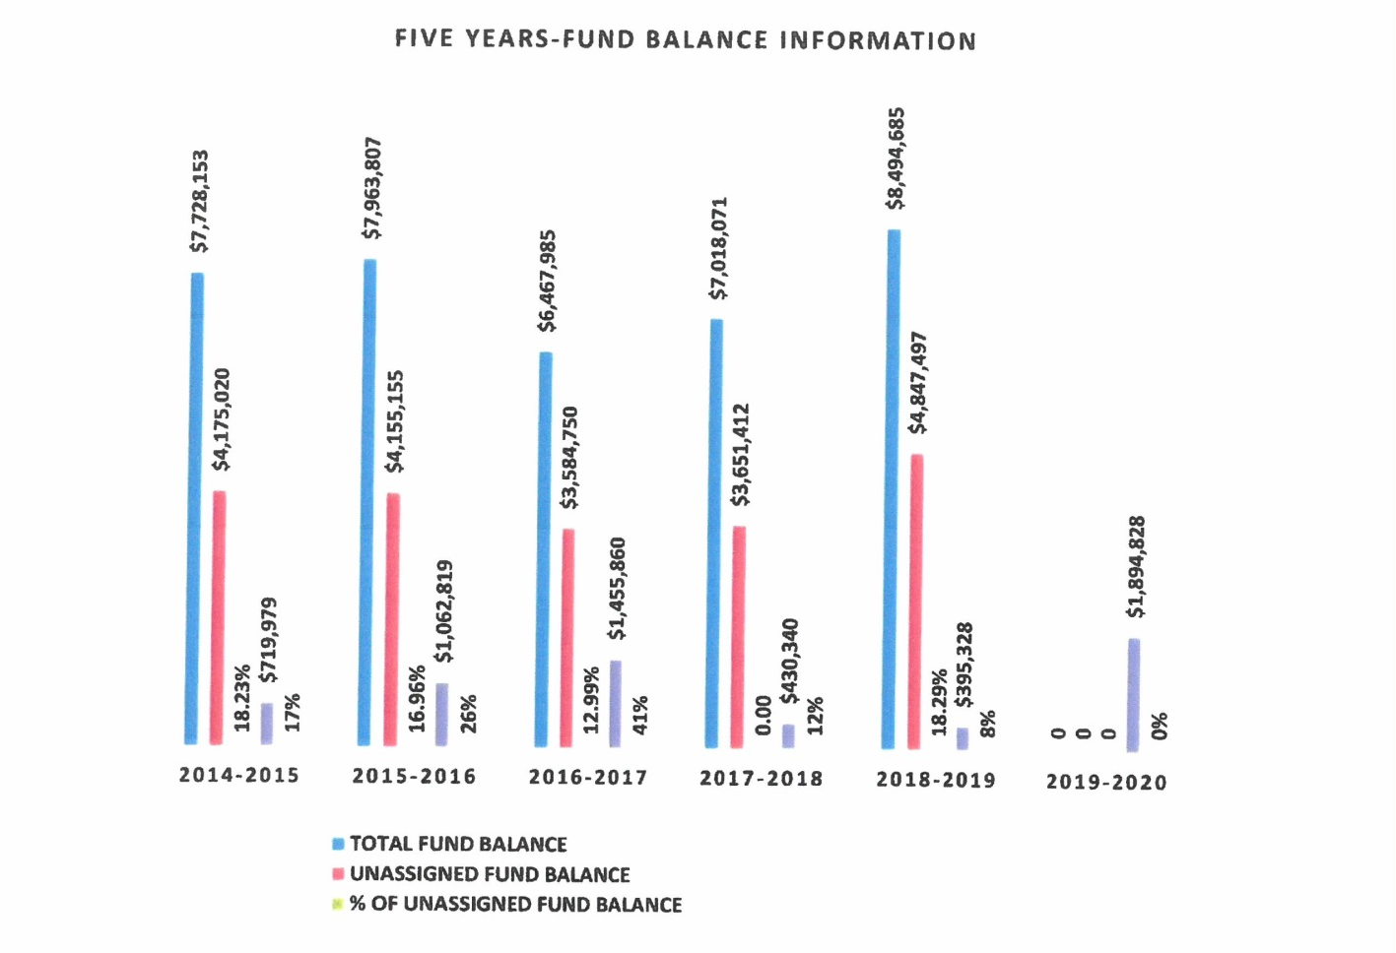
Ms. Vaughn stated that at the bottom is the Total Fund Balance for each year. She stated the next column is the Unassigned Fund Balance, then % of Unassigned Fund Balance, next Appropriated Fund Balance Fund 100 Only, and then Appropriated Percentage of Unassigned Fun Balance.

Ms. Vaughn stated on page 2 there is a little more detail with the 5 year appropriated fund balance revenues vs. expenditures.

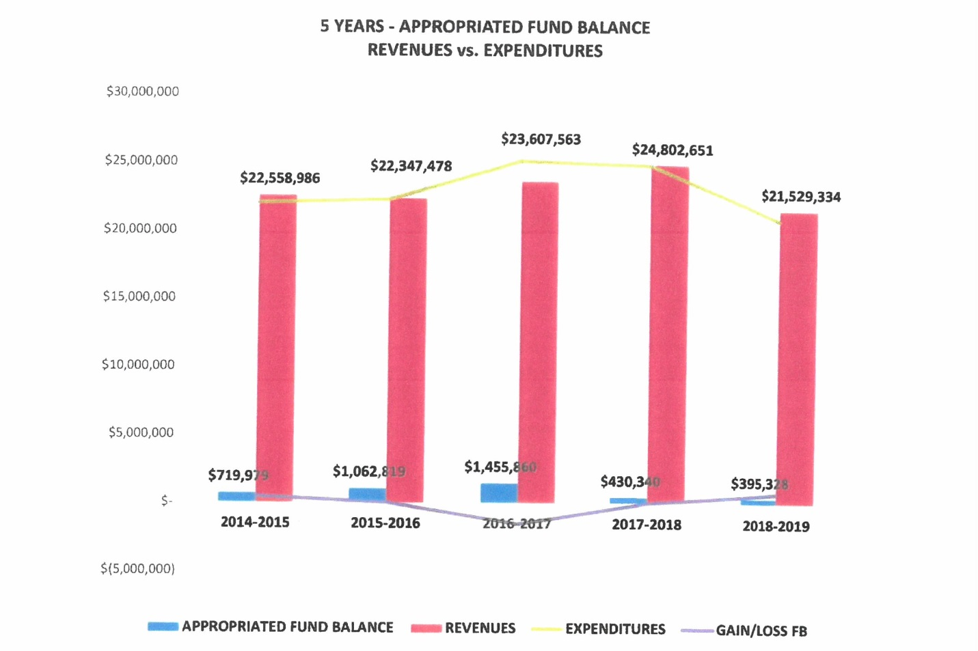
Ms. Vaughn stated that at the bottom there is chart for information. She stated that the information shows 5 years of the fund balance, the revenues vs. expenditures as well as the gain/loss and each year there was a gain even though the county appropriated fund balance but in 2016-2017 there was a deficit of $1.5 million and this was due to budgeted amount for Human Services; the revenue did not come in as budgeted as well as the county tax collection was down by over $800,000.

Ms. Vaughn moved on to page 3 and stated that Commissioner Oestreicher asked for information based on the cost of the department and what kind of revenues would come in for each department so she did a break down for each department by function: General Government, Public Safety, Economic & Physical Development, Environmental Protection, Human Services, Cultural & Recreational Services, Special Appropriations, Debt Services, Public Education, and Other Transfers. Ms. Vaughn stated that the Manager’s recommendation is in the first column, the next column is the Local Tax and Other Tax that will support that department, the next column is Local Permits, Fees, & Services, the last column is Federal & State & Other Funding.

Commissioner Oestreicher told Ms. Vaughn that this report was excellent.

Commissioner S. Carter stated “I would agree, this is very, very helpful.”

Commissioner Oestreicher asked if the capital request was included for Public Schools. Ms. Vaughn responded that the $3.1 million is not the Public Schools request, it is the manager’s recommendation and added that the school’s request was more than that but the capital outlay is included at $465,000 which is sales tax appropriations for capital outlay.

Ms. Vaughn stated that on pages 4, 5, and 6 is the breakdown for each function for each department with the percentage of the tax dollars.

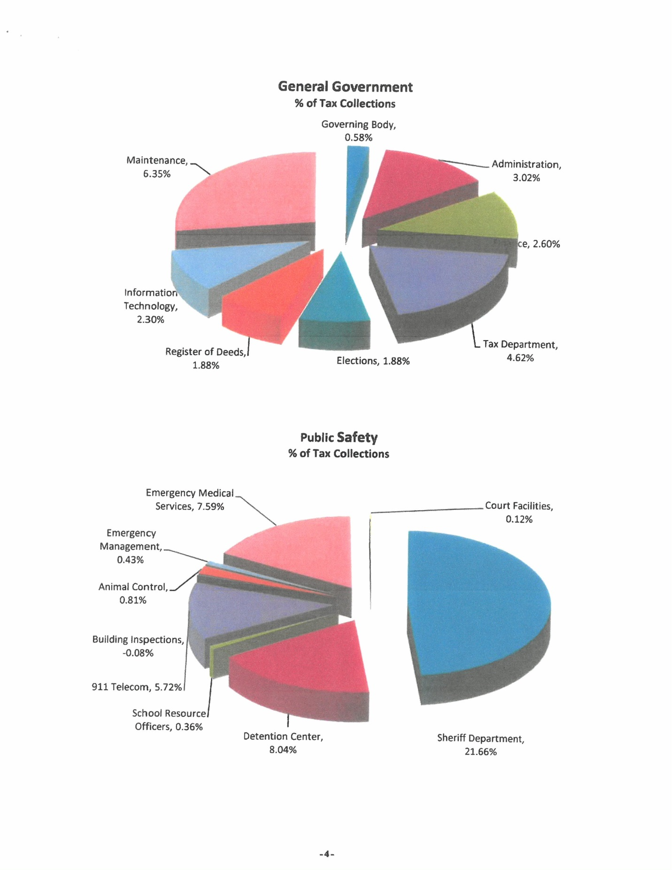

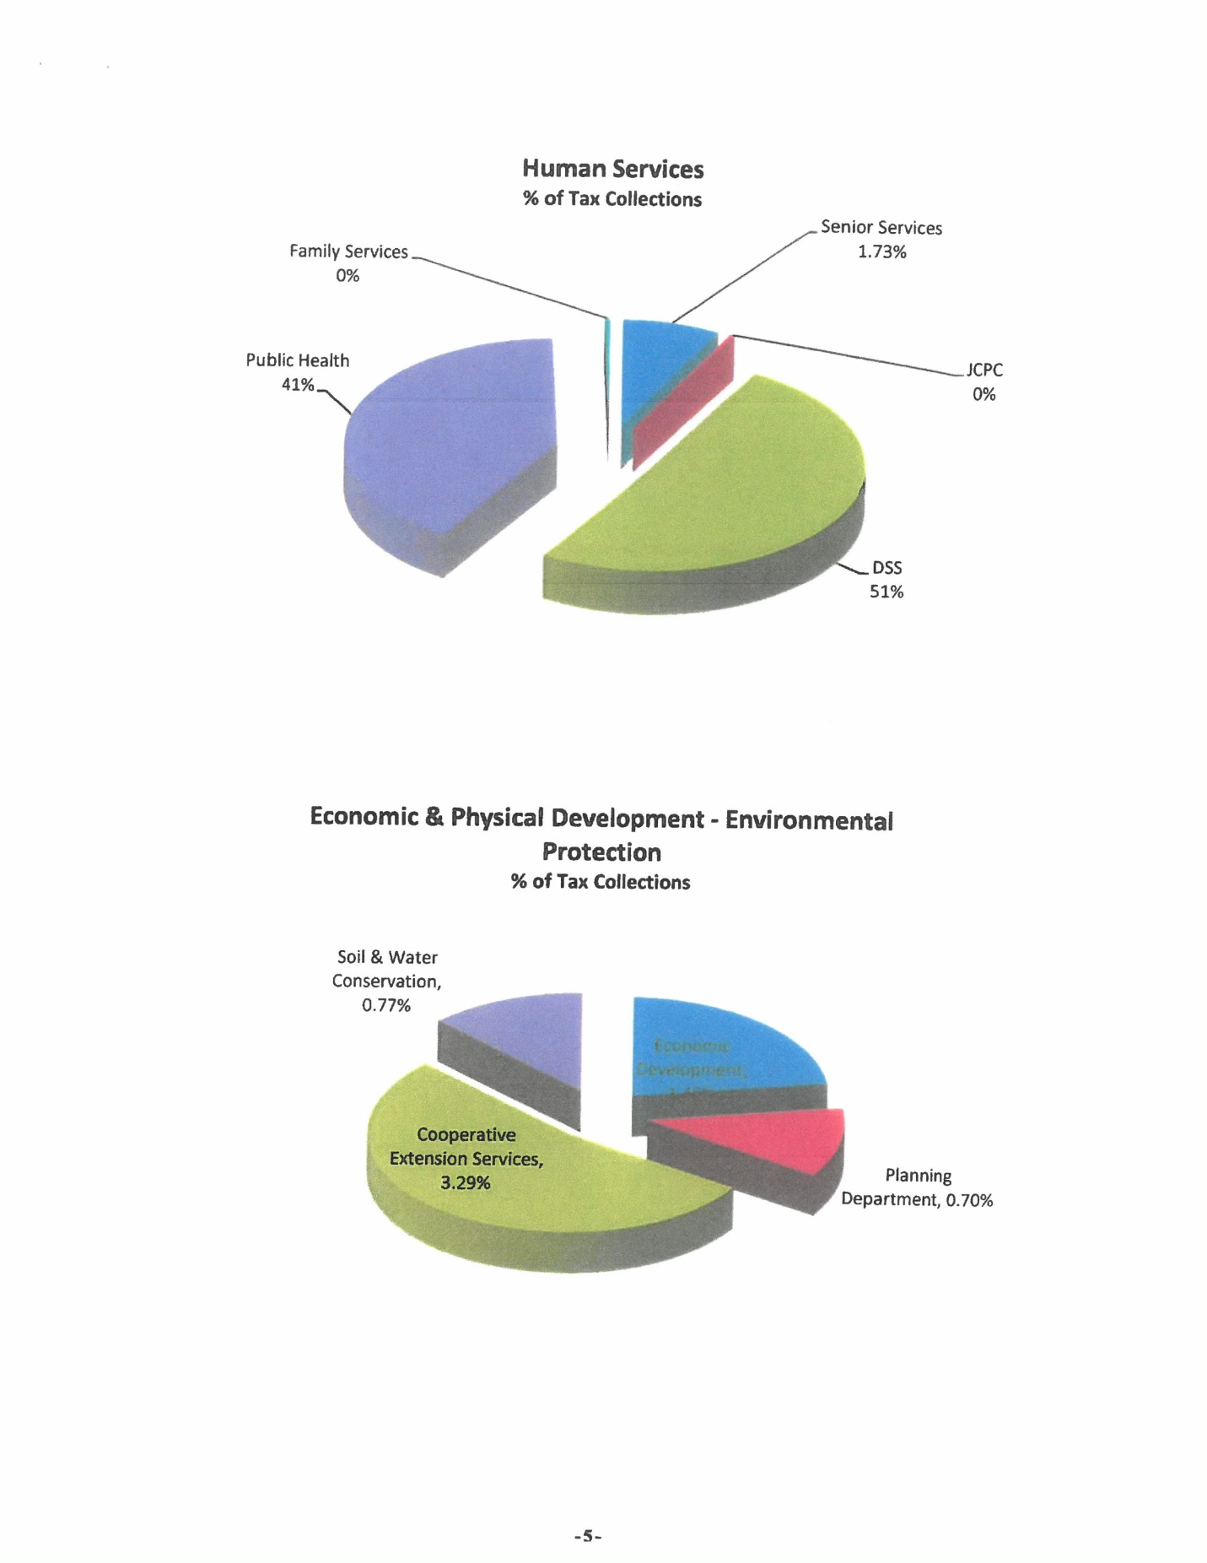

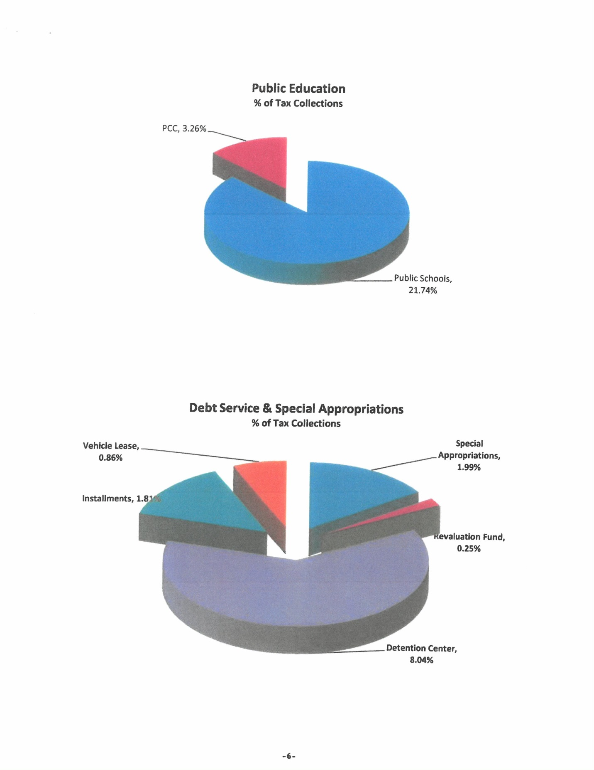

Mr. Miller asked Ms. Vaughn if all the percentages for the pie charts were added together would they total 100%. Ms. Vaughn responded that the percentages will not total 100% because there are few things that are not included in this such as medical examiner, some ROAP transportation. She added that the ones included as the main departments that receive funding. Mr. Miller stated that it is close to 100%. Ms. Vaughn responded yes it is close to 100%.

Ms. Vaughn stated that on page 7 Commissioner Oestreicher asked for the change in manager’s recommendation vs. department request and each is listed by function and each department that falls into that function. She stated that the second column has the department’s request, and then the manager’s recommendation, the last column is the change of the manager’s recommendation vs. the department’s request. Ms. Vaughn stated that these are in order by the largest to the smallest by function. She stated that the School has the largest change with a reduction of $866,000.

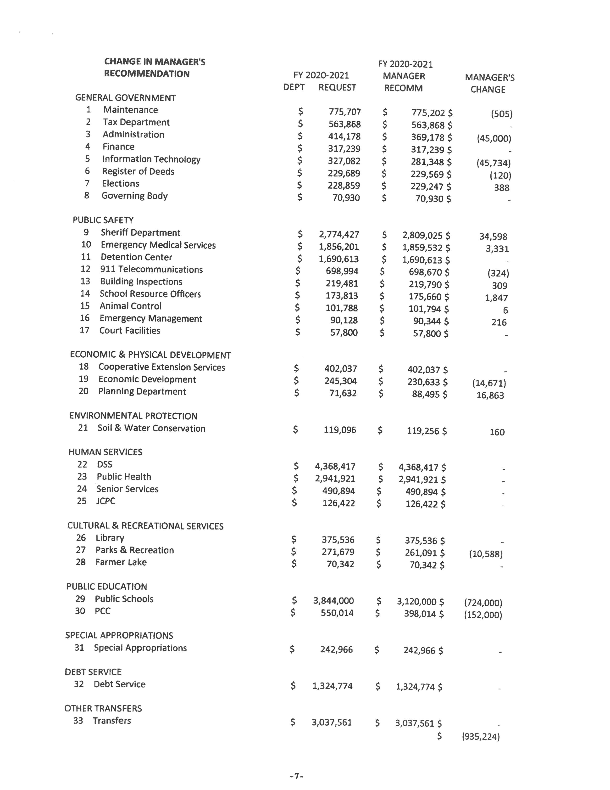

Commissioner Owen asked if the $775,000 in Maintenance reflected the new capital outlay amount. Ms. Vaughn responded that when she prepared this she used the $208,000 capital outlay so that amount will come down from $775,202 to $689,905 which is a change of about $85,000. She added that she needed to make that adjustment. Commissioner Owen stated that he had talked to Ms. Vaughn earlier about the change with the Health Department. Mr. Miller responded that he was fairly certain about the change. Commissioner Owen stated that the health department budget should be $100,000 less and wanted to know if that was reflected in these numbers. Ms. Vaughn responded that this is not reflected in the budget so both of these changes will be made. She added that this will reduce the County’s allocation for the health department by the full amount but some of it may be restricted and she asked Mr. Miller if he was aware of it being restricted. Mr. Miller stated that he did not know if it was restricted but he did not believe it was restricted.

Ms. Vaughn stated that the final page has the Department Requests for personnel and capital outlay and the items listed in red are the items that are not included. She added that Maintenance is included so a change will need to be made to that. She went through the items that were requested (See below).

Commissioner Oestreicher asked what was included in the benefits. Ms. Vaughn responded the benefits include FICA, retirement, and health insurance if applicable.

Commissioner S. Carter stated “I am sorry, what is that?” Mr. Miller responded “Cradle points is where the stretcher actually attaches to the ambulance.” Commissioner S. Carter continued “So we have some that don’t have that?” Mr. Miller responded “Well they are not compatible with some of the stretchers we have.”

Commissioner S. Carter asked “Can I ask a question about two of these?” Ms. Vaughn responded “Sure, yes.” Commissioner S. Carter continued “I may have this wrong but we have funded one social worker in the past and supplemental funding with that too, correct?” Ms. Vaughn responded “Yes there was supplemental funding at $50,000 and a social worker at $55,000. There is a social worker still in here but that’s an additional one. The $70,000 is an additional one.” Commissioner S. Carter continued “So in the budget we have money for one.” Ms. Vaughn responded “Yes, one.” Commissioner S. Carter continued “Oh, good, okay. I thought they were all gone. Then the SRO, that was a 2 year grant right?” Ms. Vaughn responded “The SRO grant has been several years and the school just gives the county that fund for the SRO officer. This is an additional one. Currently we have…” Commissioner S. Carter stated “This is for the elementary schools I think.” Ms. Vaughn responded “Yes.”

Ms. Vaughn stated that the Maintenance capital outlay should be $122,703 instead of $208,000.

Commissioner S. Carter asked “Can we get a breakdown of that on what the 122 is, what it’s for?” Ms. Vaughn responded “I do have a breakdown, let me give you that. That $122,000 will equal finishing covering a roof at the Board of Elections and Building Inspections at $36,982, replace sidewalk and steps because it’s a hazard at DSS and I think the new courthouse at $5,496, provide and install new Honeywell fire alarm system and control panel because there’s some issues with it $14,450, replace a 10 ton HVAC gas unit at Guilford Mills for $12,975, replace the steps at the new courthouse on the lower level it’s a safety issue $12,500, replace the roof at health department and a portion of the Guilford Mills for $8,000, and paint the historic courthouse ceiling at $32,800 upstairs.”

Chairman McVey asked Ms. Vaughn to give the Commissioners a breakdown like she did last year. Ms. Vaughn responded yes and stated that she would get this to the Commissioners.

Mr. Miller stated “And Commissioners just to go back over one of the things you spoke about earlier I’ve been corrected, cradle points is not what you attach the stretcher to, cradle points are the wireless service, wireless connection internet service for the ambulances to be able to communicate anywhere they need to so that is internet connection, not stretcher attachment. That will be in this upcoming year’s budget.”

Commissioner S. Carter asked “That courthouse house ceiling repair is that just for the patch work or is that for the whole thing?” Mr. Miller responded “That’s just to patch.”

Ms. Vaughn continued with the Sheriff’s Department which has a total of 1.75 positions at $64,393 for an investigator. She stated that the grant and other funds will fund 3 positions at $117,038 and then there is a position requested for a transport officer/detention officer for $48,788. Ms. Vaughn stated that all of these include salary and benefits.

Commissioner Oestreicher asked if these positions were included in the manager’s recommendation. Ms. Vaughn responded that these positions are included in the manager’s recommendation.

Ms. Vaughn stated the Sheriff’s vehicles are for 9 lease vehicles at $50,000. She stated that he did not have the details on these.

Commissioner W. Carter stated that the vehicles that were appropriated for the Sheriff’s Office this year have not been received as of yet. Mr. Miller responded that those vehicles have started to come in but it has taken a long time to start receiving those vehicles. Commissioner W. Carter stated that he thought it would be quicker with the lease program. Mr. Miller responded that this was one of the considerations that was being used and he could not give a reason why the cars were not received sooner. He added that the vehicles are showing up on the sheet for the Sheriff’s vehicles now. Commissioner Owen added that the sheet that he received from the Sheriff’s Department they have received 4 of the new lease vehicles so they are still waiting on 4 more.

Ms. Vaughn asked if there were any more questions.

Commissioner Oestreicher stated that this is a great summary and asked if each department was going to be gone through. Ms. Vaughn responded that that would be up to the discretion of the Board. Commissioner Oestreicher stated “Then we are going to go back and discuss these.”

Ms. Vaughn continued with 911 Communications $55,836 and this is a cost that is no longer eligible for state funding and the county has to assume this. She stated that this is salary and benefits and some telephone charges. Ms. Vaughn stated that the next department is Planning which includes a salary and benefits adjustment of $16,863. She stated that the total had changed. Ms. Vaughn stated included in the budget for Personnel is $302,918, not included for Personnel is $729,461 and on the Capital Outlay side the included amount is $329,203 and the items that are not included is $2,001,588. She stated that the $300,000 for the 2 ambulance remounts and the $300,000 Teacher Supplements made the changes because both of those were listed as $30,000. Ms. Vaughn stated that that was all she had for the Commissioners’ requests and she turned it over to the county manager.

Mr. Miller thanked Ms. Vaughn for her time and effort in putting the information together.

Commissioner Oestreicher stated that Mr. Miller’s comment was worth repeating and added that Ms. Vaughn did an excellent job and very timely. He added that he was impressed. Ms. Vaughn responded thank you.

Mr. Miller asked the Board how it would like to proceed.

Commissioner Oestreicher recommended starting at the beginning and work through the entire budget.

Commissioner Owen stated “I would just like to remind us before we do this and before we start to make any decisions at all just remember what we are in the middle of, we are in the middle of a you can say a recession, for us it is because of the COVID-19, we are unsure exactly how the rest of this budget is going to go but we are really unsure about next year’s budget. As I talked with our financial director she said that by October she felt like she would have some indication about revenues for the 2020 - 2021 budget so I just want us to keep that in mind. Plus too if we have another and I know it is hard to go by what ifs but if we have another outbreak and the governor shuts us down again we just need to keep that in the back of our minds. I would rather err on the side of being a little stingy and being able to release that in the fall than to go ahead and budget a lot of new stuff and then have to look at drawing it out of fund balance. I just wanted to make that statement. I think we need to be very aware of where we are at and plus we do not know even though property taxes are not exempt from people having to pay them by any legislation, you know we could come into that problem of people not being able to pay and we have asked our tax director previously to work with our citizens so we just need to keep all of that in our minds as we proceed. Thank you.”

Commissioner Jefferies stated “I would just like to say that I kind of agree with Commissioner Owen but I want us to bear in mind that this year is a terrible year and you know due to the COVID-19 I think you know as far as the farmers and for the taxpayers and for the people that are laid off we need to think about it. My suggestion was to not buy anything. We can get by with EMS without a truck or not replace anything and to try to go along as best as we can this year to see what the outcome will be because a lot of people are laid off and things don’t look good. The county manager has done an excellent job of keeping things going. I really want to emphasis on him too but I think everybody should think about this year with the COVID-19 before adding a lot of new things and try to keep the taxes down as low as we can and not have a tax increase if we can get by. Thank you.”

Chairman McVey stated “I pretty much agree with you Mr. Jefferies just on that order. I do think we will have to do something as far as the school’s tax on the building but I don’t really want to see any more taxes this year.” Commissioner Jefferies responded “That’s just my recommendation and I appreciate you listening.” Chairman McVey continued “Yes sir. That’s pretty much my recommendation, no more taxes this year other than what we have to do on that school building.”

Commissioner Jefferies stated “I want to add one more thing, you know these farmers that raised this hemp, they’ve got it all in the bulk barns and on the market with no money. They are already in the hole, no money. They cut it out before the farmers could do anything and they went in the hole on it and they still have that bill to carry.” Chairman McVey responded “Thank you sir.”

Chairman McVey asked if the Commissioners had any questions.

Commissioner Oestreicher stated that he noticed going through each of the departments that the amount attributable to the health insurance benefits was wildly different ranging from 2% to 50% and he wanted to be able to understand this different. He asked Ms. Vaughn if there was any guidance on how this should have been applied. Ms. Vaughn responded that in the budget manual the department leaders were asked to include the health insurance based on the amount for the current fiscal year and the health insurance only increase by just over 1% so it should not have been a drastic change. She added that the only reason there may be a drastic change in a department would be due to additional staffing. Ms. Vaughn asked Commissioner Oestreicher if there was a department he wanted her to look at. Commissioner Oestreicher stated that he had then marked and he can bring them up as the Board goes through the departments. Ms. Vaughn responded okay.

Commissioner W. Carter asked the county manager if there was a tax increase included in the budget. Mr. Miller responded that there is no tax increased included in the proposed budget but the budget does utilize $1.9 million from fund balance. Commissioner W. Carter asked about the taxes for the school building. Mr. Miller responded that the county is looking at 1.6 cent per $100 valuation. Commissioner Oestreicher stated that he thought it would be 1.88 cent. Mr. Miller responded that it was 1.88 cent before the bids were received and the bid came in at almost $6 million less.

Commissioner Oestreicher asked Ms. Vaughn on Information Technology on page 3-8 it shows this budget increased to $22,800 from $7,600. Ms. Vaughn responded that this includes the position that was requested in this department. Commissioner Oestreicher stated that the position was not included in the manager’s recommendation. Ms. Vaughn responded that this is correct. Commissioner Oestreicher asked how it would go from $22,600 to $15,400. Ms. Vaughn responded that this included 2 employees. Commissioner Oestreicher stated that the two employees were in the revised budget at $7,600. Ms. Vaughn responded that the revised budget only had one employee included so that budget needs to be adjusted. Commissioner Oestreicher stated that the salaries go down and the benefits double. Ms. Vaughn responded that the revision should have been done in the recommended salaries as well as the health insurance and added that she would take a look at that. Commissioner Oestreicher stated that this is not the only one and Ms. Vaughn asked for an example and this was the first one he found.

Mr. Miller recommended starting with General Government and work through the rest of the sections.

General Government

Page 3-2 Governing Body – there were no comments or questions.

Page 3-3 Administration – Commissioner Oestreicher stated that this is where he started seeing the differences in health insurance and asked if this was the recommended move and stated that the difference is 1.3%. He asked if this was what the guidance was. Ms. Vaughn responded yes and that it was only just over 1%. Commissioner Oestreicher stated to the Board that he would like to come back and look at Administration in closed session at some point. Commissioner Owen responded that it would not qualify unless it was for a specific person’s salary. Commissioner Oestreicher stated that he was talking about a specific person’s salary. Chairman McVey responded that it could be discussed in closed session. Mr. Miller asked Commissioner Oestreicher if he would like to schedule a closed session for the next budget meeting or at the end of this budget meeting. Commissioner Oestreicher responded that the end of this budget meeting would work best for him. Mr. Miller stated that he thought it would be best to schedule for the next budget meeting because there is nothing set up for a closed session for this meeting. Commissioner Oestreicher responded okay. Mr. Miller asked the clerk if there was a conference line that this could be done on. The clerk responded that she was not sure that a closed session could be done during a budget meeting but it could be done at the regular Board meeting which is scheduled for Monday, June 15th at 9:00 a.m. which is right before the next budget meeting on Monday, June 15th at 1:00 p.m. Commissioner Oestreicher stated that this would be fine and asked if this could be done. Mr. Miller and the clerk responded yes.

Page 3-4 Finance – Commissioner Oestreicher stated that the capital outlay on the revised budget $414,990. Ms. Vaughn stated that this amount of money was put into debt service which is for the new financial software. Commissioner Oestreicher asked if there were any subscriptions or other items that would fall into this category for the new software next year. Ms. Vaughn responded that this is still considered a project and until Phase 1 and Phase 2 are completed there would not be an annual cost. She stated that Phase 1 is set to go live in October and the project will carry over for 2 years. Ms. Vaughn stated that after the full implementation there will be an annual fee and that will be on the budget for 2021-2022.

Page 3-5 Tax – Commissioner Oestreicher stated that the health insurance did not change at all in here. He stated that he was under the impression that the new tax software would reduce the cost in professional service and billing. Ms. Vaughn responded that she would need to discuss this with the tax director and she added that the billing is done through an outside agency currently. Commissioner Oestreicher stated that he thought the new tax software was supposed to help with the billing. Commissioner Owen responded that he did not feel like the tax software has been fully implemented yet. Commissioner Oestreicher stated that he thought the tax software would be completed by next year. Commissioner Owen responded that the tax director could update the Board on this. Commissioner Oestreicher asked by Advertising was almost triple the amount. Ms. Vaughn responded that the revised budget for this year was $4500 and the proposed budget for next year is $4500. Commissioner Oestreicher stated that year to date advertising is only $1700 and he wanted to know if the tax office was planning some kind of advertising blitz in the next couple of months. Ms. Vaughn responded that she would ask the tax director about this as well.

Page 3-6 Elections – Commissioner Owen asked what specifically the capital outlay is being requested for. He added that it said ballot creation and printing equipment and he wanted to know what kind of printing equipment and what is this needed for. Commissioner Owen asked that this be passed along to the Elections Director. Ms. Vaughn responded on page 15-16 there is some of the detail about the equipment but she would follow up with the director. Commissioner Oestreicher stated that he thought the printing equipment was for printing ballots. Commissioner Owen responded that it said that but it also had printing equipment.
Commissioner S. Carter stated “I do know they have a very old printer in that office.”
Commissioner Oestreicher stated in the revised budget there is $8800 for board compensation, year to date $14,048 has been spent and next year the proposed budget is $11,250 and he wanted to know the difference in the numbers. Mr. Miller responded that the Elections board went from 4 to 5 members and this past year the Elections board has had to meet more often than in previous years due to the new director’s position and new voting equipment being implemented. Commissioner Oestreicher asked if the Board of Elections compensation is on a per diem. Ms. Vaughn responded that it includes the per diem and the travel for the meetings and added that there is an additional line for board travel and she was not sure why it is broken out this way. Commissioner Oestreicher asked if the part time position is covered by health insurance. Ms. Vaughn responded that the health insurance is for one full time position and the part time positions for this department would not qualify for health insurance. Commissioner Oestreicher stated that the Election Officials are at $26,000 this year and next year and he wanted to know if this made since. Ms. Vaughn asked the county manager if he had any comments on this. Mr. Miller responded that the year to date is $12,645 and he expects to see next year’s general election close to $26,000 rather than the $12,645. Commissioner Oestreicher stated that this was odd that it would be the same on an election year as on a non-election year.

Page 3-7 Register of Deeds – There were no questions or comments.

Page 3-8 Information Technology – Commissioner Oestreicher stated that this is the one that he questioned the health insurance. Ms. Vaughn responded yes.
Commissioner Owen requested a breakdown on the $104,500 for the fiber between the buildings. He asked which buildings this fiber would be ran between. Mr. Miller responded that some of this is fiber and some of it is other infrastructure. Commissioner S. Carter stated “We just need a breakdown on it.” Commissioner Owen stated that he would like to know which buildings and a breakdown. Commissioner Oestreicher asked Mr. Miller if this was for extra laptops. Mr. Miller responded that laptops may be some of it but that may be included in small tools and equipment. Commissioner Oestreicher asked for more details as well. Mr. Miller responded that that is what has been requested.
Commissioner Oestreicher asked if the reason the year to date is low was because the other full time person has not been there all year. Ms. Vaughn responded that this should be in line. Commissioner Oestreicher stated that Ms. Vaughn was right. He asked why the total goes from $105,153 to $88,872. Ms. Vaughn responded that she would have to look into this. Commissioner Oestreicher stated that it was very noble of Mr. Norris to take a $30,000 but in pay. Mr. David Norris stated that his health insurance should be waived and he was not sure if those numbers were included or not. Ms. Vaughn responded that she did not know that Mr. Norris’ health insurance was waived. Commissioner Oestreicher stated that this would not be included in the salaries. Ms. Vaughn responded that that was correct. She added that a change would be made to that. Commissioner Oestreicher stated that this will have an impact on FICA. Ms. Vaughn responded yes. Chairman McVey asked if the Board could move on to the next group. Commissioner Oestreicher asked if the Board could come back to this one. Chairman McVey responded yes. Mr. Miller stated that it may be better to go through the departments and the Commissioners point out the questions to staff and let staff bring back the information at the next meeting. Commissioner Oestreicher responded that that is what is kind of what is being done. Mr. Miller stated okay.

Page 3-9 Maintenance – Commissioner Oestreicher stated that he saw a $10,000 reduction in health insurance. Ms. Vaughn responded that the health insurance includes 7 positions. Commissioner Owen reminded everyone that the capital outlay is $123,000 instead of the $208,000. Ms. Vaughn responded that this will be adjusted.
Commissioner Oestreicher stated that on Telephone the revised budget is $14,000, year to date is $8,000 and then $1400 for next year. Ms. Vaughn responded that this will need to be increased. Commissioner Oestreicher asked if it will be $14,000 instead of $1400. Ms. Vaughn responded that she would take a look at the actual number.

Page 3-10 – There were no questions or comments.

Page 3-11 Non-Departmental – There were no questions or comments.

Page 4-2 Sheriff – Commissioner S. Carter stated “I wanted a justification for the 2 positions requested for the Sheriff’s Department. Are they totally funded by county dollars or is there a different configuration for that because I thought it was sort of under COVID not putting any new positions in and how all of this fits.” Ms. Vaughn responded “One position is a grant funded position from the Governor’s Crime Commission for a sexual assault investigator and I believe that grant has been approved by the Governor’s Crime Commission. It was the concerted effort with Family Services and the Sheriff’s Department to do that position and a second one is for an investigator and that one would be a county funded employee. The third one is for an additional deputy and that one will be funded from the Town of Yanceyville. So they are not separated on the expense side, they are all in the Sheriff’s budget but you will see the revenue coming in on the revenue side for the grant and the Town of Yanceyville.” Commissioner S. Carter continued “Well at the end of the day what are we appropriating here? You got…” Ms. Vaughn responded “The $1,575,216 includes all of the positions, the current positions plus the ones that are grant funded and Town of Yanceyville.” Commissioner Oestreicher asked “All three?” Ms. Vaughn responded “Yes they are all in there.” Commissioner Oestreicher asked “What is the county funded costs?” Ms. Vaughn responded “The county funded costs for the Sheriff’s Department, give me just a second.” Mr. Miller asked “Do you mean for the whole department or just those three positions Commissioner Oestreicher?” Commissioner Oestreicher responded “Just for the new investigator position that appears to be requested to be funded by the county.” Ms. Vaughn responded “The new investigator position is, salary and benefits, $57,295.” Commissioner Oestreicher asked “Is that our discretion to fund that or not?” Commissioner Owen, Chairman McVey and Commissioner W. Carter responded “Yes.” Commissioner Oestreicher continued “Have we seen any justification for it?”
Commissioner S. Carter asked “Just a quick question, are we violating our hiring freeze with this?” Ms. Vaughn responded “The hiring freeze does not include Public Safety, does it?” Commissioner W. Carter stated “I thought Public Safety and EMS was…it didn’t affect them.” Mr. Miller responded “It does not; it does not affect Public Safety.”
Commissioner Owen stated “As we go through this just so you know where I am, I’m not going to vote for any new positions or capital outlay other than what is necessary until we know what our budget is going to be like for next year. We can make that decision after we get through all of this I guess as to what we are going to fund.”
Chairman McVey stated “I take the position that we are only going to fund what we got to have. After we get through with this we will go back and see that got to have list.”
Commissioner Oestreicher stated “Well I am with Commissioner Owen on this one. I don’t believe we need to be funding new positions at this point unless absolutely necessary and I don’t see the justification for this in the category.”
Chairman McVey stated “We will go back through the list when we get done and cut what we need to cut, alright.”
Commissioner Oestreicher asked the Board if it was happy with 9 new vehicles. Chairman McVey responded no. Commissioner Owen stated that he was not going to vote for any new vehicles. Commissioner W. Carter stated that years ago the Board put the sheriff’s vehicles on a rotation to buy so many a year and if they are not bought this year extra vehicles will have to be bought next year. Commissioner Owen responded that the Board extended that this past year and bought 8 new vehicles plus the sheriff’s office has 5 with less than 25,000 miles on them. Commissioner W. Carter stated that he thought the Board needed to appropriate 6 vehicles a year on the rotation. Chairman McVey stated that this will be looked at later. Commissioner W. Carter stated with the lease program the vehicles cost less.

Page 4-3 Detention Center – Commissioner Oestreicher stated that there is a new position in the Detention Center. Ms. Vaughn responded yes a Transport Officer.
Chairman McVey stated that this goes back to the got to haves. Commissioner Oestreicher responded that he agreed and stated that he did not think this was a got a have.

Page 4-4 School Resource Officers – Commissioner Owen stated that a School Resource Officer was added about 2 years ago and that grant is running out so this is a position that has been added plus he has requested an additional SRO and he asked Ms. Vaughn if this was correct. Ms. Vaughn responded yes and added that there are only 3 positions in this budget and that is what is there currently. She stated that there are no new positions added in this budget. Commissioner Owen stated that he was trying to make a point that when the county has a grant funded position it always comes back to the county having to carry that position when the grant runs out. Commissioner Oestreicher asked Commissioner Owen if there was a missing number in the revenue line for this position. Mr. Miller responded that there probably is a missing number in the revenue line that has been seen in the past. Commissioner Oestreicher stated that this in fact is an increase out of county funds. Mr. Miller responded that this was correct.
Commissioner S. Carter stated “Now the additional one that they are requesting is that the one that we heard mentioned for the Library and Parks and Rec. of is that the one that we had previously mentioned?” Ms. Vaughn responded “In this particular budget, I am checking the revenue now and I am thinking that it does include the projection for the same amount of funding that we have received before for the SRO. It includes $131,000 from the schools and I think that’s still…there’s still some debate on whether the funding will come through so will have to…I guess we’ll wait and see for that. You are saying that if the funding is no longer for the School Resource Officers then you would have to take a look at that?” Commissioner Oestreicher stated “Absolutely.”
Commissioner W. Carter stated that he thought the School Resource Officers needed to be funded. Commissioner Owen responded that the Board will look at that later.
Commissioner Owen stated that he believed that a position was included in the Sheriff’s budget for security at Parks and Rec. and the Library. Ms. Vaughn responded that she got clarification from the Sheriff and he would use SRO officers at scheduled times to be at Parks and Rec and the Library. She stated that this is not an additional position but the Parks and Rec and the Library included $10,000 each in their requested budget but in the manager’s budget the $10,000 is not there because it was absorbed in the Sheriff’s budget. Commissioner Owen stated that he needed clarification on why security is needed and when the security is needed especially at the Library. He added that he could understand more about Parks and Rec. Commissioner Owen stated that he would like to get this information because if security is going to be provided for the Library there may need to be security for other areas. Ms. Vaughn responded okay.

Page 4-5 911 Communications – Commissioner Oestreicher stated that it looked like there was a new position in this budget. Ms. Vaughn responded that there is no new position, state funds will no longer allow funding for salary and benefits so the county has to absorb the cost. Commissioner Oestreicher asked if there was anything the county could do about this. Ms. Vaughn responded no. Commissioner Oestreicher asked if this could be appealed. Commissioner Owen responded that he was not aware of anything that could be done but the 911 Director could be asked. Mr. Miller responded that the county could ask for a reconsideration.

Page 4-6 Building Inspections – Commissioner Oestreicher asked if the increase was due to bringing on the apprentice. Ms. Vaughn stated that this fiscal year Building Inspections started with a part time person and now there are 3 full time employees at Building Inspections. Commissioner Oestreicher asked if the Board was happy with the revenue of $230,000 in this department. Commissioner Owen asked Ms. Vaughn if this had been pretty steady. Ms. Vaughn responded that year to date is 75% of the $230,000 so it is not meeting projections. Commissioner Owen stated that this needed to be put on the list for discussion and take a closer look at those projections and asked Ms. Vaughn to get more information. Ms. Vaughn responded okay.
Commissioner Oestreicher asked if the inspections for the school were in the school project budget. Ms. Vaughn responded that the school inspections should not be included in this budget and she asked Mr. Miller if any of those inspection fees were waived. Ms. Miller stated that no fees have been waived and added that the Board would have to waive those fees. Ms. Vaughn stated that the inspection fees for the school would be in the capital project. Commissioner Oestreicher responded that this was his recollection.

Page 4-7 Emergency Management – Commissioner Oestreicher asked if the truck listed was a new leased truck. Ms. Vaughn responded that this is a request for a pickup truck replacement.
Commissioner W. Carter asked if this was a request for another new vehicle. Mr. Miller responded yes. Commissioner W. Carter stated that there was no need for this because they have 3 trucks plus the Crown Victoria.
Commissioner Oestreicher stated that this falls in the need to have? category.

Page 4-8 Emergency Medical Services (EMS) – There were no questions or comments.

Page 4-9 Animal Control – There were no questions or comments.

Page 5-2 Economic Development – Ms. Vaughn stated that she needed to revise this budget because there will be an administrative part and an operational part for Economic Development. She added that she believed there would be an increase of between $14,000 and $20,000 but there is also revenue involved so there will be a change on the economic development budget.
Commissioner Oestreicher stated that he did not see any backup detail for economic development at all. Mr. Miller responded that it was submitted. He added that this budget is different from what has been seen in the past because it involves Co-Square and added that this budget will be a hybrid and that is the reason Ms. Vaughn needed to make some modifications to it. Commissioner Oestreicher asked if this would be discussed next Monday. Mr. Miller responded yes.

Page 5-3 Planning – Mr. Miller stated that this will be covered Monday in closed session.
Commissioner Oestreicher asked about why the retirement went up 45%. Mr. Miller responded that this can be discussed in closed session on Monday.

Page 5-4 Cooperative Extension – There was no questions or comments.

Page 5-5 Tourism Development Authority – Commissioner Oestreicher asked if this was the new board that was put in place. Mr. Miller responded yes it is.
Ms. Vaughn stated that she needed to add in revenues and expenditures for this department. She stated that the revenue will be projected higher than the $9500 and then the expense will be a reserve of the same and that can be changed when the Tourism Development Authority decides how to spend the money. Commissioner Oestreicher stated that he thought there was more money in this. Commissioner Owen stated that at one time there was about $15,000 in this. Ms. Vaughn responded that there is about $21,000 in this department.

Page 6-2 Soil & Water Conservation – There was no questions or comments.

Page 7-2 Senior Services – Commissioner Oestreicher stated that the health insurance went up $8,000 which is about 11 1/2% and the salary went down. Ms. Vaughn responded that salary is down just a little and health insurance was up from $30,400 to $38,515 and she thought this was due to an employee that had waived the health insurance and now wants it and that is probably where the change comes in. She stated that she would double check this. Commissioner Oestreicher stated that the only other thing he notices was Home Deliveries & Shelf Stable Meals. Ms. Vaughn responded that this was the contract for home delivered meals. Mr. Miller responded that this is the Meals on Wheels service and they have had to utilize frozen meals instead of fresh meals due to COVID-19 so that increase in cost and there is an expected increase next year. He added that there should be some grant funding for this on the revenue side and he asked Gwen if it was included. Ms. Vaughn responded that there was a slight decrease in revenues. Mr. Miller stated that the county has received over $70,000 in grants over the last few weeks. Ms. Vaughn responded yes from different grants and foundations. Mr. Miller asked if this was included in the budget. Ms. Vaughn responded that those funds are included in the current year’s budget and the director has stated that she will have all of these funds expended by June 30th.

Chairman McVey asked what was meant by Discarded Meals. He wanted to know if that just meant that the meals were just gotten rid of. Ms. Vaughn responded that of the grant that helps to fund this, the Community Care Grant, meals have to be tracked so it is an item in the budget. Chairman McVey stated that there is $2500 worth of discarded meals. Ms. Vaughn responded yes. Chairman McVey asked if these meals could be donated or something instead of just throwing them away. Ms. Vaughn responded that that question can be asked. Commissioner Oestreicher stated that Alice or the Caswell Parish could use those.
Commissioner S. Carter asked “Can I ask, General supplies $5,000 explain that one?” Ms. Vaughn responded “I do not have any detail on that. I can get the detail.” Commissioner S. Carter continued “Yeah we need that.”
Commissioner Owen stated that he was concerned that for the past 2 budget years the Board has given permission for the Senior Services to build a covering from where the Meals on Wheels is picked up out to the sidewalk and this has not be done and he would like to see this moved forward. He stated that this money was leftover from the original building amount. Ms. Vaughn responded yes.
Commissioner S. Carter asked “Is that just a matter of coordinating with maintenance or are we waiting on a company on that?” Mr. Miller responded that maintenance did bids.

Page 7-3 Juvenile Crime Prevention Council – Ms. Vaughn stated that there is no detailed budget for these particular items because there is a program agreement that must be submitted to the Department of Public Safety and she would have this information for the next meeting. She stated that this budget has increased by almost $19,000 due to Raise the Age and that funding is coming from the State. Ms. Vaughn stated that budget includes the required County match of $10,000 which has been the match for the last 10 years.

Page 7-5 Cardinal Innovation – Commissioner Owen stated that he would really like to see in the county’s conversation with Cardinal to have a person in Caswell. He stated the classes are really good but he would like to see a person here to handle mental health issues with the general public as well as with the Sheriff’s Department and Detention Center.
Commissioner Oestreicher asked if the county had a way of measuring the effectiveness of Cardinal’s programs and he asked if the county was getting a good value for the dollar. Mr. Miller responded that the county used to receive dashboard reports from Cardinal but those stopped some time ago. He added that he has inquired about the dashboard reports coming back and has been told that they are scheduled to come back. Mr. Miller reminded the Board that this allocation to Cardinal is required by the State that the county spend $144,000 a year for mental health services. He stated that $50,000 of the $144,000 funds the social worker at the school. Commissioner Oestreicher asked if it would be better to add another social worker and send less to Cardinal. Mr. Miller responded that there is about $11,000 that can be taken out of this budget and reallocate somewhere else. He stated that when the county starts taking money away it starts to defund programs that Cardinal already has in place for Caswell.
Commissioner Owen stated DSS calls Cardinal when they are needed and they respond very quickly. Commissioner Oestreicher responded that he would just like to see some way to measure this so that Cardinal knows what the county expected from them. Ms. Vaughn responded that she has added this to her list.

Page 7-6 ROAP Transportation – Ms. Vaughn stated that this is basically state funding projections and the same amount if on the revenue side.

Page 8-2 Parks & Recreation – “Where is the $10,000 that the department requested for the resource officer for security, well for the security from the Sheriff’s Department, under Professional Services for $10,000 and the Library also did the same thing. I am just asking them to justify the need.” Commissioner W. Carter responded that he did not think that $10,000 was included in this budget since it only went up five thousand and some dollars. Commissioner Owen responded that this was correct; it is not included in the manager’s recommendation.

Page 8-3 Farmer Lake – Ms. Vaughn stated that there may be a revision to this budget based on a conversation with the Farmer Lake director today but she did not expect it being a major impact and she would point this out to the Board at the next meeting.
Commissioner S. Carter stated “Did they get a new boat for patrol use or for responding to accidents or whatever?” Commissioner McVey responded no. Commissioner W. Carter responded that Farmer Lake has always had a boat to patrol the lake or to pull boats in if they get stranded but it is not new.
Chairman McVey what was the Mowing on Dam because he thought the county did that. Mr. Miller responded that this is contracted out because the county does not have the equipment to do what it takes to mow the dam. Commissioner S. Carter asked “What is required to do it?” Mr. Miller responded that it depends on how the county wants to do it. He added that there is automatic equipment that can be purchase to run on it that is operated from the top of the hill but there are a lot of different ways that this can be done.
Commissioner S. Carter asked “And then where are we at when it comes to the shelter? Is all of that…” Mr. Miller responded that this would be in a different place. Commissioner S. Carter continued “But the money came from the insurance.”

Page 9-2 Public Education – Commissioner S. Carter stated “I was asking about the $50,000 dollars and it says on here teachers’ signing bonus but it was the scholarship program that we talked about but we have yet to meet and figure out the details of all of that. There was potentially another route we could take with the school board or the superintendent was talking about and I am just making sure that money is still there because it wasn’t spent to move forward with.” Ms. Vaughn responded “It has been appropriated but it has not been sent to the schools so it is still there in the revised budget.”

Commissioner Owen stated that he thought this scholarship money would be used for teachers but also for professionals in the county and he asked Commissioner Hall if this was his recollection. Commissioner S. Carter responded “We just need to figure out the details.” Commissioner Owen stated that this needed to be in the county’s regular budget and not in the school’s budget.
Commissioner W. Carter stated that even though the county did not fund the school supplement last year the school board funded it out of their budget. Chairman McVey responded that this was correct.
Commissioner Owen stated in all fairness the county has had increases in FICA and health insurance and the school has had the same increase so this may need to be considered. Commissioner S. Carter responded “And that’s for just general contribution?” Commissioner Owen stated yes current expense or general expense.
Commissioner Oestreicher asked if the school’s capital outlay could be discussed because he thought the $465,000 had been reduced. Ms. Vaughn responded that the capital outlay budget was requested at $620,000 and the manager’s recommendation is $465,000. Commissioner Oestreicher stated that he thought there were some further reductions from this. Ms. Vaughn responded that there were no additional reductions. She stated that the second social worker should be SRO but this $49,000 is not included in the manager’s recommendation.
Commissioner S. Carter asked “The $49,000 is the SRO, is that what you said?” Ms. Vaughn responded “Yes. If you will look at page 9-7 it gives you a breakdown of the capital outlay expense and the personnel expense that the school requested.”
Commissioner Oestreicher asked “Can we go over those and see what we would like out of that?” Commissioner Owen responded “Personally, I mean, let’s give them an amount and let them do what they want to do.” Chairman McVey responded “Absolutely.” Commissioner Owen continued “I don’t think we need to micromanage that, that money is coming out of a restricted fund anyway and if we want to give them $465,000 in which we did the previous year then let them make the decision what they do with it and what they don’t. That’s my opinion.” Commissioner W. Carter stated “I agree with Commissioner Owen.”
Commissioner S. Carter stated “They’ve been very prudent with even if we ask for itemized how they spent that they have submitted that at least in the past for us. It’s all there so; they just need to make those decisions.” Commissioner Oestreicher stated “Got it.”

Page 9-11 Piedmont Community College – Ms. Vaughn stated that there was an increase for PCC as well, with the capital outlay they requested $217,000, and the manager’s recommendation is $65,000.
Commissioner S. Carter asked “What was the justification for the additional?” Ms. Vaughn responded “The $217,000 included: $200,000 for a building roof, $15,000 for safety lighting and street lighting, and then $2,000 for storage facility.” Commissioner S. Carter continued “I would like to know about that roof.”
Commissioner Owen asked for more information on the roof as to the age, problems with leaking, as well as what is in the building.
Commissioner Oestreicher stated that this budget is hard to follow and he asked if it would be possible to put it in the same format as the rest of the budget and he asked if anyone else would like to have this format changed.
Commissioner Owen asked Ms. Vaughn if the revised budget for PCC for this year was $491,195. Ms. Vaughn responded that this was correct. Commissioner Owen stated that the manager’s recommendation for the upcoming budget is $398,014. Ms. Vaughn stated that this was correct.

Mr. Miller asked the Board if it wanted to go line by line in Debt Services as well on Page 10-2
Commissioner S. Carter asked “I had a quick question, the middle school, we are done with that, this was the last payment correct?” Mr. Miller responded “That’s correct.”

Page 11-2 Special Appropriations – Commissioner Owen stated that he had brought to the Board’s attention before in the allocations, the Caswell Parish increase from $10,000 to $15,000 and he did not think he could approve this and not the others plus there is an additional request from the Caswell Horticulture Association and he did think the county needed to consider some allocation because this group takes care of the Historic Courthouse grounds, the Square and the Arboretum. Mr. Miller stated that in discussions with the Horticulture Club it has become clear that the county will either have to fund these or take over the maintenance of those grounds because they no longer have the ability and the funding to do that. He added that the Horticulture Club does a great job. Commissioner Owen agreed.
Commissioner S. Carter stated “Maybe we should have a more detailed discussion with them on all of that and consider those options for instance dealing with it this way. I agree with Commissioner Owen it is $10,000 for the Parish and $12,000 for the Horticulture Club. It’s not justifiable to me so if it’s a consideration of us taken over all of the maintenance for that then we need to get more details.” Commissioner Oestreicher responded that for $12,000 that was a good deal if they will continue. Commissioner S. Carter continued “They haven’t used $12,000 that I am aware of.” Mr. Miller responded “They use their own funding.” Commissioner S. Carter continued “Right.” Mr. Miller responded “And their own labor and they are getting to the point that they can’t do that anymore.” Commissioner S. Carter continued “Well we just need to determine if it is $12,000.” Mr. Miller responded “We are.” Commissioner Owen stated that the county needs to consider some kind of funding for them or the county needs to take this over. He added that taking this over may create another problem with personnel but one or the other needs to be done.
Commissioner S. Carter stated “That is why I suggest that we talk with maintenance staff and the representative from the Club to see where we are at on how to move forward. I just want to know what it will take to take over this program.” Commissioner Oestreicher responded “$12,000.” Commissioner Owen stated “I am fine if we want to meet with someone out of the Horticulture Club and they can give us a run down on what all they do, of course I kind of know but specifically what they do and how much they spend each year on that.”
Commissioner Oestreicher asked the county manager where the $12,000 came from. Mr. Miller responded that this came from a request from the Horticulture Club. Commissioner Oestreicher asked if the request was itemized. Ms. Vaughn responded that the Horticulture Club did submit a detail but it is not included in the budget notebook. She stated that she would get that detail sheet out to the Board. Commissioner Oestreicher stated that he thought this would answer the question. Ms. Vaughn responded that the Horticulture Club submitted the detail before budget time so she would locate the detail.

Page 12-2 Court Facilities Fund – Ms. Vaughn stated that this fund did not have all the detail with it and there may be some changes. She stated that she has not heard from Courts because they have been out so their budget is set based on what it has been in the past. Ms. Vaughn stated that the only difference in the budget is there is no Small Tools & Equipment added in.

Page 12-4 Automation Enhancement & Preservation Fund (ROD) – Ms. Vaughn stated that the revenue is $8,095 and the Expenditure in reserves is $8,095 and these funds are generated through the Register of Deeds. She stated these funds are State required to set aside for preservation and automation.

Page 12-6 Department of Social Services – Commissioner Owen stated he was not for any new expenditures but the $30,000 capital outlay in DSS is for carpet and painting.

Page 12-9 Public Health – Commissioner Owen asked what the $34,000 in capital outlay is for. Ms. Vaughn responded that she did not get any details from DSS and Public Health for the capital outlay. Commissioner Owen asked if the detail sheet from Public Health on the capital outlay. Ms. Vaughn responded that she would get that information.

Page 12-11 Public Library – Commissioner Owen stated that in the budget last year was $20,000 for new books and he understand it was due to the move and the discarding of many old books but he wanted to know why there was a need for $19,500 for more new books when the Library has not been open for 3 months. He stated that he thought this was a little high for new books for 2 years in a row. Commissioner Owen stated that this would be something that he would bring up when the Board gets to the needs and don’t needs.

Page 12-14 Family Services – Ms. Vaughn stated that she did not have a detail on this budget because the Director has been out. She added that the current funding that funds Family Services’ programs comes from a different fiscal year so she will need to get some detail on that. Ms. Vaughn stated that the funders close out on a September fiscal year. She stated that she would have this information on Monday.

Page 12-20 Section 8 Housing Authority – There were no questions or comments.

Page 12-22 Special Separation Fund – There were no questions or comments.

Page 13-2 Special Fire District – Commissioner Owen asked what the rate of penny per tax at this time. Ms. Vaughn responded it is just over 146.

Page 13-4 Emergency Telephone System – Commissioner Oestreicher asked if Code Red was included in this. Mr. Miller responded no that this is for 911. Commissioner Oestreicher asked where the Code Red line included. Mr. Miller responded that it is located in Emergency Management.

Page 13-6 Revaluation Fund – There were no questions or comments.

Page 13-8 School Capital Reserve Fund – There were no questions or comments.

Page 13-10 Financial Software Project/Business Incubator Co Square Project/Public School Building Capital Fund/Public Education Capital Projects – Ms. Vaughn stated that she is planning to get a capital project amendment to the Board for the Incubator, School Capital Security and the Field House as well as the High School. She hopes to have this by the next meeting.

Page 14-2 Solid Waste Management Fund - Commissioner S. Carter asked “Are we anticipating any need to adjust that rate? Are we good keeping it right where it’s at?” Ms. Vaughn responded that there has been some concern from the Solid Waste director. She stated that there is a fee adjustment that the director presented and he is requesting the Board to take a look at these maybe adjust them accordingly. Ms. Vaughn stated that the director would like to meet with the Board to discuss this. Commissioner S. Carter continued “That will justify for me to increase the fee.”
Commissioner Owen stated that he was looking at the director’s justification and there is a request to increase the solid waste fee to $70 and as well the disposal fee increases.
Commissioner S. Carter asked “Where is the fee currently at now?” Commissioner Owen responded “$59.” Ms. Vaughn stated that on page 15-166 there is a proposed fee schedule. She added that the director is proposing to move the solid waste fee from $59 per household to $70 per household. Mr. Miller recommended discussing this at the next meeting.
Commissioner W. Carter asked Ms. Vaughn is Solid Waste went in the hole this year. Ms. Vaughn responded that she could answer this question at the next meeting. Commissioner W. Carter asked how much money was in this fund balance. Ms. Vaughn responded that Solid Waste’s revised appropriation was $171,000 and the cash available was $253,000 so the department is running very close but it is still self-sufficient but may not be after another year. Commissioner W. Carter stated that Solid Waste has gone from $900,000 to $253,000 in just a couple of years. Ms. Vaughn responded yes and added that some of this is restricted but she would get the detail to the Board.

Page 14-7 Caswell Area Transportation System – There were no questions or comments.

Commissioner W. Carter asked how much was appropriated to come out of fund balance this budget year. Ms. Vaughn responded $1,927,018. Commissioner W. Carter asked how much money was used out of fund balance this year. Ms. Vaughn responded that at this point it did not look like any fund balance would be used. She stated that the county used fund balance in 2016-2017 but it has not been used for the last two years. Ms. Vaughn stated with COVID-19 there has been a freeze on spending as well as a freeze on hiring so this has been helpful.

RECESS

At 3:40 p.m. Chairman McVey recess the budget work session until Monday, June 15, 2020 at 1:00 p.m.

________________________________ ___________________________
Paula P. Seamster Rick McVey
Clerk to the Board Chairman

******************************************************************************

