MINUTES – DECEMBER 2, 2019

The Caswell County Board of Commissioners met in regular session at the Caswell County Historic Courthouse in Yanceyville, North Carolina at 9:00 a.m. on Monday, December 2, 2019. Members present: Rick McVey, Chairman, David J. Owen, Vice Chairman, Sterling Carter, William E. Carter, Nathaniel Hall, Jeremiah Jefferies and Steve Oestreicher. Also present: Bryan Miller, County Manager and Brian Ferrell, County Attorney and Davin Wilson representing The Caswell Messenger. Paula P. Seamster, Clerk to the Board recorded the minutes.

MOMENT OF SILENT PRAYER

Chairman McVey opened the meeting with a moment of Silent Prayer.

PLEDGE OF ALLEGIANCE

The Board of Commissioners and all the guests in the audience recited the Pledge of Allegiance.

APPROVAL OF CONSENT AGENDA

Commissioner W. Carter moved, seconded by Commissioner Owen to approve the Consent Agenda. The motion carried unanimously.

The following items were included on the Consent Agenda:

A. Approval of Minutes of November 13, 2019 Special Meeting

B. Approval of Minutes of November 18, 2019 Regular Meeting

C. Approval of FY 2019-2020 Budget Amendment #4

CALL TO ORDER OF ORGANIZATIONAL MEETING

Ms. Paula Seamster, Clerk to the Board, called to order the organizational meeting of the Caswell County Board of Commissioners.

ELECTION OF CHAIRMAN

The Clerk to the Board opened the floor for nominations for Chairman of the Caswell County Board of Commissioners.

Commissioner W. Carter nominated Commissioner McVey for Chairman, seconded by Commissioner Oestreicher. The nomination carried by a vote of six to one with Commissioner S. Carter voting no.

The Clerk to the Board announced that Commissioner McVey has been elected by majority vote as Chairman of the Caswell County Board of Commissioners.

Chairman McVey presided over the remainder of the meeting.

ELECTION OF VICE-CHAIRMAN

Chairman McVey opened the floor for nominations for Vice-Chairman of the Caswell County Board of Commissioners.

Commissioner Oestreicher nominated Commissioner Owen for Vice Chairman, seconded by Commissioner W. Carter. The nomination carried unanimously.

Commissioner Owen was elected as Vice Chairman of the Caswell County Board of Commissioners.

RECESS

The Board took a brief recess.

Chairman McVey called the Caswell County Board of Commissioners meeting back to order.

APPROVAL OF BONDS FOR PUBLIC OFFICIALS

Commissioner Jefferies moved, seconded by Commissioner Owen to approve the following Bonds for Public Officials. The motion carried unanimously.

Register of Deeds $ 25,000

Tax/Delinquent Tax Collector $ 75,000

Sheriff $ 25,000

Finance Officer $100,000

APPROVAL OF AGENDA

Commissioner S. Carter stated “I would like to amend the agenda wherever you see fit is fine to add the Board of Trustees for Abandoned Cemeteries on the agenda as a follow up from the last meeting.

Commissioner S. Carter moved, seconded by Chairman McVey to approve the agenda as amended. The motion carried unanimously.

Chairman McVey stated that this item will be discussed between items 14 and 15.

PUBLIC COMMENTS

Chairman Hall opened the floor to Public Comments.

Mr. John Claggett came before the Board and made the following statement:

“Good morning, my name is John Claggett and I reside at 108 Jaye Lane, Providence, NC. I would like this public statement recorded verbatim. In December of 2017 I requested copies of job descriptions for all county positions. I received an email from Ms. Satterfield dated December 14, 2017 stating ‘We are in the process of writing and rewriting the current job descriptions’. She then explained a 3 phased project and stated quote ‘I hope to be able to get back on this project full force once I get the ACA reporting requirements complete for the 2017 year. I will forward you the job descriptions once they have all been completed and approved' She also stated ‘Once this 3 phase project is complete, approved, and in place we will have an HR department that can move forward and be proactive versus reactive’. On July 2, 2018 this Board approved the Caswell County Personnel Policies and Procedures. It was incomplete. Article 1.6 of the policy states it is the responsibility of the human resources director to establish and maintain a list of authorized positions at the beginning of each budget year which identifies each authorized position, class title of position, salary range, any changes in class title and status, position number and other such data as may be desirable or useful. How is this done with current job descriptions that are 17 years old? Article 10.4 states the county manager, or designee, shall be responsible for administration and maintenance of the position classification and pay plan so that it will accurately reflect the duties performed by employees in the classes to which their positions are allocated. What position classifications? How are county employees accurately and fairly evaluated? How are job advertisements created accurately, or are they? Pay raises have come and gone, some that were authorized and some not. Job advertisements have come and gone with a standard that’s totally outdated, but according to staff, considered current. County employees have come and gone without officially understanding what is expected of them. Where’s the accountability for this ongoing saga of this incomplete policy? Let me refresh the Board’s memory since it’s been a while. According to the minutes of July 2, 2018, after the 4-1 vote approving this incomplete policy Mr. Miller stated ‘that he wanted to inform the Board that all of the elements of the Personnel Policy cannot be effective as of today’s date because there are certain elements that are required to give notice on so he asked the Board for an effective date of October 15th or September 15th’. Then the county attorney intervened and stated that ‘the Personnel Policy is effective today, July 2, 2018, and start to roll it out and the notice requirements become effective as soon as the notice period expires’. It was at that point gentlemen that this Board should have realized that the policy was incomplete and approved under questionable circumstances. So, after the Board action of July 2, 2018 I requested the job descriptions on October 11, 2018, and then again on April 21, 2019. At this time Mr. Miller explained that the county didn’t have updated job descriptions for most employees and that my inspection of the current job descriptions could be made available by appointment. I requested this same information yet again on November 15, 2019, more than one year later. Eleven days later, I got the same response that I did two years ago. I have 101 current job descriptions provided by the former county manager, Mr. Howard, who’s last day on the job was February 25, 2014, so there’s no need nor has there been a need for me to make an appointment. These job descriptions are 17 years old. I have samples if you’re interested. How forward moving and proactive is that? A Personnel Policy is supposed to be a management tool, as you should have realized during this past budget process. It’s not just paper or a punch list. Gentlemen, when can your employees expect their long, awaited accurate job descriptions? Thank you.”

Ms. Leslie Zimmerman of 732 Solomon Road, Leasburg, came before the Board and stated that good news was received the Department of Environmental Quality regarding the proposed mining site in Prospect Hill. She added that the DEQ is doing its job, they have asked Sunrock to amend their incomplete application. Ms. Zimmerman stated that Sunrock has 6 months or less to do this. She added that as she stated last month Sunrock has an additional project in Caswell, a hot mix asphalt and batch concrete plant slated for Highway 62 near Hughes Mill Road. Ms. Zimmerman stated that Sunrock submitted the air quality application on September 18th to DEQ and the DEQ has until December 18th to review this application and decide. She stated May 21st, Sunrock’s deadline, is 107 working days from today and the county must use this short time to step forward and set in place protection against polluting businesses in Caswell County. Ms. Zimmerman asked the Board to please make sure that it is not too late for Caswell’s future and she gave the Board the DEQ’s decision and asked the Board to read it.

Ms. Melissa Jones of 88 Curry Lane, Burlington came before the Board and stated to give an update on a town event which is a Light event that is coming up Friday night at 6:30. She added that she has organized several volunteer sessions with the youth in the county and highlighted that on one Saturday the boy scouts and girl scouts volunteered the help as well as the football team at Bartlett Yancey and different youth groups from church organizations. Ms. Jones stated that her purpose was trying to teach the youth to give back to the community and to help serve the community and she added that the youth did a great job. She stated that she appreciates the Town’s support and the County’s support because there have been long hours and a unity of everybody and that is the whole purpose of this event, to unify everybody for the Christmas season. Ms. Jones stated that the Veterans will be doing the food to raise money for the Veterans memorial. She added that the event will start at 6:30, there will be a short program with the Senior Center Choir singing as well as the Library kids will be doing a program. Ms. Jones stated that after this will be the tree lighting and preceding that Santa will come. She added that she has decorated the gazebo in the arboretum as Santa’s workshop and Santa will be there. Ms. Jones stated that vendors will be in front of Watlington’s and there will be roughly 10 to 15 vendors, all local and homemade items and following this there will be a surprise at 7:30 that will be really awesome. She thanked everyone for their support.

RECOGNITIONS

Chairman McVey asked if there were any recognitions.

Commissioner W. Carter recognized the fire fighters, first responders, and EMS for their job and added that they have been pretty busy here lately. He had that they have done a fantastic job.

Commissioner Oestreicher recognized Piedmont Electric Cooperative for getting power back on to about 3000 residents far in advance of their second time. He added that they had a fire at a substation and they work very diligently to get the power going again.

Commissioner Owen recognized the Winter Trail Committee and all the groups that had a part in it and he thanked everyone for what they are doing to try to bring Caswell together. He added that it has been an outstanding event so far and that he is looking forward to Friday night and Saturday as well. Commissioner Owen thanked all the youth that were involved and he added that it is so easy to overlook what our youth can and will do if they are just asked to do it.

BOARD OF COMMISSIONERS 2020 MEETING DATES

Commissioner Owen moved, seconded by Commissioner Oestreicher to approve the Board of Commissioners 2020 meeting dates.

Commissioner S. Carter asked “On the schedule, there are two that there is a holiday listed do you want to go ahead and put the Tuesday dates on there so people will now? I know on ours it just has the holidays fall on Mondays, one is in January and one is in September.” Commissioner Owen responded “It’s got Tuesday, January 21st…” Commissioner S. Carter continued “Okay.” Commissioner Owen responded “on our packet and the one in September…” Commissioner S. Carter stated “I just did not read it enough, that is fine.” Commissioner Owen responded “And the one in September…” Commissioner S. Carter continued “I was just making sure that was covered and that the public was aware of it. Thank you.”

Upon a vote on the motion, the motion carried unanimously.

Board of Commissioners 2020 Meeting Dates

Monday, January 6, 2020

Tuesday, January 21, 2020 (Holiday)

Monday, February 3, 2020

Monday, February 17, 2020

Monday, March 2, 2020

Monday, March 16, 2020

Monday, April 6, 2020

Monday, April 20, 2020

Monday, May 4, 2020

Monday, May 18, 2020

Monday, June 1, 2020

Monday, June 15, 2020

Monday, July 6, 2020

Monday, July 20, 2020

Monday, August 3, 2020

Monday, August 17, 2020

Tuesday, September 8, 2020 (Holiday)

Monday, September 21, 2020

Monday, October 5, 2020

Monday, October 19, 2020

Monday, November 2, 2020

Monday, November 16, 2020

Monday, December 7, 2020

Monday, December 21, 2020

DISCUSSION OF BOARD RETREAT

Chairman McVey asked the Board when it would like to have the Board Retreat and where should it be held. Commissioner Oestreicher responded that he would never like to have a Board retreat but that he would like to have a planning session.

Commissioner Owen stated that last year the Board held it in February.

Commissioner S. Carter stated “That is a little late, what about the 30th of December and that way we start the year fresh in January because the first meeting in January will be the week after that. I imagine you want to plan for that before starting the new year.

Chairman McVey asked the Board if Monday, December 30th at the 911 Center was okay. Commissioner S. Carter responded “Doesn’t matter on the place.” Chairman McVey asked about the time, 9:00 or 9:30.

Commissioner W. Carter asked if this was in December. Commissioner S. Carter responded “Yes.” Chairman McVey responded December 30th. Commissioner W. Carter stated that he thought this was a little early for the Board to get its thoughts together and he added that he would rather see the Board have the planning session in January or February.

Commissioner Oestreicher recommended holding the planning session on January 7th. Commissioner S. Carter responded “My only suggestion is that we have it before we have a regular meeting.” Commissioner Oestreicher stated that the date that Commissioner S. Carter recommended is the week between Christmas and New Year’s and a lot of people may be traveling during this time. Commissioner S. Carter responded “Are you going to be traveling, I am not.” Chairman McVey stated that some people do travel.” Commissioner S. Carter stated “The first meeting is the 6th, January 6th.”

Chairman McVey asked for a consensus of the Board and the consensus was January 7th.

Commissioner S. Carter asked “9:30 or 9 a.m.?” Commissioner Oestreicher told Commissioner S. Carter to pick the time since the commissioners changed the date. Commissioner S. Carter continued “8 a.m., how about that?” Chairman McVey stated the meeting would begin at 9:00 a.m. and he asked the clerk to check on getting the 911 Center for the meeting.

Commissioner Hall asked how much time is being committed to this meeting. Chairman McVey responded 4 hours and then asked Commissioner Hall how many hours was he looking at. Commissioner Hall stated that he hated to see commissioner leave while the meeting is still going on because this has happened a couple of times. Commissioner Owen suggested having the meeting until 1:00 and if the items were not complete then another date can be scheduled.

Commissioner S. Carter asked “When would you like the items to be submitted for that?” Chairman McVey responded that the items need to be submitted as soon as possible. Commissioner S. Carter continued “Can we set a date to make sure we hold ourselves accountable to that?” Chairman McVey set the deadline for December 20th.

DISCUSSION ON BOARDS AND COMMITTEES FOR COMMISSIONERS

Commissioner Owen stated that he has one addition committee to be added to his list which is the NCACC Health and Human Services Subcommittee.

Commissioner S. Carter asked “Are you adding that or?” Commissioner Owen responded that he was adding this committee to this list.

Chairman McVey stated that the commissioners will keep the same committees as assigned with the addition of the subcommittee for Commissioner Owen.

Commissioner Oestreicher asked if a commissioner was going to serve on the Tourism Board. Commissioner S. Carter responded “We’re not on that one.” Commissioner Oestreicher continued as an ex-officio. Commissioner S. Carter responded “No.”

Commissioner Owen stated that he would like to give an update on the Tourism Development Authority and stated that one application is lacking but he hopes the application will be turned in within the next week or so and hopefully the appointments to this committee will be on the next agenda.

**COMMISSIONER BOARDS AND COMMITTEES**

**2020**

Chairman McVey

Recreation Commission

Juvenile Crime Prevention Council

Personnel Committee

*Northwest Piedmont Workforce Consortium

Vice Chairman Jefferies

*Social Services Board

Piedmont Behavioral Health Board

Caswell County Adult Advisory Committee

*Home Health Advisory Committee

Commissioner Oestreicher

Personnel Committee

EMS Peer Review Committee

Caswell County Area Transportation System

Agriculture Advisory Committee

Caswell County Hunting & Wildlife Advisory Committee

*Piedmont Triad Rural Planning Organization

Commissioner Owen

Social Services Board

*Piedmont Triad Rural Planning Organization (alternate)

*NCACC Government Subcommittee

*PTRPO Transportation Advisory Council

*NCACC Health & Human Services Subcommittee

Commissioner W. Carter

E-911 Board

Local Emergency Planning Committee

Cyber Security Committee

Planning Board

Commissioner S. Carter

Cyber Security Committee

Library Advisory Board

Personnel Committee

Caswell County Hunting & Wildlife Advisory Committee (Alternate)

Farmer Lake Board

Commissioner Hall

*Piedmont Triad Council of Governments

Caswell County Adult Advisory Committee

*Caswell County Partnership for Children

Board of Health

Regional Economic Development Commission

POLICIES AND PROCEDURES

Rules of Procedure for the Caswell County Board of Commissioners

Chairman McVey asked the county manager if there was any need to make any changes on this since the Board has followed this. Mr. Miller responded that he was not aware of any changes that needed to be made.

Commissioner S. Carter moved, seconded by Commissioner Owen to adopt the current Rules of Procedure for the Caswell County Board of Commissioners. The motion carried unanimously.

BOARD OF TRUSTEES FOR ABANDONED CEMETERIES

Commissioner S. Carter stated “At the last meeting Commissioner Bill Carter and Commissioner Oestreicher requested to see other counties that have a Board of Trustees for Abandoned Cemeteries or not and if so what are their duties. Also to address spending a certain amount of monies for those purposes so I have a total of five and I will read them to you. Granville County does not have a board of trustees and handles it issues on a case by case basis as a Board of Commissioners. Harnett County has a Cemetery Board of Trustees and that’s the county Mr. Oestreicher I could not remember the last time but they do not have any bylaws that the clerk to the board was aware of and the library director maintains that data base or the list of abandoned cemeteries. Davidson County does not have a board and also handles this on a case by case basis as a board like Granville does. Transylvania County is the county I mentioned before and I have their bylaws. How they had it listed on their county website they have a cemetery board of trustees. There are no dollars allocated that I am aware of, I did make a phone call to them, I called them again today with no response and they did not respond to the listserv that Ms. Seamster put out and I would like to thank her for doing that for us. The last one is Hanover County, they actually do not have a board of trustees the Board of Commissioners handle everything but when I was researching it that was the county that came up with the most, you know, results and news articles and things like that. They do allocate money but I have not been able to determine how much but it is to the discretion of the board of commissioners as far as that goes but they handle it more as a county initiative versus as an advisory board and that is how it is handled for these purposes. That’s all I’ve got from the response and I am still happy to follow up on all of this if any of you have questions related to this and if not I will just give a summary of this and answer questions of the Board.”

Commissioner Owen stated that he did not really have any questions and he did not have a problem with the committee or a board of trustees to first of all find out how many public cemeteries there are in the county but he did not agree with the entire packet that he read as far as the Board committing to spend a dollar amount on any of this. He added that is not opposed to handling it as county commissioners as these come before the Board but this would be up to the Board.

Commissioner Oestreicher stated that he agreed with Commissioner Owen on his comments. He added that he does not have any objections to the concept of a board but since there is no money provided for it in the current budget they should not be any expenditure for this whatsoever and it would have to done on a volunteer basis.

Commissioner S. Carter stated “I will just follow up on that, the duties and responsibilities of the board of trustees or board of commissioners, the only resource I can think of that would be required would be a handheld GPS which in talking with the county manager we do have one of those that would be readily available to the group and I agree with you it would be on a volunteer basis for the citizens. At the last meeting I think I said this is something that I want pretty passionately and I am going to advocate for the board of trustees because I don’t want it to become somewhat of a quagmire that we have to deal with, you know, as it comes to us because if we get this out there that this is one of the things we have been wanting to do it’s going to come to us pretty frequently and the number one responsibility is to make a list and then we would be adding cemeteries to a list. I did want to read a list of their functions as purposes, goals and objectives. They review the present list of cemeteries that exist, we do not have a list that is filed in Raleigh and this statute requires one to be filed with the Secretary of State’s Office and Ms. Mitchell at the Register of Deeds basically has a bunch of unorganized notes and books and notepads that the register of deeds before her that done this years and years ago so we don’t have a currently list. They are to compile a list. They are to determine the County’s role in regard to the protection and maintenance of abandoned cemeteries. Bring recommendations to the Board of Commissioners as to how the County can fulfill its obligation. Develop a public information program which would be designed to inform the public of the County’s role in relation to abandoned cemeteries and would encourage their support and cooperation in those efforts. They investigate reported encroachments of abandoned cemeteries and recommend appropriate action to the County. Then they prepare and keep that list on file at the Register of Deeds office and then to the Director of Publications, Secretary of State in Raleigh. And where the GPS kind of comes into play here is they are to lay out, define and mark boundary lines of abandoned cemeteries so that there can be some data base to describe where it is on the property so we will know they are so we can find them. But they have a board of 5 people, the statutes authorize us to have a board of trustees up to 5 members and I would like for us to pursue this obviously. I would like to offer the motion to establish a board of trustees to be an advisory board to the Board of Commissioners for abandoned cemeteries.”

Commissioner S. Carter moved to establish a board of trustees to be an advisory board to the Board of Commissioners for abandoned cemeteries.

Chairman McVey stated that at this point he did not mind the county finding these abandoned cemeteries, getting them marked, and recorded at the register of deeds but he will not spend any of the taxpayers’ money to do it. He asked Commissioner S. Carter to amend his motion to include that no county money would be spent on the abandoned cemeteries then it would be fine with him to have the board of trustees for abandoned cemeteries. Commissioner S. Carter responded “I wholeheartedly agree with you.”

Commissioner Jefferies added that no money would be funded to provide transportation to find these cemeteries. Chairman McVey asked that this be added to the motion as well. Commissioner S. Carter responded “Per no county dollars are spent.” Chairman McVey stated “Per no county dollars are spent on transportation or anything else.”

Commissioner Hall stated that citizens and the Board have certain legal responsibilities if it is found that there is a cemetery on county property and the motion to not spend any county dollars might be a mute point. He added that he understands the rationale of not committing dollars but the Board needs to consider everything.

Commissioner Owen stated that before he could vote for this he would like to see the bylaws specific to Caswell County and what the board of trustees will be doing so the Board can approve that. He added that he did not have a problem with the committee. Commissioner Owen asked if there was a copy made just for Caswell County specifically. Commissioner S. Carter responded “I drafted this.” Commissioner Owen asked if the Board had had an opportunity to review it. Commissioner S. Carter responded “No because, I mean, the board of trustees once they are organized their first responsibility will be to establish bylaws.”

Chairman McVey asked if there are any cemeteries on county problem that is known. Commissioner S. Carter responded “Yes.” Commissioner Hall responded that there was one that he was aware of but he does not know about others.

Commissioner S. Carter stated “What you have there is from Transylvania County, their copy, and it’s almost verbatim to it, it’s just a suggestion.” Commissioner Owen responded that the only problem that he had with what Commissioner S. Carter read was number 2 where it said the board of trustees would determine the county’s role and he did not think they should determine the role and that the Board should determine the role. He added that he understands recommendations. Commissioner Owen asked if the Board had seen the bylaws.

Commissioner W. Carter stated that he did not think the Board should vote on this today and he agreed with Commissioners Owen’s suggestion of the Board seeing the bylaws before voting. Commissioner S. Carter responded “I will say again, it’s the duty of the board of trustees to develop bylaws, we are just approving the board of trustees and that the beginning process of that will be slow and they will provide the bylaws to us and we can say yeah or nay on that. This is just a draft based on another county and it’s all I got to go on but we can determine what our bylaws say.” Commissioner W. Carter asked how many counties have this board of trustees. Commissioner S. Carter responded “That have one?” Commissioner W. Carter state yes. Commissioner S. Carter responded “2.” Commissioner W. Carter stated that there are two out of one hundred counties. Commissioner S. Carter responded “That responded to the listserv Ms. Seamster sent out and that’s not to say there aren’t others, those were the only ones that responded to the listserv.”

Commissioner Oestreicher stated that he is trying to make sure that the Board is not getting the cart before the horse on the bylaws and the committee and he asked if there was a way to set up an investigative committee to develop these bylaws and added that this is one way to approach this issue. Commissioner S. Carter responded “I can give you piece of information on that, when we established the Hunting and Wildlife Committee they made the bylaws. Commissioner Oestreicher asked if these were made after the committee was established. Commissioner S. Carter responded “Yes.”

Chairman McVey stated that in regards to what Commissioner Hall stated about a cemetery being on county property he asked Commissioner Hall if he had a figure on what it might cost the county on this cemetery. Commissioner Hall responded that he did not have any idea about cost but what concerns him is if a family member or someone files a complaint then this would probably open up some type of financial liability at least for cleaning or upkeep.

Commissioner S. Carter stated “I can give you a good example on how we handle or remedy that, they have volunteer organizations that adopt a cemetery. They go out there and spend volunteer hours cleaning these cemeteries. What I’m saying is there is no black and white concrete rule that says cemeteries on county property we got to spend x number of dollars, we can develop our own program based on our needs and our own desires. This is a very open ended, you know, situation. We can make it what we want it to be so I would hope that will not deter someone’s decision for doing this, seeing that as a potential problem because it does not have to be.”

Commissioner Jefferies asked who would be responsible if someone tears up something. He asked if the county would be responsible. Commissioner S. Carter responded “I am trying to figure out what you just said.” Commissioner Jefferies stated that some cemeteries have trees and other items on them and what if someone throws a tree on something else and damages it. Commissioner S. Carter responded “Well first we would need to get permission from the property owner before we do anything and then obviously whoever is volunteering or whatever they will be responsible.” Commissioner Jefferies stated so the volunteers will be responsible. Commissioner S. Carter responded “They will be responsible.”

Chairman McVey stated so Commissioner S. Carter made a motion. Commissioner S. Carter responded “I did sir.” Commissioner Hall seconded the motion.

Commissioner S. Carter moved, seconded by Commissioner Hall to establish a board of trustees to be an advisory board to the Board of Commissioners for abandoned cemeteries. The motion carried by a vote of five to two with Commissioner W. Carter and Jefferies voting no.

IMPROVEMENTS AT BARTLETT YANCEY HIGH SCHOOL TEMPORARY CLASSROOMS/FIELD HOUSE – CONTRACTOR AWARD

Mr. Miller stated that the bids tabs are in front of the Board. He stated the bid opening occurred on November 20, 2019 at 2:00 p.m. Mr. Miller stated that 6 bids were received and Quality Construction of Danville was the low bid at $1,033,000 so he is recommending that the Board approve Quality Contraction as the contractor on record. He added that the bid is within budget and meets all the requirements set forth in the bid package.

Commissioner Owen stated that he thought the temporary classrooms were allotted $880,000 for the construction and the low bid listed is $1,092,500 so he wanted to know where the additional money for the difference is coming from because he is not going to vote for any additional money. Mr. Miller responded that the total budget for the temporary classrooms including the contingency money exceeded $1,033,000 and added that he thinks the money allotted was $1,056,000 for the temporary classrooms. Commissioner Owen asked if the contingency fund was for the project. Mr. Miller responded the contingency fund was for the temporary classrooms portion of the project.

Commissioner Oestreicher asked if the bids included a contingency or if the amounts were fixed. Mr. Miller responded that these figures are fixed. Commissioner Oestreicher asked if the figures were capped. Mr. Miller responded that if there is additional money needed for the project it would have to come back before the Board to be appropriated in the form of a change order.

Chairman McVey asked if the county had done any business with Quality Construction before. Commissioner Jefferies responded yes. Chairman McVey asked if the county was satisfied with their work. Commissioner Jefferies responded that they did a good job. Mr. Ferrell stated that the standard for the contract award is the lowest, responsive, responsible bidder so the numbers are extremely important when looking at a bid award but the architect also goes through a process of evaluating responsiveness and responsible and this usually involves additional submittals that come in with the bids, recommendations and experience with this type of project as well as outstanding obligations and financial ability so the architects recommendation to the Board includes these items so that is the assurance that the Board has that the company is able to complete the job. Chairman McVey stated that he is very familiar with the process but he wanted to know if the county was satisfied with the quality of work that Quality Construction does. Mr. Miller responded that he has not had firsthand knowledge of Quality Construction as a contractor but he has heard of projects that they have completed for the county and the Board of Education and it seems they have always done a good job for the county.

Commissioner Owen asked the Board to excuse him from the vote on this project because his son-in-law is a project manager for Quality Construction.

Commissioner Oestreicher asked if this really fell under the conflict of interest. Mr. Ferrell responded that there is a narrow range of items where a commissioner can be excused from awarding a contract to an immediate family member. He added that the Board is not awarding the contractor today but the Board is approving the contractor selection but the contractor award will come at a later time. Mr. Ferrell stated that selecting a contractor that is an immediately family member of a commissioner is one of the narrow range of items that can justify a recusal because it is a potential financial benefit to the family.

Mr. Miller stated that the overall budget for the project is $1,057,852.

Commissioner S. Carter moved, seconded by Commissioner Hall to recuse Commissioner Owen from voting on this project. The motion carried unanimously.

Mr. Ferrell stated that the way this works is the commissioner that is recused should not participate whatsoever in any discussion or the votes so it is not only that the commissioner cannot vote he cannot participate in the discussion either.

Commissioner S. Carter moved, seconded by Commissioner Jefferies to select Quality Contractor as the contractor on record for the temporary classrooms project. The motion carried unanimously with Commissioner Owen not voting on the motion.

COUNTY MANAGER’S REPORTS AND UPDATES

2020 Holiday Schedule

Mr. Miller stated that the 2020 Holiday Schedule follows the State Holiday Schedule and he asked the Board for approval of the 2020 Holiday Schedule.

Commissioner S. Carter moved, seconded by Commissioner Jefferies to approve the 2020 Holiday Schedule. The motion carried unanimously.

**2020 HOLIDAY SCHEDULE**

New Year’s Day Wednesday, January 1

Martin Luther King, Jr.’s Birthday Monday, January 20

Good Friday Friday, April 10

Memorial Day Monday, May 25

Independence Day Friday, July 3

Labor Day Monday, September 7

Veterans’ Day Wednesday, November 11

Thanksgiving Thursday & Friday, November 26, 27

Christmas Thur,Fri,& Mon December 24, 25, 28

New Year’s Day (2021) Friday, January 1

Building Inspections October 2019 Monthly Report

Mr. Miller stated that he understood there was a question asked at the last meeting about the Building Inspections Report and there is a response to the question in the agenda packet from Susan Walker. He added that the dollar amounts were accurate in the report however the total number of inspections were overstated by about 9 inspections and this was due to inspections doing both final inspections and certificates of occupancy and each of these were counted separately in the report and should have been reported just once instead of twice and this has been corrected.

Commissioner W. Carter asked if the dollar amount were okay. Mr. Miller responded that the dollar amounts were correct. Commissioner W. Carter stated that this was a substantial increase in building inspections revenue.

ANNOUNCEMENTS AND UPCOMING EVENTS

A. Employee Appreciation Luncheon – Tuesday, December 4, 2019 @ 12:00 – 3:00 p.m.

– Civic Center

B. Yanceyville Tree Lighting & Winter Lights Trail – Friday, December 6, 2019 – 6:30

– 9:00 p.m.

C. 12 Days of Caswell Christmas Parade – Saturday, December 7, 2019 at 10:00 a.m.

D. Milton Christmas – Saturday, December 7, 2019 at 1:00 p.m.

Commissioner Hall stated that he would not be at the luncheon on December 4, 2019.

Commissioner Owen stated “Mr. Chairman, you know, I don’t mind when we as a Board of Commissioners, because we are elected officials are attacked, it doesn’t bother me at all but it was brought to my attention about an attack on an employee insinuating that our employee policy possibly did something wrong without any proof. I think this Board is charged with protection of our employees considering morale, considering their statue and considering the work that they do and when there are people that want to attack our employees in a public publications that’s fine they have that right to do that however I do not believe that this Board should allow those types of publications to be placed in our governmental offices. If they want to attack him on a personal level that’s fine but when they start attacking our employees without any proof whatsoever I think it does not improve government, it actually hurts our government in operations as well as our employees and so I would just like for our Board to think about that a little bit and consider that down the road as to how we handle those kinds of things. We generally don’t allow them to attack our employees here in public comments and I believe when we have the opportunity we need to make that statement because I am going to support our employees until I am shown proof that they have done something wrong and if I thought and I’ve shared this with our county manager, if I thought for one minute, if I had any inkling, anything that pointed to that proof wise then I would be the first one to go to the State Board of Ethics or to the DA’s office so I just wanted to bring that to your attention. I don’t like for them to be attacked for the job that they are doing in this county without proof. Thank you.”

Commissioner W. Carter stated “One comment on that, you know you can go too far posting about employees and you can be sued for defamation of character and that is pretty well the way it is going, that political group.”

RECESS

At 10:10 a.m. Chairman McVey recessed the meeting to set up for the Zoning Presentation.

ZONING PRESENTATION

Chairman McVey called the meeting back to order.

Mr. Lynn Cochran, Regional Planning with the Piedmont Triad Regional Council in Kernersville gave the Board and those present a presentation on zoning. He added that he was asked to come to present this information because Caswell has had several controversial issues lately such as the rock quarry as well as other commercial entities. Mr. Cochran stated that he is not here to advocate for or against zoning but just to present what zoning is and what zoning can do for the county. He stated that a zoning plan takes each parcel of land within a jurisdiction and assigns it to a class and then each of those classes is beholden to certain guidelines and regulations. Mr. Cochran stated that zoning first came into practice in North Carolina and nationwide in the 1920s and counties in North Carolina were granted the power to institute zoning in 1959. He added that a zoning ordinance can also set general guidelines that are applicable to all districts. Mr. Cochran stated that the primary purpose of zoning is rooted in the idea of public health, safety and welfare and these are balanced with the individual rights of a property owner. He added that some decisions are clear and easy and some decisions are not once zoning has been put into place. Mr. Cochran stated that zoning helps to ensure incompatible land uses are separated from each other and ensures that compatible land uses are grouped together. He added that Caswell County has partial zoning.

(At 10:20 a.m. Commissioner Hall left the meeting.)

Mr. Cochran stated that zoning happens between three departments in counties: Planning, Building Inspections and Environmental Health. He added that putting zoning in place takes a while to go through the process; a lot of information has to be gathered. Mr. Cochran stated that in order for a county to enact zoning it has to have a comprehensive land use plan in place and Caswell’s was adopted in 2014. He added that a zoning map is part of a comprehensive plan. Mr. Cochran stated that without a zoning ordinance a county is open to any kind of commercial enterprise but with zoning a county can dictate what is allowed. He added that North Carolina exempts bona fide farms from any zoning code or regulations. Mr. Cochran stated that within a 60 miles radius of Caswell County there are 3 mega sites and North Carolina has 14 mega sites.

The following is information that was given during the presentation by Mr. Lynn Cochran:

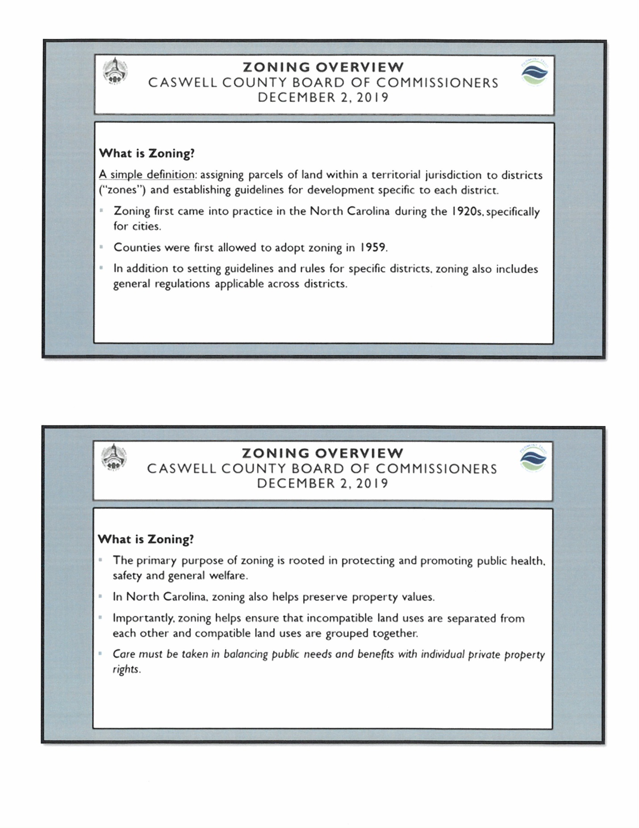

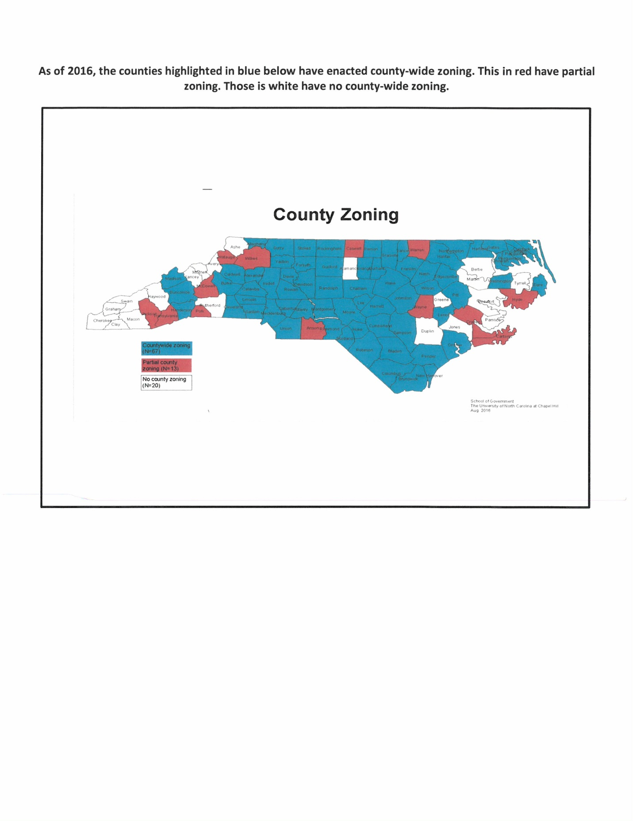

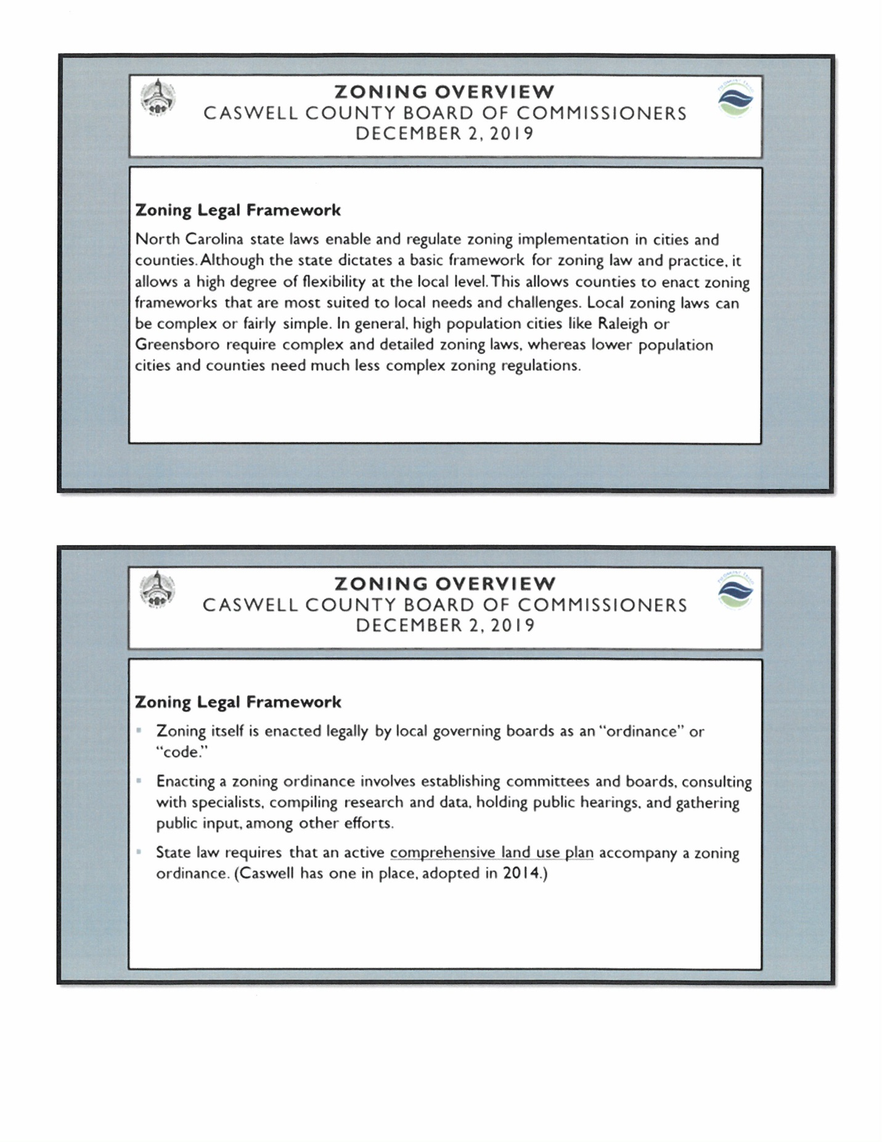

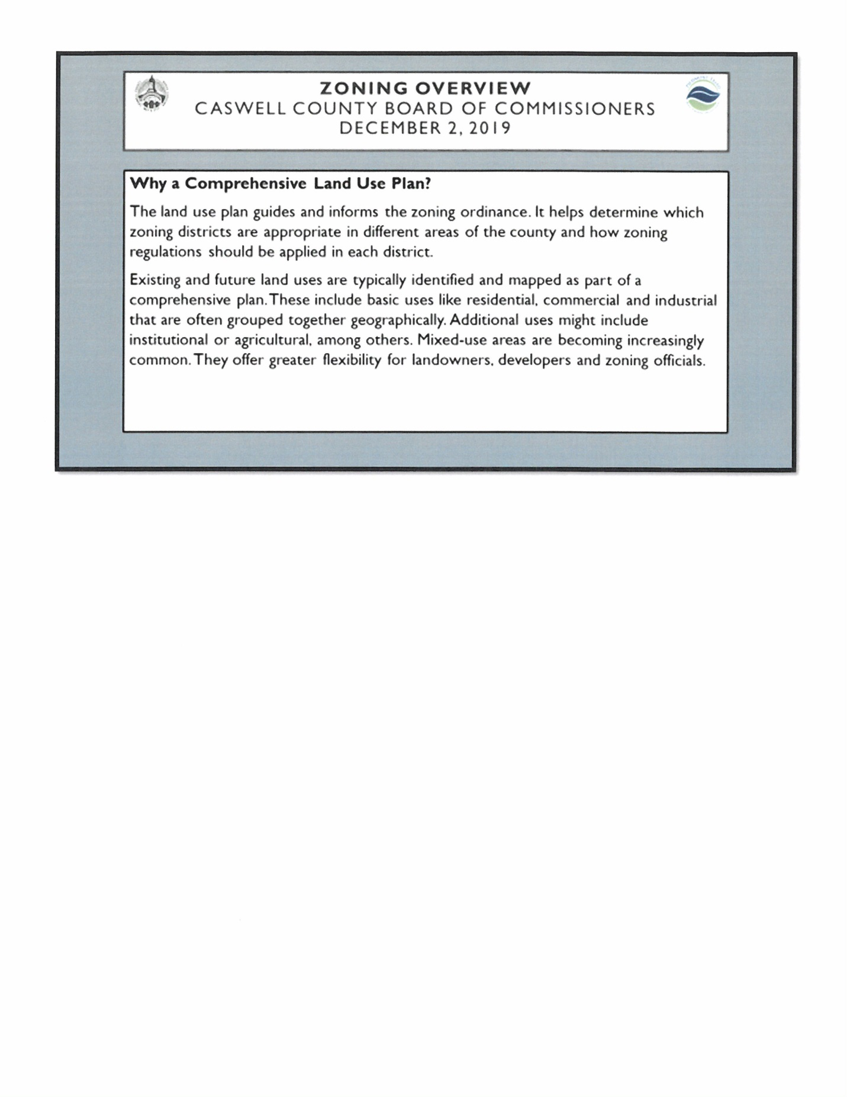

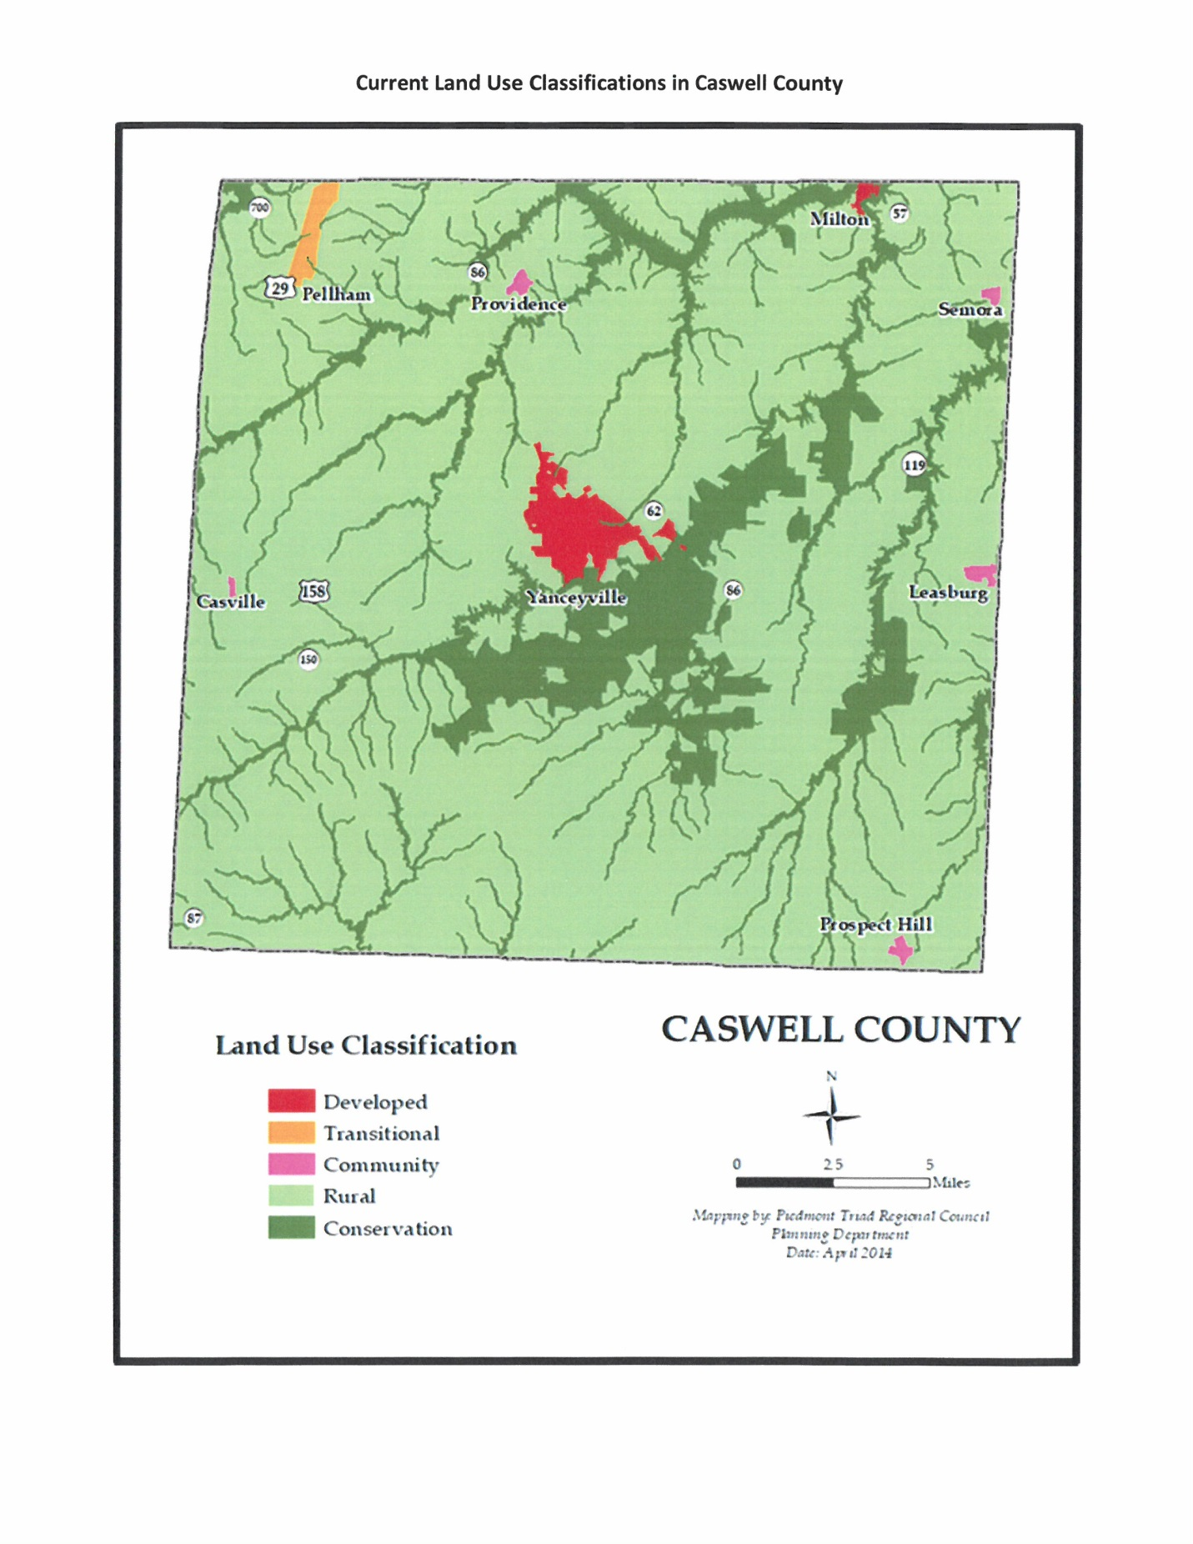

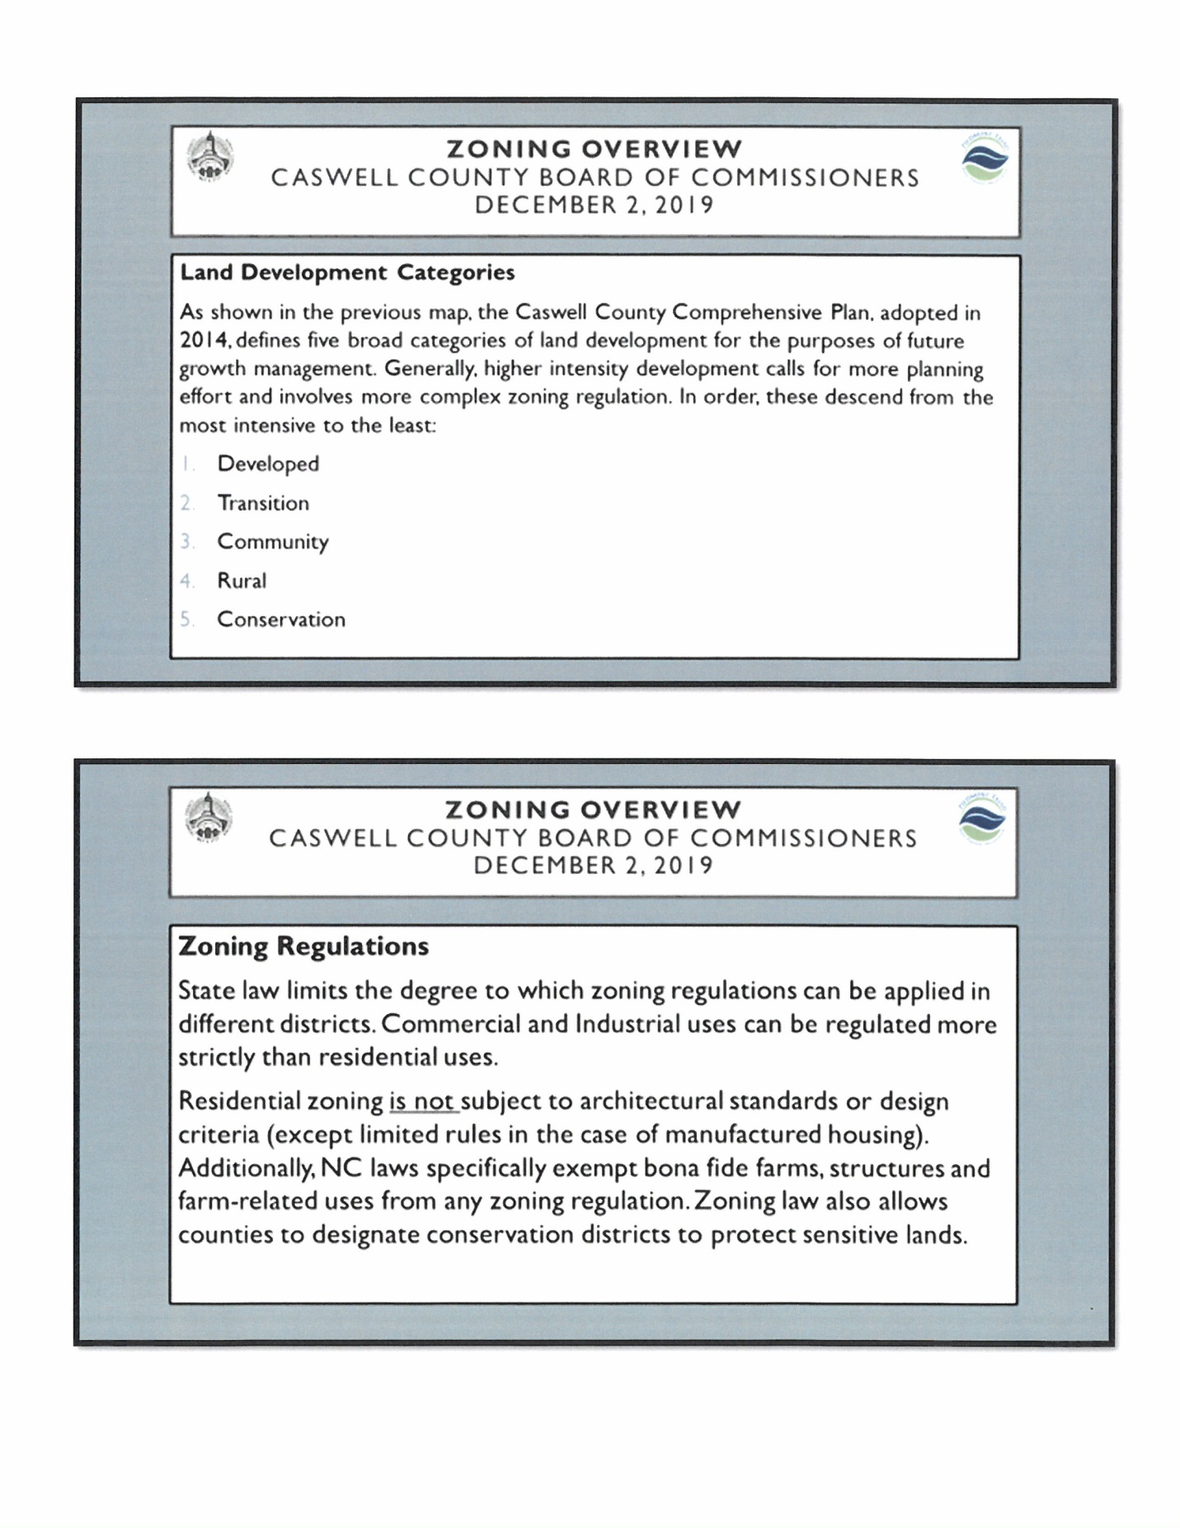

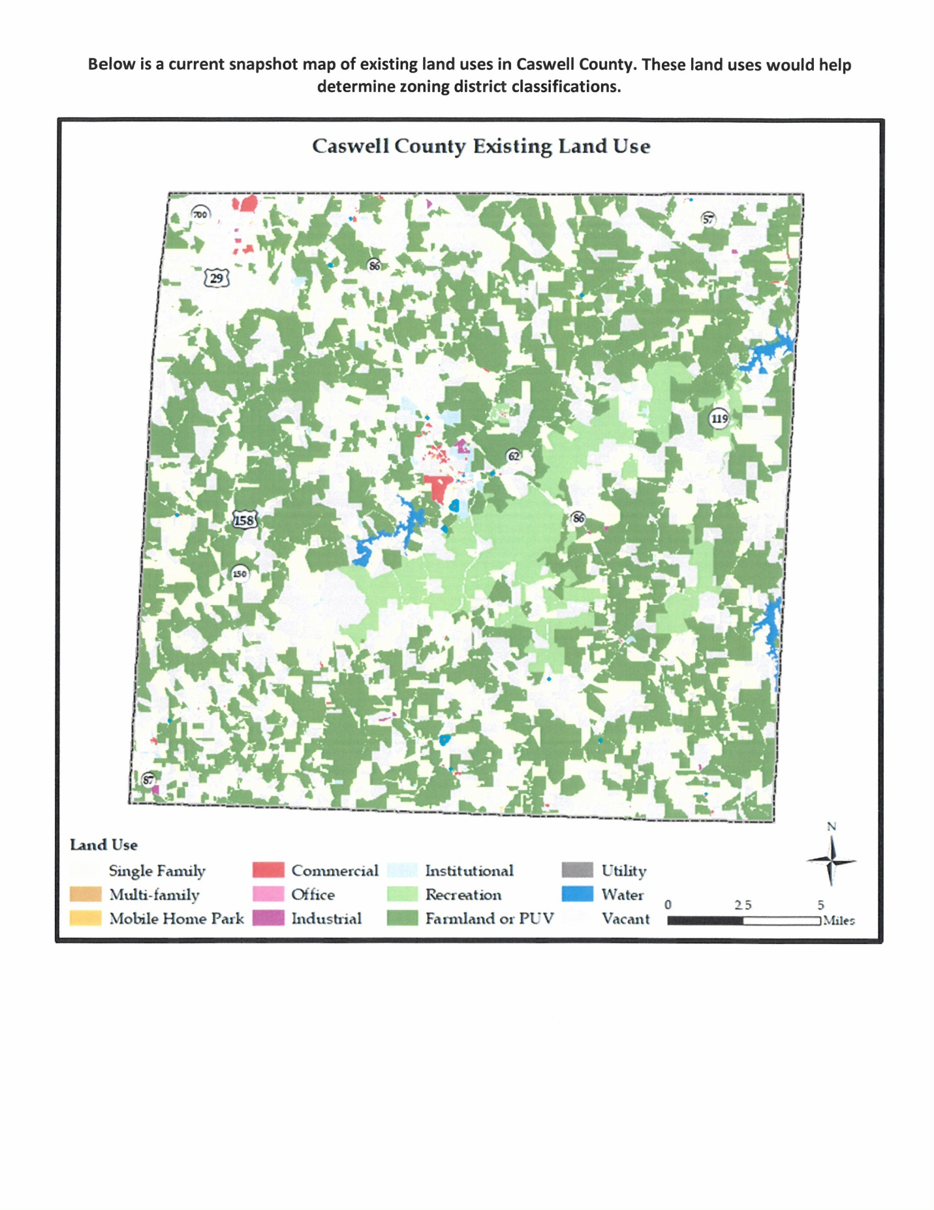

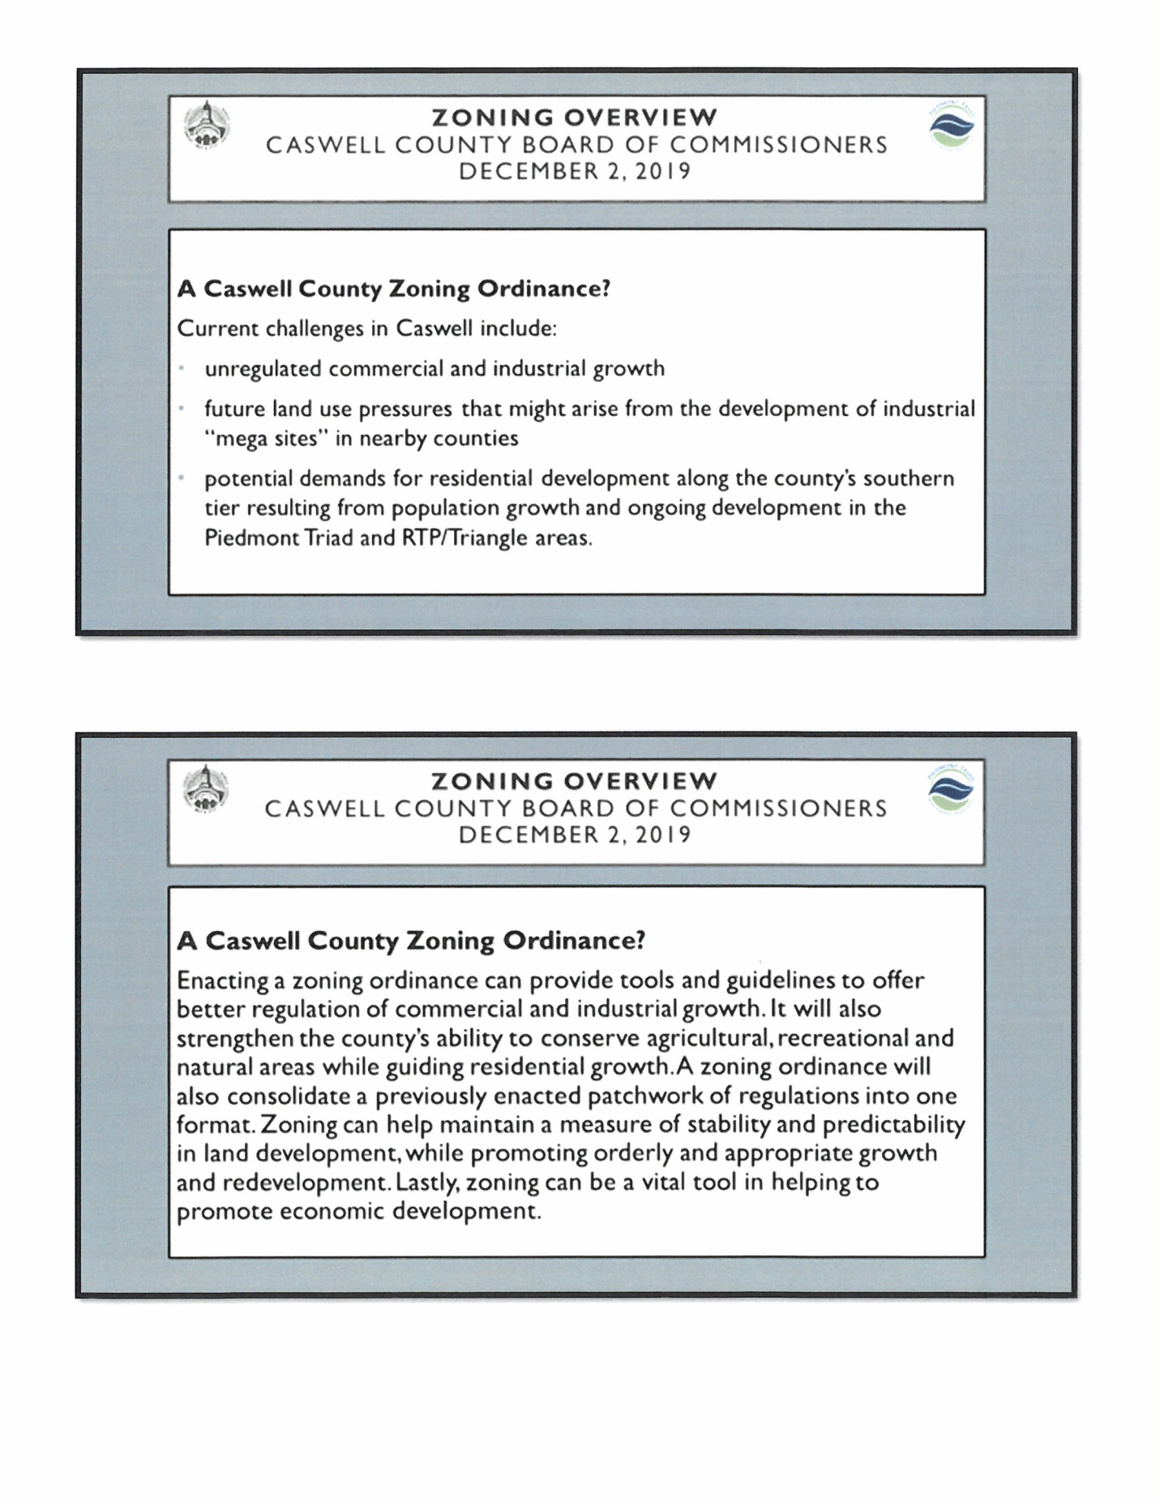

Commissioner Owen asked if the slide presentation is available to put on the County’s website. Mr. Cochran responded yes it is.

Commissioner Oestreicher stated that bona fide farms are exempt from zoning regulations and he wanted to know what the definition of a bona fide farm. Mr. Cochran responded that it does not have to do with the size of the farm but more with what the activity is on the farm. He added that legislation changed the rules of a bona fide farm in 2016-2017 to allow more freedoms for farms but at the same time making sure it is a bona fide farm. Mr. Cochran stated that in order to be considered a bona fide farm they need to have a USDA tax return, be enrolled in the present use value program with the local jurisdiction for a tax reduction, have a forestry management plan, farm status proof from the North Carolina Department of Revenue, or enrolled in Goodness Grows in North Carolina that allows the production and sell of farm related products that is sanctioned by the state for sell and exemption. Commissioner Oestreicher asked if someone had a 630 acre farm that was in an area that is zoned for residential and agricultural use only and they sell the farm to someone that has an industrial permit will this be allowed. Mr. Cochran responded that without a zoning ordinance yes. Commissioner Oestreicher asked if it was zoned. Mr. Cochran responded with zoning it could be stopped. He added that in the zoning plan it would state what the zoning districts allow. Commissioner Oestreicher asked what would exempt land from zoning regulations. Mr. Cochran responded that a bona fide farm would be exempt from zoning regulations. He added that if 300 acres of that farm is sold then the exemption status is removed because it is no longer associated with the farm operator which means it is open territory without zoning. Commissioner Oestreicher stated that the exemption status applied to the existing owner and the existing uses. Mr. Cochran responded that the exemption status is owner specific. Commissioner Oestreicher wanted clarification on zoning ordinances or zoning regulations is enacted by the Board of Commissioners and not by public referendum. Mr. Cochran responded that this is correct; a governing body must pass a zoning ordinance for it to be a law. Commissioner Oestreicher asked what role the public could play in this. Mr. Cochran responded that he encourages all jurisdictions to state what they would like to see. He added that it could take up to 18 months to pass zoning but during this time frame the county may want to hold 5 or 6 key stakeholders meetings, establish a steering committee, as well as 6 public forums to talk about what the public is looking for. Mr. Cochran stated that getting feedback from the public is essential to a zoning ordinance.

Chairman McVey stated that it is his understanding that the Board has to make the decision on zoning. Mr. Cochran responded that he did not say that the Board had to make a decision on zoning. Chairman McVey stated that he understands it can be put on a referendum. Mr. Cochran responded that the Board could pass a resolution to put this on a referendum. Chairman McVey asked if this could be put on a referendum and let the people vote on it or not. Mr. Cochran responded that he would have to check with the School of Government on a definitive answer. Chairman McVey stated that Commissioner Jefferies told him that it has been on the ballot twice and it failed both times so he wanted to know if it could be put on a ballot. Mr. Cochran responded that he would find out the exact legalities and get back with the Board. Chairman McVey also asked if the Board had to go through legislation to get this approved. Mr. Cochran responded that it is his understanding that in the end eventually the Board would have to get legislation’s approval. He added that public input is good and that way the Board would know where the residents want zoning or not but enacting the ordinance is different because this has to be done by the Board of Commissioners.

Commissioner W. Carter asked if there could be satellite zones or does this have to be countywide. Mr. Cochran responded that it does not have to be countywide, the county can do a small area plan, targeted development plans, and there are different levels of zoning. He added that certain township could be zoned for certain things. Commissioner W. Carter stated that Yanceyville has zoning in place but if the Board knows a need in a certain part of the county zoning could be proposed for that area. Mr. Cochran responded that this could be done but it would not be retroactive, what has already been put in motion can be affected.

There were multiple questions from the audience.

Someone asked if the old moratorium could be re-enacted. Mr. Ferrell responded that the old moratorium could not be re-enacted because it took effect in the early 2000s. Mr. Cochran stated that it is very different to re-enact a moratorium once it has expired due to state laws. This person stated that the deadline for stopping the asphalt plant is December 18th and she wanted to know what was going to be done to prevent this from happening.

Mr. Miller stated that the meeting was designed as an educational meeting and not a meeting for the Board to make a decision on zoning. He added that the county would have to go through the process to make sure that zoning would be fair and equitable to everyone. Mr. Miller stated that if the Board decides to take up zoning it would need to be well thought out.

There was a lot of discussion back and forth.

Chairman McVey brought the meeting back to order.

Commissioner Jefferies stated that when BFI wanted to come to the county it was put on the ballot and the citizens voted to not allow BFI to come into the county. He added that this was taken before the legislature as well. Commissioner Jefferies stated that it should go on the ballot and let the residents of Caswell County state what they want since they pay the bills for the county.

Commissioner S. Carter stated “I was just going to validate the ladies comments and concerns in relation to zoning and for the health, safety and the wellbeing of the citizens of the county we can do something about that, we may have to delve into the legalities of it but I do think we can do something before the 18th with the polluting industries. We did it in 2002 and I think we can do it again. That would help that specific situation and it is unrelated to your presentation and I am sorry for that but I do not want your concerns to be shut down during this meeting because you can say what you want to say for the health, safety, and wellbeing in the Anderson community in relation to the big picture of the government and I think we should do something about that in regards to the asphalt plant because they have a pending permit for the 18th and you can say well it is not our, you know, place to get in the middle of this, it is because you have health concerns of a community that a lot of the residents did not find out about this until recently. When I brought up my concerns about zoning months ago that one of my pet peeves was this industry is coming and they don’t let the community know what they are doing. These people were caught unawares and then we get to a point where we are currently at where you can’t do anything so they have to be our voice on the ground to do petitions and have public information meetings, that is what we should be doing. That’s why this presentation is this today but as far as what that is with that specific concern regarding the asphalt plant there is definitely something this Board can do and I will be the first to say I am in favor of doing a moratorium even if it’s for a year, that gives us time as she said clearly to inform ourselves of what we can and can’t do moving forward. And in relation to your presentation I have another question, I think Commissioner Oestreicher you asked for a copy of this. If this can be made available to the public and we can put them in public places for them to pick up that would be better for their information moving forward during this whole process.” Mr. Miller responded that it can definitely be posted on the website. Commissioner S. Carter continued “Other than the website because a lot of people do not have access to the internet.”

There were more questions and comments from the public.

Mr. Cochran stated that he is in communication with Matthew Hoagland, Planner and Bryan Miller so if anyone else has any questions or concerns they could get those questions to him through those two individuals.

Mr. Ferrell stated that residents can weigh in their opinions about zoning through a referendum but this would need to be submitted to legislation for approval and the results of that referendum could inform the Board on how to proceed with zoning in the county.

Commissioner S. Carter asked “Mr. Chairman I have a question, I understand the rationale but I don’t think we can wait for that to happen.”

Commissioner Jefferies moved, seconded by Commissioner Owen to request special legislation that Caswell County be allowed to place an advisory referendum on an upcoming ballot.

Commissioner Owen seconded the motion but he did not think the Board needed to wait on looking at the county and proposing zoning districts. He added that he did not mind it being on the ballot because the people need to have a voice. Commissioner Owen recommended directing the Planning Department or whoever to begin to working on a plan for Caswell County which may start with a specific area.

Commissioner S. Carter asked “Is that a complex motion?” Commissioner Owen responded that it was his comment but no it is not part of the motion, he just made a personal comment.

Upon a vote of the motion, the motion carried by a vote of five to one with Commissioner S. Carter voting no.

Commissioner Oestreicher asked in reference to the December 18th deadline he did not think a year moratorium is what is trying to be addressed but the specific issue is the asphalt plant but he asked if a 6 month moratorium that doesn’t send a message that the county is against industrial development and he wanted to know if this was something the Board would consider to buy the county time. Commissioner S. Carter responded “That’s it verbatim.”

Mr. Ferrell stated that legislation has given counties the authority to impose development moratoria in certain circumstances and the point of the moratoria is essentially to declare a pause while the county does a certain specific thing. He added that there is a criterion that has to be done before adopting a moratoria and one thing depending on the length of the moratoria is that at least one or a number of public hearings have to take place. Mr. Ferrell stated that in order to adopt a moratoria the county has to have a clear statement of the problems or issues that the county is trying to address with the moratoria, there has to be a clear statement of development approvals that are subject to the moratoria and how the moratoria on those approvals will be addressed during the period of time that is subject to the development pause and there has to be an expressed date for termination of the moratoria and a statement of the particular actions that the county is going to undertake during the period of the moratoria to address the problem. He stated that the county cannot just declare a moratorium and do nothing. Mr. Ferrell stated that he would have to go back and look at the statute to verify all the qualifications if it is going to be longer than two months but he did know that a public hearing would have to be held before adopting a moratoria.

Commissioner Oestreicher asked if two weeks’ notice is required. Mr. Ferrell responded that he would have to look into that but if that is the Board’s intention then it should have started yesterday. He added that the Board can direct staff and him to move forward as quickly as statutorily possible implementing a moratorium and it will be done. Commissioner Oestreicher asked if the moratorium in 2002 ever challenged. Mr. Ferrell responded that he did not know because he was not with the county in 2002 but he knew that no zoning regulations came out of it.

Commissioner S. Carter stated “In regards to what is required for a public hearing, Ms. Seamster what is our requirements in the way of notification is concerned.” The clerk responded that most public hearing require at least 10 days but no more than 25 days before a public hearing. Commissioner S. Carter continued “So we could set two simultaneously?” The clerk responded that she would double check that when it comes to this instance.

Mr. Ferrell stated that if the Board wants to move in this direction it can set the date now and start moving forward to the public hearing.

Commissioner Owen moved, seconded by Commissioner W. Carter to adjourn the meeting. The motion failed by a vote of three to three with Commissioners S. Carter, McVey and Oestreicher voting no.

RECESS

(At 11:50 a.m. Commissioner W. Carter left the meeting.)

Chairman McVey called the meeting back to order.

Mr. Ferrell stated that during the break he looked up the moratorium statute so he could speak to the notice timelines and this is found in G.S. 153A-340(h). He stated that if a moratoria is for 60 days or less the public hearing needs to be noticed not less than 7 days before the date set for the hearing and if the moratoria is for more than 61 days or long the county will have to follow G.S. 153A-323 the public hearing needs to be noticed once a week for two consecutive calendar weeks and the notice shall be published the first time not less than 10 days nor more than 25 days before the public hearing. Mr. Ferrell stated that the Board can set the public hearing date now so it can be noticed.

Commissioner Oestreicher asked if there would be enough time to notice for a public hearing on the 16th if the notice is put in the newspaper on December 4th and 11th. Mr. Ferrell responded that he would have to count the days. Commissioner Oestreicher asked if the 10 days would be from the first notice or the second notice. Mr. Ferrell responded it would start on the first publication. Commissioner Oestreicher stated that this would give the county time to hold a public hearing before the deadline of December 18th. Mr. Ferrell responded that the county does not have a deadline. He added that he did not know if this December 18th is a DEQ permit deadline but these are not related. Commissioner Oestreicher asked if DEQ could issue the permit which is superseded by the moratorium and he wanted to know if the moratorium would affect this permit. Mr. Ferrell responded that it would depend on the wording and added that a moratorium would impose a pause or restriction in local government issuance of permits but Caswell County does not issue any permits so it would be an interesting legal question that he would have to look into. He added that if the Board wants to move forward with the moratorium now is the time to do it but there needs to be a plan.

Commissioner S. Carter stated “Mr. Chairman, I think we’ve determined our two notice dates on a public hearing suffice on the 16th versus doing one on a Saturday…Monday the 16th, our regular meeting date.” Commissioner Oestreicher responded that it would be good for him. Commissioner S. Carter continued “What time?” Commissioner Oestreicher responded 9:00.

Chairman McVey asked Commissioner S. Carter if he is suggesting holding the public hearing on December 16th. Commissioner S. Carter responded “The earliest we can do it is the 14th which is a Saturday and I recommend let’s do it on Monday morning.”

Mr. Ferrell stated that the Board can open the public hearing on Monday, December 16th, close the public hearing and take action. Commissioner Oestreicher responded that the Board has to have a moratorium to vote on. Commissioner S. Carter stated “Yes.”

Commissioner S. Carter stated “I have a comment on that, if another commissioner would like to join me in drafting this, we have a very good one to go by here so we could have one drafted and sent out so that you can review it so if there are any questions or concerns. Do you have to publish it in the notice?” Mr. Ferrell responded that the general statutes do not say that it has to be published with the notice but the document does need to be ready by the public hearing.

Commissioner Oestreicher stated that it could be put out in the notice as bullet points on what it will cover. Mr. Ferrell asked if what the Board is considering is a moratorium on…” Commissioner S. Carter stated “Polluting industries.” Mr. Ferrell responded polluting industries. Commissioner S. Carter continued “The purpose of this moratorium shall be able to protect public health, safety, general welfare, and property values of the Citizens of Caswell County, etc. etc.” Mr. Ferrell responded “From polluting…” Commissioner S. Carter stated “Industries. Can we say asphalt plant?” Mr. Ferrell responded yes the wording can be very specific. Commissioner Oestreicher stated to put in asphalt. Commissioner S. Carter responded “There is a cement plant as well.” Commissioner Oestreicher stated to combine cement and asphalt plants. Mr. Ferrell responded that quarries will not be included but cement and asphalt plants. Commissioner S. Carter stated “Because we already have an existing rock quarry.” Chairman McVey stated that if the Board is going to do one of them why not do them all. Commissioner Oestreicher responded that he did not think the quarry could be stopped.

Commissioner S. Carter asked “Question on that, we have an existing rock quarry, can we do a moratorium on rock quarries, does it affect current industries?” Mr. Ferrell responded that the county cannot revoke any permits already in place so the moratorium would prevent future locations. Commissioner S. Carter continued “Is that something anybody else would be willing to help draft something?” Commissioner Oestreicher volunteered to help draft the moratorium.

Commissioner S. Carter moved, seconded by Commissioner Owen to set a public hearing for a proposed moratorium on asphalt plants, cement plants and rock quarries in Caswell County on Monday, December 16, 2019 at 9:00 a.m. The motion carried unanimously.

ADJOURNMENT

At 12:12 p.m. Commissioner Owen moved, seconded by Commissioner S. Carter to adjourn. The motion carried unanimously.

________________________________ ___________________________

Paula P. Seamster Rick McVey

Clerk to the Board Chairman

******************************************************************************