MINUTES – JUNE 5, 2019

The Caswell County Board of Commissioners reconvened in special session at the Caswell County Historic Courthouse in Yanceyville, North Carolina at 9:00 a.m. on Wednesday, June 5, 2019. Members present: Rick McVey, Chairman, Jeremiah Jefferies, Vice Chairman, Sterling Carter, Nathaniel Hall, Steve Oestreicher, and David Owen. Absent: William E. Carter. Also present: Bryan Miller, County Manager, Gwen Vaughn, Finance Director, Barbara Hughes, Interim Cooperative Extension Director and Samantha Monroe representing The Caswell Messenger. Paula P. Seamster, Clerk to the Board, recorded the minutes.

MOMENT OF SILENT PRAYER

Chairman McVey called back to order the reconvened FY 2019-2020 Budget work session and opened the meeting with a moment of Silent Prayer.

PLEDGE OF ALLEGIANCE

The Board of Commissioners and all the guests in the audience recited the Pledge of Allegiance.

PROPOSED FY 2019-2020 BUDGET
Cooperative Extension

Mr. Miller stated that the Finance Director has prepared some additional information that was requested at the last budget meeting. He added that there is a lot of information to talk about today but there is one department leader present today, Barbara Hughes, Interim Cooperative Extension Director. Mr. Miller stated that first item for Cooperative Extension is 2 positions: Agri-Hort-Row Crops which would be funded 100% by the County and Agri-Progressive Farmers which would be funded at 50%. He added that Caswell County needs to focus on its farmers and farm land and these are needed positions and will benefit the county very well.

Commissioner Oestreicher asked Ms. Hughes if she had an estimate or an idea of how many people have a garden or would take advantage of the Progressive Farmers position. Ms. Hughes responded that she met with the Women Farmers of Caswell County and most of them would like to become Master Gardeners and with this program they would have to give back 50 hours of community service. She added that she receives a lot of telephone calls on things that this position could handle.

Commissioner Jefferies asked if someone in the county that would be able to go out into the county and check on hemp and that will be able to help the farmers. Ms. Hughes responded yes the State of North Carolina has people who check on this. Chairman McVey responded that this would fall under the Row Crops position.

Ms. Hughes stated that her expectation with these positions is they would seek grants and opportunity to bring into the county.

Commissioner S. Carter asked “The $35,000 is that our half of the salary for this?” Mr. Miller responded that this is correct and added that this position is in cooperation with NC A&T.

Commissioner Jefferies asked if the county could build a building cheaper than renovating the current Cooperative Extension building. Mr. Miller responded that he had a contractor to come in and give an estimate on the renovation of the building and the estimate was $1.5 million and a new building would cost approximately $2 million.

Commissioner Oestreicher stated that he thought the Board talked about building this building in conjunction with the Ag Business Center in Pelham. Mr. Miller responded that the community has made it clear that it wants the Ag Extension to remain in Yanceyville.

Mr. Miller asked the Board how to proceed with the positions and/or renovations for Cooperative Extension. Commissioner Owen responded that he would like to know where the money will be coming from first.

Chairman McVey stated that he thinks the Board needs to go through and prioritize what needs to be included in the budget and then a decision can be made on the building. He suggested that the Board go through the list that was presented by staff.

Technology
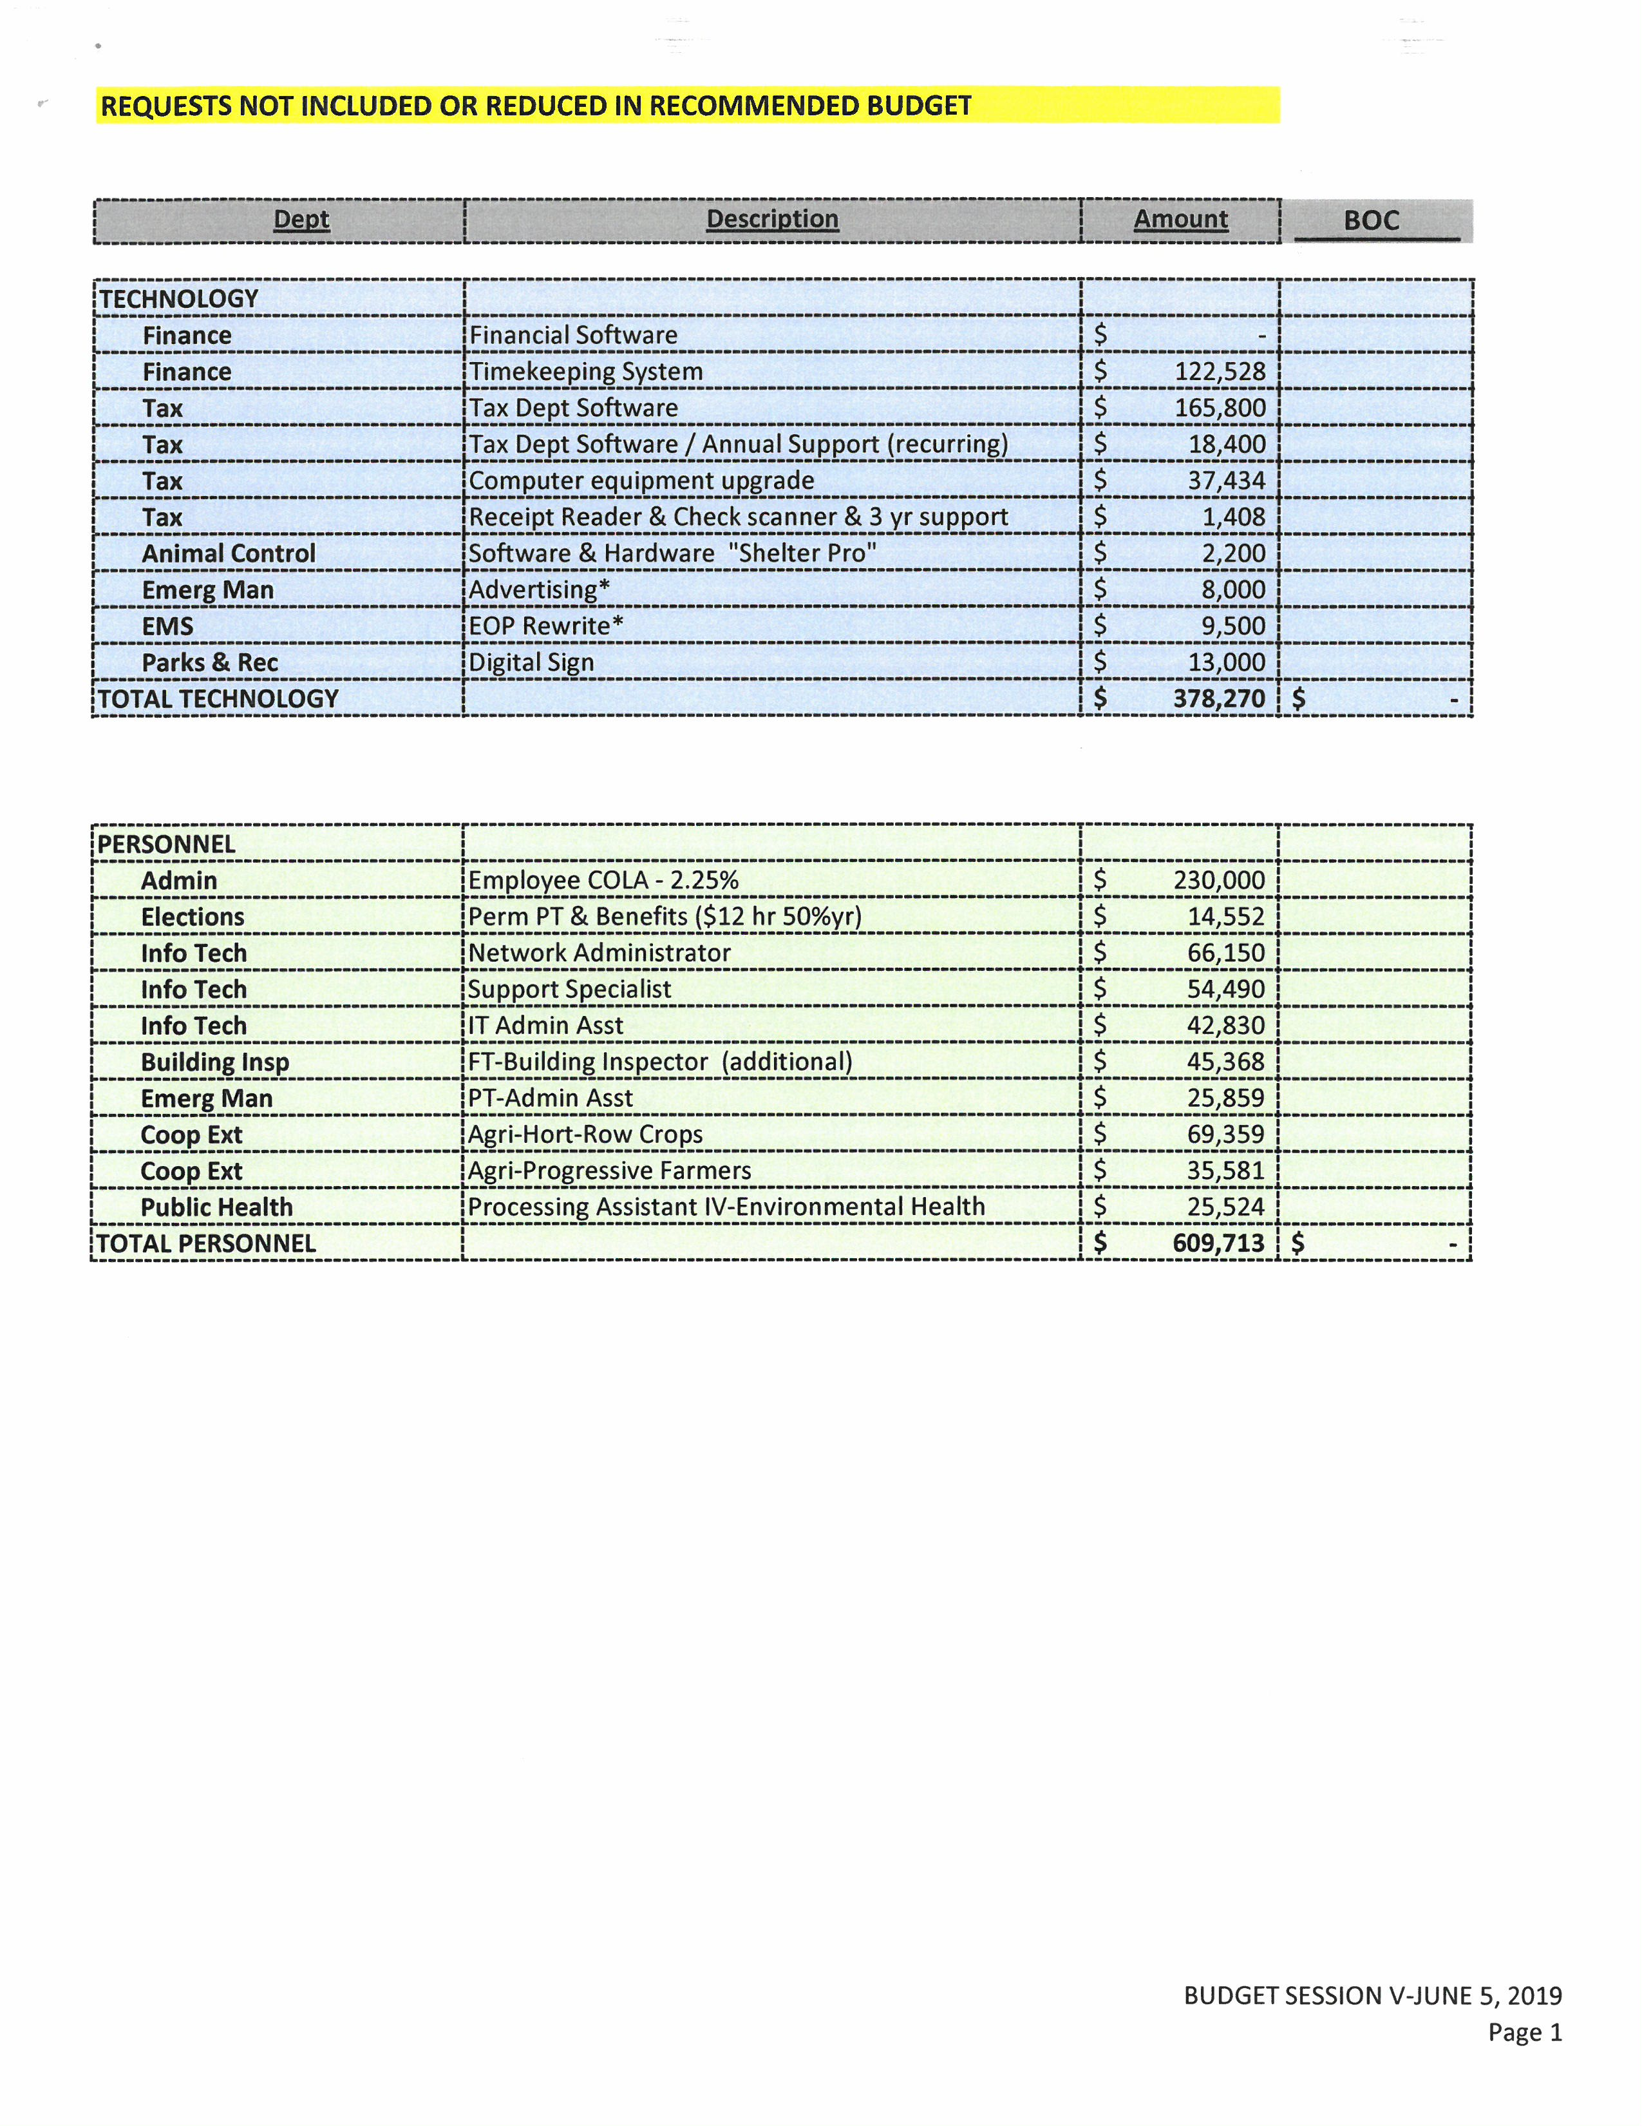
Mr. Miller presented the technology requests that were not included in the budget.

Ms. Vaughn stated that she spoke with a representative from a software vendor today and the complete package that includes the financial software and timekeeping software is $414,990 which included licensing, implementation and expense for travel for training. Mr. Miller added that the Maintenance work order software would be $6500.

Commissioner Oestreicher asked the tax office software will interface with the new financial software. Mr. Miller responded yes this is a requirement.

Commissioner Hall asked if the financial software includes purchase orders. Ms. Vaughn responded that the financial software did include purchase orders.

Commissioner Owen asked for the updated total on the technology that is being requested. Ms. Vaughn responded that the total amount for technology requested included the financial software and work order software is $678,640. She added that the cost on the Tax office computer equipment upgrade should be $38,842.

Mr. Miller asked the Board if it wanted to proceed to personnel or if it wanted to prioritize technology.

Commissioner S. Carter stated “Mr. Chairman I need to know what amount of fund balance are we currently at again that has already been put into the budget?” Commissioner Owen responded that he thinks it is $682,000. Commissioner S. Carter continued “And then how much are we left with in fund balance?” Ms. Vaughn responded that it would be 15% that is unassigned which is $4.25 million. Commissioner S. Carter continued “And that’s with the 682 deducted from it?” Mr. Miller responded that this is unassigned and not the total fund balance. Commissioner S. Carter asked “It’s over $7 million total isn’t it?”

Commissioner Owen stated that he wanted to make sure that the Board is aware that out of the $682,370 that is coming out of this budget about $465,000 is for capital items.

Commissioner Oestreicher asked for the EOP rewrite to be taken out and figure out another way to do this.

Chairman McVey asked that the digital sign be removed at this time. He asked about the EM advertising. Commissioner Oestreicher responded that this is worth doing.

Commissioner Owen stated that even after taking these small items out that still leaves over $600,000 in technology but he did think the tax software and the financial software are needed. Mr. Miller responded that the tax software could be paid for over 2 years.

Commissioner S. Carter asked “That whole package or just the software?” Mr. Miller responded that this is just the tax software at $165,800. Commissioner Hall stated that this would not matter.

Personnel
Mr. Miller stated that the Employee COLA would give all county employees a 2.25% increase as well as move all those county employees that make less than $25,000 up to that amount.

Commissioner Jefferies did not think that $25,000 was enough to help the employees. Mr. Miller responded that staff could bring back a scale for $27,500, $30,000, $32,500 and $35,000 and what it would take to get to these amounts. Commissioner Jefferies responded that this is what he would like to see. Commissioner Owen did not think this should go beyond $30,000.

Commissioner S. Carter asked “What is our current lowest salary, full time salary?” Ms. Vaughn responded that there is also permanent part time and the Board included in this amount. Commissioner S. Carter continued “The 2.25 includes us?” Ms. Vaughn responded yes. Commissioner S. Carter continued “I thought I understood that it would exclude us and the direct reports to the Board.” Mr. Miller responded that his numbers did not reflect the Board, no one that reports directly to the Board, elected officials, or employees that report directly to other boards. Commissioner S. Carter asked “Your last point Bryan, your calculation also excludes employees that report to other boards, is that Social Services and Health Department?” Mr. Miller responded that it would be the Social Services director and Health director. Commissioner S. Carter continued “That’s the only two that…okay.” Commissioner S. Carter stated “Lowest paid full time salary.” Ms. Vaughn looked through the employee listing. Commissioner S. Carter continued “Is it possible to get copies of that updated, I would like to get a copy of that?” Mr. Miller responded that $23,580 is the lowest full time salary. Commissioner S. Carter asked “Is it okay to ask what position that is or what department?” Ms. Vaughn responded that the lowest full time salary is $20,808. Mr. Miller stated that this amount could not be a full time position at $10.00 an hour. Commissioner S. Carter continued “So that’s the lowest one, $20,808, what position is that?” Ms. Vaughn responded that is a Community Social Service Assistant.

Commissioner Hall stated that as the Board talks about salaries it needs to take 3 things into consideration: 1) a living wage, 2) being competitive and 3) identifying positions and what the employee brings to the table. He added that the county needs to encourage staff to get more education and training. Commissioner Hall stated that the Board needs to think this through because it is not a one thing fits all because a person without a high school diploma cannot demand a high salary. Mr. Miller responded that he agreed with Commissioner Hall but there are some exceptions to this. Commissioner Hall stated that the people in the community where he grew up were some of the hardest working people he knew but they did not have the skills to do anything but work hard and that is what he is trying to address, the Board has to look at the skills level and suggest that the employee get more training at the community college.

Mr. Miller added one more additional position to the personnel list, he recommended that the County hire the Economic Development staff from the part time partnership with Piedmont Community College to full time with the County and this could be done with the current request from Piedmont Community College which is roughly $96,000.

Commissioner Owen asked who this would include. Mr. Miller responded that this would include the economic developer and 2 part time administrative positions.

Commissioner Oestreicher stated that according to this there would be no additional cost for putting economic development under the county. Mr. Miller responded that this is correct. He added that the County has received a grant for the HIVE project on the Square for operational support for 4 years at $77,000 a year and this would cover the gap between what the county has been paying PCC and what PCC has contributed in the past.

Commissioner Owen asked if the economic developer currently has 2 administrative assistants. Mr. Miller responded that there are 2 administrative assistants that are funded currently. Commissioner Owen stated that Dr. Bartlett stated that the salary would be $56,000 a year plus benefits which would be about $77,000 a year and the budget has gone up $18,000 and he has said all along that if the county is going to spend this kind of money the county needed to have this position full time. He added that the $96,000 is already in the budget.

Chairman McVey asked which position the IT director asked for. Mr. Miller responded that the IT director asked for all 3 put he really needs a Support Specialist.

Commissioner Oestreicher asked if the economic developer get the 2.25% increase. Mr. Miller responded yes but this needs to be discussed in closed session. Commissioner Owen asked if the 2.25% raise was included in the $96,000. Mr. Miller responded no.

Chairman McVey stated that he thought the Extension office was requesting a Livestock agent and a Row Crops agent but it now says a Row Crops agent and a Progressive Farmers agent. Mr. Miller responded that the Livestock agent is already in the budget.

Commissioner Oestreicher asked if the $609,713 was the correct number for Personnel at this point.

Commissioner Owen asked if the Board could prioritize the positions. Chairman McVey responded yes. Commissioner Owen stated that he is okay with adding the position of Support Specialist for IT and Ag Row Crops position as his top two positions. He added that the Board needs to remember that these are reoccurring positions so the only way to pay for these is through a tax increase.

Chairman McVey stated that the Agri-Progressive Farmers positions needs to be added as well because the county has so many small farmers.

Commissioner S. Carter asked “Have we already agreed on the COLA at this point, that’s in the Personnel category?” Commissioner Owen responded that staff will come back with the other figures. Commissioner S. Carter continued “Up to 30 but at this point are we willing to do something?” Commissioner Owen responded yes.

Commissioner Oestreicher stated that the building inspector should be another one because it will pay for itself.

Commissioner S. Carter stated “My thought on the building inspector is we have not even put the part time person into effect yet and I would wait and see how we function with a full time and one part time for this upcoming year because the part time is already calculated into everything, we just haven’t hired the person yet.” Mr. Miller responded that he spoke with one of the previous building inspectors and he said he would help the county out until someone is hired. Commissioner Owen agreed with Commissioner S. Carter. Commissioner S. Carter continued “What I have down is COLA, IT and the 2 Ag positions.”

Commissioner Oestreicher asked the Board about the Elections position.” Commissioner S. Carter responded “I don’t want to do that this year.”

Commissioner S. Carter asked “With the Economic Developer again what is the amount that we are making the difference on?” Mr. Miller responded that there is an increase of about $19,000 to the economic development budget and this is currently included in the budget. Commissioner S. Carter continued “But for this upcoming budget all we need extra is the $19,000?” Commissioner Owen responded that this is already included in the budget. Commissioner S. Carter continued “So we are just transferring it over?” Mr. Miller responded that this is correct the money would be transferred over to a county department. Commissioner S. Carter asked “So to the Public Education section of this spreadsheet we are talking about Personnel the request of support $18,917?” Mr. Miller responded that this is correct. Commissioner S. Carter continued “So we don’t need the $22,000 underneath that or we are keeping that as well in addition to this total amount?” Mr. Miller asked Commissioner S. Carter to repeat what he said. Commissioner S. Carter continued “My understanding is this sheet is to show things that are not currently in the budget and when I am looking at the Public Education section for PCC…” Mr. Miller responded that he understands his question now and the $22,000 has always been included.” Commissioner S. Carter continued “Both of which are in the budget?” Mr. Miller responded that both are included in the budget.”

Commissioner Owen asked the Chairman if the Board could make a determination on moving the economic director under the county. Commissioner S. Carter asked “Do we need to cover something in closed session before we move on, you said?” Mr. Miller stated that that closed session was not required to confirm the position.

Commissioner Oestreicher asked if the Board could come to a consensus on the whole package. Chairman McVey responded that one things needs to be handled at a time.

Commissioner Oestreicher moved, seconded by Commissioner Owen to move the Economic Development Department under the County effective July 1, 2019. The motion carried unanimously.

Chairman McVey stated now the Board will go through the list for Personnel and vote yes or no.

COLA – Consensus was yes.

Commissioner S. Carter stated “At minimum that is what we are doing.” Chairman McVey responded yes.

Perm PT & Benefits for Elections – Consensus was no.
Network Administrator for IT – Consensus was no.

Support Specialist for IT – Consensus was yes.

Commissioner Hall stated that he had a little bit of a concern about the pay for this position because he knows someone that was hired for a similar type of position and was hired at $90,000 a year. Commissioner S. Carter responded “So this Support Specialist is going to be making more than our director.” Ms. Vaughn stated no.

IT Administrative Assistant – Consensus was no.

FT Building Inspector – Consensus was no.

PT Administrative Assistant for Emergency Management – Consensus was no.

Agri-Hort-Row Crops – Consensus was yes.

Agri-Progressive Farmers – Consensus was yes.

Processing Assistant IV for Environmental Health – Consensus was no.

Ms. Vaughn stated that this bring the total for Personnel to $389,430.

Commissioner S. Carter stated “I was asking the Finance Director what we had done with the Technology portion, if we had gone through with any of that yet.” Mr. Miller responded that he did not have any changes on that yet. Commissioner S. Carter continued “Do we want to look at that or move on to Capital items, I am curious what direction you were doing?” Chairman McVey recommended moving on to Capital next.

Capital Outlay
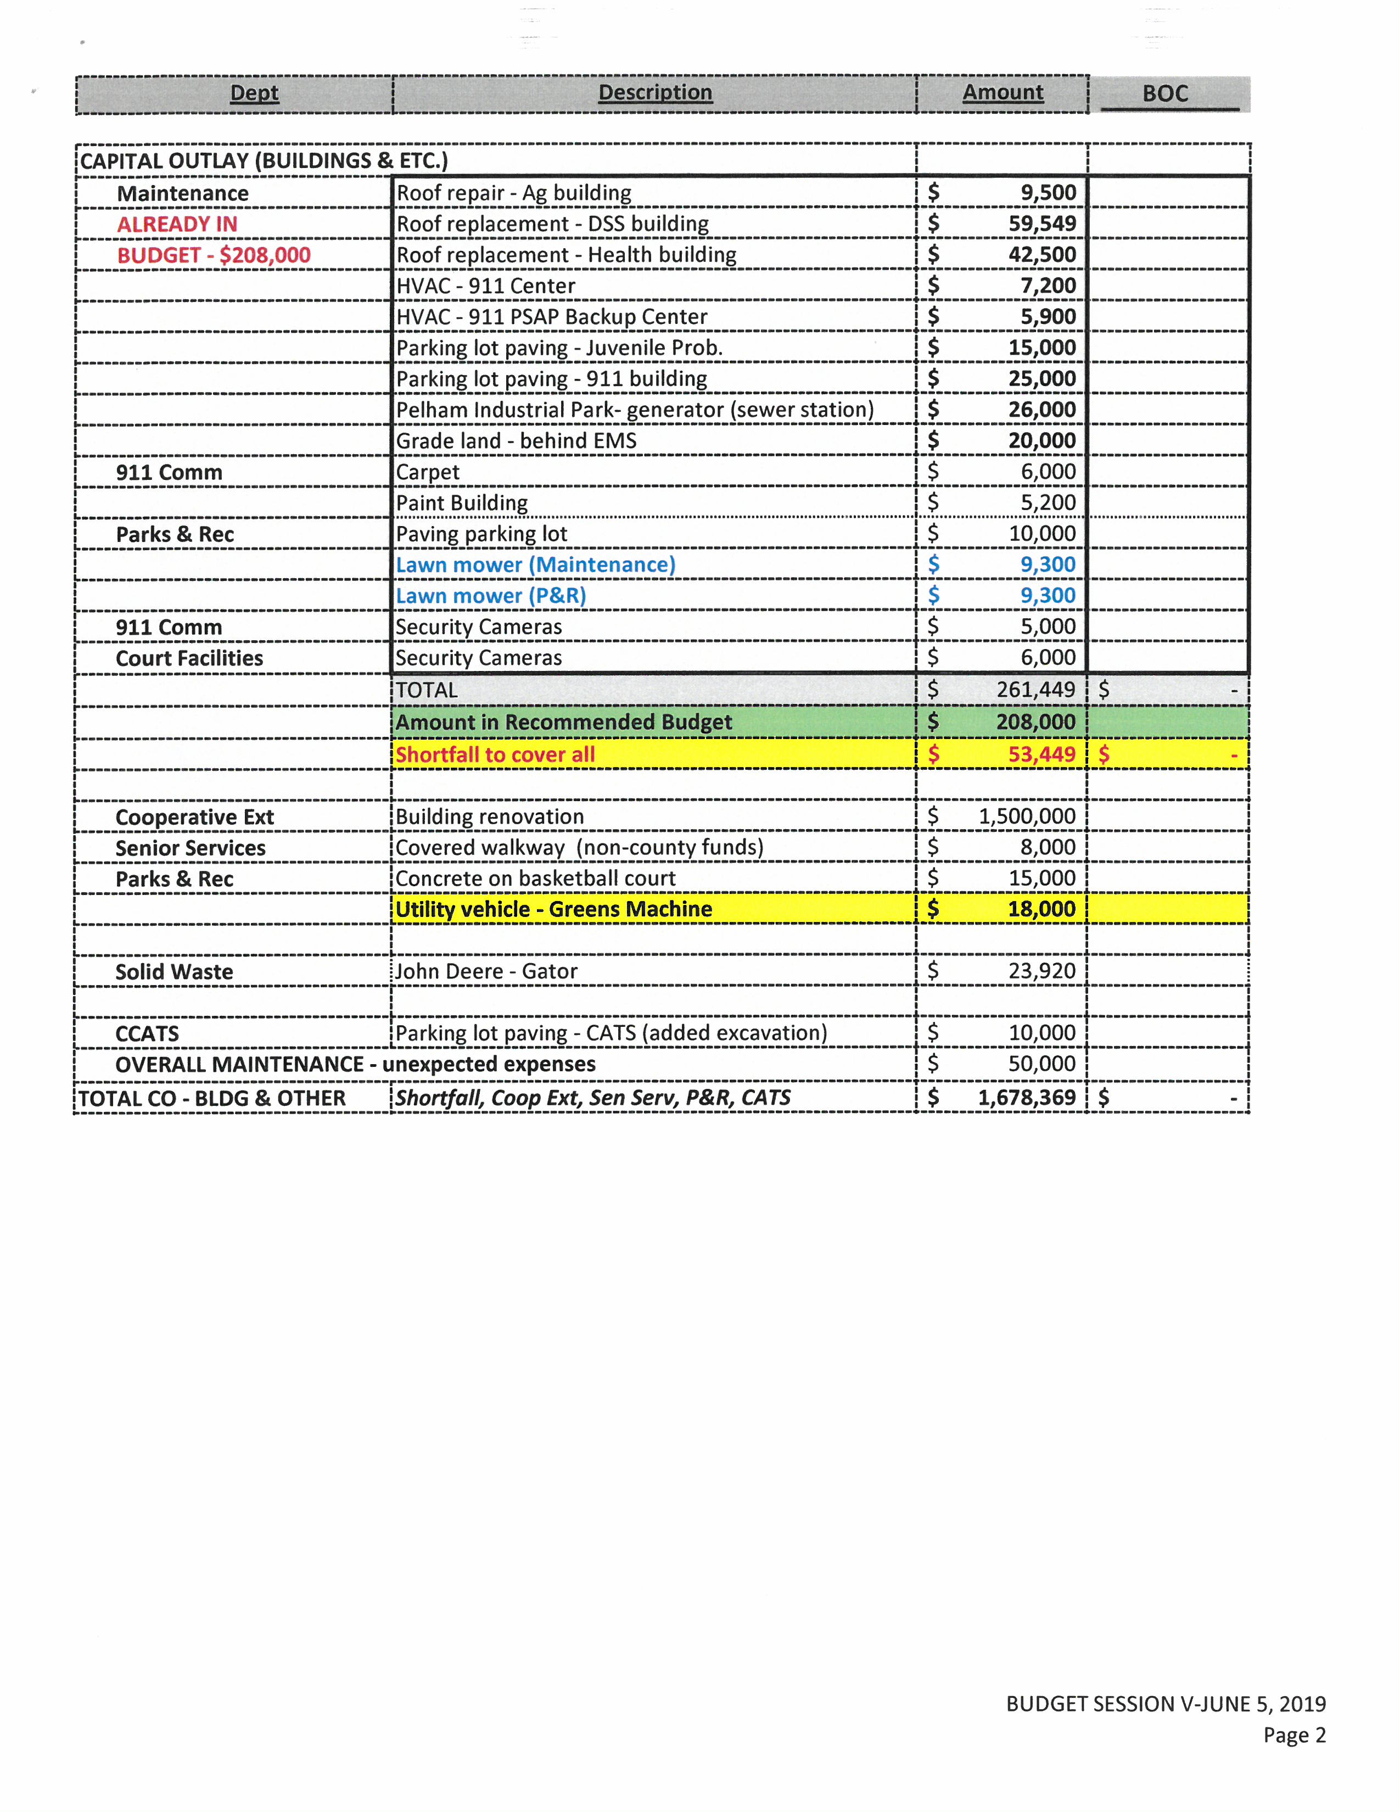
Commissioner S. Carter stated “This whole top box is the $208,000, I like that, it is very visual.” Ms. Vaughn responded that the top section all the way down to the total section of $261,449, $208,000 of this is already included in the budget and the shortfall is $53,449. Commissioner S. Carter continued “Starting at carpet, is that where the extra starts?” Ms. Vaughn responded no that the Board can pick and choose what should be included.

Commissioner Owen stated that he had talked to the Maintenance Director today and he still did not know if the State would pay for the generator but he did know that a lawnmower was a definite for Parks and Recreation and Maintenance as well.

Commissioner S. Carter asked “Can Maintenance and Parks and Rec. get by with one, sharing it or whatever? I don’t know what our current lawnmower status is.” Commissioner Owen responded that Parks and Rec. had one but the frame broke on it and this was from Maintenance. Commissioner S. Carter continued “They got a hand-me-down.” Commissioner Owen responded that Maintenance needs to replace this mower and Parks and Rec. needs one as well.

Chairman McVey suggested taking the Juvenile Probation parking lot paving out. Commissioner S. Carter added “I would like to take the 911 parking lot out too.” Chairman McVey agreed with Commissioner S. Carter on the 911 parking lot and he added that the generator is still a guessing game so that could be an extra $26,000. Mr. Miller stated that this can be taken out and if the generator is needed it could be brought back to the Board for approval. Chairman McVey stated that the work behind the EMS building needs to be done.

Chairman McVey asked about the 911 carpet. Commissioner S. Carter responded “I don’t think it is necessary.” Chairman McVey recommended that someone pick up the paint and let staff paint the interior of 911. Mr. Miller asked if the Board wanted to leave $1,000 in there to purchase the paint. Commissioner S. Carter asked “Is that what it would cost?” Mr. Miller responded that it would be close. Commissioner S. Carter continued “Interior paint shouldn’t be that much. It’s not a huge building.” Commissioner McVey stated instead of $5200 leave $1000 to purchase the paint.

Chairman McVey recommended taking out paving at Parks and Rec. He added to leave in the 2 lawnmowers and to leave in the security cameras for 911 and Court Facilities.

Commissioner S. Carter asked “Are we leaving both HVAC and roof projects on there?” Chairman McVey responded yes especially the Ag building. Commissioner S. Carter continued “Are there any other preventative maintenance projects that we could do to that building other than roof repair since we keep having issues with it?” Mr. Miller responded that he thinks it would be advisable to form a long range plan for the Cooperative Extension building. Commissioner S. Carter continued “Mr. Chairman I would like to recommend in addition to that that overall we have a capital outlay plan of all of our buildings. I would like for us to have a little binder that we could access quickly and know what year that we had the roofs, what year we had certain systems, all the HVAC systems that keep running out and surprise us, I did not know this one here above us is the original one and the status of it is questionable.” Commissioner McVey responded that if the County gets the work order software this could be worked into that. Commissioner S. Carter continued “Sure but even in the meantime for us to be able to have a visual to know for budgeting to know what we will have to deal with in the coming years that would be good for all of our buildings.” Mr. Miller responded that Commissioner Hall had suggested many times that it would be smart for the county to look at all the county buildings holistically and to look at bonds to pay for the renovations on these facilities at one time. Commissioner S. Carter stated “I just think at very minimum like if I want to know when the roof was put on the DSS building I wouldn’t have to wait for you to answer that, we could have that easily accessed.” Mr. Miller responded that this information could be put together for the Board.

RECESS

The Board took a brief recess.

Capital Outlay (cont’d)
Chairman McVey stated that the county will have to hold off on the Cooperative Extension building renovation. He added that the Senior Center covered walkway would come out of the Senior Center budget already. Commissioner Oestreicher responded that this will be done but at no cost to the county. Chairman McVey stated that the new Parks and Rec. director stated that the concrete on the basketball court was not needed at this time. He added that the Parks and Rec. needs something like a Greens Machine but he was unsure about the cost.

Commissioner S. Carter asked “Didn’t we mention something about possible hookups on some of these tractors, gators, etc. versus it being a separate machine?” Chairman McVey responded that there are no hookups on a gator that he is aware of. Commissioner S. Carter continued “There is not another vehicle or piece of equipment where it would have attachment options?” Chairman McVey responded that this is a greens machine like what is used on a golf course and all the attachments are on it at one time. Commissioner S. Carter stated “I am kind of a maybe. Won’t they talking about looking at golf courses?” Chairman McVey responded that he asked Mr. Blackstock to check some golf course to see if someone has a used one that they want to get rid of. He added that these machines are specialty machines and not everyone handles them.

Commissioner Hall asked how often the greens machine would be used. Chairman McVey responded that this machine would be used at every baseball and softball that is held every day.

Commissioner S. Carter asked “Will it also mow?” Chairman McVey responded that it does not mow. Commissioner S. Carter continued “Does it have a hookup to mow?” Chairman McVey responded that it does not have a hookup to mow.

Commissioner Oestreicher recommended putting in $10,000 to purchase a used greens machine. Chairman McVey responded that he did not think one could be purchased for this and volunteered to look for one that would be at a reasonable cost.

Chairman McVey stated that next on the list if the Solid Waste John Deere gator, this will be purchased out of the Solid Waste fund and I think the price is cheaper than what is listed according to the solid waste director. Mr. Miller responded that the price will be close because attachments will be purchased as well.

Commissioner S. Carter asked “This is coming out of his restricted?” Ms. Vaughn responded that it would come out of the solid waste fund balance and this is simply just for the approval from the Board.

Commissioner Owen stated this would reduce the Solid waste fund balance below $300,000. Mr. Miller responded that it would. Commissioner Owen stated that he said this because he thinks the Solid Waste fee needs to be raised or the county will have to start putting money into this fund.

Commissioner S. Carter asked “Mr. Chairman I would like to know what the current solid waste fee is?” Commissioner Owen responded that he thinks it is $44. He added that it started at $84 and the Board dropped it $20 and then another $20. Commissioner S. Carter continued “Did we drop it again last year?” Commissioner Owen responded that it was year before last.

Mr. Miller stated that the solid waste fee needs to be raised a minimum of $10 in order to continue to use this fund for solid waste needs.

Commissioner S. Carter asked “Is that the absolute minimum?” Mr. Miller responded yes.

Chairman McVey stated that the next thing is the CATS parking lot paving and he said no on this now because there may be more stumps. Mr. Miller stated that he would not recommend repaving or resurface this parking lot at this time.

Commissioner S. Carter asked “Do we have other available land; I know the answer is yes, that would be willing to take on that parking lot?” Mr. Miller asked Commissioner Carter to repeat the question. Commissioner S. Carter continued “Do we have land available if this site is going to keep having issues? It is in an awkward place to begin with. So have we thought about other spots that it could possibly be located?” Chairman McVey responded that it was his understanding that this was the landfill area during the detention center construction. Commissioner S. Carter stated “It is full of crap.” Commissioner Hall responded that CATS can park at the Health Department. Commissioner S. Carter continued “Yeah, why can’t they do that?” Mr. Miller responded that CATS could do that. Chairman McVey stated that he did not think the parking lot was that bad yet. Commissioner S. Carter stated “I know but it seems like we are going to have problems in the future if we keep using it.” Commissioner Owen responded that if CATS does not feel comfortable parking there they can park across the road.

Chairman McVey stated next is Overall Maintenance and unexpected expenses.

Commissioner S. Carter asked “What is that?” Ms. Vaughn responded that this is unexpected things that come up during the year. Mr. Miller responded that these are expenses that are not budgeted. Commissioner S. Carter continued “Do we normally do that in our budget?” Commissioner Oestreicher responded that it is like a contingency.

Ms. Vaughn stated that now the Capital Outlay is at $243,249 and $208,000 of this is already in the budget for capital outlay so that leaves a balance of $35,249.

Commissioner S. Carter stated “And the $50,000 is already absorbed in that. Ms. Vaughn responded that this is correct.

Capital Outlay – Vehicles
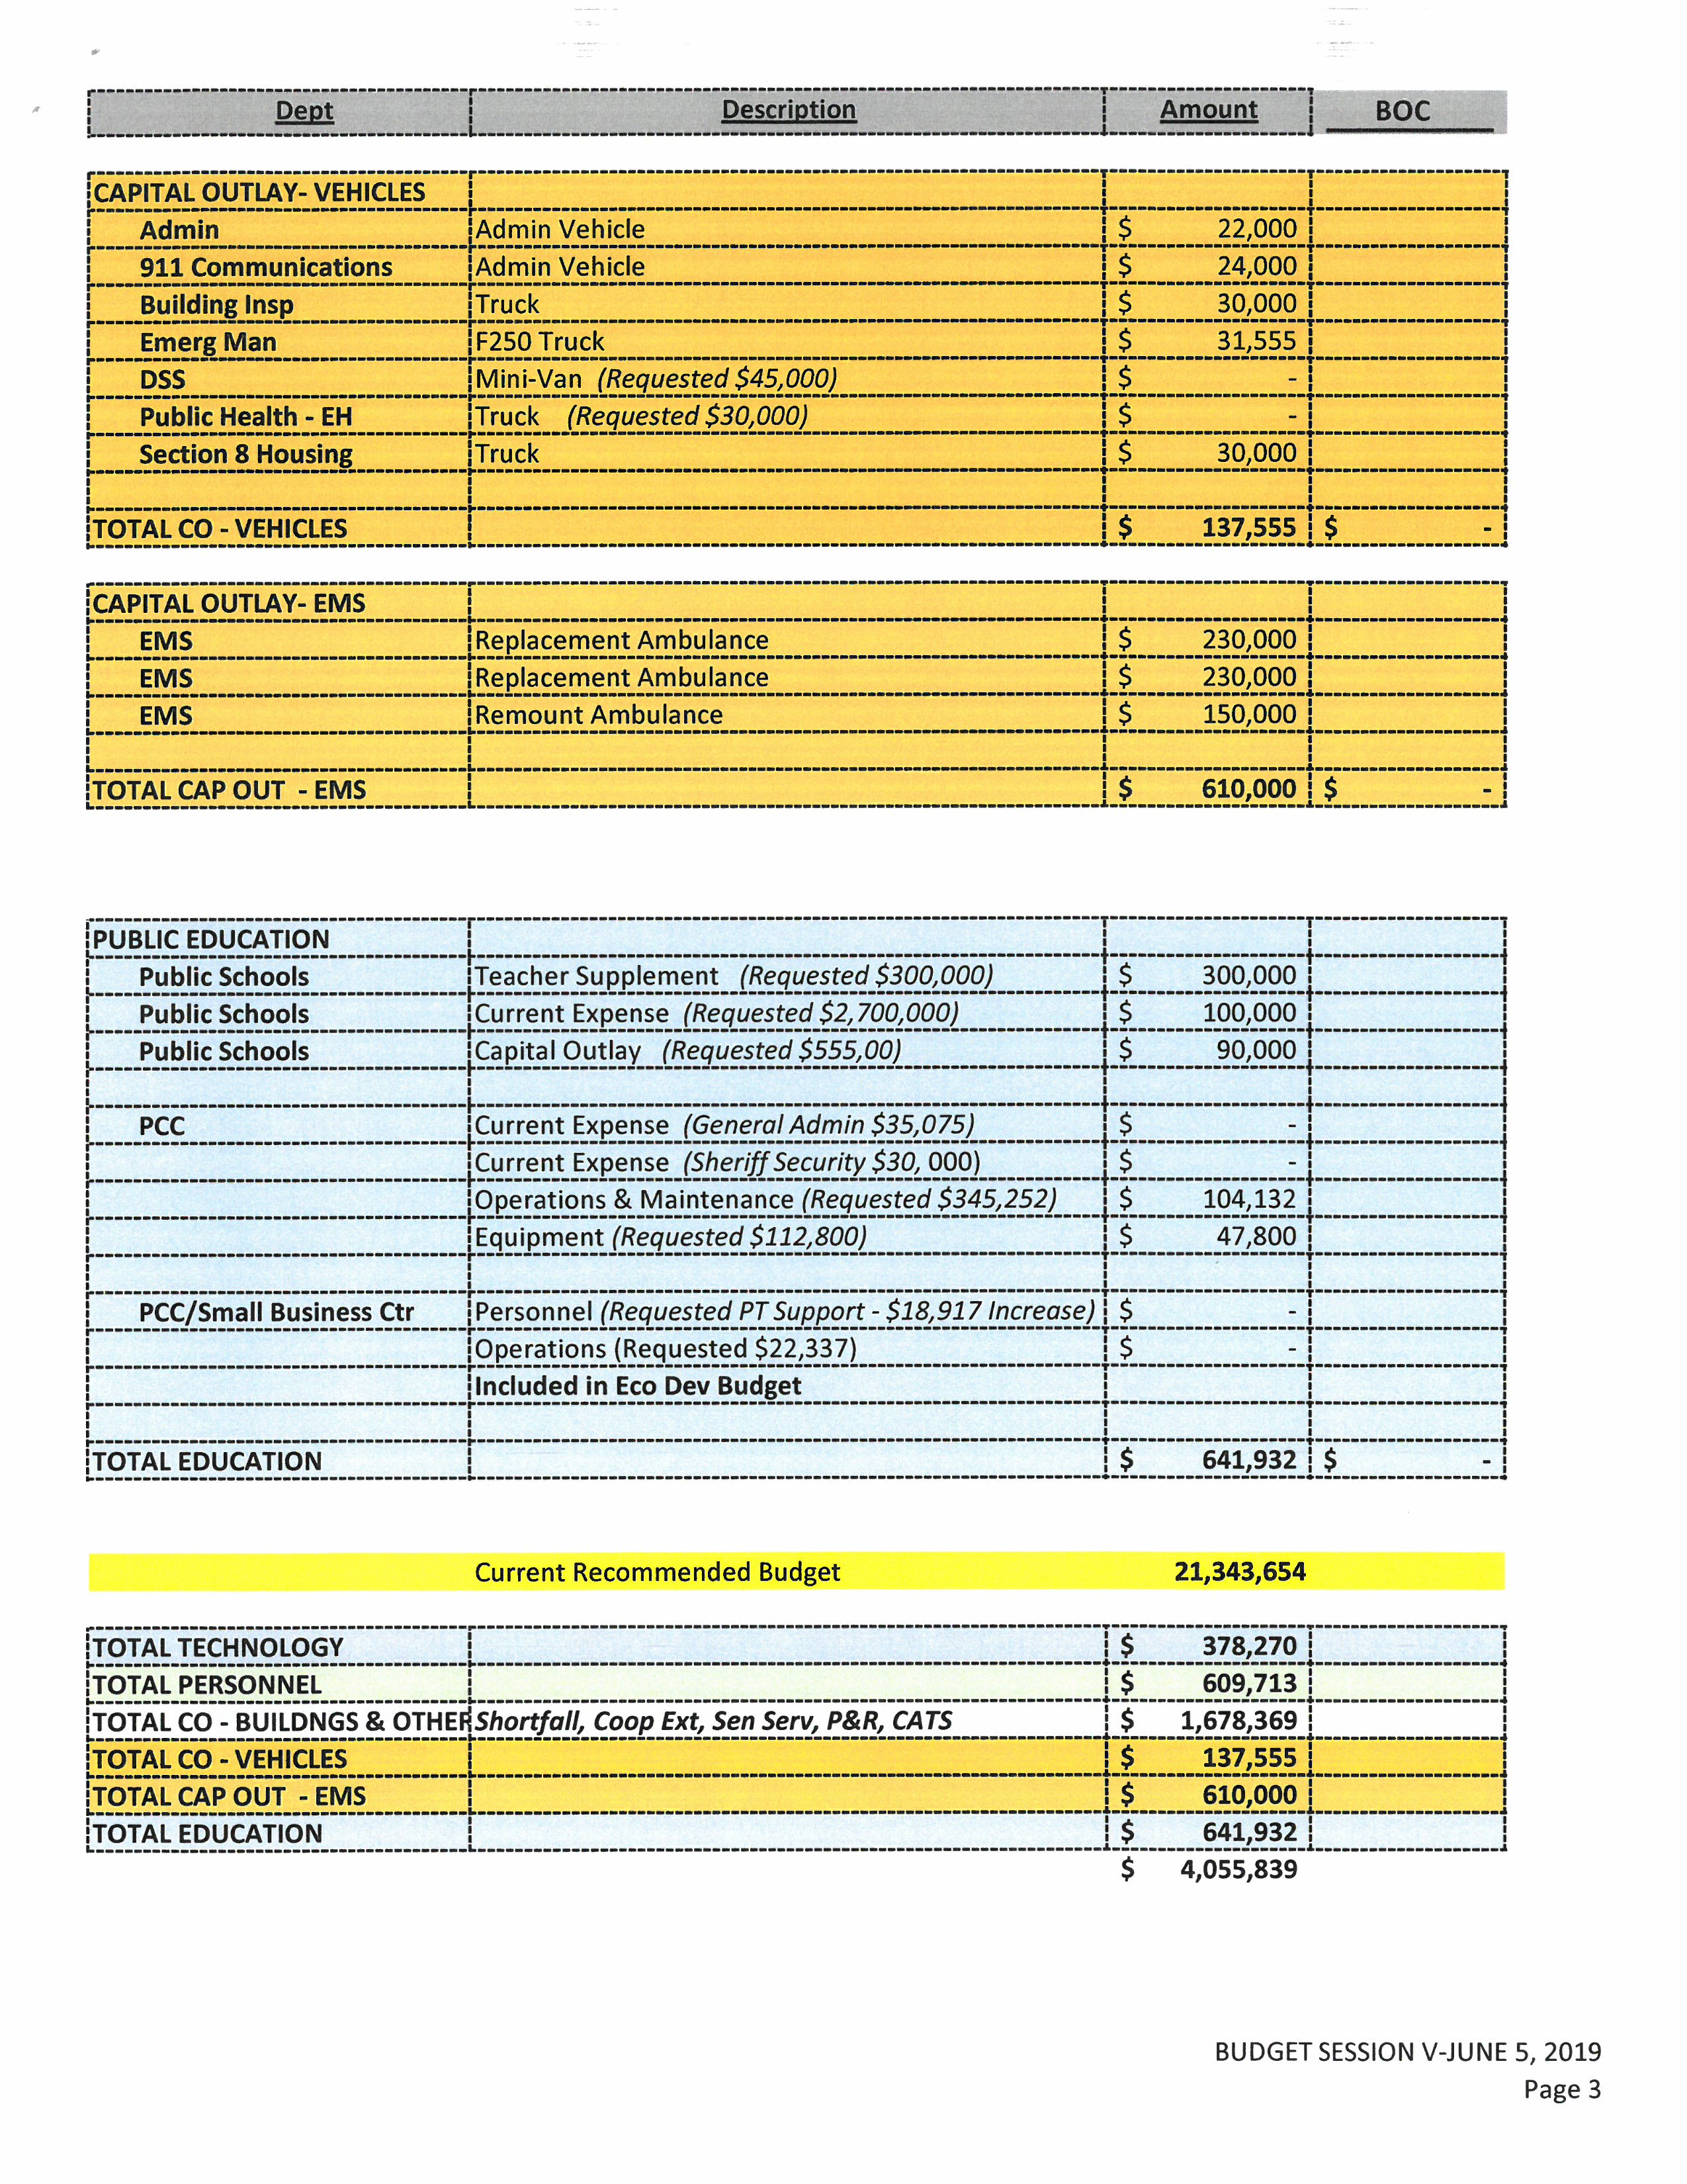
Mr. Miller went through the list of vehicles that have been requested by the various departments and added that these figures would be reduced through the lease program.

Commissioner S. Carter asked “So you are giving us two options?” Ms. Vaughn stated that the Administration would be $3,097 through the lease program. Commissioner S. Carter continued “Back to my question, $22,000 is the outright purchase versus the lease program of $3,000 and what did you say.” Ms. Vaughn gave the figures through the lease program: Two admin vehicles would be $3097 each, trucks $6,732 each, mini- van $5141, trucks $5142 each for a total of $33,490.

Mr. Miller reminded the Board that there is $75,000 in the budget currently for the purchase of two of these vehicles and this amount would be removed if the Board decided to go through the lease program.

Commissioner Owen stated that he received a spreadsheet today with mileage for the Sheriff’s Department. He added that there are 12 patrol cars that are in service that have over 100,000 miles and he suggested before deciding on these other vehicles the Board may want to reduce the number of vehicles the Sheriff’s Department will get. Commissioner Owen stated that 5 are on the way now and he requested 12 more this year. He suggested cutting the 12 down to 8 to fund these other cars.

Chairman McVey recommended 5 cars for the Sheriff’s Department. Commissioner Oestreicher stated that the number he was thinking was 7.

Chairman McVey asked the Board opinion on this. Commissioner S. Carter responded “I would almost want to hear from the Sheriff’s Department point of view before I commit to a number and I completely understand Commissioner Owen’s rationale on doing this. I just feel like I might be missing out on some input.” Commissioner Hall stated that he did not have a number in mind. Commissioner Jefferies responded 8.

Chairman McVey asked what the cost would be for 8 sheriff vehicles. Mr. Miller responded that it would cost approximately $59,000. Ms. Vaughn responded that 8 cars would be $71,215 and she added that this would be the 5 that they are waiting on and then 8 new cars.

Commissioner S. Carter asked “So that $71 dollar number that you mentioned, does that include any of these other vehicles?” Ms. Vaughn responded no that it only included the Sheriff’s vehicles. Mr. Miller responded that for around $105,000 all the vehicles listed as well as the sheriff’s vehicles, 5 allocated last year and the 8 for this year. Commissioner Oestreicher stated that there is already $75,000 included in the budget. Mr. Miller responded that there is $88,000 included in the budget. Commissioner Oestreicher stated that there is $163,000 in the budget. Commissioner S. Carter stated “I am going back to the report on the vehicles that we asked for at the last meeting, the Senior Center for example they also have a van that is terrible, I don’t see that on this list here.” Chairman McVey responded that the Senior Center did not ask for a van. Commissioner S. Carter continued “They didn’t ask for it?” Chairman McVey responded that when the Senior Center director came before the Board she did not ask for a van. Commissioner S. Carter stated “She says this van is not dependable and I would not want to leave Yanceyville with it.” Mr. Miller responded that when the county purchased the vehicles before there was a vehicle ordered for his use and he gave it to the Senior Center to for them to use and he added that the Senior Center could use another vehicle. Commissioner Oestreicher asked if the Senior Center needed a van or a car. Commissioner S. Carter responded “Preferable a van I would think.” Mr. Miller responded yes. Commissioner S. Carter stated “We already have a van, a minivan at DSS already in the budget?” Mr. Miller responded that this was included in the budget but it would come out and be a part of the lease program.

Commissioner S. Carter stated “I am going back through this list real quick because there were some things that caught my attention. Family Services of Caswell County, they also want a van. They are not asking for one.” Mr. Miller responded that Family Services has a dependable car. Commissioner S. Carter continued “My whole rationale is if it is a piece of junk why are we using it, I mean why would we still keep it? If they don’t need it and they are fine with the Honda Fit.” Commissioner Owen responded that the Board just needs to handle the ones that were requested because if the Board starts looking at every department it could add 10 more vehicles. Commissioner S. Carter asked “Mr. Chairman may I go back to the point I brought up earlier? The county vehicle report was given to us has 9 possibly 10 vehicles that were requested and this spreadsheet right here only has 7 vehicles. We are not talking about a huge difference as far as the requests go to a clarification on where we are at. To DSS it says they are requesting one Ford Focus and one Ford van, are we transferring one of those over or are we just getting the van?” Commissioner Owen responded that the original report was done by the Maintenance director and every department head had the opportunity to sit before the Board and request a vehicle and those that needed one or some have said that. Mr. Miller stated that this is correct.

Commissioner Owen stated that he did not want to go beyond the list. Commissioner S. Carter responded “I am not advocating for one or the other, there is a slight difference in the two of them and I thought we had asked for all and we would just eliminate.”

Commissioner Oestreicher stated that at some point the Board will need this budget reprocess so it will understand the true numbers. Chairman McVey responded that the county manager and finance director will have to go back and regroup and the Board will have to have another budget meeting. He added that he would like for the Board to vote on the budget on June 17th because the budget is due June 30th. Commissioner Oestreicher stated that he agreed 100%. Commissioner S. Carter stated “Sure.”

Mr. Miller asked if the Board wanted to leave all 7 vehicles included in the lease program. Commissioner S. Carter added “And the 8 sheriff’s vehicles.” Chairman McVey responded yes.

Capital Outlay – EMS
Mr. Miller stated that in the EMS vehicle request there is 2 replacement ambulances and 1 chassis remount ambulance.

Commissioner Owen recommended purchase 1 and 1 remount. Chairman McVey agreed that 1 new ambulance needed to be taken out.

Public Education
Mr. Miller stated Public Schools – Teacher Supplement, Current Expense and Capital Outlay. Commissioner Oestreicher responded no, no, no.

Commissioner Hall asked what the Board did last year for the Public Schools. Mr. Miller responded that the Board did exactly what is included in the budget already and none of these items listed were included last year. Commissioner Hall asked if there were any discussions with the School Board internally or whatever on what the County would do this year. Mr. Miller responded that there have not been any discussions other than Dr. Cater appearing before the Board at the last meeting. Commissioner Hall stated that he has his concerns about education but he also has concerns about not providing any supplements. He added that last year the School System could provide this because they had sufficient funding but he did not want to say that there would not be any more supplements for the teachers.

Chairman McVey stated that he felt like last year when the School Board came to the Board and asked for this money and they knew they had sufficient funds to take care of this that the School Board tried to pull the sheet over the Board’s eyes and therefore he will not vote for this because it was brought up in the School Board’s meeting that it found an extra $500,000 and due to this he did not know the absolute truth about the School Board’s money. He added that he is going to vote no on all three issues because the School Board had the money in their account and everyone came before the Board crying and wrote things about the Board on Facebook and all the telephone calls and all the grief he received over the decision the Board made and then $500,000 was found. Chairman McVey stated the School Board did not tell him the truth so he could not vote for this.

Commissioner Owen stated that if the county had a surplus budget he would be the first to say yes the county need to do teacher supplements but the county is looking at a 2 cent increase to do a teacher supplement of $300,000 in taxes and there will also be a 4 cent tax increase for the school.

Commissioner Oestreicher stated that Senator Berger stated that there is a pile of money going towards to the schools with Caswell’s name on it, close to $12 million that is for SROs, teacher’s salaries, etc. and he did not hear Dr. Carter mentioned anything about this even after he asked her about it.

Commissioner S. Carter stated “In a perfect world yes, would I like to do nothing to support the teachers or to support individuals that are going into education from this county I would like to take some time between now and the next budget meeting to put something together where we could support 2 or 3 at least individuals that are pursuing education degree and give them an incentive to come back to this county and be educators here. I think doing nothing is…bickering about the two boards which I am not even going to add a comment to, yes it was very unprofessional in the past but that’s not the way we should, you know, address it now. We need to think of something to recruit some people here.” Chairman McVey responded that Commissioner S. Carter would have time before the next budget meeting to come up with something and see where that does. Commissioner S. Carter continued “And whether or not it comes from the general fund or it is reoccurring or whatever I think it is very important to retain some individuals in our school system and let them know that, you know, some part of this budget is going towards their well-being.” Chairman McVey responded that the School System needs to retain some good teachers because the grades have gone from Cs to Ds.

Commissioner Oestreicher stated that according to the NCACC Caswell spends $9,174 per student and the average cost per student in North Carolina is like $9,023 so the state average is less and the 5 school’s scores were Ds, 1 C and 1 C- last year. He added that he likes to pay for performance.

Commissioner S. Carter stated “The state is taking a higher incentive now towards their salaries and I agree with you it has been like that the last 5 years but I just think this Board needs to do something proactive to positively impact our educators.” Chairman McVey asked Commissioner S. Carter to see what kind of compromise he could come up with. Commissioner S. Carter continued “It not necessarily will be a compromise; it is going to end up being a dollar amount stating this will go towards x.” Chairman McVey responded that this will be compromise because from nothing to something is a compromise. Commissioner S. Carter stated “Sure.” Commissioner Oestreicher asked Commissioner S. Carter to let him know if he could help.

Mr. Miller moved on to PCC and stated that PCC is requesting $104,132 for Operations & Maintenance and $47,800 for Equipment.

Commissioner S. Carter asked “Can you be specific on what those are, what those will go towards?” Ms. Vaughn responded that these were just the dollar amounts that were but from the budget to match last year’s budget. Commissioner S. Carter continued “Like the Sheriff’s security I don’t remember hearing much about this.” Ms. Vaughn responded that it is the same as last year. Commissioner S. Carter asked “What is extra in it?” Mr. Miller responded that retirement increased, Medicare increased, Unemployment insurance, etc. Commissioner S. Carter continued “This is $104,000?” Mr. Miller responded that this was in the maintenance budget for PCC. Commissioner S. Carter asked “What the difference is, that’s the $47,000?” Mr. Miller responded yes.

Mr. Miller stated that one request that Dr. Senegal made when she came before the Board was for at least $20,000 to renovate one of the rooms at PCC for continued training for the law enforcement officers and EMS staff. He continued by saying that there would be savings because the county currently pay the church $200 a month for parking as well as the maintenance cost for that building.

Commissioner Owen stated that he would definitely like to include the $20,000 for public safety at PCC.

Commissioner S. Carter stated “In my notes it just said they needed at least $20,000 to make those renovations.”

Mr. Miller stated that the Board made it through the list.

Commissioner S. Carter asked “Can we go through the dollar amounts on each of those sections? Well we don’t have the technology done yet.”

Mr. Miller asked the Board if they wanted to prioritize technology like it has done the rest of the list. Commissioner S. Carter responded “I say go ahead and do it and then we can come back and narrow it down. It seems like we wanted the software packages, I think everybody was on board with that. That is why I was asking Ms. Vaughn earlier on what we had narrowed down.”

Commissioner Owen stated that the Board had said the Finance and Tax software. Chairman McVey responded that he had said Tax software and the Finance software which included timekeeping and maintenance.

Commissioner S. Carter stated “Which includes the timekeeping.” Chairman McVey responded yes from his prospective he included all the software to bring the county up to date. Commissioner S. Carter continued “I would like to take the Animal Control one out.” Chairman McVey responded that he would like to leave it in. Commissioner Oestreicher added that for that amount of money he would like to leave it in the budget. Commissioner S. Carter continued “Might as well.”

Mr. Miller asked the Board about Emergency Management advertising. Commissioner Oestreicher wanted to leave it in. Commissioner S. Carter stated “We took out EOP Rewrite.” Commissioner Oestreicher responded that the Board took out the EOP and the digital sign.

Commissioner S. Carter asked “What is your total now?” Ms. Vaughn responded that the total for Technology is $656,140. Commissioner S. Carter continued “And all of this is non-reoccurring except for that $18,400 as part of the Tax?” Mr. Miller responded that there is some of it that is reoccurring. Commissioner S. Carter stated “But we don’t really have an absolute figure on that.” Mr. Miller responded not yet but there will be at the next meeting.

Budget Section Totals
Ms. Vaughn stated that the total right now for Technology is $656,140. She added that in Personnel it includes the COLA, IT Support Specialist, Agri-Hort-Row Crops, and Agri-Progressive Farmers totals $389,430. Ms. Vaughn stated Capital Outlay includes Roof repair on Ag Building, Roof replacement on DSS and Health Buildings, HVAC replacements at 911 Center and 911 PSAP Backup Center, Grade land behind EMS, Paint for 911 Center, 2 Lawnmowers, and Security Cameras for 911 and Court Facilities which totals $175,249. She stated that the Board added money for the Greens machine and $50,000 for unexpected expenses. Commissioner S. Carter responded “And that’s included in the $179,000.” Ms. Vaughn stated that this would add $35,249 for capital outlay and the total cost is $243,249 minus the $208,000 already included in the budget. Commissioner S. Carter asked “And $208,000 of that is already in capital right?” Ms. Vaughn responded that $208,000 was already included in the budget. Ms. Vaughn continued with Capital Outlay – Vehicles in the lease program $33,490 and the total for EMS Ambulances is $380,000 so the total all together is $413,490. Mr. Miller asked Ms. Vaughn to add the 8 Sheriff’s vehicles to the 7 on this list. Ms. Vaughn responded that the 7 vehicles on this list and 8 Sheriff’s vehicles would be $104,706 but the 8 Sheriff’s vehicles are already included in the budget. Commissioner Oestreicher stated that there are 12 Sheriff’s vehicles included in the budget. Ms. Vaughn stated for Education nothing was added to Public Schools but $20,000 was added to PCC’s budget. She stated that the Board started with $4,055,839 and right now the list is down to $2,004,309.

Ms. Vaughn stated that all the adjustments will be made in the budget and this entire list and be brought back to the Board.

Commissioner Owen asked for the increase in tax cents what it is going to cost the taxpayers. Ms. Vaughn responded that it would be 13 ½ cents. Commissioner Owen stated that some of the list is capital and anything that is one-time expense is a capital expense.

Chairman McVey stated that the Board needed to set another budget meeting and he stated that he would like to vote on the budget at the meeting on June 17th. He recommended meeting again next Wednesday, June 12th and he asked what time of the day suited the Board. Commissioner S. Carter responded “I prefer the mornings, I feel more wiped out in the evenings but that’s up to the Board but Wednesday is fine.” Commissioner Oestreicher responded that would prefer Wednesday morning and recommended 9:00 a.m.

RECESS

At 8:07 p.m. Chairman McVey recessed the FY 2019-2020 Budget Work Session until Wednesday, June 12, 2019 at 9:00 a.m. The motion carried unanimously.

________________________________ ___________________________
Paula P. Seamster Rick McVey
Clerk to the Board Chairman

******************************************************************************

