MINUTES – MARCH 15, 2021

The Caswell County Board of Commissioners met in regular session at 9:00 a.m. on Monday, March 15, 2021. The meeting was held electronically using Zoom Webinar software. Members present: David J. Owen, Chairman, Jeremiah Jefferies, Vice Chairman, William E. Carter, John D. Dickerson, Nathaniel Hall, Rick McVey, Steve Oestreicher. Also, present: Bryan Miller, County Manager, Brian Ferrell, County Attorney, and Debra Ferrell representing The Caswell Messenger. Paula P. Seamster, Clerk to the Board, recorded the minutes.

WELCOME
MOMENT OF SILENT PRAYER

Chairman Owen read a couple of cards that the Board had received. The first card stated “To the Caswell County Board of Commissioners and Staff. We were so touched to receive the flower you sent and appreciate your kindness. We are grateful you are a part of our lives. Sincerely, The Family of Mary Eliza Jeffries McCain. Judy, Jeff, and Darrell (McCain). The second card was from the County Outreach Ministry. He stated that the card would be made available for everyone to see. Commissioner Owen stated that it was a lengthy card but he read the last line “Thank you for the support of this Ministry…Those who bless others are greatly helped by God and you have blessed us with your donation.” He stated that the donation was through the CARES Act funding.

Chairman Owen opened the meeting with a moment of Silent Prayer.

PLEDGE OF ALLEGIANCE

The Board of Commissioners and all the guests in the attendance recited the Pledge of Allegiance.

PUBLIC COMMENTS

Commissioner Owen stated that he wanted to make one correction that was made on a public comment last week and he stated “The comment was that this Board voted 5 to 2 on July 6, 2020 to leave all the monuments in place, I just want to correct that because that was not the motion, Commissioner Hall made the motion and here is the motion ‘Commissioner Hall said that I move that we receive the statue from the Square. So, the Board actually voted 5 to 2 not to remove the statue, not the monuments on the Square.”

The clerk read the public comments received:

“R. David Wrenn. Good morning Board of County Commissioners, Today, we are presenting to the board the second installment of our signed petitions which will now make our total well over 1000 names of who want all the monuments to stay on the Square, as they are today. Many more petitions will be presented again at a later date. Again, we want to be clear that these are not just statues as some people say, rather they are historic monuments. They are a memorial monument to those who fought and or died in the War between the States, a memorial to our Caswell soldiers who died during World War 1 & 2 and a memorial honoring a leader in Caswell County education. I believe this shows the board that there are many, many people that support keeping our monuments on the Square and now Mr. McVey can’t say that nobody has spoken out in favor of keeping the monuments in place. Almost everyone we have spoke to about this said that they will come to the Commissioners meeting to voice their opposition to moving the monuments and they want to do this in person and face to face. So, we are asking you to start meeting at night, in person, to hear what your constituents want to say. If our schools can be open, the Commissioners meetings should be open. We hope you will look hard and study this issue because it represents our past and is part of our history. Our county motto is ‘preserving the past & embracing the future’. We thank you and strongly urge you to do the right thing. Thank you.” (A copy of the petition is attached).

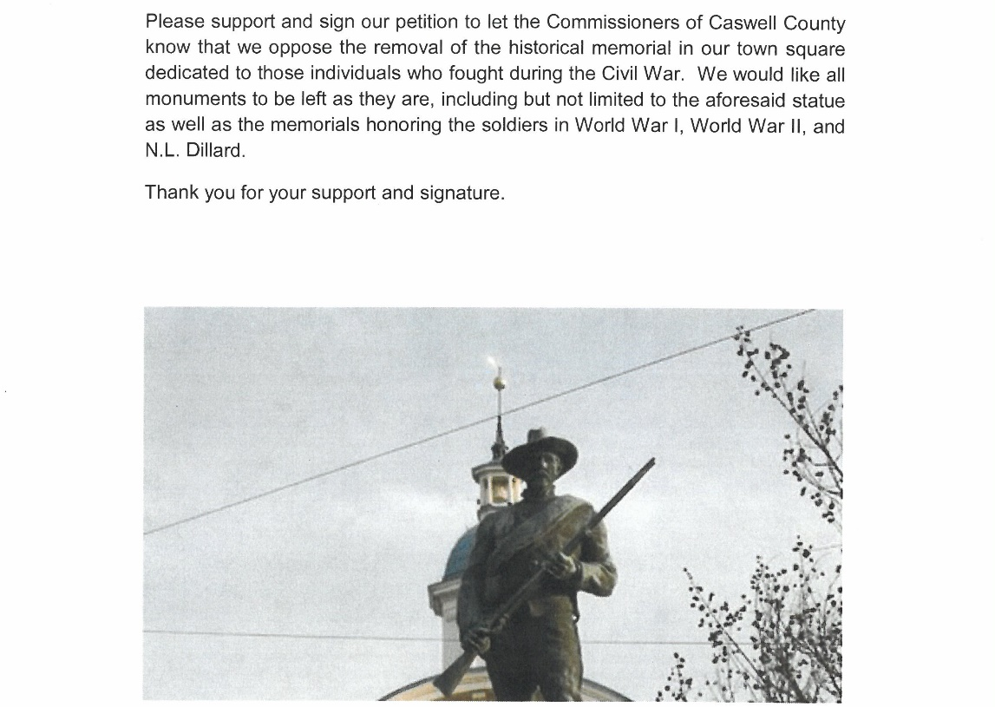
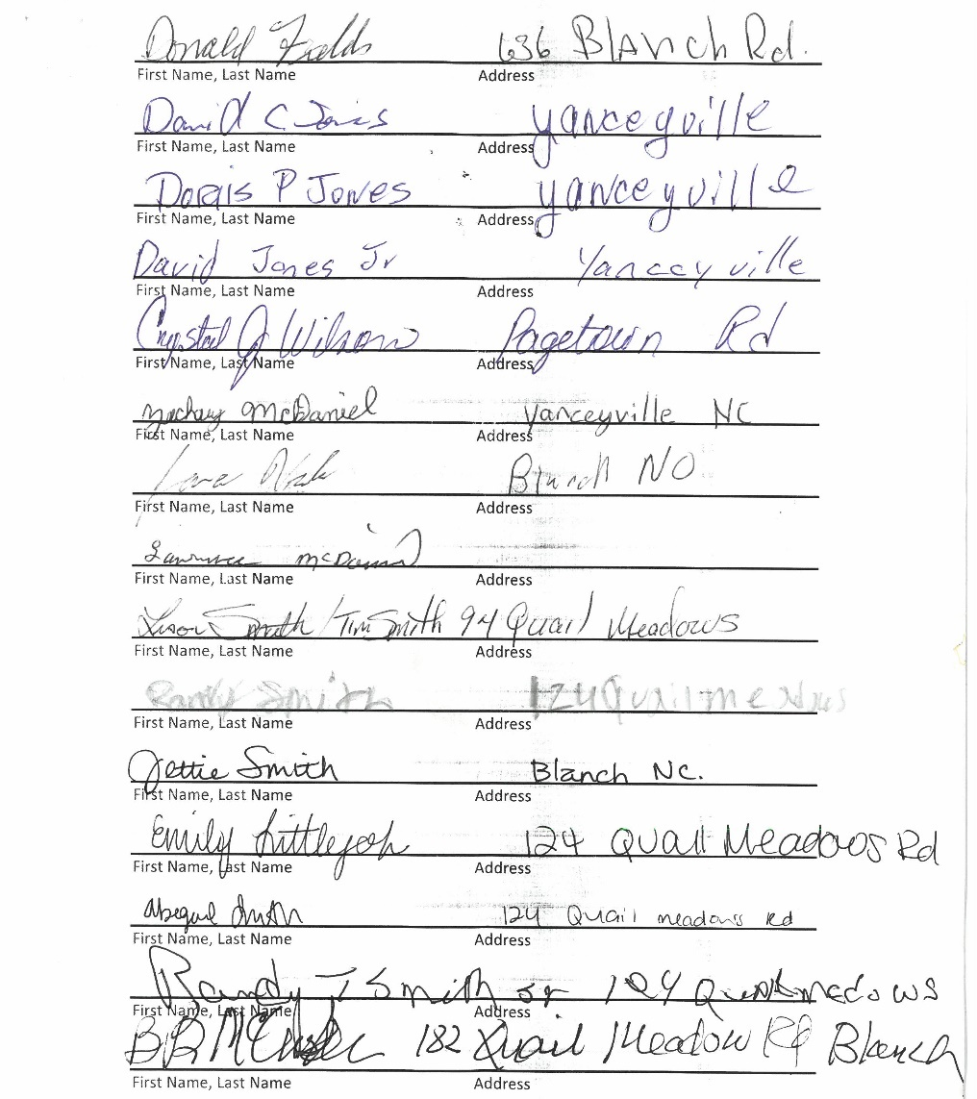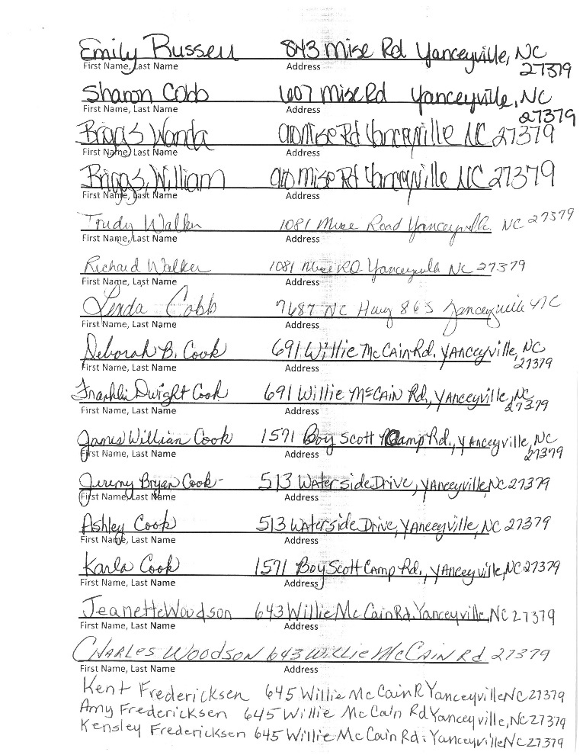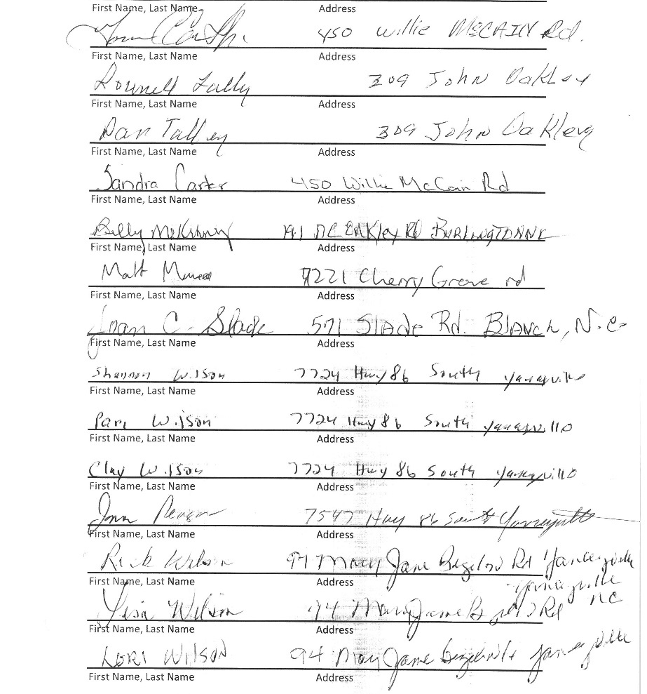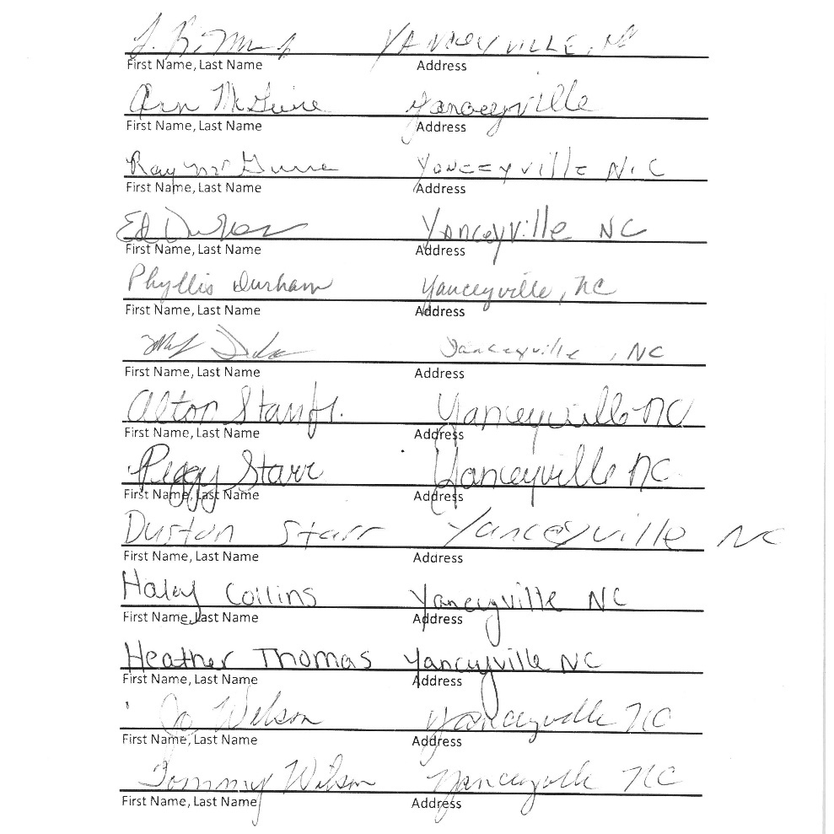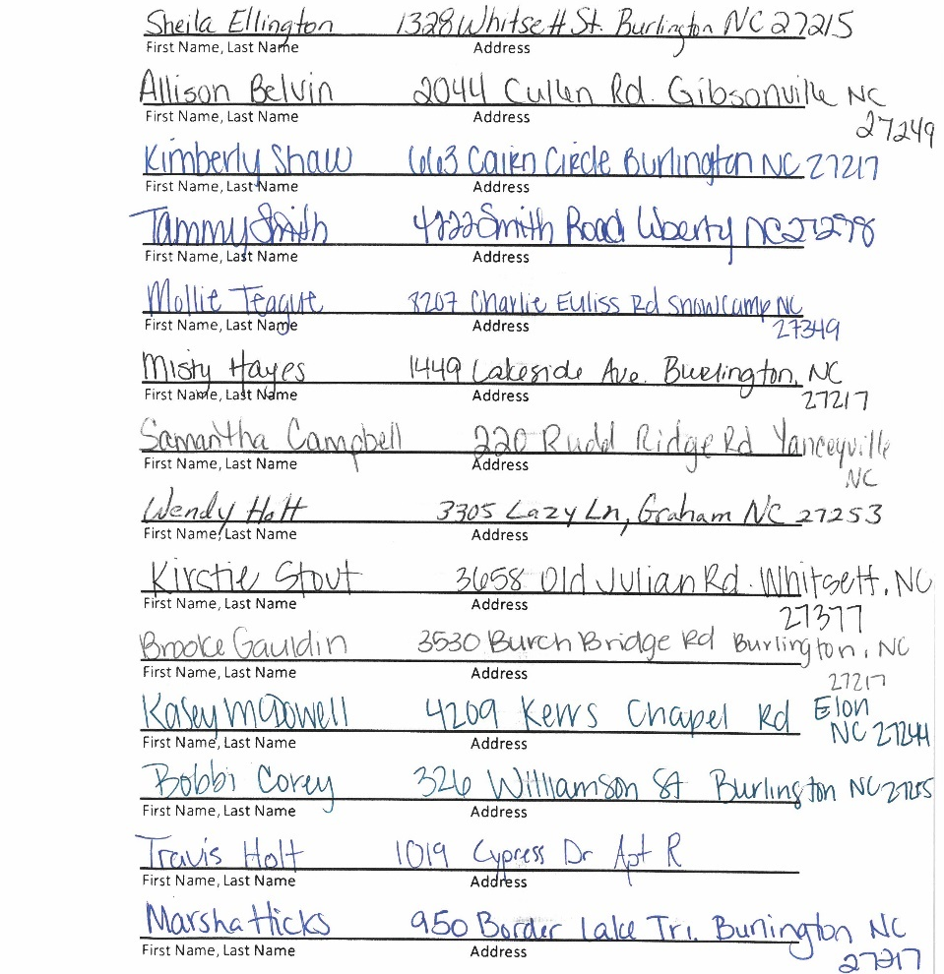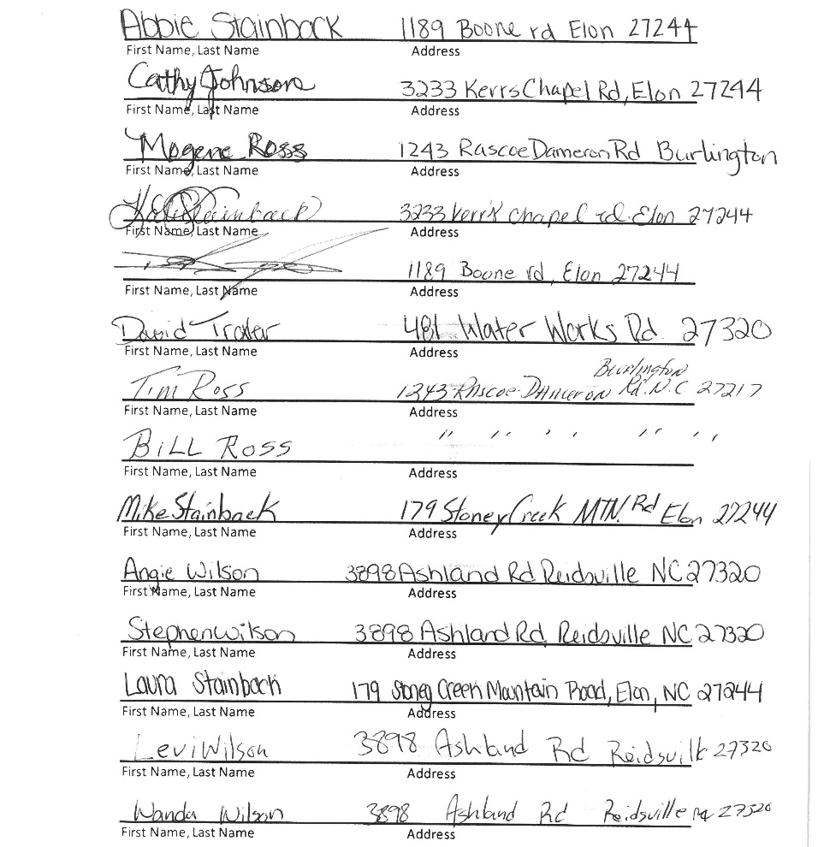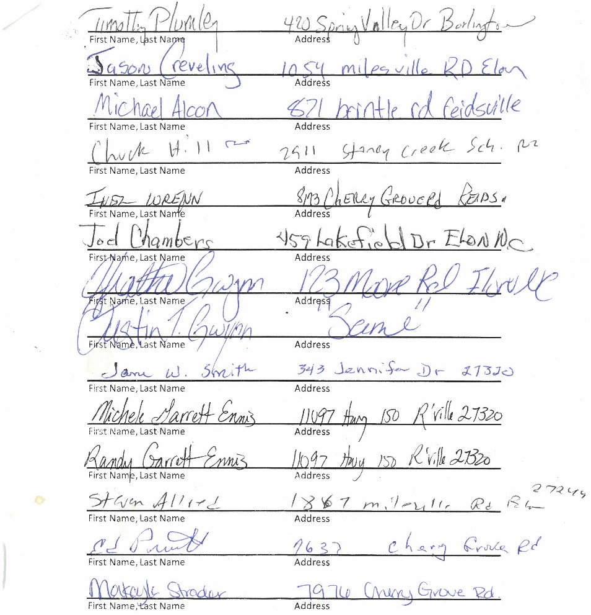

“Good Morning Caswell County Board of Commissioners, my name is Earnestine Hamlett. I am one of the Concerned Citizens of Caswell County. I am one of many citizens who have been lobbying for the relocation of the confederate statue on the Town Square since July of 2020.
I am writing to ask the Board of Commissioners to explain the delay on the progress report or lack of, on the facilitating and redesigning of the Town Square which was assigned to the County Manager Bryan Miller. There have been very little updates on the issue for months. I am aware that the redesigning of the Town Square does include all of the monuments. However, let’s not forget on June 26th, 2020 at 5:00 p.m. a proclamation declaring a state of emergency was declared by Caswell County and the town of Yanceyville setting a curfew that extended to July 9th, 2020. The curfew was because of the social unrest surrounding the confederate monument which is erected in front of the Historic Courthouse. Caswell County was on high alert with limited police resources to protect all its citizens. It is with high hopes that this board will not forget how and why we are having this conversation today. On November 30th, 2020, a special board meeting was held. At that meeting it was voted on unanimously after much discussion to direct the staff and necessary boards and committees to pursue the redesigning of the Square, with the first step being developing a plan to relocate ALL monuments on the Square. At that time, it was obvious that particular issue was settled. It is again we have high hopes that this board will stand by its decision to move forward keeping its citizens and the public safe, also adding to the economic growth of Caswell County.”

RECOGNITIONS

Chairman Owen recognized Ms. Ashley Kirby, Administrative Assistant, on behalf of Alamance Community College on making the Honors List for part time students this past semester. Her outstanding grades placed her amongst a select group of students that have achieved academic excellence. He congratulated Ashley on this.

Commissioner Carter recognized the healthcare workers at the health department for getting the vaccinations out as well as the pharmacists and drug stores for giving the vaccinations. He also recognized Ms. Gwen Vaughn on her retirement for so many years with Caswell County Government. Commissioner Carter stated that Ms. Vaughn did an outstanding job and wished her a happy retirement.

ACTION ITEMS
APPROVAL OF AGENDA

Chairman Owen stated that there are several items that needed to be amended on the agenda and he asked the county manager to list those items and where they would be on the agenda.

Mr. Miller stated that the COVID-19 moved from Item 10 to item 7, the Sheriff Tony Durden will appear before the Board to talk about vehicle funding as Agenda Item 8, Agenda Item 7 will move to 9, Agenda Item 8 will move to 10, add DOT Tipping Fees as Agenda Item 11, and Agenda item 9 will move to 12.

Chairman Owen asked if there were other amendments to be made to the agenda.

Commissioner Jefferies moved, seconded by Commissioner McVey to approve the agenda as amended. After a roll call vote, the motion carried unanimously. (Commissioners Carter, Dickerson, Hall, Jefferies, McVey, Oestreicher and Owen voted in favor.)

BOARD MINUTES

Chairman Owen asked if there were any corrections to the February 22, 2021 Special Meeting Minutes, February 25, 2021 Special Meeting Minutes, or March 1, 2021 Regular Meeting Minutes. Chairman Owen stated that with no corrections the Minutes stand approved.

COVID-19 UPDATE

Ms. Jennifer Eastwood, Health Director, thanked the Board for moving her up on the agenda due to the health department holding a vaccination clinic starting at 10:00 a.m. today. She stated that the county’s case number are looking a lot better. Ms. Eastwood stated that the county had 2017 cases and 25 of those are active cases. She stated that county had one additional death to report bringing the county’s total to 25. Ms. Eastwood stated that a couple of goals have been met over the last week, the latest counties summary report Caswell is now a yellow county and the county’s positivity rate was sitting at 5% and she hoped the county would continue to stay there. She stated with spring break and Easter coming up the county did not want to see an up tick in the cases so she asked the county to continue doing what it had been doing and to continue practicing the three Ws. Ms. Eastwood went over some guidance that was released by the CDC last week which said if someone is fully vaccinated and around other individuals who are fully vaccinated they do not have to wear a mask and if you are around other people from one other household besides your own even if they are unvaccinated you do not have to wear a mask. She stated that this would not apply when in public or gatherings of people from multiple households. Ms. Eastwood stated that the definition of fully vaccinated meant 14 days after the second shot. She stated that the county had administered 4,779 first doses and 2,643 second doses which represents 11.7% of the county’s population is fully vaccinated right now and 21% is at least partially vaccinated. Ms. Eastwood stated that the county continues to receive the Moderna vaccine and does not expect the county to receive the J & J vaccine for at least a couple of weeks. She recommended that individuals waiting on the one-shot vaccine to try to get it somewhere else if it is available. Ms. Eastwood stated that Parks Recreation was still being used as the pod for vaccination clinics. She stated that Wednesday will be the next vaccination day for the week but it will be a short clinic because it has been one month since the storm and the short supply of vaccinations but next week will be a huge week for the health department. Ms. Eastwood stated that second doses for around 900 will be done on Wednesday, first doses of around 500 will be done on Thursday, and then second doses for the school staff on Friday.

Commissioner Oestreicher asked Ms. Eastwood how many hours were in her day. Ms. Eastwood responded that she goes on about 4 hours of sleep now.

Chairman Owen thanked Ms. Eastwood for the update and thanked her for what she was doing.

SHERIFF DURDEN

Chairman Owen moved on to Item 8 Sheriff Durden from the Sheriff’s Office. Mr. Norris responded that he did not see where Sheriff Durden had joined the meeting. Chairman Owen stated that the Board would hold Item 8 until Sheriff Durden can connect.

PROCLAMATION DESIGNATING THE MONTH OF APRIL AS “NORTH CAROLINA 811 SAFE DIGGING MONTH”

Chairman Owen asked the county manager to read the proclamation.

Mr. Miller read the proclamation:

Proclamation

Caswell County, designating the month of April 2021 as “North Carolina 811 Safe Digging Month.”

WHEREAS, as utility owners, excavators, designers, and homeowners work to keep pace with North Carolina’s economic development, it is important to minimize damages to underground utility lines, danger to workers and the general public, environmental impact, and loss of utility services to the citizens of North Carolina; and

WHEREAS, North Carolina 811, a utility service notification center and leader in education celebrates its 43rd year of continuous service to the State, is key to preventing injuries and damages when excavating; and
WHEREAS, this unique service provides easy, one-call notification about construction and excavation projects that may endanger workers and jeopardize utility lines while promoting workplace and public safety, reducing underground utility damage, minimizing utility service interruptions and protecting the environment; and

WHEREAS, this vital service, which began in 1978 serves the citizens of North Carolina from the mountains to the coast, educates stakeholders about the need for excavation safety whether the project is as small as planting a tree to designing and beginning construction on a new interstate; and

WHEREAS, in 2020, the North Carolina one call system received 2.1 million notification requests and transmitted over 12.2 million requests, providing protection to utility companies infrastructure, their employees, excavators, and customers.

NOW, THEREFORE, BE IT RESOLVED, That Caswell County has designated the month of April 2021 as “North Carolina 811 Safe Digging Month” to encourage all excavators and homeowners of Caswell County to contact 8-1-1 either by dialing 8-1-1 or contacting NC811 via the webpage of NC811.org at least three working days prior to digging in order to “Know What’s Below,” avoid injury, protect the environment, prevent millions of dollars in damages and to remind excavators that three working days’ notice is the law, for safe digging is no accident, and that more information may be obtained by visiting www.nc811.org.

S/David J. Owen_______________________ March 15, 2021 _____________________
David J. Owen, Chairman Date
Caswell County Board of Commissioners

Chairman Owen stated that this was extremely important especially for those who have purchased new homes that already exist, so they know where the power lines, telephone lines, etc. come into the house.

Commissioner Oestreicher moved, seconded by Commissioner McVey to approve the proclamation as written. After a roll call vote, the motion carried unanimously. (Commissioners Carter, Dickerson, Hall, Jefferies, McVey, Oestreicher and Owen voted in favor.)

RESOLUTION OF THE CASWELL COUNTY BOARD OF COMMISSIONERS AUTHORIZING THE DISPOSITION OF COUNTY PROPERTY

Mr. Miller read the resolution:

A rESOLUtion OF THE CASWELL COUNTY BOARD OF COMMISSIONERS
Authorizing the disposition of County property

WHEREAS, the Caswell County Board of Commissioners (the “Board”) received an offer from Wells and West, Inc., on behalf of West Leasing, LLC, to purchase the following described real property owned by Caswell County for the sum of $8,000.00 per acre (the “Offer”):

Approximately 8.5 +/- acres of real property located in the Pelham Industrial Park, being a part of the property acquired by the County in Deed Book 392, Page 316 of the County Caswell Registry, a map of which is available in the Caswell County Clerk’s Office, the final boundaries of which are to be determined by a subdivision plat to be recorded at the closing of the purchase and sale (the “Property”); and

WHEREAS, at a regular meeting of the Board held on November 2, 2020, the Board proposed to accept the Offer to purchase the Property and directed the Clerk to the Board to advertise the Offer for upset bids in accordance with N.C. Gen. Stat. § 160A-269; and

WHEREAS, the offeror deposited the amount five percent (5%) of their bid with the Clerk as required by law; and

WHEREAS, the Clerk published a notice of the Offer for upset bids as required by law; and

WHEREAS, no upset bid was received.

THEREFORE BE IT RESOLVED by the Board that the terms of the Offer as outlined herein and on that certain “Notice of Intent to Sell County Property” attached hereto and incorporated herein by reference, is accepted and the Property shall be sold to West Leasing, LLC subject to the terms thereof and upon recording of a survey of the Property prepared and recorded at buyer’s expense.

FURTHER RESOLVED, that the County Manager, County Attorney, Clerk to the Board and Board Chair are hereby authorized and directed to execute any and all conveyance documents necessary to carry out the resolutions contained herein.

Adopted this the 15th day of March, 2021.

S/David Owen________________________
David Owen, Chairman
Board of Commissioners

Attest:

S/Paula Seamster_________________
Paula Seamster,
Clerk to the Board

Mr. Miller stated that the total sum of the purchase was $64,000 or $8,000 per acre.

Commissioner Hall moved, seconded by Commissioner Oestreicher to approve the resolution. After a roll call vote, the motion carried unanimously by those connected. (Commissioners Carter, Hall, Jefferies, McVey, Oestreicher, and Owen voted in favor.) (Commissioner Dickerson lost audio connection).

DOT TIPPING FEES

Mr. Miller stated that he had had several communications with residents needing more time to haul storm debris and he had had several conversations with DOT about the possibility of DOT repairing and fixing a road that leads back to the debris field in exchange for consideration in the reduction of the tipping fees associated with storm debris. He stated that DOT had stated that 3,000 tons of debris will be removed from the right of ways in Caswell County. Mr. Miller suggested reducing the $45.00 tipping fee to no more than $10.00 because the county would still have to incur cost with the debris such as grinding the debris and hire an entity to keep the debris pushed back. He suggested reducing tipping fees for DOT contractors to $35.00.

Commissioner McVey asked the county manager to explain more about the road that DOT was possibly going to repair, where it goes, use of the road, etc. Mr. A.J. Fuqua, Solid Waste Director, responded that the road goes back to the county’s temporary debris field as well as the old land field. Commissioner McVey stated that it was his understanding that the fire departments use this road. Mr. Fuqua responded that the fire departments have used this road for trainings. He added that this road when it rains gets very muddy and it is hard to maintain with the current solid waste equipment. Commissioner McVey asked what DOT had agreed to do as far as repairing the road. Mr. Miller responded the DOT had agreed to re-rock the road, cut side ditches to prevent some of the issues the solid waste director mentioned, and to rework the surface with millings that are currently at the solid waste stock yard. Mr. Fuqua stated that DOT will use the millings to widen the area for the debris. Commissioner McVey stated that DOT would repair the road to where fire trucks could get back to where they need to go. Mr. Fuqua responded yes. Commissioner McVey stated that DOT would being the road pretty much up to specs. Mr. Fuqua responded yes. Commissioner McVey asked how long the road was. Mr. Fuqua responded that it was between a quarter to a half a mile long. Commissioner McVey asked how much it would cost the county to repair this road. Mr. Miller responded that he did not have any estimates on that but the reduction in fees based on the DOT’s estimates would result in a savings to DOT of about $30,000. He stated that the estimate on the rock to repair the road would cost around $5,000 to $6,000 and then there is labor, and equipment associated with that. Commissioner McVey stated that the reduction in tipping fees would save DOT about $30,000. Mr. Miller responded yes and added that the road would probably cost the county about $20,000 to repair the road.

Commissioner Jefferies moved to reduce the tipping fees to $35.00 for DOT and to have DOT to repair the road at the landfill.

Commissioner Oestreicher asked how long the reduction in tipping fees would last. Mr. Miller responded that he suggested that the time period last through the end of the DOT’s contract. Mr. Fuqua responded that it would just be for the debris from the February 13th storm.

Commissioner McVey stated that DOT would come in and fix the road after that. Mr. Fuqua responded that DOT would repair the road before and after hauling.

Commissioner Oestreicher asked Commissioner Jefferies to amend his motion to add a time frame. Mr. Miller responded that an appropriate time frame would be 75 days. Commissioner Oestreicher stated 75 days and limited to current storm damage.

Chairman Owen asked Commissioner Jefferies if he was willing to amend his motion. Commissioner Jefferies responded that he was willing to add 75 days to the motion. Chairman Owen asked Commissioner Jefferies if he was willing to amend the motion to state this was for the Valentine storm.

Commissioner Jefferies moved, seconded by Commissioner McVey to reduce the tipping fees to $35.00 for DOT for 75 days and limited to the Valentine storm debris and to have the DOT to repair the road at the landfill. After a roll call vote, the motion carried unanimously. (Commissioners Carter, Dickerson, Hall, Jefferies, McVey, Oestreicher and Owen voted in favor.)

Mr. Miller asked the Board to reduce the solid waste brush fees to $0 for the residents for an additional two-week period or until the next Board meeting.

Commissioner Oestreicher asked if the landfill was getting a lot of traffic with debris. Mr. Fuqua responded that the first couple of weeks after the storm residents could not get into their yards to remove the debris. Commissioner Oestreicher asked Mr. Fuqua if he was seeing a lot of debris. Mr. Fuqua responded yes.

Commissioner Oestreicher moved, seconded by Commissioner McVey to suspend the tipping fee for Caswell County residents for the next three weeks for storm debris associated with the Valentine Day storm. After a roll call vote, the motion carried unanimously. (Commissioners Carter, Dickerson, Hall, Jefferies, McVey, Oestreicher and Owen voted in favor.)

SHERIFF DURDEN

Sheriff Durden reminded the Board that the Sheriff’s department went with Enterprise for its fleet management. He stated that the Sheriff’s department has 13 vehicles in the fleet management program and there are 42 or 43 vehicles in the Sheriff’s department fleet in which 7 of these vehicles are inoperable. Sheriff Durden added that about 13 or 14 more vehicles needed to be replaced. He stated that during the last budget the Sheriff’s department settled for 4 vehicles due to the pandemic and added that public safety must have vehicles. Sheriff Durden stated that he came before the Board today to asked for vehicles, but he was also going to ask for two positions at the Sheriff’s office. He stated that one would be for a U.S. Marshal Task Force and one for courthouse security. Sheriff Durden stated that one officer was taken from the courthouse security to put on the DEA Task Force to help with the opioid crisis. He stated that Caswell is the only Sheriff’s office in the state that conducts door duties at the courthouse so there is a need for this position. Sheriff Durden stated that the U.S. Marshal Task Force member would be use for fugitive warrants as well as tracking sex offenders that cross state lines.

Commissioner McVey asked if the 7 vehicles that were down were county owned vehicles. Sheriff Durden responded yes and added that there are 13 vehicles that are leased through fleet management. Commissioner McVey asked Sheriff Durden if he was satisfied with the Enterprise fleet management program. Sheriff Durden responded yes but he did not think the county was fully engaged in the fleet management part of the program. He added that he was not sure if the county was able to take the vehicles to vendors to get the discount. Mr. Miller stated that the county was currently doing this. Sheriff Durden stated that there were two vendors in the county that were approved which was Caswell Tire and Country Auto. Mr. Miller responded that this was correct.

Commissioner Carter asked Sheriff Durden if the program went by the mileage on the car or the year of the car. Sheriff Durden responded that he thought it was through the years. He stated that after four or five years the vehicle is paid for and then Enterprise would sell the vehicle and give the county a credit toward the next vehicle leased. Sheriff Durden stated that the county had not reach that plateau yet as far as turning vehicles in on the lease program. He stated that Enterprise is managing all the Sheriff’s vehicles through fleet management. Sheriff Durden stated that the Sheriff’s department was still driving 2008 vehicles.

Mr. Miller informed the Board that the initial projections showed about $40,000 of equity in about 5 of the vehicles in this month’s report and added that this would be discussed during the budget process.

Commissioner Dickerson asked how many vehicles were assigned to the Sheriff’s department. Sheriff Durden responded about 42 but 7 of these vehicles are inoperable. Commissioner Dickerson asked when the 4 or 5-year-old vehicles go back on the lease program how many miles are on those vehicles. Sheriff Durden responded that Enterprise would like vehicles with the least number of miles on them, but the Sheriff’s department had vehicles with over 200,000 miles on them. Commissioner Dickerson asked if those vehicles were on the lease program or county owned vehicles. Sheriff Durden responded that there were 13 vehicles in the lease program and the county started with the lease program three years ago and those vehicles have around 90,000 miles on them.

Commissioner Carter asked if the county owned vehicles would go back to the lease program or through county surplus. Sheriff Durden responded that lease management recommended that those would be sold or go through county surplus. Mr. Miller responded that the vehicles with little to no equity will be surplus by the county and sold at a county auction.

Commissioner Oestreicher asked how many vehicles would be in this category. Sheriff Durden responded that he did not have that number in front of him. Commissioner Oestreicher asked the Sheriff to give a guess. Sheriff Durden guessed around 8 vehicles.

Commissioner Dickerson asked how many of the vehicles listed are used for patrolling the county and how many of the vehicles are used for other purposes. Sheriff Durden responded that all his deputies patrol the county. He added that he had 17 deputies that are on patrol. Sheriff Durden stated that the Sheriff’s office is responsible for patrol, serving the civil process, and courts. He stated that 17 vehicles are assigned to patrol. Commissioner Dickerson thanked Sheriff Durden.

Commissioner Carter asked what the cost would be to replace the 7 vehicles through the Enterprise program. Sheriff Durden responded if the county lease Dodge Chargers V6 AWD it would cost approximately $600 a month or $7200 a year. Commissioner Carter asked Sheriff Durden if he was going with all Dodges or something else. He stated that he knew that Rockingham County was using Fords. Sheriff Durden responded that he spoke to Sheriff Sam Page this past Saturday morning to see how many vehicles he had and they have about 103 vehicles and that he was going to get the Dodge Chargers V6 AWD. He added that everyone else was going to the SUVs and the only sedan that would be available would be the Dodge Charger. Commissioner Carter stated that he thought Sheriff Durden stated that the cost was $7200 per vehicles. Sheriff Durden responded yes but it did not include the striping, lights, etc.

Commissioner McVey asked if the old equipment can be transferred from the old vehicles to the new vehicles. Sheriff Durden responded some of the equipment can be used but technology changes every year.

Commissioner Dickerson asked if Enterprise was the only company that bid on the contract or were there other providers in the area. Sheriff Durden responded that he brought this before the Board three years ago and the Board voted for it. He stated that he could not remember the process and added that Enterprise was a state approved vendor. Sheriff Durden stated that he went through this process to help relieve the problems with getting vehicles for public safety.

Chairman Owen thanked Sheriff Durden for sharing the information and state that the Board would keep all of this in mind during the budget process. Sheriff Durden thanked the Board.

APPOINTMENTS TO BOARDS AND COMMITTEES
Board of Health

Commissioner Oestreicher moved, seconded by Commissioner Hall to appoint Jessica “Michelle” King-Stamps to the Board of Health. After a roll call vote, the motion carried unanimously. (Commissioners Carter, Dickerson, Hall, Jefferies, McVey, Oestreicher and Owen voted in favor.)

LETTER FROM BOARD OF ELECTIONS

Chairman Owen informed the Board that he had not been in touch with the Board of Elections, he had not sent the Board of Elections a letter, he did speak to the Elections Director about a month ago about receiving complaints about restroom facilities at polling places. He stated that the Elections Director was not aware of any complaints and he had asked if he would check with the precinct heads just to see and somehow the information was relayed to the Board of Elections. Chairman Owen stated that he had still not talked to the Board of Elections, so he wanted to Board to know that this was not something that he initiated and received a response.

Commissioner Hall stated that in his district, District 4, there are two precincts and at one of those precincts which is located at the Crossroads there have been some concerns about restrooms there and this was also mentioned in the letter from the Board of Elections. He stated that it was a nice letter but all it informed the Board about was barriers. Commissioner Hall stated that he hoped that the Board was aware of the importance of bathroom facilities for seniors and for those individuals with health conditions. He also hoped that the Board would contact the Board of Elections and asked them to look at all precincts to reconstruct the setup of the precincts or to consider moving the precincts because this would be a valuable service to the citizens of Caswell County. Commissioner Hall stated that a nice letter stating general statutes provided the service that the citizens of Caswell County need.

Chairman Owen stated that after this meeting he was going to ask the Board of Elections to examine every polling place that is used to see if these could be reconfigured and to give the information to the Board as well as if needed the Board of Elections can request port-a-johns in its budget for the sites that restrooms are not available.

Commissioner Dickerson stated that he thought the Board was all in agreement that there needed to be a solution to this problem. He stated that he thought that Chairman Owen had to right idea to reach out to the Board of Elections to get some information, finalize what needed to be done, and get to get it done. Commissioner Dickerson stated that voters at the polls needed to have a facility that could be used.

Chairman Owen stated that he would proceed with the county manager to draft a letter asking the Board of Elections to look at each of the precincts to try to reconfigure to allow access to the restrooms and if not ask them to include in their budget what was needed to remedy the situation. He asked if this was acceptable to Commissioner Hall. Commissioner Hall responded yes.

COUNTY MANAGER’S UPDATES
Better Communication with Residents

Mr. Miller informed the Board that the clerk had done a lot of work gathering how other jurisdictions handle communications with their residents and he thought the clerk had come up with some really good ideas some of which are operational in nature and some of which will require a little bit of funding if the Board chooses to move forward with some of these. He stated that he would keep the Board updated as other suggestions are made and as the Board goes through the budget process. The clerk stated that as she received other suggestions, she would share those with the Board.

Joint Meeting with Town of Yanceyville and Town of Milton

Mr. Miller stated that he believed the Board was forwarded an email response about a joint meeting and the fact that the Yanceyville town council did not feel the need to meet virtual at this time however if an issued needed to be addressed they would be open to scheduling a virtual meeting.

Commissioner Oestreicher stated that there was quite a bit of press information out about the new airport land acquisition and he thought that would be a good topic for a meeting with the Town. He stated that he would like to know more about what the strategy is and what it is all about. Commissioner Carter responded that he could answer that question. He stated that the Page farm, the existing airport, is a grass strip of about 1750 feet in West Yanceyville, was sold to an individual and that individual gave the airport to the Town. Commissioner Carter stated that the Town was in the process of buying some land on the upper end of the runway and they plan to extend the runway about 4,000 feet. He stated they also plan to build a helicopter pad for life flight. Commissioner Carter stated that the airport could be used by private small air crafts and helicopters. He stated that when he heard about this the county manager reached out to the town manager and asked if the town would be willing to have both boards to work on it together and he reached out to the mayor and the town said they would rather do it on their own. Commissioner Oestreicher asked how much increased traffic would increasing the length bring to the airfield. Commissioner Carter responded that he could not see any increased traffic. He stated that he did not know the plans for the future. Commissioner Oestreicher stated that he was hoping to hear the long-range plans for the airfield.

Mr. Miller stated that he could reach out to Mayor Foster or the staff at the town to see if they are willing to appear at the next Board meeting to give the Board an update. Commissioner Oestreicher responded that he would be interested because he thought it would be a part of the strategic plan for the county especially with the casino coming into Danville. He wanted to know how it would support the strategic plan for economic development in the county.

Commissioner Carter stated that he could not see it doing anything for the casino because the people would need rental cars and hotels and they are not available in the county. He stated that would most likely fly into Danville so they would be close to restaurants, hotels, and rental cars. Commissioner Carter stated that the Danville airport would be turned over to Averett College on July 1st.

Commissioner Hall wanted to know if this property was inside the town limits or outside the town limits. Commissioner Carter responded that the property is outside the town limits but the town would be annexing that property at the airport so it would be in the town limits. Commissioner Hall stated that as a good neighbor the town needed to talk to the Board if they are going to annex property in the county. Commissioner Carter responded that he agreed with Commissioner Hall.

Commissioner Oestreicher asked if this could be added to the action item list. Mr. Miller responded yes.

Chart of Pending Issues

Mr. Miller stated that a Chart of Pending Issues was included in the agenda. He stated that this was something new with the agenda and will be included with every agenda moving forward.

$50,000 Scholarship for Student Education for Teachers

Mr. Miller stated that he had informed Commissioner Jefferies that he would go back and research the minutes to see what he could find. He stated that he went back through the minutes where scholarship was discussed and he only found that Commissioner Sterling Carter made the comment that if it only helped one student that he would be happy and that was the only time he could find any reference to it being only one individual and he did not think this meant only one individual would be helped. Mr. Miller stated that all the other references were 3 to 4 to setting up a foundation and setting up a foundation seemed to be the most recent discussion had by the Board.

Commissioner Jefferies stated that it was his understanding that the $50,000 was for one student and he thought this was what was voted on and he added that he could be wrong. Mr. Miller responded that he could not find it in the minutes that way. He added that he was not saying it was not the way the Board intended it. Mr. Miller stated that there was conversation about what the Board of Education was doing now with having a foundation manage the money and allocate scholarships out of the management fund from the foundation. He stated that the county attorney had said during that discussion that he did not know if the Board of Commissioners had the authority to set up a foundation like that as well as manage the foundation and there were concerns surrounding the Board specifically setting up the foundation and running it ourselves from a legal standpoint. Commissioner Jefferies stated that if the Board did knot know what it was doing the $50,000 should have come back to the county because he did not know anything about a foundation until the money was sent to the Board of Education. He did not think this was discussed with the Board. Commissioner Jefferies stated that Commissioner Hall was on the committee with Sterling Carter and asked him to elaborate on his recollection.

Commissioner Hall stated that he remembered all of the discussions and it was never his thinking or intentions that any money would be transferred to the school board without any type of Board approval and from what he thought the Board never approved the transfer. He stated that there had been all kinds of discussion with general counsel but the general idea was that the Board would support a local person going to school, coming back, and teaching in Caswell County for so many years and that was the general discussion that he had and what he had in mind when it was being discussed. Commissioner Hall stated that he did not remember just transferring the money to the school board because the school board had ample funds if it wanted to set up a foundation, the school board could have requested money if it wanted to set up a foundation, and the school board did not do either. Commissioner Jefferies responded that this was his understanding as well. He stated that he was not happy with what happened.

Chairman Owen stated that the Board approved the budget that the $50,000 was allocated in. Mr. Miller responded that this was correct and added that it was approved again on November 2, 2020 in a regular meeting as part of a budget amendment carryover to Public Education and the heading was Teachers’ Signing Bonus of $50,000 under the expenditure line so it was actually approved to the Board of Education twice, once through the regular budget and once through a budget amendment.

Commissioner Hall stated that if this was done as a teachers’ signing bonus then it was not the intent to put it into a foundation.

Commissioner Carter stated that his recollection was the same as Commissioner Jefferies and Commissioner Hall. He stated that the signing bonus was different from the $50,000 for the scholarship, these were two different items. Mr. Miller responded that the signing bonus was discussed in a different work session where the Board discussed that it appeared as the teachers signing bonus, but it was actually the scholarship fund. He stated that this was discussed at a different Board meeting at a different time.

Commissioner Oestreicher stated that this was put in there as an existing budget category, but it was not a signing bonus. Mr. Miller responded that this was correct.

Chairman Owen asked the county manager to collect the information on the $50,000 scholarship and to send it out to the commissioners to see how it progressed. Mr. Miller responded absolutely.

Commissioner Hall stated that he had one final comment. He stated that over the years it had been a practice that when the Board had a work session, it was a work session but over the last one or two work sessions the Board has had the Board voted on things during a work session and for him this mudded the waters. Commissioner Hall stated that the Board should have work sessions and if there are items that needed to be voted on it should be put on a regular Board agenda. Chairman Owen responded that when the Board discusses it Policies and Procedures it needed to be put in those Policies and Procedures if that is what the Board wanted to do. He stated that the Board could vote on items during a work session but if the Board did not want that to happen it needed to be put in the Policies and Procedures.

Chairman Owen asked the county attorney if it was correct that the Board could vote on items during work sessions. Mr. Ferrell responded yes items could be voted on during work session. He stated that it could be put into the Policies and Procedures because other local governments have this as a matter of policy that they do not act during work sessions. Chairman Owen stated that his question was that the Board could act at a work session. Mr. Ferrell responded that action could be taken at any properly noticed meeting, but the Board would be limited to taking actions only on those items that were noticed. Chairman Owen stated that this could be addressed with the Policies and Procedures in December or it could be taken care of sooner.

Commissioner Dickerson stated that the action on the $50,000 scholarship happened before he became a member of the Board and hearing the conversations on this, he wanted to know the proper way to avoid this happening again. He asked if money was given to the School Board for an intended purpose did that money have to be earmarked to ensure the money is spent the way the Board wanted it to be spent. Mr. Miller responded that in the budget there are certain line items that are earmarked and one of the ways it had been discussed was to keep these items in the Board’s budget instead of the Board of Education’s budget and to work through a process with the Board of Education. He stated that this did not happen in this instance because the funding was included in the Board of Education’s budget. Mr. Miller stated that there were a number of ways to work through these kinds of issues and he would be happy to talk with the Board about them as the Board moves through the budget process and those items are reconsidered again. Commissioner Dickerson stated that he thought that would be a good idea because if the Board is having problems with money being spent other than the way it was intended then maybe some type of strings will need to be put on the money so the school system would spend the money for what it was intended for. Commissioner Hall responded that there were very few strings that the Board could put on the school board’s budget and this was the problem. He stated that there was about four or five categories that the Board appropriates money for and once it is appropriated the money is the money of the school board and they can use it any way they see fit and the Board can’t get it back. Commissioner Hall stated that the Board had to be very careful up front with what is done for the school board.

Chairman Owen stated that the $50,000 would be going to the students in scholarships so it would be going towards what the Board discussed but the process was not followed.

Caswell County Historical Association

Mr. Miller informed the Board that he had received a request from the Caswell County Historical Association (CCHA) for some technical assistance namely a donation of an old iPad. He stated that the iPad would help the CCHA achieve some social distancing and some non-touching of items with credit card transactions through their normal course of business. Mr. Miller stated that he had checked with several other departments to see if they could use these iPads and they will not be able to use the iPads. He recommended to the Board that the county donate an iPad to the Caswell County Historical Association which can be done through general statutes for the disposition of county property.

Chairman Owen asked what the pleasure of the Board was.

Commissioner Carter asked if this was just for one iPad. Mr. Miller responded yes just one iPad. He added that two iPads have been turned in and they have been completed wiped and the county would donate one of these two iPads. Commissioner Carter stated that he did not have a problem with it.

Commissioner Hall stated that as a point of procedure if the Board was going to take action like this it should be on the agenda as an agenda item so the public will know what was being voted on. He did not have a problem with donating the iPad, but he wanted to follow procedure. Chairman Owen responded that he agreed. He stated that what he was going to do was if the Board had a consensus on doing this would be to put this on the next agenda as an action item.

State & Local Fiscal Recovery Program

Mr. Miller informed the Board that he was on a county manager’s call Thursday afternoon and was informed that Caswell County’s direct federal contribution would be $4,383,907 and he expected the treasury to make some adjustment to this number but this money will come down straight to the county from the federal government. He stated that the municipalities will also have money to come down from the federal government that will be filtered through the federal or state government depending on population. Mr. Miller stated that half of this amount is expected within 60 days and the remainder within one year. He stated that there are several allowable uses and as in the past the allowable uses may change while going through the process but right now this money is to respond to public health emergency with respect to COVID-19 or its negative economic impacts, respond to workers performing essential works by providing premium pay to eligible workers of the county and for the provision of government services to the extent of the reduction in revenue, and to make necessary investment in water, sewer, or broadband infrastructure. Mr. Miller stated that it is a broad category right now but could be narrowed down. He stated that the money had to be expended by December 31, 2024 and the number one goal would be to respond to the pandemic locally. Mr. Miller stated that he would keep the Board updated as the process moves further along.

Commissioner Oestreicher asked the county manager if he could provide a list of eligible categories to the Board. Mr. Miller responded that he could, but the list was what seemed to change as the funding cycle progresses. He stated that he would be happy to provide the list to the Board now, but the items listed now that are approved may not be approved later. Commissioner Oestreicher asked that the county manager keep the Board informed as changes happen. Mr. Miller responded absolutely. Commissioner Oestreicher stated that after hearing the county manager’s comment and that when the county gets the $2.2 million and sees a category that was approved at that time and the money is expended and then find out it was not approved what would happen. Mr. Miller responded that he would not know how to move through that process other than to show the guidance that was relevant at that point in time and to pray for leniency. He stated that additional guidance would be provided as the county moves through this process.

Conservators’ Center

Mr. Miller stated that there seemed to have been a lot of discussion and speculation about a lion being loose within the boundaries of Caswell County. He stated that he became aware of the speculation about a week or so ago. Mr. Miller stated that he received a call from the Conservators’ Center stating that there was a rumor going around and the Center had nothing to do with it because all their animals were accounted for. He stated that since this time the conversation has really ramped up on social media and other places pointing fingers at the Conservators’ Center. Mr. Miller informed the Board that as of this morning Dr. McBride with the USDA had been to the Conservators’ Center seen and accounted for all the animals at the Conservator’s Center. He stated that he was fairly confident after the USDA inspection which came at the request of the Conservators’ Center that all the Center’s animals are present and accounted for.

COMMISSIONER COMMENTS
Providence Convenient Center Site

Commissioner Carter stated that last week he had a telephone call about the Providence Convenience Center Site was closed at 5:00 p.m. so he went to check on this and the gates were closed when he got there at 5:10 p.m. He stated that he told the person who called that the site may be having problems with the compactor. Commissioner Carter stated that he noticed yesterday it was closed and had trash piled high and he asked if the county manager knew anything about this. Mr. Miller responded that he had been made aware twice of closing convenience sites, one was an issue with a camera and was deemed unsafe by the operator. He stated the solid waste director went out and fixed the issue. Mr. Miller stated that the other issue and he thinks this may be the one that Commissioner Carter was referring to and it was simply the compactor was full and would not take anymore trash and he believed it had been rectified as well.

Chairman Owen stated that the compact in Providence is changed out on Saturday mornings, but he had seen it complete full by Monday.

ANNOUNCEMENTS AND UPCOMING EVENTS

There were no announcements or upcoming events.

CLOSED SESSION

Commissioner Carter moved, seconded by Commissioner Jefferies to enter Closed Session to discuss economic development (NCGS 143-318.11(a)(4)). After a roll call vote, the motion carried unanimously. (Commissioners Carter, Dickerson, Hall, Jefferies, McVey, Oestreicher, and Owen voted in favor.)

REGULAR SESSION

Commissioner Oestreicher moved, seconded by Commissioner McVey to resume the regular meeting. After a roll call vote, the motion carried unanimously. (Commissioners Carter, Dickerson, Hall, Jefferies, McVey, Oestreicher, and Owen voted in favor.)

ADJOURNMENT

At 11:00 a.m. Commissioner McVey moved, seconded by Commissioner Owen to adjourn. After a roll call vote, the motion carried unanimously. (Commissioners Carter, Dickerson, Hall, Jefferies, McVey, Oestreicher, and Owen voted in favor.)

________________________________ ___________________________
Paula P. Seamster David J. Owen
Clerk to the Board Chairman

******************************************************************************

