MINUTES – FEBRUARY 4, 2019

The Caswell County Board of Commissioners met in regular session at the Caswell County Historic Courthouse in Yanceyville, North Carolina at 9:00 a.m. on Monday, February 4, 2019. Members present: Rick McVey, Chairman, Jeremiah Jefferies, Vice Chairman, Sterling Carter, William E. Carter, Steve Oestreicher and David Owen. Absent: Nathaniel Hall. Also present: Bryan Miller, County Manager, Brian Ferrell, County Attorney and Luke Burris representing The Caswell Messenger. Paula P. Seamster, Clerk to the Board, recorded the minutes.

MOMENT OF SILENT PRAYER

Chairman McVey opened the meeting with a moment of Silent Prayer.

Commissioner Owen asked “Mr. Chairman if I could ask the ones that are here today and all the Board to remember our former representative Bert Jones, he had a heart attack yesterday, he survived it but he did have a heart attack. He had a 100% blockage in a descending artery so if we would remember him today.

PLEDGE OF ALLEGIANCE

The Board of Commissioners and all the guests in the audience recited the Pledge of Allegiance.

APPROVAL OF AGENDA

Commissioner Owen asked to add an item to the Agenda for a Closed Session for Personnel (NCGS 143-318.11(a)(6)) to the agenda.

Commissioner Oestreicher asked to add an item to the Agenda for Budget Review Request of the County Manager.

Commissioner Jefferies moved, seconded by Commissioner Owen to approve the agenda as amended. The motion carried unanimously.

APPROVAL OF CONSENT AGENDA

Commissioner Jefferies moved, seconded by Commissioner Owen to approve the Consent Agenda. The motion carried unanimously.

The following item was included on the Consent Agenda:

A. Approval of Minutes of January 22, 2019 Regular Meeting

PUBLIC COMMENTS

Chairman McVey opened the floor to Public Comments.

Chairman McVey asked if there was anyone that would like to speak during Public Comments. With no comments Public Comments was closed.

RECOGNITIONS

Chairman McVey recognized the Animal Shelter for the good work that they have done. He added that Caswell County had a celebrated on the Puppy Bowl this past weekend and this puppy came from the Animal Shelter. Chairman McVey stated that Remington represented Caswell County very well in his rough and tough tumble action.

FYE 2018 AUDIT PRESENTATION

Mr. Stuart Hill from Thompson, Scott, Price, Adams & Co. P.A. presented the FYE 2018 Audit Presentation to the Board. Mr. Hill thanked the Board for allowing Thompson, Scott, Price, Adams & Co. the opportunity to do the audit again this year. He also thanked Gwen Vaughn, Finance Director and staff for their assistance. Mr. Hill informed the Board that they have the full audit in front of them as well as a summary.

(At 9:10 a.m. Commissioner S. Carter entered the meeting.)

Mr. Hill stated that on page 1 of the audit presentation is a letter to the Board of Commissioners which is a requirement. He added that this letter goes through the Significant Audit Findings. Mr. Hill stated that if the Board has any questions to please feel free to contact him. He added that the audit has been sent to the Local Government Commission (LGC) and has been approved. Mr. Hill stated that on page 4 are a lot of number for a 5 year trend and those numbers will be backed up by charts later in the presentation. He stated that on page 5 is the Analysis of Fund Balance. He added that the fund balance is an amount of the excess of assets over liabilities. Mr. Hill stated that fund balance is not the bank balance; it is the excess of assets over the liabilities. He stated the blue bars represent the total fund balance and the red bar represents the amount that the county has already committed or encumbered in some way. He added that fund balance in 2014 was$7,168,771 and in 2018 it was $7,018,071. Mr. Hill stated that the chart on the bottom of page 5 is the Analysis of Fund Balance Available. He added that the blue line represents Caswell County and this represents the percentage of general fund expenditures. Mr. Hill stated that in 2014 the percentage was 22.51% and in 2018 it was 19.46%. He added that the red line represents other counties with similar size so the Board can see how Caswell County relates to other counties of the same size.

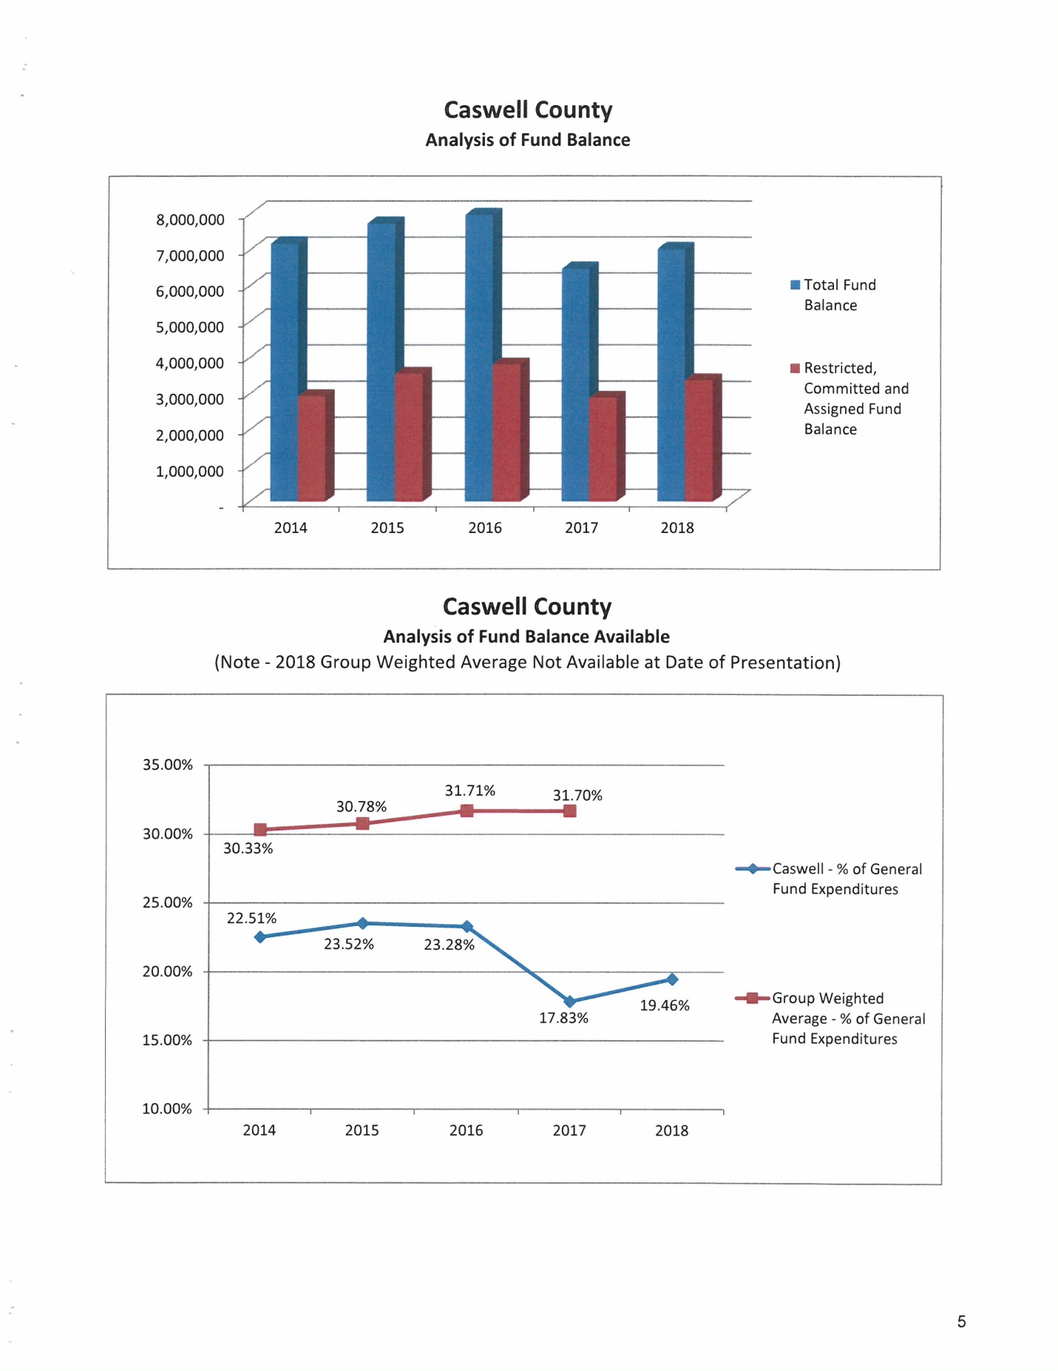

Mr. Hill stated that on page 6 the chart at the top is similar to the chart the Board was just looking at but this chart takes out the things that have been committed by the Board but also what has been restricted by state statute. He stated that in 2014 it was 18.52% and in 2018 it was 13.50%. Mr. Hills stated that the chart at the bottom of page 6 there is a correction, the Blue represents the General Fund but the Red should be for Transportation and the Green should be for Solid Waste. He added that these are the revenues over or under expenditures before transfers. Mr. Hill stated in 2014 the General Fund had a deficit of $738,000 and in 2018 it was an excess of $1 million. He added that Transportation in the red in 2014 had a $45,000 deficit and in 2018 Transportation was $18,000 to the good. Mr. Hill stated that Solid Waste which is in the green had a $52,000 deficit in 2014 and $369,000 deficit in 2018.

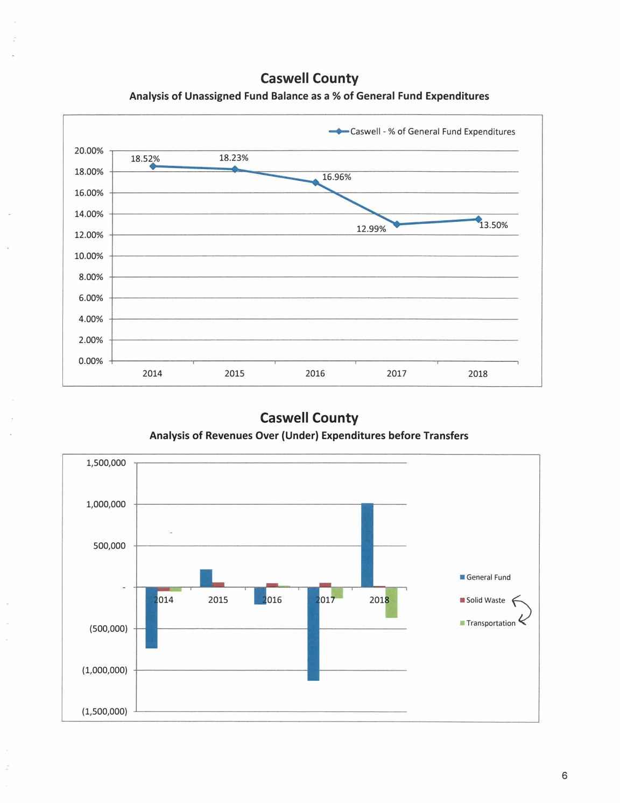
Mr. Hill stated that on page 7 the chart at the top represents where the County’s cash balances and fund balances are located. He added that the cash balance is the money that is in the bank and fund balance is the excess of assets over liabilities. Mr. Hill stated the bulk of the Cash balance is in the general fund and the bulk of fund balance is in the general fund as well. Mr. Hill stated that the chart at the bottom represents the County’s tax rate in comparison with other counties in the state of similar size. He added that Caswell County is in the color blue and the other counties are in red. Mr. Hill stated the data for the state was not available for the data just yet.
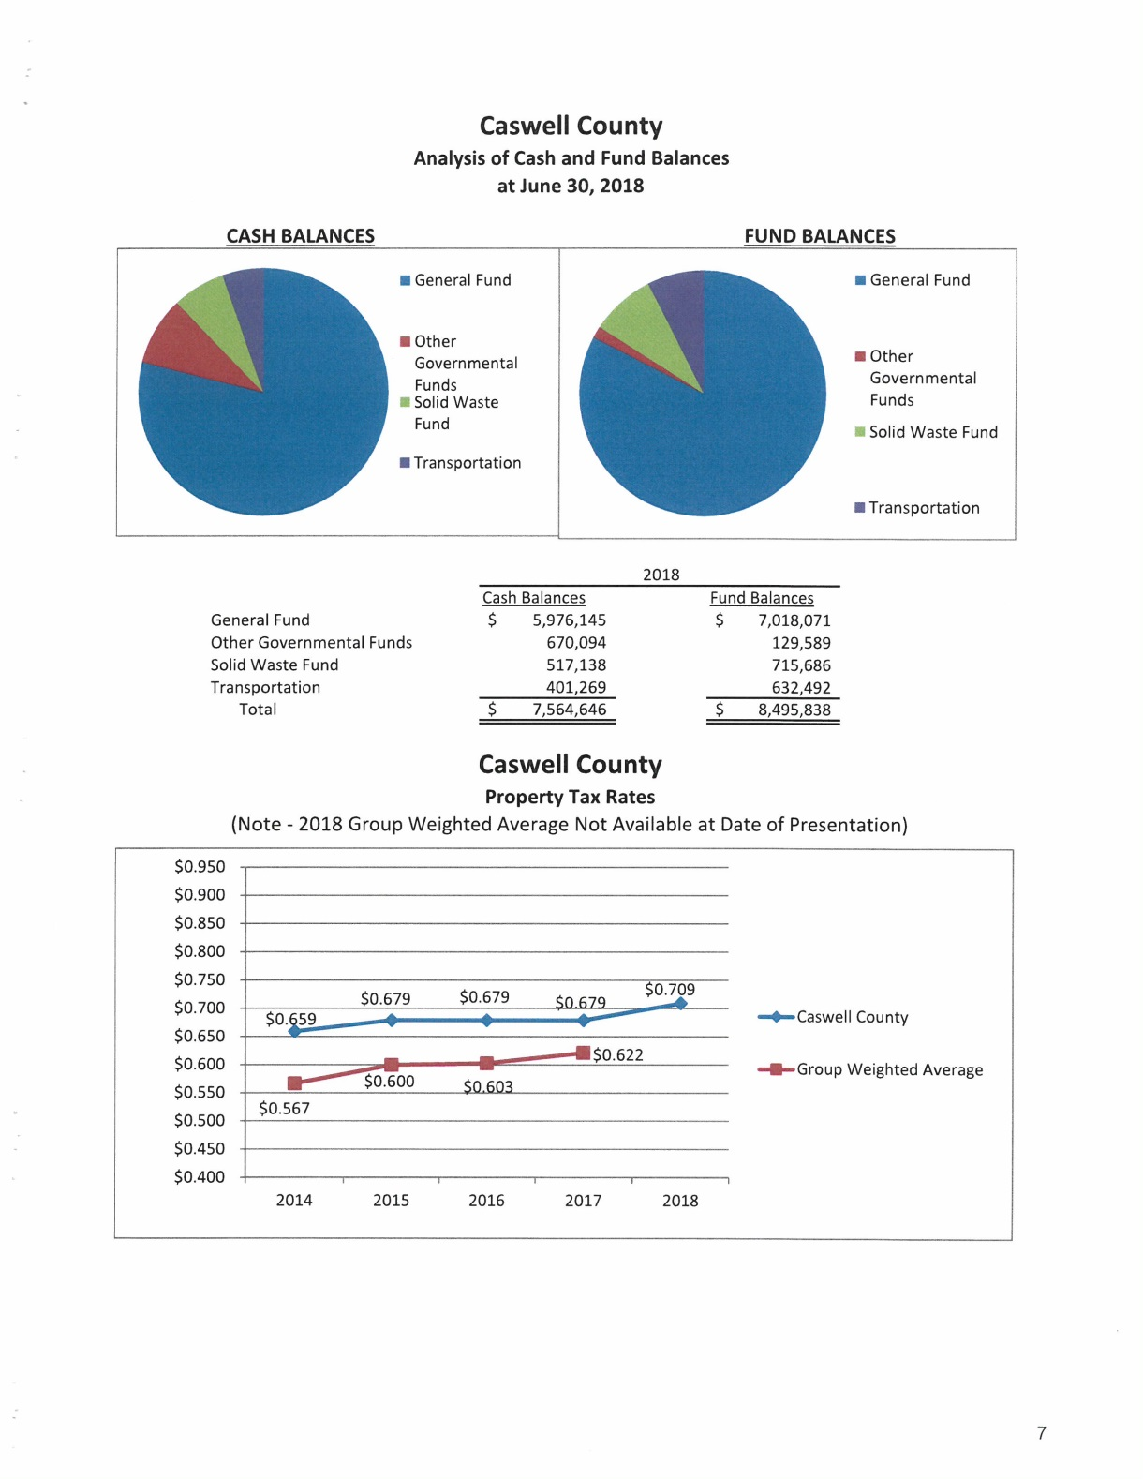

Mr. Hill continued on page 8 where it compares the collection percentages to other counties in the state. He added that Caswell is in blue and the average of the state is in red. Mr. Hill stated that the chart on the bottom of page 8 the chart with the red bars represents the property valuation and the chart with the blue bars represents the actual tax levy.
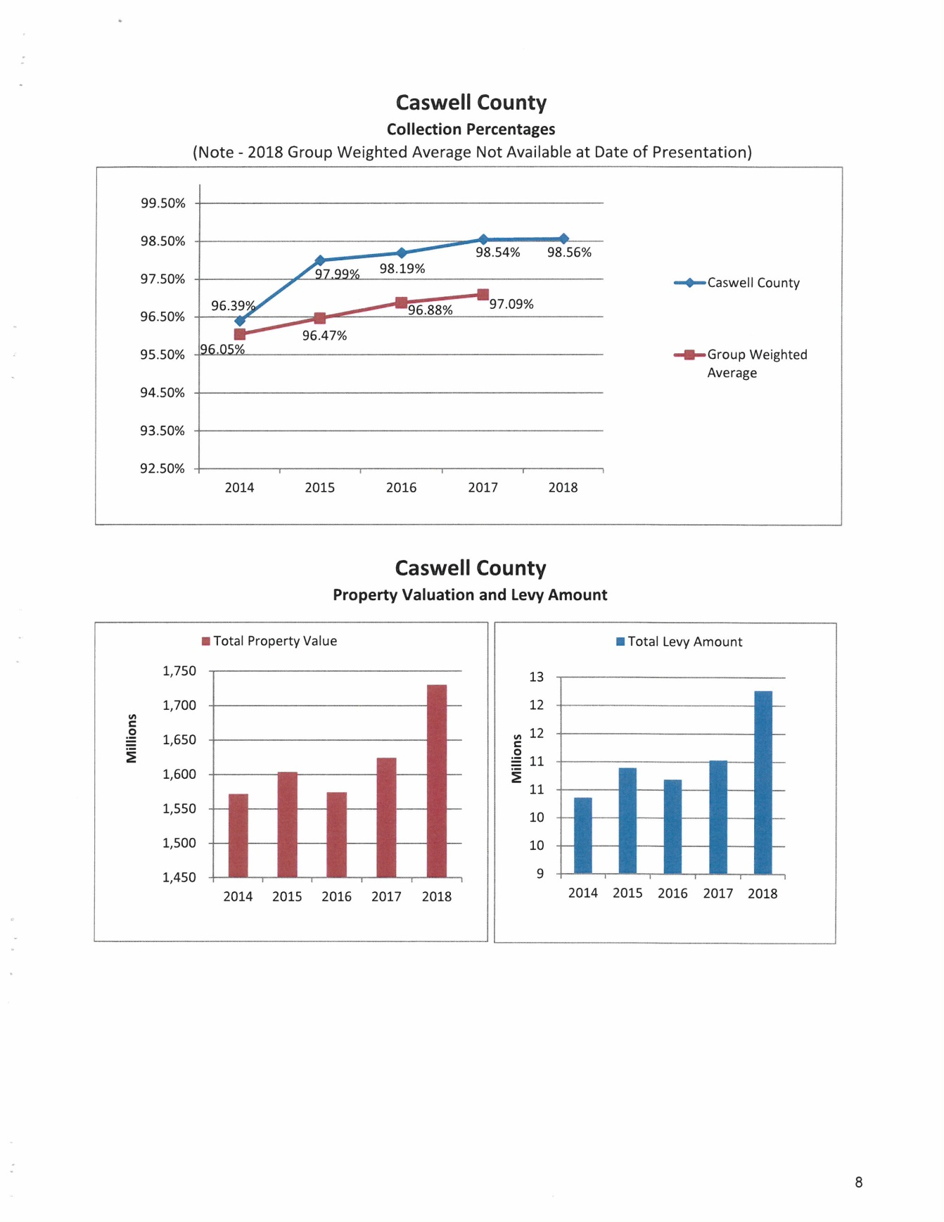

Mr. Hill stated that on page 9 the chart at the top represents the Debt Analysis which tells basically where most of the County’s debt lies. He added that the bulk of debt is in Private Placement, then Installment Purchases and then General Obligation. Mr. Hill stated that the chart at the bottom represents the revenues by categories with Ad Valorem being the largest with 48.61%.

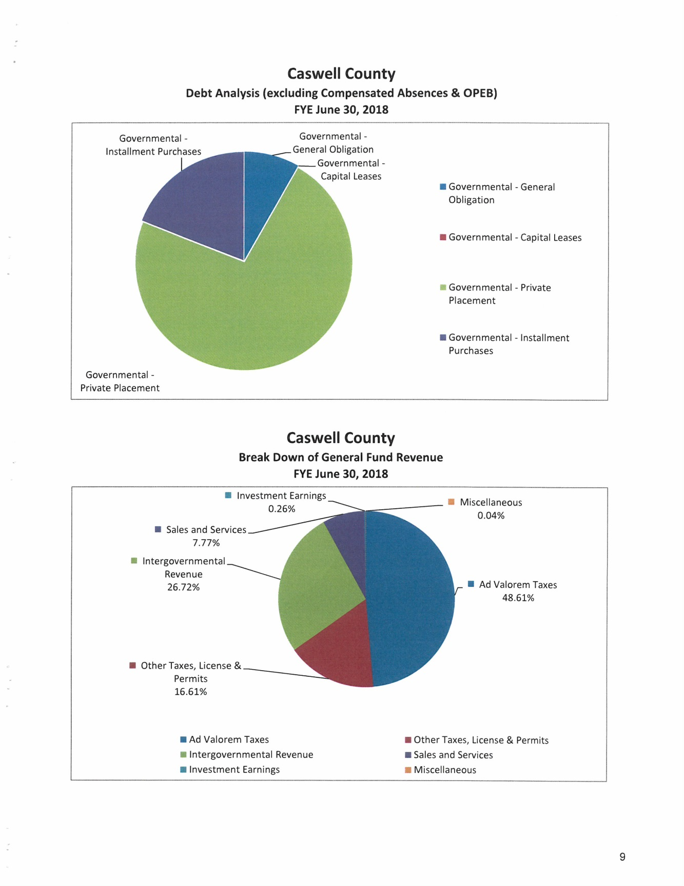
Mr. Hill continued on page 10 with the Break Down of Expenditures by categories with Human Services at 34.87% is the largest expenditures followed by Public Safety at 26.47% followed by Education at 15.31%.
Mr. Hill stated that that was basically the presentation and stated that if the Board had any questions he would be glad to answer those questions and if he could not answer the question he could get an answer.

Commissioner Owen asked Mr. Hill to go over the audit findings and issues in the letter. Mr. Hill responded that the reports goes over reconciliations, reports and other things that should be done prior to the auditors viewing and he added that some of these things are slow in getting done such as bank reconciliations. Mr. Hill stated that this is a finding that was there last year as well but it has improved from last year. He added that he understands that there has been some turnover in key positions in the finance department throughout the year and he understands that these things can happen at times but as auditors it cannot be over looked.

Commissioner Oestreicher stated that during a recent workshop there was a need for a new financial system and he asked Mr. Hill if he could give the Board an assessment of the County’s financial system versus other systems that are out there. Mr. Hill responded that he has not worked with the financial system itself and he does not know how much that system hinders the finance department from getting some of the reconciliations that were talked about but he would be happy to share brands that other people are using and he suggested talking to other counties about their programs.

Chairman McVey thanked Mr. Hill for his presentation.

S&ME LANDFILL EVALUATION: STATE RECONCILIATION

Mr. Miller introduced Mr. Edmund Henriques from S&ME which handles the County’s semi-annual landfill monitoring on the closed landfill. He added that the County has received some readings that are what the State considers to be above the allowable limit and Mr. Henriques is here to propose a plan for the County to move forward in the process.

Mr. Edmund Henriques stated that S&ME has been handling the Solid Waste landfill work since 2007. He added that the County received a letter from NC DEQ for the County to put forth a corrective action work plan which was in response to the detection of benzene, chromium and other chemicals in the ground water at the landfill that exceed the ground water standards. Mr. Henriques stated that based on his experience the levels are not high but they do exceed the ground water standards for the state and this does trigger certain regulatory requirements. He added that now it to determine the cause, significance and extent of the contamination on the property. Mr. Henriques gave some background on the landfill; the landfill that was issued this letter is under Permit #1701 and was closed in 1994. He added that something that is important to this process and is important to a part of his work is they looked at the drawings that were prepared for the closure by Dewberry & Davis and there were two other closures that took place prior to 1988 and the significance of this is within NC DEQ there is a program called the Pre-Regulatory Landfill Program and this program covers landfills that were closed prior to January 1, 1983. Mr. Henriques stated that on these landfills there is a $2 per ton tax collected on waste disposed of today that goes into a fund and that fund is used to pay for the cleanup of those old landfills. He added that the monitoring wells that are on the closed landfill are down below the old landfill and it is his suspicion but not proven that the old landfill may actually be the cause of the high numbers that are being detected. Mr. Henriques stated that S&ME work plan is to put in some additional wells down in this oldest landfill area to try to determine the extent of the contamination as well as see if the old landfill is actually the source of the contamination. He added that if this is successful it is possible that the state will accept this and take over the work on the landfill. Mr. Henriques stated that he could not promise this but this is one of the key elements of the land. He added that he would need information that proves that the old landfill was closed prior to January 1, 1983. Mr. Henriques stated that a work plan will need to be submitted to the state and this work plan will include installing 3 monitoring wells to determine the cause, testing water quality of those wells as well as testing on the ground water itself to try to determine how fast it moves because this will be a key element in determining what can be done to clean this up. He asked if there were any questions.

Commissioner Owen asked if the readings have been pretty consistent over the years or if this is an all of a sudden spike. Mr. Henriques responded that the readings have been fairly consistent over the last several years and it has only been in recent time that the State sent this letter. He added that the old landfills have been ignored and there is a new interest in these old landfills from the State in regulations associated with them. Commissioner Owen asked if S&ME had to wait on the approval from the State to put the other ground wells in. Mr. Henriques responded that he would need approval from the Board of Commissioners for the expenditure that would be tied to the work plan. Commissioner Owen asked the county manager if he had a ball park figure on this expenditure. Mr. Miller responded that he has a proposal from S&ME for $43,000 and this is to continue with the plan, to submit the plan to the State, monitor the wells and drill the wells. Mr. Henriques stated that this information is correct.

Commissioner S. Carter stated “Just a slight concern, are we going to do anything for the residents in that area as far as testing to make sure that it hasn’t traveled that far.” Mr. Henriques responded that part of their scope of work is called a receptor survey where they will determine where the water supply is and who if anyone is on the public water supply. He added to answer Commissioner Carter’s question if S&ME felt like there were wells at risk it would be appropriate to test those wells. Mr. Henriques added that S&ME monitors the stream below the landfill and nothing has been found. Commissioner S. Carter continued “That is good news.”

Commissioner Oestreicher asked if sufficient data can be found with the existing wells versus digging new wells. Mr. Henriques responded that the new wells will be put near the old landfill to help determine that the contaminants are possibly coming from that landfill instead of the newer closer landfill. Commissioner Oestreicher asked how deep the wells will be drilled. Mr. Henriques responded that the wells will be 30 to 40 feet deep.

Commissioner Owen stated that these new wells will give the County an indication if the contaminants are coming from the old landfill. Mr. Henriques responded that this is correct.

Commissioner W. Carter stated that he was in favor of put new wells at the closed landfill.

Commissioner Owen stated that he agreed as well. He added that this issue carried a lot of ramifications especially if new problems are found with the new wells. Commissioner Owen stated that it would be prudent for the Board to make a decision today on this issue.

Commissioner Owen moved, seconded by Commissioner S. Carter to approve the funds to install the new wells and for monitoring.

Commissioner Oestreicher asked how many wells the $43,000 would cover. Mr. Henriques responded that this would cover 3 new wells. Commissioner Oestreicher then asked what the cost would be for the monitoring. Mr. Henriques responded that there would be three different monitoring events and he did not have a breakdown for each monitoring event. He added that there would be three monitoring events following the installation of the wells.

Upon a vote of the motion, the motion carried unanimously.

AMERICAN LEGION POST 89/VFW POST 7316 DEED REQUEST

Mr. Fred Smith came before the Board and made the following statement:

“Mr. Chairman, commissioners, county manager and Mrs. Seamster thank you all for allowing us to come before you today. I would like at this time to recognize the Veterans that are here. Veterans stand please. Some information on our two Veteran organizations: American Legion Post 89 also known as Algernon Sidney Neal was chartered in 1932, Mr. Neal for whom the Post is named was wounded 1 November 1918 in France and died 2 November 1918 from his wounds. Veterans of Foreign Wars Post 7316 was chartered in 1946 by returning WWII Veterans. Mr. Neal Watlington now 96 years old and maybe one more of the original charter members still survive. Mr. Watlington served in the Army and was in the Battle of the Bulge. On the 10th day of February 1970 the Caswell County Commissioners sold to these two veteran organizations 8.52 acres on County Home Road which everyone knows by the Fairgrounds. I think the Caswell County Agriculture Fair was held there until 2004; that is the last program flyer I have found. The fairground property is used by the VFW and American Legion for meetings, we also let non-profits use it, we also let the Caswell County Senior Center use it for a fundraiser each April to hold a car show. We also lease the large building to a church and we also rent the old metal building to the Caswell County Schools for storage of old equipment and every couple of years they clean it out and have an auction. I have also talked with Brandon Enoch, Director of the Caswell County Parks and Recreation Department about the use of the property for children’s t-ball, softball and maybe some soccer fields. In the deed there is a clause which read ‘It is understood and agreed that in the event that both of the grantees cease to exist that the grantor shall have the option of purchasing the above described tract of land at the same purchase price of this deed’. The 8.52 acres was sold to the VFW and American Legion in 1970 for $4,260.00. Now I will tell you that the word has got out and some rumors have said we have the property up for sale; that is not true. I will tell you that in 2008 Brad White and myself were approached by the Division of Prisons, no negotiating was ever done, and after the downhill slide of the economy in 2008-2009 we have heard nothing else. What we would like for you all to do is to remove the clause from the deed so in the future if we are approached we would have the liberty to sell. There are two safeguards to make sure we are legal in the selling of the land if you will take the clause out: The VFW and American Legion Headquarters in Raleigh would have to give us the approval for any transaction of a part or all of the property if ever sold. The entire property is owned by the VFW and American Legion members. No individual can profit from this. If there was ever a partial piece of the property or all of the 8.52 acres sold it would have to be used for keeping up the property or reinvested in other property that was owned by VFW Post 7316 or American Legion Post 89 or used for Veteran support. It could be used for things such as helping out Veterans that need help, scholarships for the programs we have in the middle school and high school. For almost 49 years this has been Veteran property and it may well be for 49 more but we would like to have a clear deed in case we have the opportunity. Thank you for your time today and for your consideration in this matter. I would also like to make another comment, American Legion Post 210 started at the fairgrounds prior to 1970 so we have had 3 of the 4 Veterans organizations that has been on the property where the fairgrounds are now. Questions or clarifications?”

Commissioner Oestreicher asked Mr. Smith what the clause was keeping the organization from doing now other than selling it at your own discretion. Mr. Smith responded that it looks like the veterans would have to get the Board’s permission to sell the property. He added that with the clause being removed it would clarify that it is the Veterans property alone. Mr. Smith stated that the Veterans have kept the property up and they just want a clear deed to the property.

Commissioner Owen asked the county attorney to share his opinion on this issue. Mr. Ferrell stated that this deed is a little different from most deeds he has seen because it is not a use restriction but it is as long as the entity survives clause. He added that the request is for this clause to be removed and he thinks the county has the ability to decline the option and extinguish it if that is what the Board wants to do. Mr. Ferrell stated that he did not agree with the assumption that the organization would need the County’s approval to sell any of this property and he added that it sounds like that the Veterans think that is the intent and they want to honor the 1970 deed.

Commissioner S. Carter asked “Just in those comments, if those of those entities cease to exist who would execute the deed?” Mr. Ferrell responded that in the general statutes when you have a non-profit organization in this case you would hope the organization would exercise their option beforehand but if not the county could exercise its option or not.

Mr. Smith asked if the clause would move forward if the organization sells the property. Mr. Ferrell responded no but he could see where a purchaser may have a concern that the option could spring forward later. He added that he understands the request to resolve this issue now.

Commissioner Oestreicher moved, seconded by Commissioner W. Carter to remove the clause from the deed. The motion carried unanimously.

RECESS

The Board took a brief recess.

MAKERSPACE POLICIES AND COSTS

Ms. Rhonda Griffin, Library Director, stated that in the new library there will be a very cool program called the Makerspace and the library received a $44,000 grant from Duke Energy to buy the equipment and supplies. She added that Ajarie is going to show the Commissioners the items that will be available in this space, some of the supplies are reusable but most of the supplies will have to be replaced.

Ms. Ajarie Holman explained what a makerspace is which is a collaborative workspace inside a school, library or separate public or private facility for making, learning, exploring to share hi tech and low tech tools. She added that this could be anything from robotics to just building with blocks. Ms. Holman stated that it is a space where people can get creative this DIY projects and share ideas. She stated that the makerspace is supposed to open in May of 2019 with the grand opening of the new library. Ms. Holman stated that this program will be available to children, teens and adults and it will be available for library programs, individuals and group use. She added that to be able to use this space the individual must have a library card in good standing without any outstanding fees, sign the makerspace user agreement, and some equipment in the makerspace area will require training before use. Ms. Holman stated that there will be a 3D printer and this will have a charge per half hour of filament use. She showed several examples of what the 3D printer can make. Ms. Holman stated that there will be a poster printer in the makerspace as well as a beginner sewing machine, cricket maker machine, button maker, soldering irons, A/V equipment such as cameras, microphones and green screens and basic supplies. She added that there will be STEAM kits for larger programs.

Ms. Griffin stated that some of the items in the makerspace will be reusable such as the robots but some of the items will need to be replenished. She added that Ajarie did an excellent job researching other libraries on what they charge for the use of the equipment. Ms. Griffin stated that the cost of the items is included in the Board’s packet in the policy of the Makerspace. She added that normally the Library implements new costs at the beginning of the year but with the Library opening in May she is requesting that the cost begin when the Makerspace is opened. Ms. Griffin stated that the Library Advisory Board has already approved these charges.

Commissioner Owen asked if the equipment was in a place where it is visible to the library staff or will someone be in that space. Ms. Griffin responded that someone will be in the room. She added that this room will be locked unless someone is using the room. Commissioner Owen asked if there was a rate charge on the machines. Ms. Griffin responded that everyone will receive 2 free things a month. She added that there is not a charge if the person is in a program. Ms. Griffin stated that the charge is for someone that wants to do things on their own. She added that other libraries have encountered individuals making items and then selling them on eBay so there will be a charge per hour for the 3D printer and per 30 minutes for the pen so there is a different rate depending on what you are using and doing. Commissioner Owen asked if there is a charge for a business to come in and do a video. Ms. Griffin responded that there would not be a charge unless they use supplies.

Mr. Ferrell stated that this is a cost recovery model.

Commissioner Oestreicher asked Ms. Griffin if she was asking the Board for money. Ms. Griffin responded no she is only asking for approval to implement the cost of the Makerspace on May 1 when the Library opens.

Commissioner Jefferies moved, seconded by Commissioner Owen to approve the rates for the Makerspace starting May 1, 2019. The motion carried unanimously.

Commissioner W. Carter asked Ms. Griffin when the new library would open. Ms. Griffin responded that as far as she knows the construction is on time so the ribbon cutting ceremony is scheduled for May 1st at 10:00 a.m.

ECONOMIC DEVELOPMENT UPDATE

Ms. Cori Lindsay, Economic Developer, stated that the Board should have received her written update. She stated that there have been a lot of seminars this year and more seminars will start tomorrow and go through March. Ms. Lindsay stated that on March 27th a one day conference will be held on Agribusiness and the keynote speaker will be Ben Berquet which is with the Association of Mississippi Cooperatives and the National Family Farm Coalition. She added that Mr. Berquet is a 4th generation African American farmer and a James Beard Leadership Award winner. Ms. Lindsay stated that she participate in a half day interview in December with the Health Collaborative that helped to receive a Blue Cross Blue Shield planning grant for Caswell. She added in December there was an industry event at Honey Bee Farms where an announcement was made that Mesur.io will be relocating its business to Caswell and they will be an anchor tenant in the downtown co-working space. Ms. Lindsay stated that the agreement with HQ Raleigh has been finalized regarding the co-working space and she is working on the layouts of the space with the architect that was selected. She added that Caswell has received nearly $1 million in funding to support this renovation and operations for this new facility. Ms. Lindsay stated that several agriculture stakeholder meetings have been held about the new Caswell enterprise center on the Farm.

Chairman McVey asked for an update on the Caswell Enterprise Center on the Farm as far as the public meetings. Ms. Lindsay responded that a really good meeting was held last week in Pelham and a lot of good feedback was received and it will be an agenda item for the Board the second meeting in February to discuss recommendations.

Commissioner Owen asked the county manager for an update on the co-working space and when bids will be sent out. Mr. Miller responded that the County is waiting on the architect and engineer’s finalized plans to send out for bids. He added that there will be a meeting today with the architect and engineer. He added that Cori was modest when she said the County has received close to a $1 million in funding but he wanted the Board to know that Cori wrote those grants to receive those monies.

Commissioner Jefferies asked if a decision has been made on where the center on the Farm will go. Chairman McVey responded no there will be a public hearing the second meeting in February.

Commissioner Owen asked Ms. Lindsay about the participation in the business seminars. Ms. Lindsay responded that it varies from two or three to up to ten attend the seminars. Mr. Miller asked Ms. Lindsay to highlight the highest attendance seminar. Ms. Lindsay responded that there was a seminar on agriculture taxes and more than 20 people attended that seminar.

Commissioner S. Carter stated “Thank you for seeking those monies out.”

BUDGET REVIEW

Commissioner Oestreicher stated that prior to the meeting he discussed with the county manager to make a quarterly presentation of where the County is in the budget, budget versus actual. He added that he would like to see where the County stands on a departmental basis. Mr. Miller responded that this can be done quarterly.

PLANNING WORK SESSION

Chairman McVey stated that he felt like after the workshop that there were several items that needed the Board’s attention and he would like for the Board to consider another workshop to add these things in to prioritize what the Board wants to do. He asked the Board for dates to give to the county manager.

Commissioner Jefferies asked if the workshop could be on a Saturday.

Commissioner Owen suggested that the county manager and the clerk get together on some dates that would work and poll the Board. Commissioner Owen stated that the only problem he has with Saturday is staff is being pulled in on Saturday.

Commissioner W. Carter stated that Tuesdays and Wednesdays are bad for him.

COUNTY MANAGER’S UPDATES
Catastrophic Inmate Insurance

Mr. Miller stated that at the last Work Session the Board identified the catastrophic inmate insurance as a priority and directed him to take some action on this as quickly as possible. He added that he spoke with the Sheriff’s office and they have an application in t provide this type of coverage and they are checking with this provider to start the policy today forward and there should be an answer on this fairly soon.

ANNOUNCMENTS AND UPCOMING EVENTS

A. Caswell County Board of Commissioners, Town of Yanceyville and Town of Milton Joint
Meeting – Thursday, February 7, 2019 at 6:00 p.m. – Thomas Day Tavern, Milton.

CLOSED SESSION

Commissioner Owen moved, seconded by Commissioner W. Carter to go into Closed Session to consider the compensation, terms of appointment and performance of an individual public officer (NGS 143-318.11(a)(6)). The motion carried unanimously.

REGULAR SESSION

Commissioner W. Carter moved, seconded by Commissioner Jefferies to resume the regular meeting. The motion carried unanimously.

Commissioner Owen stated that the County received a bid to purchase land at the landfill and he would like for the county manager to inform Mr. Atwater why this process is being delayed. Mr. Miller responded that he wanted today’s meeting to occur and have a legible copy of the minutes and an explanation from S&ME before speaking to Mr. Atwater. Commissioner Owen stated that he just thought the County owed Mr. Atwater that courtesy.

Chairman McVey stated that in the workshop there was a discussion about leasing the ambulances and Commissioner Jefferies wanted to know if this information could be presented at the workshop. Mr. Miller responded that it would depend on the date of the workshop but he thinks it can be done. He added that he has a meeting with the Sheriff on the 14th to review leasing information from a company that he is bringing to the County. Chairman McVey asked to have Mr. Lynch to put this information together for the workshop.

ADJOURNMENT

At 10:55 a.m. Commissioner W. Carter moved, seconded by Commissioner Owen to adjourn. The motion carried unanimously.

________________________________ ___________________________
Paula P. Seamster Rick McVey
Clerk to the Board Chairman

