MINUTES – MARCH 27, 2018

The Caswell County Board of Commissioners met in special session at the Caswell County Historic Courthouse in Yanceyville, North Carolina at 2:00 p.m. on Tuesday, August 27, 2018. Members present: Nathaniel Hall, Chairman, Rick McVey, Vice-Chairman, Sterling Carter, William E. Carter, Jeremiah Jefferies, David Owen and Kenneth D. Travis. Also present: Bryan Miller, County Manager, Gwen Vaughn, Finance Director. Paula P. Seamster, Clerk to the Board, recorded the minutes.

MOMENT OF SILENT PRAYER

Chairman Hall opened the meeting with a moment of Silent Prayer.

PLEDGE OF ALLEGIANCE

The Board of Commissioners and all the guests in the audience recited the Pledge of Allegiance.

HIGH SHOOL FINANCING OPTIONS

Chairman Hall informed the Board that it received some information from the county manager and he asked the county manager to go over the information.

Mr. Miller stated that the information passed out is options for some additional funding scenarios. Staff received a telephone call from Davenport, the County’s financial advisors and with the County’s bond counsel this morning. These agencies ran some numbers on the high school project financing. The county manager went through the scenarios with the Board. The scenarios went through a 25 year, 30 year and 40 year financing option for $42.5 million and for $33.775 million. These scenarios are based on USDA financing which would be a 3.5% interest rate. Mr. Miller stated that some of the questions the Board asked the county attorney were answered during this telephone conversation. The main question was if this issue could be put on the ballot in the form of a referendum and still us the USDA financing and the answer to that question is yes. The difference in the two sheets in total amounts borrowed is based on $3 million the School System has in its ADM fund balance and Lottery fund balance. In the first column the $3 million would be used to pay debt service as the loan goes along which would prolong the tax increase and allow some of the existing debt the County has now to be paid for. The second column assumes that the $3 million is used to pay down the project initially and reduce the cost of the overall project all together. Both of these sheets are included in the minutes on the next two pages. While explaining the sheets he asked if the Board wanted to spend some time reviewing the sheets.

Commissioner S. Carter stated “Mr. Chairman I would like the county manager to continue in his explanation of each of these columns so it would be reflected in the minutes and for the public attending could hear these figures as well so they can have some options.”

Mr. Miller continued his explanation of the two sheets.

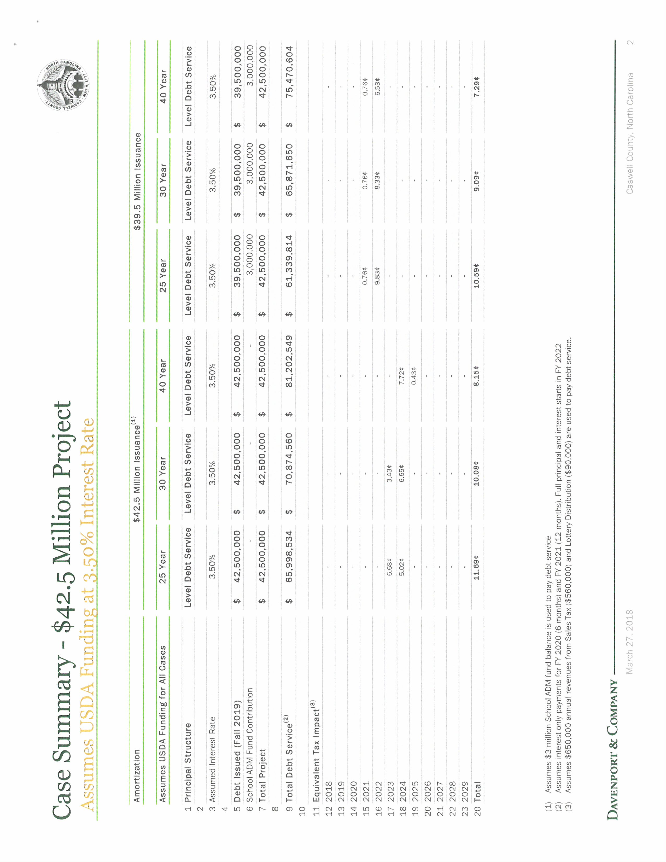

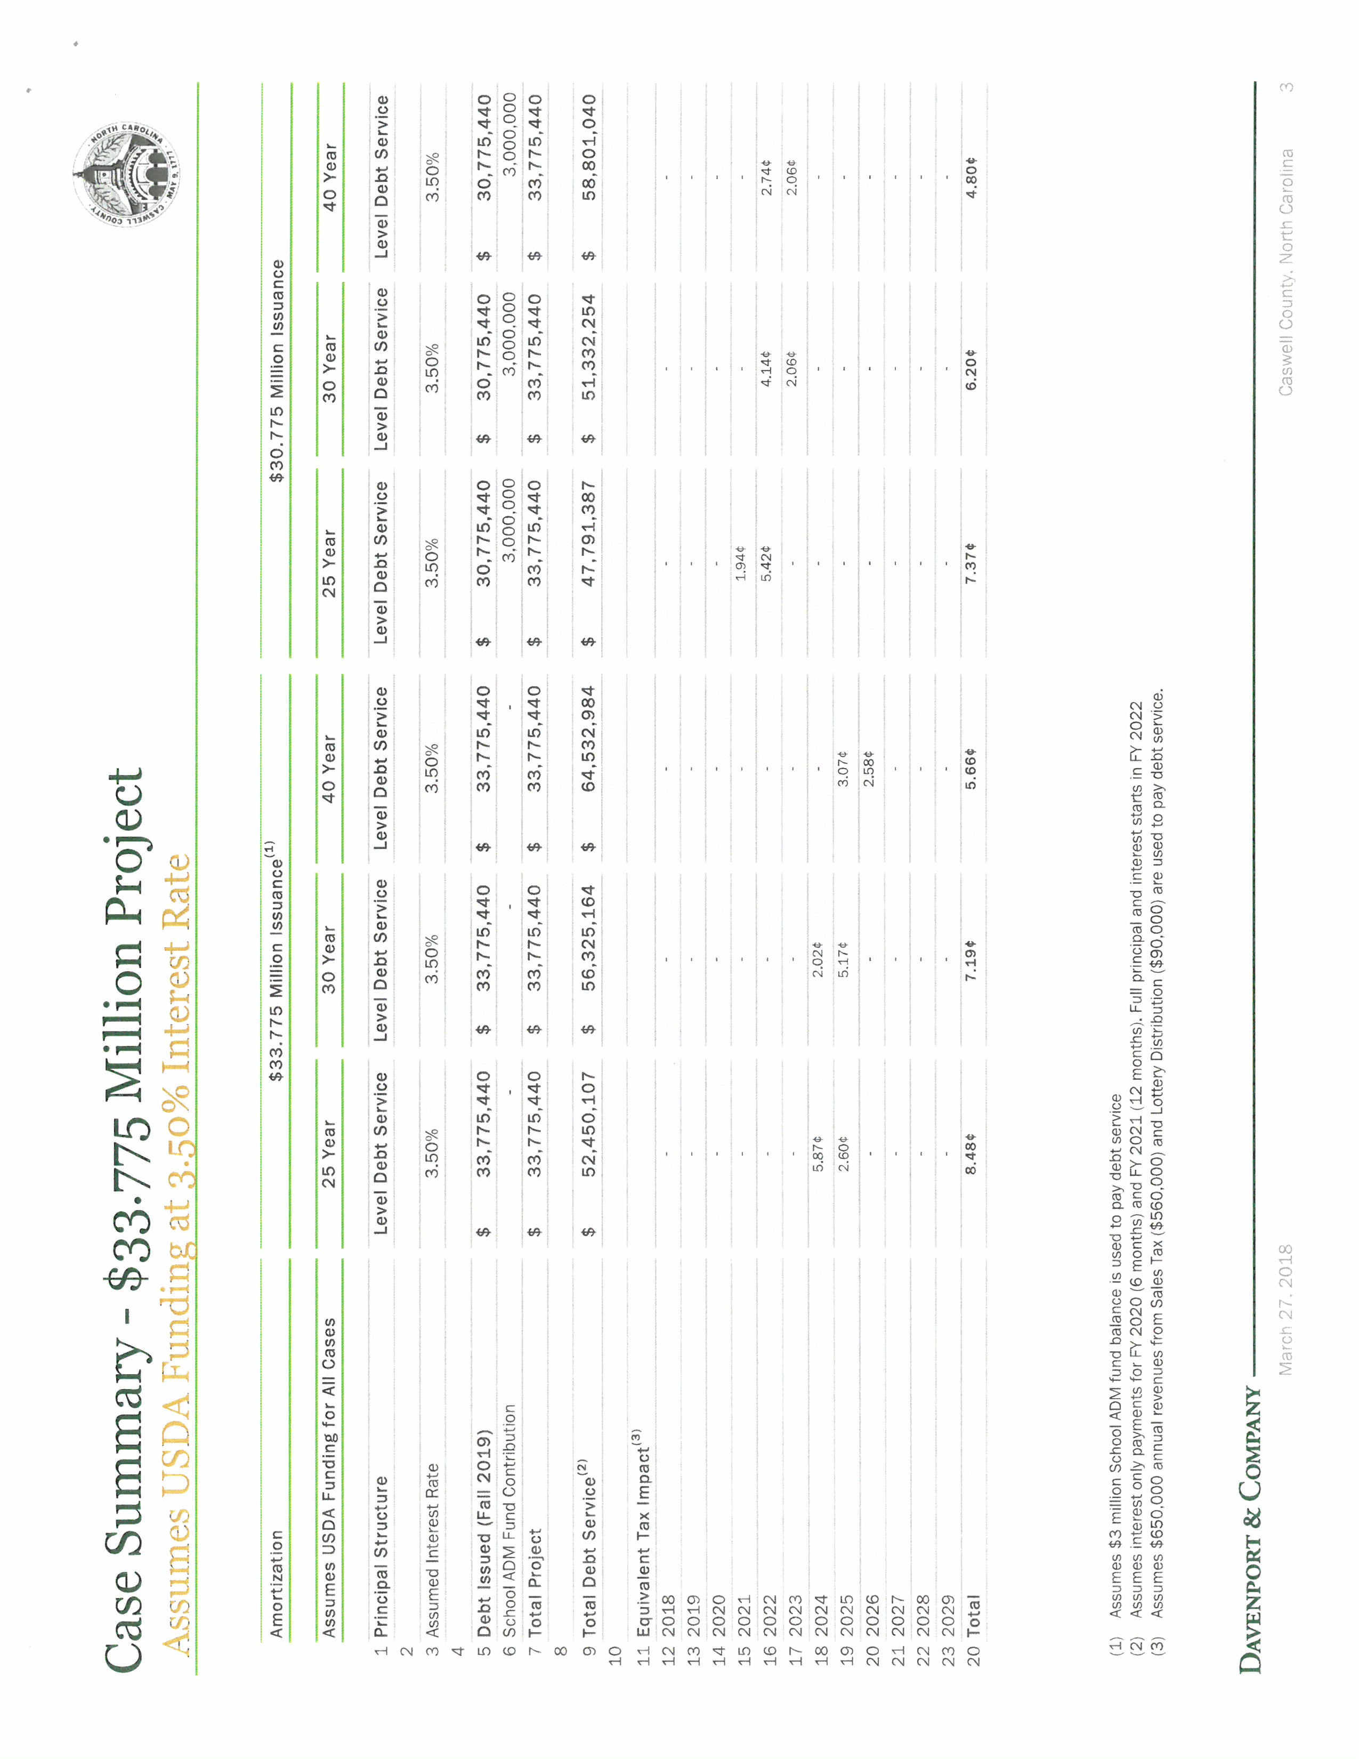

Commissioner S. Carter asked “Mr. Chairman, I am just curious with the $39.5 million why is there such a harsh tax increase between 2021 and 22 versus having this split out more?” Mr. Miller responded that these numbers were calculated by Davenport and would be necessary in that tax year to cover the balance. Commissioner S. Carter continued “Could that not be covered earlier?” Mr. Miller responded that it could. He added that these scenarios are not the only arrangements for the financing because taxes could be raised next year to offset the balance but these scenarios are just one way to calculate the financing. Mr. Miller stated that there are probably over a hundred different ways to figure this. Commissioner S. Carter stated “I just wanted to public to be aware of that. That needs to be spread out more so it is not so harsh in that one given year, that’s all.” Mr. Miller stated that taxes could be raised at any given time.

Chairman Hall asked the Board if there were any questions to the county manager on the handouts.

Commissioner McVey asked if the county assumes this debt if it would affect the county’s fund balance, if so how would the county increase fund balance and how it would be done. Ms. Vaughn responded that the county’s fund balance is approximately 21%. Chairman Hall stated that the question was if the county borrows this money will it affect fund balance. Ms. Vaughn responded that it would not affect fund balance until the county starts making debt service payments. Mr. Miller responded that it would affect fund balance and the Local Government Commission requires a fund balance of 8%. Chairman Hall responded to Commissioner McVey that if the county starts making payments prior to an increase in taxes the fund balance will go down. Mr. Miller stated that this is correct but it is important to increase the amount in fund balance on hand to remain at the same percentage level due to increased spending. Chairman Hall stated that Commissioner McVey second question was how does the county plan to do this, keep the fund balance percentage up. Mr. Miller responded that absent additional revenue streams the county would have to increase taxes.

Commissioner Travis asked how far the fund balance would decrease if taxes were not increased. Mr. Miller responded it would decrease fund balance about 1.9% every year. Ms. Vaughn added and this would depend on the expenditures every year. Chairman Hall asked if the expenditures were on the project or the county. Ms. Vaughn responded the overall county expenditures. Chairman Hall stated that the assumptions would be that the expenditures would remain the same or go up a little bit.

Mr. Miller stated that based on some of the comments that have been said there will be some additional spending that the Board will have to look at in this year’s budget. One of which will be insurance which will be about $323,000 increase. This will be an 18% increase from the current year. Chairman Hall stated that it makes sense if the Board decides to proceed with the project to increase taxes that year. Mr. Miller agreed.

Commissioner S. Carter stated “Mr. Chairman if I am not mistaken about splitting out this tax increase basically and initially if we chose the 40 year option there will be a 4.8 cent tax increase but if you spread that over 5 years that is basically 1 cent a year.” Mr. Miller responded that the fund balance would grow initially roughly by $156,000 a year so this could be a feasible option. Commissioner S. Carter continued “I see that as very realistic.”

Commissioner W. Carter asked how the $15 million that Commissioner Owen discussed through the state and the $15 million applied for by the School Board would come into play. Commissioner Owen stated that the school bonds for the state are in committee and according to Senator Woodard and another senator that bond is pretty much dead at this point so the county cannot count on this money. Mr. Miller added that there is a resolution going around through other counties to urge the legislature to support SB 866 and HB 542. He added that the clerk shared the resolution with him and he has put together a resolution for Caswell County and it will be on the next agenda to support that legislation. The other $15 million is a grant that the school system would apply for and that grant can only be used for new school construction and this grant is for up to $15 million. If these monies were received it would be used towards the cost of the construction for the new high school.

Commissioner McVey asked if it makes sense to finance the school building for 40 years. Chairman Hall rephrased the question to say if the Board approves the project should the Board be looking at 40 years for financing. Commissioner Travis responded no. Commissioner Owen responded that the struggled on 40 years and the Board needs to look at something other than 40 years. The county is looking at paying back a loan for the library project and there is at least $230,000 that the county has to come up with in addition to this. This will tie the hands of the Board for 40 years. He added that he thinks that the detention center will be paid off in 10 years. He asked to look at a short span of time. Commissioner McVey responded that he is not a fan of 40 years. Chairman Hall stated that this is one of the decisions the Board will have to make at the next meeting since this is a work session. Commissioner Jefferies responded that he would have to vote for 40 years because there are other buildings that may need some repairs. Commissioner Owen stated that he understood Commissioner Jefferies statement but he would like to wait to see if the county receives the $15 million before moving forward.

Chairman Hall stated that looking at the scenarios the total in interest is significant going from 25 years to 40 years. On the $42.5 scenario the county is looking at an additional $9 million. Chairman Hall asked the Board for their thoughts on the terms of the loan so staff can look at this. Commissioner Owen responded nothing past 30 years. Commissioner McVey responded 30. Commissioner Travis responded 30. Commissioner W. Carter responded 30. Commissioner S. Carter responded “I am in favor of 40 or 30 however sensitive to the fact that it is a tax burden to the citizens but I am also looking at the total debt service, the differences of $7 million if we choose the 30 and that seems very realistic and respectful to the public as well with that knowledge and if they understand there is a huge difference there in debt service.” Commissioner Jefferies responded 40. Chairman Hall stated that right now the consensus is 30 years. His suggestion was to put the final package together and then the Board can vote on the terms as it relates to years. Staff can work with 30 years to do their calculations.

Mr. Miller stated that the School Board recommended the $30 million. Chairman Hall recommended working with that one.

Commissioner S. Carter stated “Mr. Chairman I believe that was the $33, well it was basically both but what I need clarification is if someone could answer it from the school board, were they planning to pay down the loan initially with the $3 million or it is to be divided amongst the term? Are y’all aware which one that was?” Dr. Sandra Carter responded that it was the $30 million. Commissioner S. Carter continued “So it’s the $30.775.”

Chairman Hall stated that the Board was advised by the general counsel through the county manager that the Board could do a referendum either way. He asked the Board if they wanted to do a consensus on the referendum.

Commissioner S. Carter stated “Mr. Chairman I would like clarification on that point before we proceed. The question I had at the last meeting was about whether we could do a referendum with the USDA loan but the comment from the general counsel although it was not an absolute answer, it was a yes or to the best of his understanding is that that would reduce the term of the loan to 20 or 25 years is how he responded to that, not the 30, not the 40 but the 20 or 25 so I need clarification on that.” Mr. Miller responded that the short answer is yes the Board can do that and it can be for 20, 25, 30, 40 years. The Board has the option to put it on the ballot for a referendum and for using USDA for 20, 25, 30, or 40 years. Commissioner S. Carter continued “So it is now open to all of these terms because he was saying contingent upon the LGC it would reduce that because they normally don’t do the 40 years.” Mr. Miller responded when the Board puts this on the ballot for a referendum the county is pledging the full faithful credit of the county, the taxing power of the Board. He added that the financing mechanism that is used to secure that is separate and apart of pledging the full faithful credit of the county.

Chairman Hall asked if the county would have a problem with the LGC (Local Government Commission) with any amount. Mr. Miller responded that if the Board wants to put it on a referendum staff needs to talk to the LGC pretty soon. The Board would need to start making authorizations its first meeting in May if not sooner. The LGC approves the interim financing that will span the gap until the county receives the USDA loan. Mr. Miller added that the county does have to make application to the LGC to put this on the ballot in November and it is a very time sensitive and complicated issue. A couple of public hearings have to be held, a statement from the general counsel and finance director have to be made, there is a 30 day challenge period, there are a lot of moving parts to the process.

Commissioner S. Carter asked “Follow up Mr. Chairman, could you explain if we do not put it on a referendum?” Mr. Miller responded that the county still has to make application to the LGC to receive the interim financing. Commissioner S. Carter continued “By May?” Mr. Miller responded no because it will not be going on the referendum. He continued that an application to the LGC will need to be made. Mr. Miller stated that the USDA process is not a short process either. He stated that the time frame from starting the application to breaking ground would be approximately 18 months and with putting it on a referendum it would be approximately 18 months to 2 years.

Chairman Hall stated that the Board needs to come to a consensus to authorize the county manager to move forward with the LGC to start the process.

Commissioner McVey asked if this would be to put it on a referendum. Chairman Hall responded that either way the LGC will need to be involved but right not the general thinking is to put it on a referendum. He added that it should be voted on at the next meeting to authorize the county manager to move forward with the LGC. Chairman Hall stated that at the previous meeting the commitment was to put it on the ballot. That was the consensus at the last meeting so the process needs to be started immediately to get it on the ballot.

Commissioner S. Carter asked “Mr. Chairman does that need to be made in the form of a motion to proceed?” Chairman Hall responded no because it is a work session. The clerk will have 2 to 3 items on the next agenda for the Board to vote on.

Commissioner McVey asked what the anticipated enrollment is at the high school for next year. He asked that this information be gathered for the next meeting. He added that this project is being looked at with safety in mind so he asked if safety and security were being looked at with all the schools in the county and if this is the case how much would it cost for this to take place. Chairman Hall responded that the county manager would get these answers. Commissioner McVey then asked if the school system had completed the grant application and how would the funds from the grant be used. Chairman Hall responded that he was going to depart from the normal procedure of a work session and ask Dr. Carter to come forward and answer the question about the application for the grant.

Dr. Sandra Carter stated that she could answer all the questions that have been asked. Dr. Carter stated that the anticipated enrollment for the high school will increase by about 50 students next year. She added that the School System’s budget does include security for all the other schools in the county expect for the high school. Also in the budget they are asking for a second social worker. Dr. Carter stated that the grant application has not been released yet, last year it was not released until August and was awarded in October.

Commissioner McVey asked for an approximately amount on the safety and security at all the other schools. Dr. Carter responded around $1.34 million which includes fire alarms, online security system, entrance and secondary buzz in systems, additional camera, metal detectors, etc. She is also seeking a grant for a SRO for the elementary schools.

Commissioner S. Carter asked “Just a quick question, Dr. Carter that $1.34 million in the budget request for this year does this include anything for Bartlett Yancey or is it excluded?” Dr. Carter responded no.

RECESS

The Board took a brief recess.

HIGH SHOOL FINANCING OPTIONS (cont’d)

Chairman Hall called the meeting back to order.

Commissioner McVey asked what the current annual payment is for Dillard and where the funds come from to make this payment. Mr. Miller responded that it is around two hundred and forty some thousand dollars. $245,800 for 2018, $234,250 for 2019, $222,800 for 2020 and $206,500 for 2021. The funding source to pay this debt services comes from sales tax money that is allocated specifically for schools.

Chairman Hall asked for the sales tax numbers. Ms. Vaughn responded Article 40 & 42.

Commissioner McVey’s next question was what percentage of taxpayers is on a fixed income in the county. Mr. Miller responded that he had some general statistics from July 1, 2017 that list individuals over 65 years old is 20.8%. The median income in Caswell is $38,310. 53.1% of the population in Caswell is in the work force. The poverty percentage is 19.7%.

(At 3:09 p.m. Commissioner Travis left the meeting.)

Commissioner McVey stated that the county is in the process of building a new library so he wanted to know if the county was on target with the spending on the new library and he has for a guarantee that no more money will be requested for this project for overruns and extra cost. Mr. Miller responded that the project is on target. There was an additional expense for asbestos removal. Commissioner McVey asked if there was a possibility for extra funds. Chairman Hall responded yes. Commissioner McVey stated that the Board needs to take this into consideration when making a decision on the high school. Chairman Hall agreed.

Commissioner Owen asked for the contingency amount for the library project. Mr. Miller responded that he did not remember that amount. He added that he has had several conversations with the architect and the architect is very much aware that the project needs to stay on schedule and at cost. Commissioner Owen added that in his conversations with the county manager the library director is looking for additional grants to cover the overruns for the project. Mr. Miller responded that the library director has worked very hard to find grants for the project in fact she is writing 3 grant applications now.

Commissioner McVey stated that he did not want a bunch of surprises with the library if the Board decides to help the school system. He added that it has taken at least 7 or 8 years to get to this point with the library.

Chairman Hall stated that at the next meeting there will several items on the agenda such as the term of the loan, the referendum and authorizing the county manager to move forward with the LGC.

Commissioner W. Carter asked the county manager when the budget would be ready for the Board. Mr. Miller responded that the School System just gave him their budget. He received the Health Department’s budget today. He is still waiting on Social Services. Mr. Miller stated that he should have some type of information to the Board at the next meeting or the following meeting. Commissioner W. Carter asked if there were going to be any surprises. Mr. Miller stated that he would try to have something for the Board to review at the next meeting. Commissioner W. Carter stated that last year the county did not fund the sheriff’s cars and now they want 12 this year. Commissioner S. Carter stated “Not a surprise, not a surprise, sir.”

ADJOURNMENT

At 3:19 p.m. Commissioner W Carter moved, seconded by Commissioner Owen to adjourn. The motion carried unanimously.

________________________________ ___________________________
Paula P. Seamster Nathaniel Hall
Clerk to the Board Chairman

******************************************************************************

