MINUTES – NOVEMBER 16, 2020

The Caswell County Board of Commissioners met in regular session at 9:00 a.m. on Monday, November 16, 2020. The meeting was held electronically using Zoom Webinar software. Members present: Rick McVey, Chairman, David J. Owen, Vice Chairman, William E. Carter, Nathaniel Hall, Jeremiah Jefferies, Steve Oestreicher and N. Kent Williamson. Also, present: Bryan Miller, County Manager, Brian Ferrell, County Attorney, and Debra Ferrell representing The Caswell Messenger. Paula P. Seamster, Clerk to the Board, recorded the minutes.

WELCOME
MOMENT OF SILENT PRAYER

Chairman McVey opened the meeting with a moment of Silent Prayer.

PLEDGE OF ALLEGIANCE

The Board of Commissioners and all the guests in the attendance recited the Pledge of Allegiance.

PUBLIC HEARING – SPECIAL ASSESSMENT ON SHADOW RIDGE ROAD

Commissioner Owen moved, seconded by Commissioner Williamson to go into public hearing to hear comments on the Special Assessment on Shadow Ridge Road. After a roll call vote, the motion carried unanimously. (Commissioners W. Carter, Hall, Jefferies, McVey, Oestreicher, Owen, and Williamson voted in favor.)

The clerk informed the Board that no public comments were received.

Commissioner Owen moved, seconded by Commissioner Oestreicher to recess the public hearing until Tuesday, November 17, 2020 at 9:00 a.m. to receive additional public comments. After a roll call vote, the motion carried unanimously. (Commissioners W. Carter, Hall, Jefferies, McVey, Oestreicher, Owen, and Williamson voted in favor.)

PUBLIC COMMENTS

The Clerk to the Board read the public comments received via email.

“Ms. Pat Warren, 36 Main Street, Prospect Hill, NC. It is with the greatest concern that I make this public comment regarding the High Intensity Development Ordinance (HIDO). Considering that the zoning referendum lost by a slim margin in the county at-large, the protections that the HIDO will offer may possibly be the only protections that the citizens of Caswell County will have when it comes to the encroachment of polluting industries and other undesirable businesses in our neighborhoods. The highly capable HIDO Committee painstakingly conducted research, met numerous times, and studied the legal aspects of the submitted HIDO draft so I trust that you will take that into serious consideration in your deliberations and that you will accept the HIDO as submitted. Among other aspects of the HIDO draft, it is particularly important that the following aspects are held into full account. I am requesting that:
- The HIDO is passed before the Moratorium on Polluting Industries expires in early January
- Section 14-71 is kept intact as submitted by the Committee in that it protects Caswell citizens:
  - By reasonably creating land use spacing and operations setbacks. It is imperative that these setbacks are not reduced.
  - By reasonably defining minimum lot size
  - By reasonably defining “Protected Facilities”
  - By reasonably protecting private wells
- Section 14-68 is kept intact as submitted by the Committee in that it classifies all industries that will be regulated, specifically placing asphalt plants as Class III industries and quarries as Class IV industries.
- Section 14-18 is kept intact as submitted by the Committee because it includes screening buffers. It is imperative that screening buffers are not reduced.
You have been entrusted with the daunting task of studying and understanding the HIDO draft as submitted by the HIDO Committee. They have done their job of protecting Caswell County citizens while taking into account industrial growth, and I know the Board of County Commissioners will do its part to care for and protect Caswell citizens as well. Thank you for your service to Caswell County and its citizens.”

“Mr. Mark Zimmerman, Leasburg, NC. To Members of the Caswell County Board of Commissioners: There is only one reason to pass the HIDO. It is needed to help provide safeguards to Caswell County residents and landowners from high impact industries. The HIDO is all about protection from potentially harmful businesses which can operate here. Therefore, the HIDO needs to have adequate protections. It needs to have ample spacing and setbacks, for land use and operations. It needs to have ample screening buffers. Neighboring and downstream property owners need strong safeguards. The proposed HIDO provides the shields necessary to ensure this security. Do not water down the HIDO. Do not shrink from protecting our citizens. Keep Caswell a safe and healthy place to live. Thank you.”

“My name is Evangeline Vinson Gaudette. I live at 441 Baynes Rd. Burlington NC 27217. I am in support of the HIDO and look forward to seeing it passed by the end of the year, as the Moratorium expires in January. I would like to emphasize the importance of the Table of Classifications and wish to see “Asphalt Plants” as Class III and “Quarries” as Class IV. The current Table of Classifications should not be changed. I am also asking that you NOT accept the Planning Board’s suggestion to reduce the Land Use Spacing and Operation Setbacks in Section 14-71. Thank you for your attention to this matter.”

“Ms. Mimi Logothetis, 9501 NC Highway 86N, Cedar Grove, NC. I am writing to ask that in light of the very strong showing of support for county wide zoning, despite a large misinformation campaign against, you support the passing of the HIDO put forward by the planning board. This document is all that can protect Caswell County from being infiltrated and poisoned by outside polluting industry. Air, soil, and water travel, and once polluted, can move and poison uncontaminated areas for miles. I would ask that you support the HIDO in its original form, keeping the suggested operations setbacks and land use, no reductions. Also, the table of classifications must remain in place as written, with asphalt plants as Class III and quarries as Class IV. Thank you for your time and consideration.”

“Frankie & Lynn Pendergraft. Commissioners, please do NOT reduce the Land Use Spacing and Operations Setbacks in Section 14-71, as suggested by the Planning Board. We, the vulnerable, need all the protection we can get against those who’d want to take advantage of us. And please do NOT change The Table of Classifications. You are our ONLY DEFENSE in helping us keep the “invaders” at bay.”

“Ms. Karen Tate Gray, 948 Union Ridge Road, Burlington, NC, Anderson Community. Dear Board of Commissioners: I am voicing my support for the HIDO that was developed by the special appointed committee that was submitted to the Planning Board. I am asking that you support the version that came out of committee and not what the planning board is proposing. Setbacks and Operational Spacing should remain as the committee has put forth to protect citizens of Caswell that may own land adjacent to any development site. These setbacks should be at a maximum and not reduced as suggested by planning board. We have thousands of acres of land in Caswell owned by persons from outside our county who have little concern about the people who own land that may be adjacent to theirs. They must be protected. Personally speaking, my brother's farm is being sold, and I have lost sleep worrying about whether someone from outside the county will purchase it and what impact it may have on those who own land adjacent to it. They have owned the land for generations and should not fear what would happen to the property. These maximum setbacks put forth by the special committee in Section 14-71 are needed. I also am requesting that you honor the committee's recommendations and no changes be made to the Table of Classifications in Section 14-68. Please protect the lands and people of Caswell for future generations by approving the HIDO that was developed by the special committee and NOT the watered-down version from the planning board. Thank you.”

“My name is Carol Warren. I live in the Purley community of Caswell County and am very concerned about protecting the healthy environment and natural beauty that we enjoy in this county. The planning board suggests reducing the land use spacing and operations setbacks requirements (in Section 14-71) that were included in the draft of the HIDO ordinance. Any reduction in those requirements would allow industries to be more densely packed together. They could be packed closer to each other and also closer to our homes, concentrating more pollution, more noise, more traffic, and more degradation of natural beauty in our communities. Please reject any reduction in those requirements. Also, the planning board may recommend changes to the table of classifications in Section 14-68. Please keep the current table of classifications without changes. Thank you for caring about Caswell County and for your work in protecting the County from polluting industries.”

“Rev. Bryon Shoffner, 150 Shoffners Loop, Burlington, NC. To the Board of Commissioners, I request that you do not accept the recommendations from the Planning Board that has been submitted before you. The HIDO COMMITTEE that was formed put in a lot of hard working, searching hours to come up with an ordinance that would not only protect the people but one that makes sense to the growth of the county. Thank you, Commissioners, for your time and my I state again accept the HIDO as the committee wrote it. God bless and remember you are voted in by the county for protection and the Planning Board is appointed for planning so let them plan and you all protect. Accept the HIDO as it was written.”

“My name is Sharon Vinson. I live at 703 Vinson Rd, Burlington, NC in the Anderson community, very near the proposed asphalt plant site. I’m writing to implore you NOT to accept the reductions to the land use Spacing and Operations Setbacks in Section 14-71 that the planning board is suggesting. In addition, please do not make any changes to the Table of Classifications in Section 14-68. Thank you.”

“My name is Kristin Newnam and I live at 1703 Alvis Boswell Rd Yanceyville. Thank you, Commissioners, for supporting the adoption of a HIDO that will provide protection to our county and citizens. It is imperative that the HIDO is passed before the Moratorium expires in January. The reductions in setbacks and land use spacing in the current draft of the HIDO should NOT be accepted. These setbacks and land use spacing are meant to strengthen the HIDO, therefore any reduction in those numbers weakens it. As mentioned, the HIDO provides protection for our land, our water and wells, our property, and our way of life. It is also meant to “promote the peace and dignity of the County”. There is a need to set this bar high! Let Caswell County be the standard by which others look to for guidance and inspiration when it comes to the protection of their citizens and the dignity of the county. “Preserving the past, embracing the future” with the assurance that the “health, safety, and general welfare of the citizens” will always take precedence.”

“Phil Barfield, Yanceyville. We have seven weeks before the moratorium expires to have an effective ordinance in place that will protect Caswell County residents from polluting industries constructing and operating right next door to our homes, farms, community centers, or churches and threatening our health, safety, livelihood, and way of living. Many heavy industrial plants emit toxic pollutants above healthy limits that require state and federal regulation. For example, asphalt plants are permitted by the state to exceed healthy emission levels of formaldehyde, mercury, nickel, arsenic, benzene, and cadmium in hopes that these pollutants will be diluted by the time they reach the neighbors’ property. For the already permitted asphalt plant that sits on only 19 acres on Wrenn Road, benzene level is calculated to be barely under the limit considered unhealthy as it crosses the property line. Benzene causes cancer and is unacceptable at any level. We need an ordinance that stipulates minimum lot spacing, land use spacing, and operations setbacks to maintain a proper arm’s length from industries like this. You have in front of you today a well-constructed HIDO drafted by commissioners, community members, the County Manager, and the Planning Director who have worked hard to establish appropriate criteria relating to high impact development and associated land uses. The HIDO leverages off other county ordinances to provide a solid basis for our needs in Caswell County and to survive legal scrutiny. By classifying the industries and having unique requirements for minimum lot spacing, building height, screening buffers, land use spacing, operations setbacks, and stream setbacks, the HIDO will ensure the proper placement of these industries in our county. They are very reasonable and have been well thought out by your committee. Please do not reclassify them or reduce spacing and setback requirements. Any changes would make the HIDO less effective and not provide the needed protection for the people of Caswell County. This HIDO, as written, achieves a good balance between the need to attract industry and jobs to the county and the need to protect our health, wellbeing, and environment. Please accept the HIDO as presented by your committee.”

“I’m Chris Newnam and reside at 1703 Alvis Boswell Rd. Yanceyville. Thank you, members of the Board of County Commissioners, for your support in adopting a HIDO. It is paramount this ordinance pass before the end of the year. As you are aware the County is severely lacking in protections, and the HIDO is a great step forward to ensuring every citizen has clean water, fresh air, and a quality of life that is unique to a rural lifestyle. As you review the information presented today, I want to offer some thoughts to help guide you. Today you have the opportunity to be leaders. To not simply follow what other counties have done, but instead strengthen items such as setbacks, spacing, and screening buffers. The HIDO should include the maximum setbacks suggested by the HIDO committee. To allow items such as the setbacks to be reduced would do the citizens a disservice. Let us think of our fellow man, placing ourselves in their shoes. If one of the facilities outlined in the HIDO purposed to move in next to you would you not want the maximums outlined by the HIDO committee, and be afforded protections to items such as private wells? As you will see from the many letters written to the Board of County Commissioners as well as the Planning Board, many residents stand united in their desire for a strong HIDO. And lastly, I ask you to consider this; when we’re gone from this world what we leave behind is important as it is our legacy. Therefore, what we do today shapes and defines what future generations will remember us for. What will your legacy be? With kind regards.”

“Ms. Rebecca Page, Yanceyville, NC. This HIDO's sole purpose is to protect the citizens of Caswell County from undesirable industry for neighbors. Please make this ordinance do its job by restoring the Land Use Spacing and Operation Setback distances as specified by the HIDO committee, not as revised by the Planning Board. Also restore the Table of Classifications of industries to that recommended by the HIDO committee. Without zoning, this ordinance is all Caswell citizens have to protect us from polluting or undesirable industry neighbors. The setback distances as the committee originally specified are reasonable, though minimal in my opinion. Why would anyone with the motivation of protecting the citizens want to reduce them further? I repeat, make this ordinance do its job!”

“Mr. Bruce Pleasant. I urge the Board of Commissioners not to accept the Planning Board’s reductions to the Land Use Spacing and Operations Setbacks in Section 14-71 of the High Intensity Impact Ordinance draft for Caswell County. There should also be no changes to the Table of Classifications in Section 14-68. The draft proposal without the changes recommended by the Planning Board is needed to encourage smart industrial development and protect our residents and commercial businesses as well as agricultural producers. Thank you for giving this matter the serious attention it deserves.”

“Ms. Vonda Oakley, 1425 Baynes Road. Dear Commissioners, thank you for the on-going work to get the HIDO passed before the moratorium on polluting industries expires. Please do not accept changes from the Planning Board to change the table of classifications or reduce the land use spacing or operation setbacks as currently drafted in the HIDO.”

“Mr. Scott Oakley, 1425 Baynes Road. Dear Board of Commissioners, I encourage the entire Board to support the minimum lot sizes, operation setbacks and land use spacing as it has been provided to you by the HIDO committee. The reductions recommended by the Planning Board would significantly diminish the protections we are trying to achieve with the HIDO.”

“Ms. Anita Foust, 2501 Hughes Mill Road. Please find attached my comments that are longer than 3 minutes and add them to the official public record as well as the following short statement. EA, EIS, Title VI, and Environmental Justice (EJ)I understand that this is a "rush job" to get the HIDO in before the expiration of the moratorium. Please include the requirements for an environment assessment (EA) and an environment impact assessment (EIA). Another important measure needs to be addressed and that is Title VI and Environmental Justice (EJ) requirements. This needs to be addressed to prevent further burdens to neighborhoods whose residents are historically burdened by other people's pollution (OPP). Setbacks and the Corona-19 Virus Making decisions about setbacks based upon other counties' antiquated pre-Corona-19 pandemic practices seems to be poor planning. Some residents wanted up to a five-mile setback from homes. This is due to the well documented negative impacts of air pollution on the health of people. These studies were done by Harvard University, the American Heart Association, and others. Studies also revealed that even a small increase in air pollution causes a high increase in Corana-19, cancer, heart disease, etc. Caswell County Commissioners, you are our first line of defense. Please keep the pandemic in mind during the planning decision by recognizing the need for larger setbacks than neighboring counties because of the realities of air pollution's link to the Corona-19 virus, cancer, heart disease, and etc., and include the setbacks that will save lives, EA, EIA, and EJ protections in the HIDO. Caswell County Government is the citizens first line of defense for our health and safety. The environmental assessment (EA) and environmental impact study (EIS) should be included in the HIDO even if the NC Department of Environmental Quality (NCDEQ) has EA and EIS as requirements. Caswell County Board of Health Strategic Plan The county board of health should be involved in the planning process especially when the plan has an environmental impact that contributes to cumulative impacts to the health of the citizens. Please include the board of health in this HIDO planning process. It is too important to the community for this to be an after-thought or completely ignored. Please include in the HIDO the Caswell County Health Board’s strategic plan to deal with the cumulative health issues that accompany polluting industries that enter into established vulnerable neighborhoods who have citizens with pre-existing life-threatening illnesses. Please follow the link to see more about the board health’s role in developing a strategic plan to protect the health of the citizens:
https://www.health.state.mn.us/communities/practice/assessplan/lph/org/strategicplan.html
EARTH AND CUMULATIVE IMPACTS FROM BURLINGTON DUMPING Please take into consideration pollution that is already going on with open dumping that is negatively impacting the health of citizens. The link to the following article gives details of the dumping occurring: http://www.ncpolicywatch.com/2019/11/18/selc-plans-to-sue-burlington-over-pfas-14-dioxane-pollution-in-drinking-water-sludge/. The citizens are already plagued by a high rate of cancer and other life-threatening disease. Please include in the HIDO protections that will prevent the land from contamination. Please protect us. AIR Some people move to where asphalt plants are already established. The following news article demonstrates what this community is enduring living close to an asphalt plant: https://www.youtube.com/watch?v=VMjjlZ5Sv28. In Caswell County, it is the opposite. An asphalt plant wants to come where our community is already been established for decades. Some residents suggested that there should be a five-mile setback from homes to protect human life from the pollution of asphalt plants. FIRE In the case of asphalt plant fires, there are two ways of handling them, to let them burn out or to use the foam that contain PFAS. The HIDO needs to include how fires are going to be handled and how citizens are going to be evacuated and compensated, with timeframes, for the life-threatening damages to their homes and environment. Hughes Mill Road has citizens in both Caswell and Alamance Counties. There are two different fire departments that have to be involved in case of a fire. Residents need to be notified of a fire before the fire trucks come due to the toxic fumes. There needs to be an alarm system put in place for the residents to evacuate. The firefighters should be notified of the dangers of PFAS. According to the article at the following link, the foam that is used to put out these types of fires cause various forms of cancer including testicular cancer:
https://firefighterfoam.sokolovelaw.com/?src=google_webppc_10160930586_afff%20foam%20lawsuit_%7Bcontent%7D_b_g_%7Bquerystring%7D_438242896937_%28CjwKCAiAtK79BRAIEiwA4OskBrF0bfK8OEpDEPAGoWvG8NGf2I44a_FMtOgtq2CBIGTxHczIwvOIGBoCL8oQAvD_BwE%29&jpow=aa_10160930586_bb_103408085962_cc_afff%20foam%20lawsuit_dd_b_ee_g_ff__gg_c_hh__ii__jj_9009745_kk__ll__mm__nn_kwd-879545968305_oo_438242896937_pp_13023136690700590270_qq__rr_%7Badid%7D_ss_%7Borderitemid%7D_tt_CjwKCAiAtK79BRAIEiwA4OskBrF0bfK8OEpDEPAGoWvG8NGf2I44a_FMtOgtq2CBIGTxHczIwvOIGBoCL8oQAvD_BwE What protections can you put in place to protect the fire fighters and the residents once this “forever” chemical is put into our environment? Please include the proper protections in the HIDO to protect us from PFAS.
WELLS and WATER When the citizens wells are run dry because the industrial wells which go 1,000 feet or more and cause the residents wells to go dry, the HIDO should include how the citizens will be evacuated and compensated with a specific timeframe. The following link to an article shows what a community continues to endure with their wells running dry and the challenges to their quality of life. Some residents want to know where is this excess water going to run off? Is it going to run off into our water supply? Please ensure that the HIDO includes a plan for the runoff water and these sick residents to be transported to hotels or other alternative homes until their wells are replace and that their hotel stay, or other living alternatives, and the replacement wells are paid for by the offending company:
https://www.pennlive.com/news/2017/04/when_is_it_going_to_happen_to.html INTERLOCAL AGREEMENT Also, since Hughes Mill Road runs through Caswell and Alamance Counties, there should be an interlocal agreement to notify taxpayers in both counties of public hearings on projects that impact citizens in both counties. Please add the EA, EIS, the precautions for fire, wells, the interlocal agreement, and all of the suggestions to the HIDO. You are the first line of defense for the citizens health and safety. Protect us. Thank you.”

RECOGNITIONS

Chairman McVey recognized Emergency Services which participating in a program with another county using the drone system for the apprehension of an individual. Mr. Miller added that Emergency Services used the drone to apprehend a person that was listed as a suspect in Rockingham County. He added that with the use of the drone they were able to identify the suspect and they were able to apprehend the suspect.

Commissioner Oestreicher recognized the HIDO Committee for its many hours of hard work, research, diligence, and thoughtfulness on the creation of the HIDO draft. He added that the committee consist of Scott Oakley, Kim Steffan, Bryon Shoffner, Commissioner David Owen, Planning Director Matthew Hoagland, and County Manager Bryan Miller. Commissioner Oestreicher stated that this committee deserved a lot of recognition.
ACTION ITEMS
APPROVAL OF AGENDA

Commissioner Williamson moved, seconded by Commissioner Owen to approve the agenda.

Commissioner Hall stated that at the last meeting it was mentioned that there would be some Boards and Commissions applicants on this agenda, and he did not see this on the agenda. Mr. Miller responded that this was correct and that the Board stipulated advertisement for those boards and commissions he thought for 10 days and asked the clerk if this was correct. The clerk stated that he normally advertises the Boards and Commissions for a month and that these would be on the next agenda. Commissioner Hall stated that he thought that the Boards had been advertised and asked if this was talking about the actual applicants. He added that he thought the Boards and Commissions that were talked about at the last meeting had been advertised for more than a month. The clerk responded that when the Boards and Commissions are going to be placed on the agenda, they are advertised for one month prior to that meeting. She stated that he is still getting requests for applications especially for the Board of Adjustment and residents have until November 24th or 27th to get those applications in and added that these appointments will be on the agenda for the next meeting. The clerk took responsibility for these Boards and Committees not being advertised in enough time for this current meeting due to her absence.

After a roll call vote on the motion, the motion carried unanimously. (Commissioners W. Carter, Hall, Jefferies, McVey, Oestreicher, Owen, and Williamson voted in favor.)

APPROVAL OF CONSENT AGENDA

Commissioner Owen moved, seconded by Commissioner Williamson to approve the consent agenda.

Commissioner Oestreicher stated “On page 15 of the agenda package regarding the meeting minutes on the HIDO draft, second paragraph, that covers my comments. There is a sentence that says, ‘Then he requested’ referring to myself ‘that a public hearing be scheduled as soon as the HIDO is approved by the Board.’ I hope that is a typo, I hope I didn’t say that, if I did, I didn’t mean it, but I hope, I meant to say was ‘as soon as possible after public comments’. I would not say to approve it before public comments. So, I want to make a note that if that is in there it shouldn’t be.”

Commissioner Owen moved, seconded by Commissioner Williamson to approve the consent agenda as amended. After a roll call vote, the motion carried unanimously. (Commissioners W. Carter, Hall, Jefferies, McVey, Oestreicher, Owen, Williamson voted in favor.)

The following items were included on the Consent Agenda:

A. Approval of Minutes of November 2, 2020 Regular Meeting
B. FY 2020-2021 Budget Amendment #2

APPROVAL OF TEXT AMENDMENTS TO ARTICLE 5 AND ARTICLE 6 OF THE CASWELL COUNTY UNIFIED DEVELOPMENT ORDINANCE

Mr. Miller stated that at the last Board meeting there was a public hearing held on the text amendments to Article 5 and Article 6 of the Caswell County Unified Development Ordinance to all the convenience center sites to be located in the Hyco Lake zoned area of the County. He added that there were no public comments during the public hearing and no additional comments were received during the 24 hours after the public hearing, so he asked for the approval of the text amendments.

Commissioner Oestreicher stated that he thought he mentioned to Mr. Miller that it appeared that one of the tables in Section 6.22 was not listed and wanted to know if this had been added. Mr. Miller responded that he was not sure, but the table of contents would be added.

Commissioner Owen moved, seconded by Commissioner Oestreicher to approve the text amendments to Article 5 and Article 6 of the Caswell County Unified Development Ordinance. After a roll call vote, the motion carried unanimously. (Commissioners W. Carter, Hall, Jefferies, McVey, Oestreicher, Owen, Williamson voted in favor.)

RECESS

Commissioner Hall asked for a recess due to equipment failure.

APPROVAL OF CATS FY 2021-2022 COMMUNITY TRANSPORTATION PROGRAM, CAPITAL 5310, AND CAPITAL CALL FOR PROJECT GRANT APPLICATIONS

Mr. Miller stated that the November 2nd Board meeting a public hearing was held for the CATS FY 2021-2022 Community Transportation Program, Capital 5310, and Capital Call for Project Grant application. He added that during the public hearing there were no public comments and after the 24 hours wait period there were still no public comments so he asked for approval of the CATS FY 2021-2022 Community Transportation Program, Capital 5310, and Capital Call for Project Grant application.

Commissioner Oestreicher moved, seconded by Commissioner Hall to approve the CATS FY 2021-2022 Community Transportation Program, Capital 5310, and Capital Call for Project Grant Applications. After a roll call vote, the motion carried unanimously. (Commissioners W. Carter, Hall, Jefferies, McVey, Oestreicher, Owen, Williamson voted in favor.)

PIEDMONT COMMUNITY COLLEGE PROJECT CEAD UPDATE

Dr. Pamela Senegal, President of Piedmont Community College gave an update on the Piedmont Community College Project CEAD.

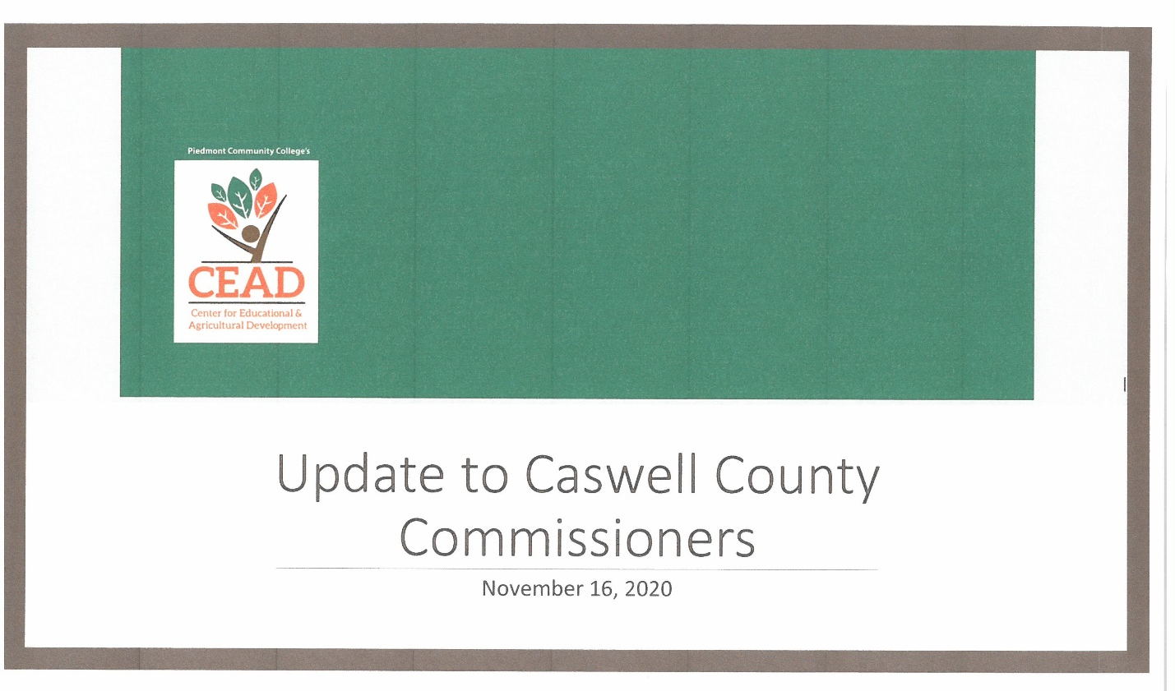
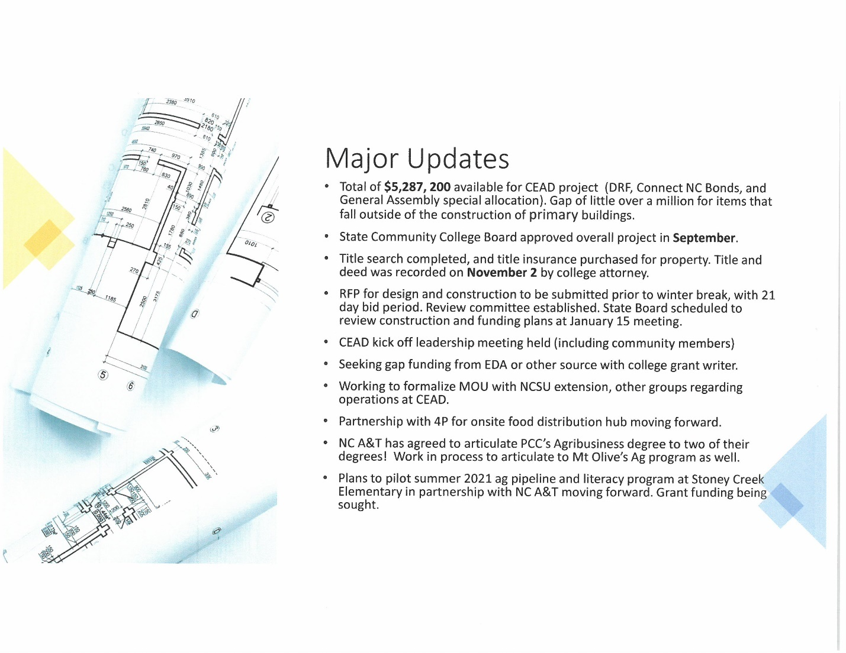

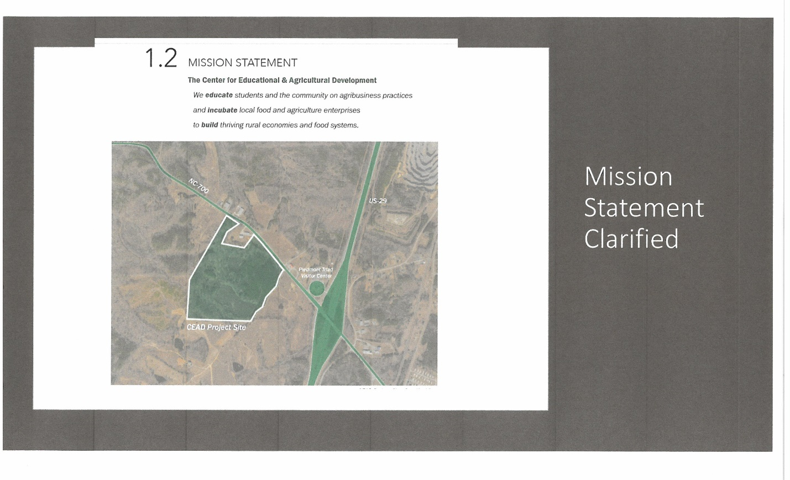

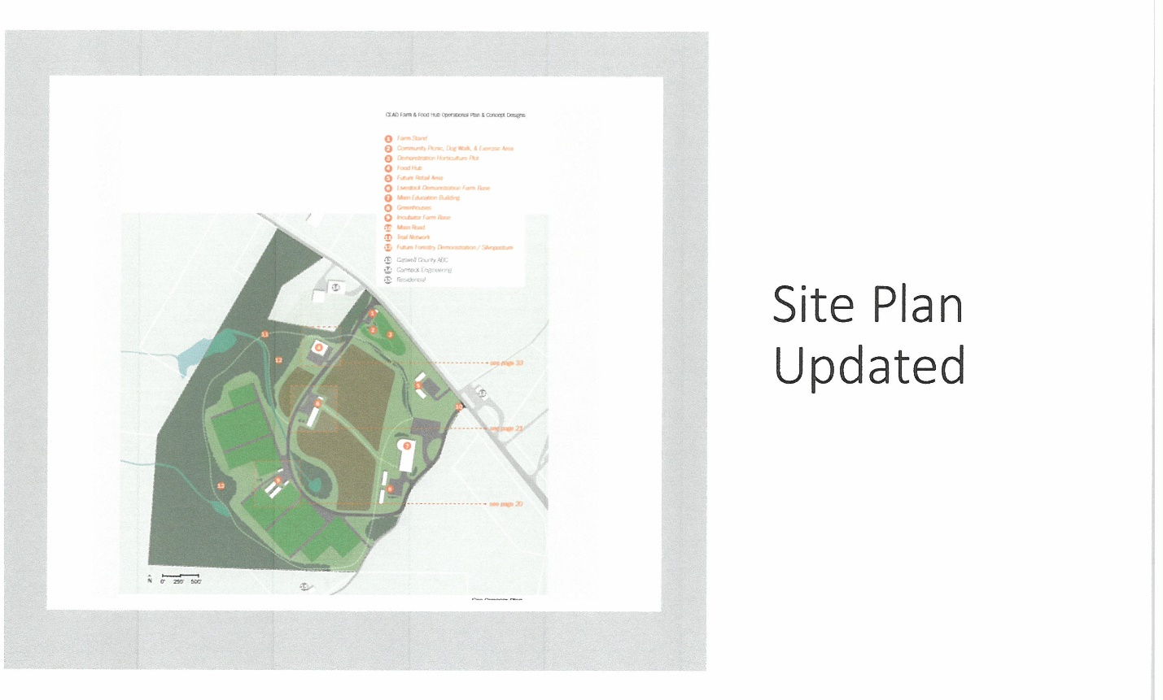

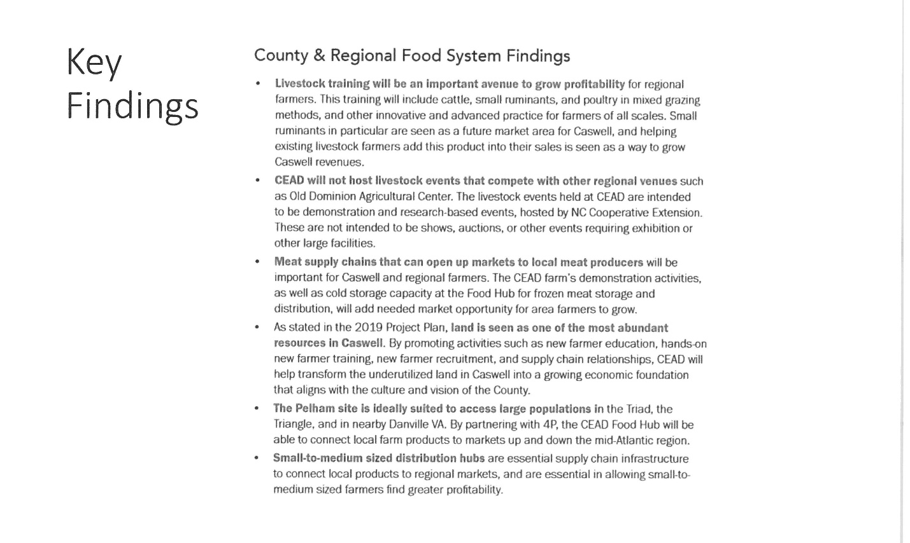

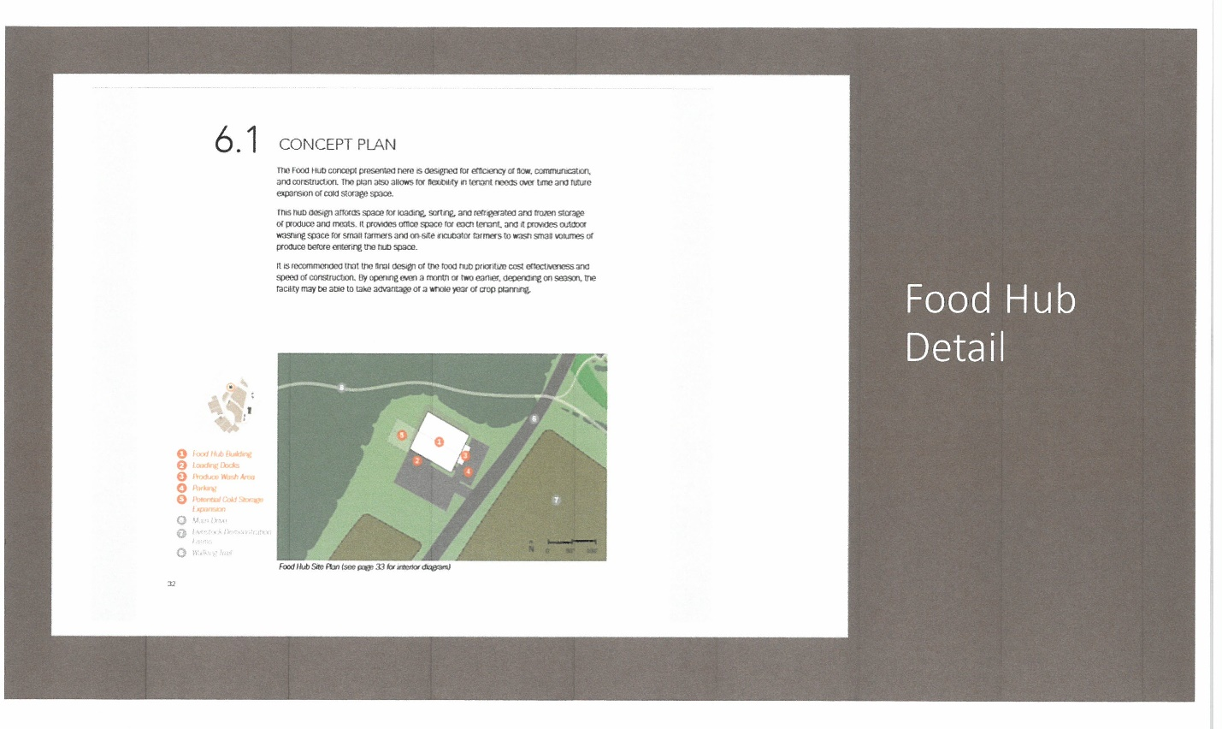

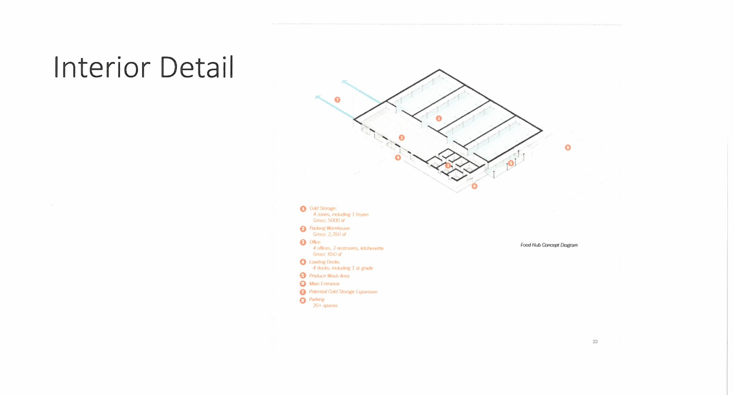

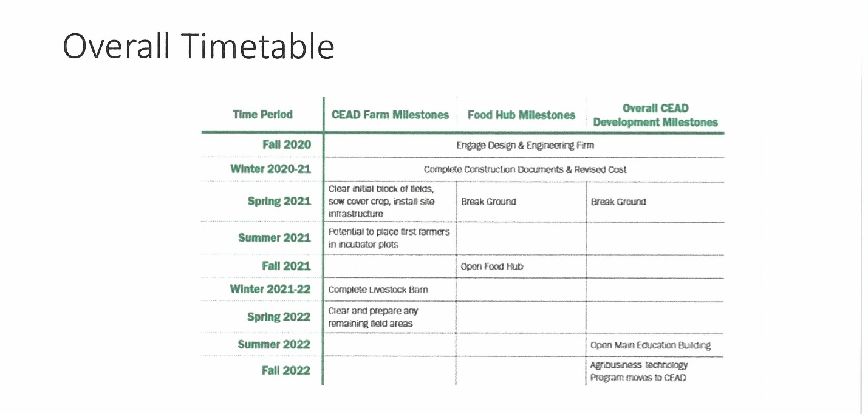
Commissioner Owen thanked Dr. Senegal for doing the presentation so quickly because he had just asked the county manager to get an update about a week and a half ago. He added that he would like for this presentation to be shared with the Board as well as it being put on the County’s website. Commissioner Owen stated that he gets a lot of questions about Project CEAD and this presentation was very informative and would answer a lot of those questions. Dr. Senegal responded that she gets a lot of questions as well. She added that she would email the presentation to the clerk and the county manager as soon as the meeting is over. Dr. Senegal thanked the Board for its support.

HIGH INTENSITY IMPACT ORDINANCE COMMITTEE DRAFT FINAL v (4)

Mr. Miller stated that this was the fourth version of the draft that the Board has seen from the HIDO committee. He added that the Board has heard several public comments about the HIDO draft, and the Board also received information from the Planning Board on its recommendations to the draft of the HIDO ordinance. Mr. Miller stated that a public hearing on the HIDO draft has been scheduled for November 30th at 9:00 a.m. He added that he expected the HIDO committee to meet again before the public hearing.
Commissioner Owen stated that his comment relates to the email received from the Planning Board. He stated that every ordinance that the Board adopts has been reviewed by the county attorney to make sure it meets all the legal requirements but the most important thing that he wants everyone to understand is that agricultural activities such as farming are exempt from the HIDO. Commissioner Owen read an excerpt of the proposed HIDO ordinance ‘Exceptions to Applicability. The following are exceptions, by right, from regulations under this Ordinance:
1) Agricultural Farming Operations; 2) Residential Land Uses; 3) Municipal or Community Drinking Water or Wastewater Treatment Facilities. Exception from this Ordinance does not grant immunity from other applicable Ordinances including, but not limited to, the Caswell County Noise Ordinance, Watershed Protection Ordinance, Flood Hazard Protection Ordinance, etc.’ Commissioner Owen stated that he wanted to mention this because it was mentioned several times in public comments. He added that some of the suggestions from the Planning Board did not have any data or any reasoning for suggesting the changes and he thought this was important. Commissioner Owen stated that he thought the HIDO was a very good ordinance as it is, but he would not be opposed to some of the items that were mentioned in the Planning Board’s suggestions.

Commissioner Oestreicher stated that he was going to just hit the high points of his comments and that he wanted to echo Commissioner Owen’s comments that many of the Planning Board’s comments were short on the rationale as opposed to how the HIDO was drafted. He stated that the first comment received was to not prohibit industry and he pointed out that the HIDO does not prohibit any industry and added that he thought the definition was that industry could not be prohibited. Commissioner Oestreicher stated that the second comment was that the 1800 foot spacing setback would eliminate basically all the parcels within the county and stated that the statement was totally incorrect and offered data that in the county there were 274,000 acres and gave examples of the parcel acreages in the county. He stated that he would not want to consider an affidavit where adjoining landowners could exempt their land from setbacks because this would just be a way to get around the setbacks. Commissioner Oestreicher stated that the HIDO was created by the committee to protect the citizens of Caswell County from polluting industries so the table of classifications and table of industries were very specific and limited, the setbacks were designed to conform with other setbacks that are within the state and designed to protect the citizens of the county. He added that any reductions in those setbacks would reduce the effectiveness of the ordinance. Commissioner Oestreicher stated that the Planning Board and Board of Commissioners has heard over 26 comments and not a one of those comments asked for the setbacks or the acreages to be reduced but several wanted these increased. He stated that he would submit his comments to the clerk for examination later. Commissioner Oestreicher stated that the HIDO committee had researched this and had responded to everyone of the Planning Board’s comments and he fully endorsed the comments by the HIDO committee and invited anyone to listen to the review of this at the next meeting of the committee. He suggested that his comments be read in detail at the November 30th public hearing.

COVID-19 UPDATE

Ms. Jennifer Eastwood, Health Director stated that Caswell County’s current case count is at 726 with 10 people hospitalized, 98 currently in isolation, and 6 deaths. She stated the positivity rate is 7.4% and the County’s rate of infection is one of the highest in the state. Ms. Eastwood stated that some of the urgent care facilities and doctor’s offices are starting to offer antigen test which is a rapid test. She added that the good new about these tests is the individual gets the results in about 15 minutes but the bad news is these tests are only about 60% reliable and that is when a individual has symptoms and if the individual does not have symptoms the test is completely unreliable. Ms. Eastwood stated that the Health Department does not recommend getting the rapid test, they recommend getting the molecular test and these results are coming back within 24 to 36 hours. She also asked the residents to please cooperate with the instructions that are given about isolation and quarantine. Ms. Eastwood stated that isolation is for sick people. She added that a stay at home order allows individuals to go out to do the things that are needed done but true quarantine does not allow individuals to have movement outside of the home, the individual is supposed to be at their house and no around other people. Ms. Eastwood stated that the Health Department is seeing a lot of cases that are coming out of gatherings such as Halloween parties, funerals, and weddings so she asked the public to continue to be mindful of the way individuals gather in groups and stay 6 feet apart, wear a mask or face covering, and wash your hands. She stated that the Board of Health issued a statement asking that everyone work together to get through the virus. Ms. Eastwood stated that this statement has been shared on Facebook from the Health Department’s page and they may investigate getting this information out through a mass mailings and other avenues to the community.

Mr. Miller asked Ms. Eastwood to go over what is being done at the state level as far as the adjustments to Phase 3. Ms. Eastwood responded that last Tuesday the state remained in Phase 3, but mass gatherings are limited back to 10 indoors and 25 outdoors and she believed this was through December 3rd.

EMPLOYEES APPRECIATION LUNCHEON

Mr. Miller stated that as the Board had just heard mass gatherings have been limited to 10 indoors and 25 outdoors so unfortunately this year’s Employees Appreciation Luncheon will not be possible. He added that the Committee always puts in a lot of hard work for this event and the employees will miss this year’s event. Mr. Miller asked the Board for suggestions on the best to show appreciation to the County’s employees or to grant ½ day to 1 day of leave to the employees presumably to be used around the holidays.

Commissioner Carter recommended giving the employees a day off with pay since the appreciation luncheon will not be held this year. Chairman McVey asked Commissioner Carter if this was in the form of a motion. Commissioner Carter stated that this would show the employees the Board’s appreciation.

Commissioner Carter moved, seconded by Chairman McVey to give the County employees a day off with pay in lieu of the employees appreciation luncheon.

Commissioner Owen stated that the luncheon usually takes about 3 hours and he recommended giving the employees a half a day and the majority use this the Wednesday before Christmas and he understood that some would not be able to take off that day. He added that he thought a whole day was a little too much. Commissioner Owen stated that the Board appreciate the employees and he thought the Board had showed its appreciation by giving a 2% raise during the middle of COVID.

Chairman McVey asked Commissioner Carter if he would like to amend this motion. Commissioner Carter responded no that he wanted to stay with the one day since the employees have gone over and beyond in their jobs this year and this would be a good way for the Board to show it’s appreciation.

Commissioner Owen asked how a day off would cost the county. Mr. Miller responded that a day off salary wise would be about $27,000.

After a roll call vote of the motion, the motion failed by a vote of three to four. (Commissioners Carter, McVey and Oestreicher voted in favor. Commissioners Hall, Jefferies, Owen, and Williamson voted against.)

Commissioner Jefferies moved to give the employees a ham or a turkey for their hard work instead of a day off. The motion died due to a lack of a second.

Commissioner Carter moved, seconded by Commissioner Williamson to give the employees a half day off with pay.

Commissioner Oestreicher asked if the Board wanted to specify which day per Commissioner Owen’s comment. Commissioner Owen responded that if this could be done there are some departments that could be shut down at lunch time, but this would be up to the Board. Commissioner Williamson asked for a suggestion from the county manager. Mr. Miller responded that it would be a lot easier to close the buildings all at one time at 1:00 on December 23rd and this would be a lot easier for payroll as well. He added that Emergency Services, some with DSS and the Health Department that may not be able to comply with this but they could use this time whenever it is more convenient but the majority of county offices would be able to shut down early.

Chairman McVey asked Commissioner Carter if he would amend this motion to added that county offices would shut down at 1:00 p.m. on December 23rd. Commissioner Carter agreed.

Commissioner Carter moved, seconded by Commissioner Williamson to give the employees a half pay off with pay on December 23, 2020 at 1:00 p.m. After a roll call vote, the motion carried unanimously. (Commissioners Carter, Hall, Jefferies, McVey, Oestreicher, Owen and Williamson voted in favor.)

COUNTY MANAGER’S UPDATES
CARES Act Spending

Mr. Miller informed the Board that to date the County has spent $294,095.43 of the CARES Act money and the total County allocation was $792,354.22. He added that Milton has spent $8,931.51 and this number may be higher because they recently ordered a Smart Board and a stand so it may be closer to $12,000 to $13,000. Mr. Miller stated that the Town of Yanceyville has spent $60,134.05 and they still have $71,065.56. He stated that the County still has $498,258.79. Mr. Miller stated that over all the County has spent $1,056,472.22 and expended $365,160.99 and the County still has $691,311.22 left remaining. He stated that the County has plans to utilize a large portion of the CARES Act money to help the Health Department in some of its testing activities. Mr. Miller asked Ms. Eastwood to expand on this.

Ms. Eastwood stated that one of the issues is that when the Health Department starts to begin vaccinations it will be the middle of winter so doing a drive thru will be a challenge so one of the things that she looked at purchasing a drive thru tent that also has a connected command center where people can be set up to data entry, etc. She added they will also need a trailer to store this tent and to pull it as well as a truck that will be used by the Environmental Health staff and to tow the trailer. Ms. Eastwood stated that this can also be used for the annual drive thru flu shots to provide the staff with shelter so that they are not out in the cold, wind, or rain. She stated that this will be an inflatable tent that is easy to set up. Ms. Eastwood stated that this can be set up as a mobile clinic if needed or to hold classes as well as population based public health.

Mr. Miller stated that another large expenditure would be to purchase a vehicle for the community health paramedic. He stated that the community paramedic is currently driving one of the old Crown Vic cars. Mr. Miller stated that he believes these are the kinds of items that the CARES Act money was intended to purchase to help provide better healthcare and better response to the citizens.

Mr. Miller stated that Family Services has received $56,603 in CARES Act money to purchase a new minivan, client cost: basic food, shelter and transportation, office rent, office technology and supplies, as well as hazard pay for staff.

Chairman McVey asked if the County would be leasing or purchasing a truck to pull the Health Department trailer. Mr. Miller responded that the County would purchase a vehicle to pull the trailer. Chairman McVey asked if the County already had a truck that was big enough to pull the trailer. Mr. Miller responded that the County does but many times the trucks are utilized by the department they are associated with and the Health Department will need to have a dedicated vehicle. Chairman McVey asked if this would be a ¾ ton or a ½ ton truck. Mr. Miller responded that he was not clear on the specifications of the truck and added that the environmental health director has done a lot of research on the truck. Ms. Eastwood added that the Health Department is looking at a ¾ ton truck. She added that this truck will be used at Environmental Health daily and it will be a huge cost savings when they looked at mileage versus fuel in that department.

Commissioner Owen stated that it is better usage of the CARES Act money if the County purchases the vehicle instead of leasing it. Mr. Miller responded that all the CARES Act money must be spent by December 31st and a lease does not comply with the spending requirements.

Chairman McVey asked if this was the same for the community paramedic. Mr. Miller responded that after several cost comparison the Ford Bronco comes out as one of the least costly vehicles to drive out of the SUVs. He added that Ford has dedicated the sale of the Ford Bronco to go to first response organizations before they are made available to the public.

Commissioner Oestreicher asked if a summary could be prepared on the CARES Act spending on what had already been expended as well as the future plans for spending so it could be shared with the Board and the public. Mr. Miller responded that he would be happy to do that by the next meeting. Commissioner Oestreicher stated that the summary should show people how the money is being spent. Mr. Miller responded absolutely. Commissioner Oestreicher stated that this summary should also include proposed spending. Mr. Miller responded yes.

Board of Adjustment Training

Mr. Miller informed the Board that he had done some research on Board of Adjustment training as suggested by the Board of Commissioners and Mr. Jesse Day with the Piedmont Triad Regional Council has agreed to provide the County with this training. He added that he had sent out an email earlier today with an overview of some similar trainings that he had done in the past and he asked the Board to please review this information. Mr. Miller stated that the training will be tapered to the specific needs of Caswell County so the training will not be exact as the email that was sent out.

Commissioner Oestreicher stated that he believed that he saw the email that was sent out and it stated that that training was for the planning board. Mr. Miller responded right. Commissioner Oestreicher stated that the training would be tailored to the planning board and to a quasi-judicial board. Mr. Miller responded that this is correct. Commissioner Oestreicher asked if this training would be designed for the Board of Adjustment or the Planning Board or used for both. Mr. Miller responded that the training that he suggested to Mr. Day was training specific for presiding over a quasi-judicial hearing. He added that if the Board wanted him to he could put together a joint training for the planning board after the board of adjustment or hold training for the planning board and a quasi-judicial board all at one time. Mr. Miller recommended that the training be just for the Board of Adjustment since it was a new board and that it was a quasi-judicial board. Commissioner Oestreicher stated that he would like to have some consideration for planning board training as a side thought. Mr. Miller responded okay. Commissioner Oestreicher asked that the training be flexible to add modules for the planning board. Mr. Miller responded okay. Commissioner Oestreicher asked if this made sense to the rest of the Board. Commissioner Owen responded that any time there could be training and cross training of more than one group would be good. Commissioner Oestreicher stated that he thought it was worth the extra effort. Mr. Miller responded that this was not a problem.

(Commissioner Carter left the meeting at 10:30 a.m.)

Monument Update

Mr. Miller informed the Board that he had spoken with two separate groups of facilitators. He stated that one was Tim Swantes, and another was Andrew Palmer and he believed that the training could possible be done as early as the week of December 1st through 4th. Mr. Miller stated that he would keep the Board engaged and up to date on the facilitation process.

Commissioner Owen stated that he wanted to go back to his original idea on the Square and he asked for a consensus of interest from the Board about relocating all the monuments that are on the Square. He stated that he thought it would serve a greater purpose for the Square to be used by the community. Commissioner Owen stated that if there is interest in moving all the monuments he wanted to go ahead and get the Monument Committee involved to start talking to various groups about the placements of the monuments and to get the cost on what it would cost to relocate the monuments and if there is no interest then the Board can proceed with the training. He stated that he understood that there was a cost on the facilitation training, but he wanted to get a feel from the Board on relocating all the monuments. Commissioner Owen stated that if the Board wants to relocate the monuments, he did not believe there was a need for the facilitation training.

Commissioner Williamson asked Commissioner Owen if he was going to do a motion. Chairman McVey responded that he was only going to ask for a consensus.

Commissioner Oestreicher stated that he was not sure it needed to be either or because he thought maybe one of the outcomes of the facilitated discussion may be this. Chairman McVey asked if Commissioner Oestreicher still wanted to have the facilitator. Commissioner Oestreicher stated that he did and that one of the objectives that may come out of this discussion may be the relocation of the monuments and the reconfiguration of the Square. Commissioner Owen responded that he understood what Commissioner Oestreicher was saying and added that his first discussion on the Square had nothing to do with the Confederate statue. He added that he had talked to the county manager about this 3 years ago. Commissioner Owen stated that he thought he could make better use of county property to not have monuments there and to place tables and chairs out there so the people can enjoy reading, eating lunch, etc. He added that he did not have a problem with a facilitated discussion, but he thought this process will take longer than the Board thinks. Commissioner Owen stated that he thought it was good to sit down and talk about the differences of opinions and why people feel the way they do. He stated he just wanted to see how the Board felt about relocating all the monuments and if there is no interest, he would not bring it up anymore. Commissioner Owen stated that this was just his vision for the Square. Commissioner Oestreicher stated that it would make sense to see what this would look like and then have it as part of the discussion. He added that he did not see the two as being exclusive. Commissioner Oestreicher stated that if Commissioner Owen was looking for a consensus on what the Square would look like cost wise he was good with that but it would be looked at as a point of consideration that may come up during the facilitated discussion.

Commissioner Owen stated that the Board needs to know what it is going to cost to do the facilitation and he would not vote on this process until he know what it is going to cost. He added that if the Board has a consensus to relocate all the monuments, he did not think there was a need for the facilitation process. Commissioner Owen stated that if the Board would give him a consensus on the relocation of the monuments, he would start the discussion with the Monument Committee.

Chairman McVey asked for a consensus on the relocation of the monuments on the Square.

Commissioner Hall stated that he was a little hesitant to say yes because he was having a problem with the term ‘better use’ because to him it is subjective and added that he would like to hear comments from other individuals on their thoughts on what is a better use. Chairman McVey asked if Commissioner Hall was giving a consensus at this time. Commissioner Hall responded no.

Commissioner Jefferies asked Commissioner Owen if he was talking about removing everything from the Square. Commissioner Owen responded yes; he was talking about relocating all the monuments. Commissioner Jefferies stated that he would go along with removing everything from the Square.
Commissioner Oestreicher stated yes.

Commissioner Owen stated yes.

Commissioner McVey stated yes.

Commissioner Owen stated that this does not necessarily mean this is what is going to be done but this will allow him to get the Monument Committee involved so they can begin to look and discuss with groups that have placed monuments on the Square to see where they could be relocated and then look at the cost of relocating all the monuments. He added that it may be too expensive to remove them all so then the Board will have to discuss how to proceed then. Commissioner Williamson suggested that the owner may want to help with the move of the monument. Commissioner Owen responded that there have been community members or groups that have paid for the relocation of monuments.

Commissioner Hall asked how diverse the Monument Committee was. Mr. Miller stated that off the top of his head this committee is fairly diverse or at least the last time the committee met it was fairly diverse, but he was not sure about the new appointments. Commissioner Hall stated that as these discussions move forward he thought the Board needed to look at diversity in terms of racial diversity, gender diversity, political diversity, geographical diversity, and age and all of this is not in the mix then the answer may be swayed in one particular position or another and that goes back to what he said earlier about the term ‘better use’. He stated that he could look at the committee to see how diverse it is. Commissioner Hall stated that is this is going to move forward progressively then the Board needs to take diversity to heart. Commissioner Owen stated that he agreed 100% and added that when he started working on the Boards and Committees about a year ago one of the things that was done was to look at the diversity in the areas of race, age, geographically, etc.

CARES Act Spending

Mr. Miller informed the Board that the CARES Act money will also be trying to support some of the local feeding sites. He stated that some of these sites have been identified and he will be reaching out to those place that are known to have served food during COVID-19 to the community to have them to submit applications. Mr. Miller stated that a copy of the application will be put on the County’s website and maybe a notice in the newspaper to solicit any applications from organizations that the county may not be aware of that distributed food during COVID-19.

Commissioner Owen thanked the county manager and the group that decided that this was something that needed to be done because the county does have good pantries and people that have been feeding people since COVID started and they are still getting food to those that can’t get out and now with Thanksgiving and Christmas coming up there is a real need to try to help these groups out.

Notice of Intent to Sell County Property

Mr. Miller informed the Board that the county has entered into the negotiated offer upset bid process with Wells & West, the group that the Board approved to purchase 8 ½ acres in the Pelham Industrial Park. He added that there will be a notice in this week’s newspaper that will outline the process and to solicit any upset bid. Mr. Miller stated that the clerk to the Board has received a 5% initial down payment from Wells & West, so this is moving forward.

Economic Development Presentation

Mr. Miller informed the Board that the Economic Developer Cori Lindsay gave an impressive presentation at the last EDC meeting and one of the things that he thought was very interesting was the thought process of economic development purposes. He added that basically two criteria are used to judge economic development purposes and those are the number of jobs and capital investment but after this presentation he thought everyone saw a shift not just in Caswell but a shift statewide and maybe even nationally to incorporate natural capital, how it affects the environment; social capital, how it affects us socially; human capital; cultural capital; political capital; and then as he said earlier financial and real capital. Mr. Miller stated that as the county moves forward these are the things that will be looked at when making decisions on economic development.

Mobile Entrepreneurship Week

Mr. Miller stated that today is day one of Mobile Entrepreneurship Week and he thought it was important to recognize this because it is also day one of Co-Square opening and he invited members of the public to go through Co-Square in groups of 10 or less to see the facility. He added that he was sure the economic developer would be happy to sit down and speak with individuals about the facility.

COMMISSIONER COMMENTS

Commissioner Williamson stated “To Commissioner Jefferies, Commissioner Hall, Commissioner Carter, Commissioner Oestreicher, Commissioner Owen, and Chairman McVey, I thank y’all for accepting me in this interim position for over the last 3 months. It’s been good to be with you guys. I feel like that y’all have the county in mind, not working for yourselves but you are working together to move this county forward. The four years that I wasn’t here you kept things going as far as the projects that you are working on, I appreciate you for staying with that and I encourage you to stay with it in the next four years moving this county forward and helping out the citizens of this county. To educate our youth, very important, put the money in our youth and we will benefit that in the upcoming future. The project out at PCC, the high schools, for what you have done for the Health Department, the public projects, y’all have had a lot. And I would also like to say to our staff, to Mr. Miller, our county attorney and all of your staff thank you for the support that you have given me and thank you for everything that you have done for the public. Thank you for supporting me during this time.”

Commissioner Owen stated that the Board may want to think about starting a capital fund.

Commissioner Oestreicher stated that the moratorium was set to expire on January 6th. He added that when the moratorium was put into place the county planned to have informational sessions for the public on how to protect the citizens of the county and how to enhance the rural and agricultural nature of the county however due to COVID those sessions had to be cancelled. Commissioner Oestreicher asked the Board to consider extending the moratorium to give staff more time to conduct those informational sessions, to look at the results of the zoning referendum, and to reconsider some of the proposals that had been put forth by some of the districts on ways to manage the protections that they desire. Commissioner Oestreicher asked the county attorney what some of the issues were associated with extending the moratorium for 6 months to give staff time to fulfill the mission of the moratorium.

Mr. Ferrell stated that when the moratorium was adopted it was discussed about the length of time that it would be effective and one year is generally looked at as the outside limit for a moratoria but no one predicted what the county would be facing from March to date so this was something that he would have to look into. He stated that the county may have to go through another public hearing process but if this was something that the Board is considering he would look into the logistics of procedural requirements for extending the moratoria and bring that information back to the Board.

Commissioner Oestreicher stated that he would be in favor of this and that it was something that would be warrantied.

Commissioner Owen stated that he was good with him for the county attorney to investigate this.

Chairman McVey stated that it was good with him as well.

Commissioner Oestreicher asked if a Board consensus was necessary. Commissioner Owen responded that unless there was an objection it would not be necessary. There were no objections. Commissioner Oestreicher thanked Mr. Ferrell for his comments and added that he looked forward to Mr. Ferrell’s comments at the next meeting. Mr. Ferrell responded thank you.

Chairman McVey thanked Commissioner Williamson for everything he had done.

ANNOUNCEMENTS AND UPCOMING EVENTS

A. Caswell County Blood Drive – Wednesday, July 15, 2020 – 9:30 a.m. –
2:30 p.m. – Senior Center (Red Bus)

CLOSED SESSION

Commissioner Owen moved, seconded by Commissioner Williamson to go into closed session to consider the compensation, terms of appointment and performance of an individual public officer (NGS 143-318.11(a)(6)). After a roll call vote, the motion carried unanimously. (Commissioners Hall, Jefferies, McVey, Oestreicher, Owen, and Williamson voted in favor.)

ADJOURNMENT

At 11:30 a.m. Commissioner Jefferies moved, seconded by Chairman Owen to adjourn. After a roll call vote, the motion carried unanimously. (Commissioners Hall, Jefferies, McVey, Oestreicher, Owen and Williamson voted in favor.)

________________________________ ___________________________
Paula P. Seamster Rick McVey
Clerk to the Board Chairman

******************************************************************************

