MINUTES – JANUARY 21, 2020

The Caswell County Board of Commissioners met in regular session at the Caswell County Historic Courthouse in Yanceyville, North Carolina at 6:30 p.m. on Tuesday, January 21, 2020. Members present: Rick McVey, Chairman, David Owen, Vice Chairman, Sterling Carter, William E. Carter, Nathaniel Hall, Jeremiah Jefferies and Steve Oestreicher. Also present: Bryan Miller, County Manager and Brian Ferrell, County Attorney. Paula P. Seamster, Clerk to the Board, recorded the minutes.

WELCOME
MOMENT OF SILENT PRAYER

Chairman McVey opened the meeting with a moment of Silent Prayer.

PLEDGE OF ALLEGIANCE

The Board of Commissioners and all the guests in the audience recited the Pledge of Allegiance.

PUBLIC COMMENTS

Chairman McVey opened the floor to Public Comments.

Mr. John Dickerson came before the Board and made the following statement:

“Hi, my name is John Dickerson and I reside at 7326 Blanch Road, Blanch, North Carolina and I come to you tonight to ask you to support and pass this resolution to make Caswell County a Second Amendment Sanctuary County. As we have witnessed over the past weeks and months Virginia’s attempt to restrict gun owners’ rights and circumvent the second amendment to our constitution, we need to protect our rights as citizens of this county. As you may be aware, several other North Carolina counties have passed or are in the process of passing similar resolutions. I present this resolution to you for your consideration. I strongly urge you, as the Caswell County Board of Commissioners, to show your support for our constitutional rights and pass this resolution declaring Caswell County’s support for protection of our second amendment rights.” Mr. Dickerson gave the Board a copy of the resolution.

Mr. Phil Barfield came before the Board and made the following statement:

“I had an opportunity to present these comments to the Planning Board and I would like to represent them here tonight to the Board of Commissioners. Good afternoon, my name is Phil Barfield and I live at 910 Melvin Wrenn Road, Yanceyville. I come before you this afternoon to voice my opposition to the construction and operation of the asphalt plants and quarry in our county. I oppose them because they are an environmental danger to humans, plants, and animals. I have numerous concerns about the projects shared by others. They are too many to read here today, so I am providing copies to the Board for inclusion into the record. They include concerns about pollution, fires, noise, smell, roads, traffic, wells, agriculture, wildlife, environment, zoning and the enjoyment of one’s property. These are not just my concerns. These are concerns voiced by citizens at the quarry mine hearing on November 4th of last year, at community meetings, from our ProtectCaswell online group, and from the North Carolina Department of Environmental Quality. These lists can also be found on the ProtectCaswell.org website. Without zoning, the public must rely on a notice in the local newspaper, social media, or word of mouth to know about an industry like this coming into our county. Then we must individually investigate to find out what this means, how it impacts us, and how to have our concerns addressed before permits are issued. This is clearly to the company’s advantage because they can have their key permits processed out of our sight at the state level without review and determination by our local government or by public comments from our citizens. In my opinion, this is what happened with the approval of the asphalt plant on Wrenn Road. Until we have zoning, we need a better process. For now, that process is found in our Environmental Impact Ordinance. It mandates that an Environmental Impact Statement (EIS) be accomplished for the quarry. An EIS should provide a full and fair discussion of significant environmental impacts and include local and state review and a public hearing. For the reasons provided to you in the lists of concerns, we should have EISs accomplished for the asphalt plant sites since they are anticipated to have significant impacts. Please note that if the company is unwilling to provide EAs and EISs or does not provide complete EAs and EISs, our Environmental Impact Ordinance allows for enforcement. Therefore, I stand before this Board and respectfully: Demand Environmental Assessments (EAs) and Environmental Impact Statements (EISs) be accomplished per the county’s Environmental Impact Ordinance. I request EISs be accomplished in addition to EAs for the asphalt plants. I request EISs to be complete and address all concerns of citizens. I request the Board to ensure public notices, state review, and public hearings are accomplished for the EISs. I request the Planning Department not process any county permits or allow construction at the quarry and asphalt plant sites per the moratorium and the ordinance. I request the Board require the County to file injunctions and seek equitable relief per the ordinance if the company is not meeting the EA and EIS requirements. Thank you.”

Mr. Edward Heintz came before the Board and made the following statement:

“Commissioners, County citizens, first of all I want to thank you all for letting us have a minute to speak. Secondly, I want to thank Mr. John Dickerson back here for bringing to the floor a resolution for a Second Amendment Sanctuary. The citizens of this County are very much supportive of such an amendment and the second amendment is very important to each of us as well as to each of you because I know each of you and a lot of you do hunting and you each have guns as well, firearms of some sort to protect yourselves and family. So I strongly urge the County Commissioners to adopt this resolution submitted by Mr. John Dickerson, adopt it, pass it, and make us a second amendment county so that we can have our sanctuary to protect ourselves until further laws may be implemented. Right now we all are working under the constitution, it’s our constitution and the second amendment belongs to us. It does not belong to anyone of you, it belongs to everyone in this building, we the people, so the urgency of this is important and that we fall in line with the other counties that have now joined the rank and file of the second amendment sanctuary’s and once again I urge you to take heed and join in with us and pass this resolution tonight is possible. Thank you.”

Ms. Leslie Zimmerman came before the Board and made the following statement:

“Leslie Zimmerman, 732 Solomon Road, good evening. We are hoping to hear your dates for presenting zoning education to the county’s citizens as stated in the moratorium. These dates cannot be tabled until the next week’s agenda, let’s not waste any time.”

Chairman McVey asked if there was anyone else that would like to speak during Public Comments. With no further comments Chairman McVey closed public comments.

RECOGNITIONS

Commissioner S. Carter stated “Yes sir. I have a resolution honoring the life and service of James Yancey Blackwell who was both a member of this Board and the Board of Education. If there’s no objection I’m going to read this resolution, I would like to read it.

A RESOLUTION
HONORING THE LIFE AND SERVICE OF
JAMES YANCEY BLACKWELL, Jr.

WHEREAS, James Yancey Blackwell, Jr. was born on May 7th, 1928 in Caswell County to the late James Yancey Blackwell, Sr. and Alice Taylor Blackwell, and passed away on January 4th, 2020, and

WHEREAS, James was the devoted husband of Nettie Dameron Blackwell of 63 years, and the loving father of Susan Blackwell Crawford, James Russell Blackwell and John Reid Blackwell; and

WHEREAS, James attended Caswell County Schools, Lee McRae College and the University of North Carolina at Chapel Hill; and

WHEREAS, James was a proud and hardworking farmer and faithfully served his country in the United States Army; and

WHEREAS, James was an active citizen as a member of the VFW, American Legion and Ruritan Club as well as providing faithful service on the Board of Directors of Annie Penn Hospital, the Caswell County Medical Center Board and the Board of Directors of Wachovia Bank, First South Bank and American National Bank; and

WHEREAS, James faithfully served the citizens and children of Caswell County on the Caswell County Board of Commissioners from 1962 to 1970, serving as Vice Chairman for four years and as a member of the Caswell County Board of Education from 1974 to 1992 serving as Chairman; and

WHEREAS, James, through his passionate and selfless service as County Commissioner and as a member of the Caswell County Board of Education, willingly gave of his time, resources, guidance, wisdom, and knowledge, helping lead Caswell County through a great era of progress and serving countless generations;

NOW, THEREFORE, BE IT RESOLVED, that we the Caswell County Board of County Commissioners do hereby honor the life and service of James Yancey Blackwell, Jr. and as representatives of the citizens of Caswell County, offer our affectionate support and sincere condolences to the Blackwell Family at this time.

And I would entertain that we adopt the resolution.”

Commissioner Hall stated “Mr. Chairman, just a point of order, I will be speaking to this a little later, according to our Rules of Procedure resolutions of this sort, ordinances, and any other type of order must be on the agenda number 1 and if they are on the agenda then the Board has the option with 100% of the members voting for but this item was not even on the agenda.” Chairman McVey responded “Yes sir, so I don’t guess we can vote on it right now.”

Commissioner S. Carter stated “I had asked the clerk whether or not this issue could be on the agenda and whether or not it could be included in recognitions and I was told that you could do both. It is neither here nor there. I am happy to add this to the next agenda. I just think something should have been said, this gentleman passed away rather recently but it doesn’t offend me to put it on the next agenda.” Chairman McVey responded “Why don’t you put it on the next agenda since it is not on this agenda.” Commissioner S. Carter continued “Do you need a motion for that? Thank you for allowing me to read it.”

Chairman McVey asked “Do you have any more?” Commissioner S. Carter responded “I do not.”

ACTION ITEMS
APPROVAL OF AGENDA

Commissioner Jefferies moved, seconded by Commissioner Owen to approve the agenda. The motion carried unanimously.

APPROVAL OF CONSENT AGENDA

Commissioner Owen stated “Mr. Chairman, I just have a slight correction on the January 6the packet under For The Record. The third line down in that information should read ‘I went to see our county manager not asking for proof’ so there is just a change in how it was worded and I’ve already given this to the clerk and she has taken care of it on the normal minutes but I wanted to make the Board aware of it, there was a change.”

Commissioner Oestreicher stated “I have two changes that I proposed, on page 23 of the packet the minutes of the January 6th meeting about the 1, 2, 4th paragraph half about three quarters of the way down, it says ‘Ms. Zimmerman stated that the Board can “draft” their feet every two weeks’ I believe the word should be “drag”. I can’t imagine drafting our feet; I suspect the recording is at fault for that one.” The clerk responded “No, it was my fingers.” Commissioner Oestreicher continued “What…okay. The page 32 on the 7th January meeting this could be my mouth but it says here that ‘5% of the rock quarry residents are in his district’ what I meant to say was ‘5% of the rock quarry property is in my district’. Considerably more than 5% of the residents are in my district. That’s all I have.”

Commissioner Owen moved, seconded by Commissioner S. Carter to approve the Consent Agenda as amended. The motion carried unanimously.

The following items were included on the Consent Agenda:

A. Approval of Minutes of January 6, 2020 Regular Meeting
B. Approval of Minutes of January 7, 2020 Special Meeting
C. Approval of Capital Project Ordinance – 2019 Bartlett Yancey High School
Construction Project

USDA LETTER OF CONDITIONS – BYHS CONSTRUCTION AND RENOVATION PROJECT

Mr. Ty Wellford stated that this is a follow up to the presentation from last spring when he gave the Board two different financing options the County has related to a portion of the Bartlett Yancey High School project. He asked Mr. Miller if there was anything he wanted to add before he started. Mr. Miller responded that the Board had asked Davenport and Mr. Wellford to attend tonight. He added that the Board has two financing options for the Bartlett Yancey High School construction and renovation project and Mr. Wellford will go over both options at a very high level review and give the Board the option to ask questions. Mr. Miller stated that after Mr. Wellford finishes Mr. Tobais Fullwood with USDA will speak to the Board about the Letter of Conditions and the Board will need to make a decision one way or the other tonight on a public issuance or USDA. He added that if the Board choses USDA then the Board will need to approve the Letter of Conditions which will set the rate at 2.75% and then he asked the Board to take a recess so the paperwork could be signed.

Commissioner Oestreicher asked if it would make more sense to hear from the USDA first. Mr. Miller responded that he arranged this agenda item the way it current is so the Board can hear both financing options before the Board hears the actual conditions laid out from the USDA but the Board could which those if it so choses.

Chairman McVey instructed Mr. Wellford to continue.

Mr. Wellford stated that the presentation was included in the Board packet but he is going to go through it at a fairly high level. The presentation is attached below.

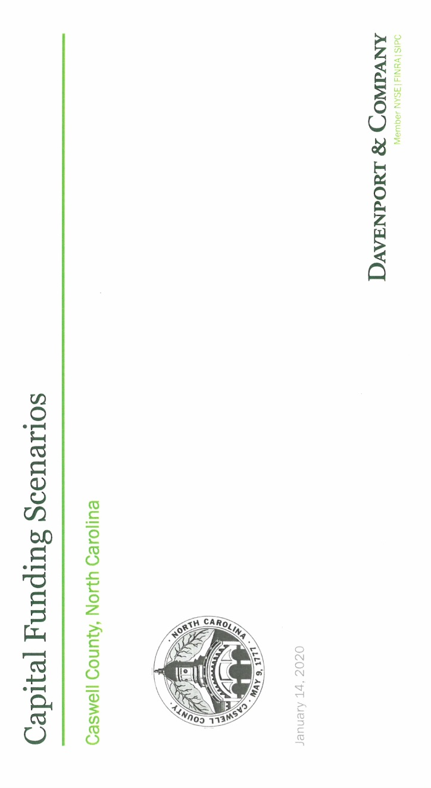

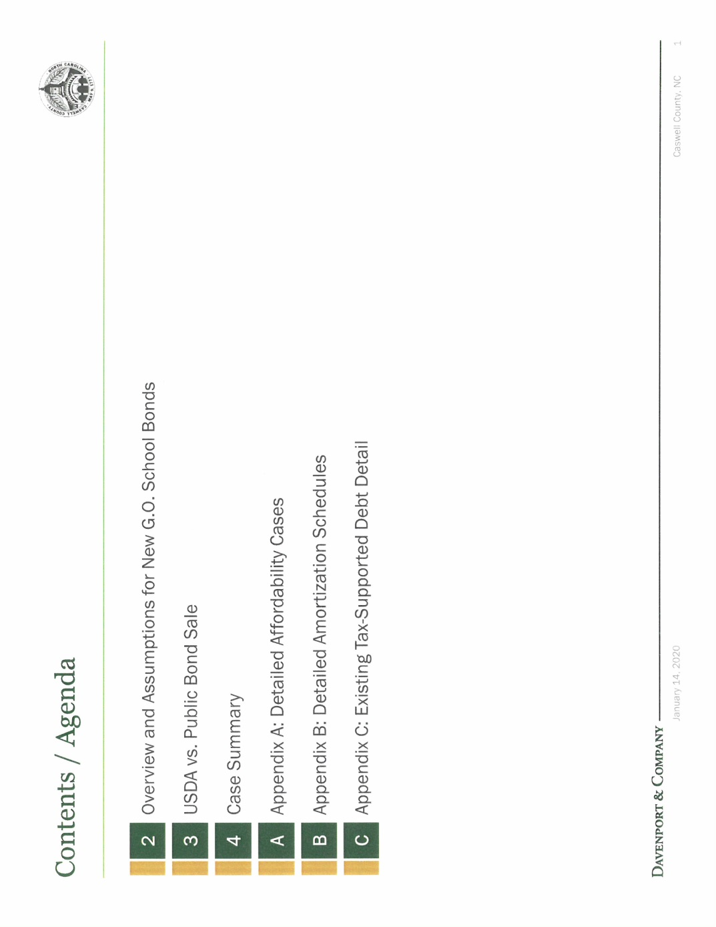

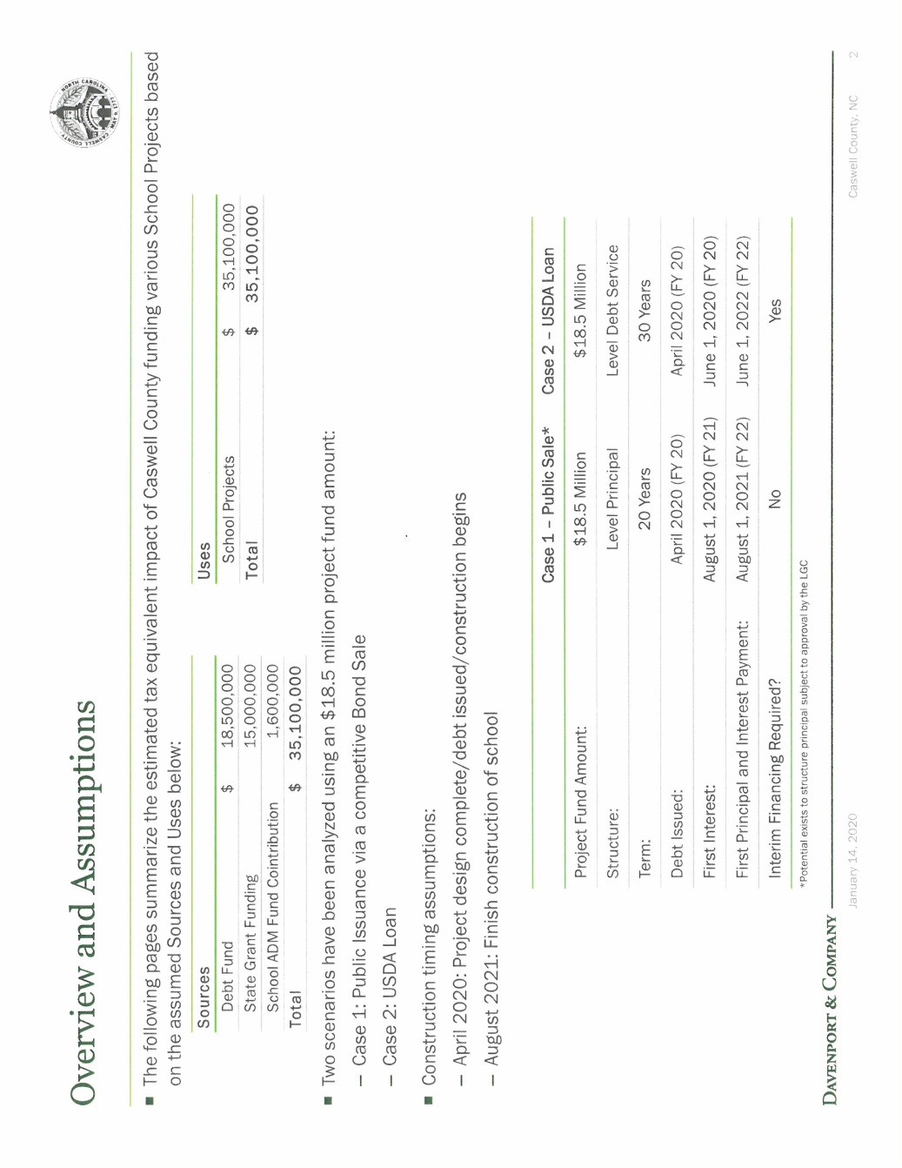

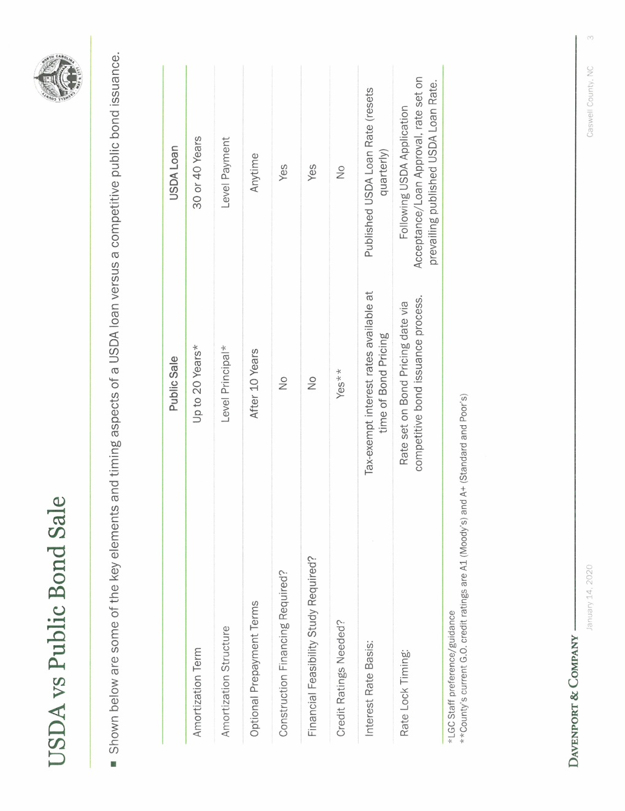
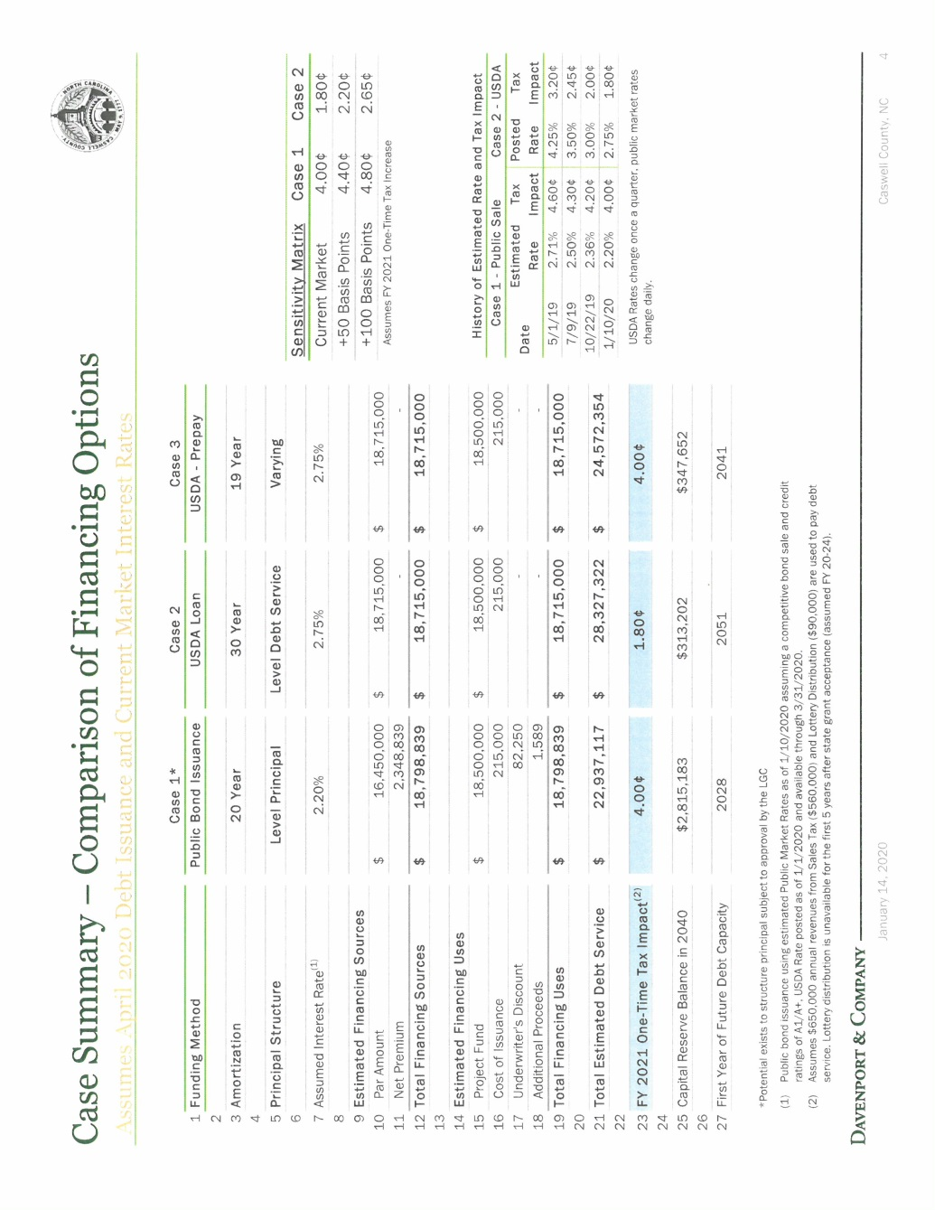

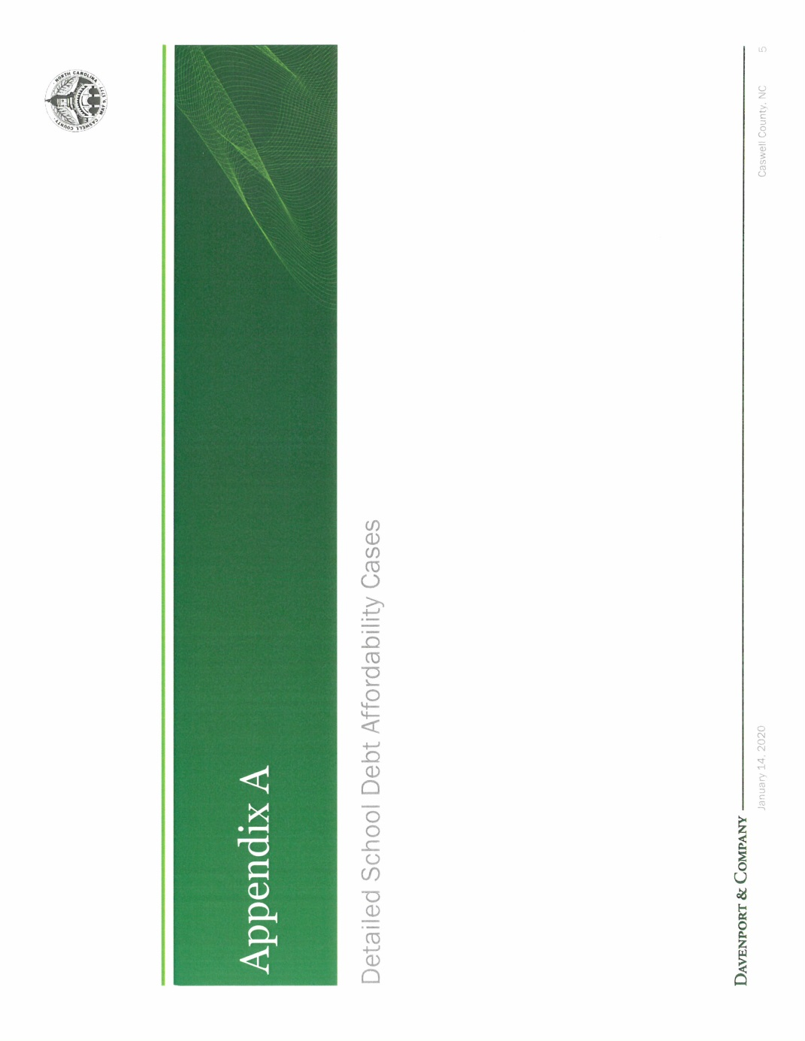
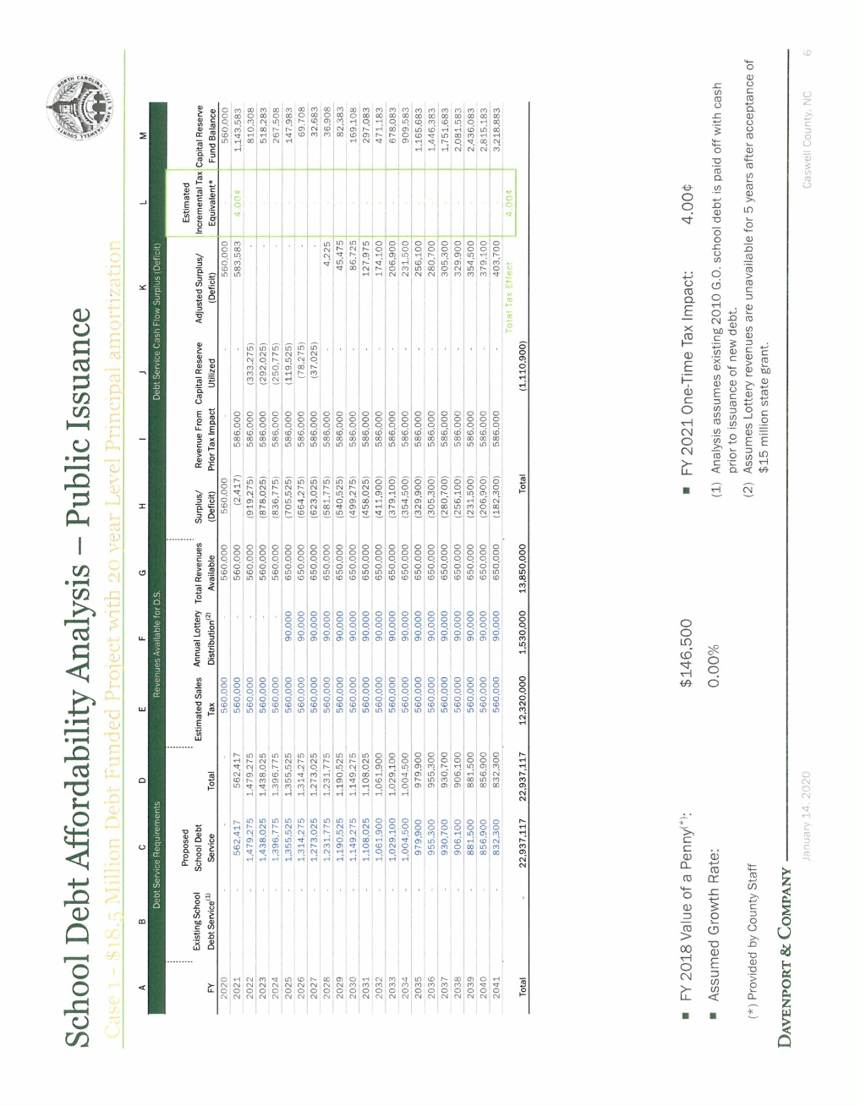
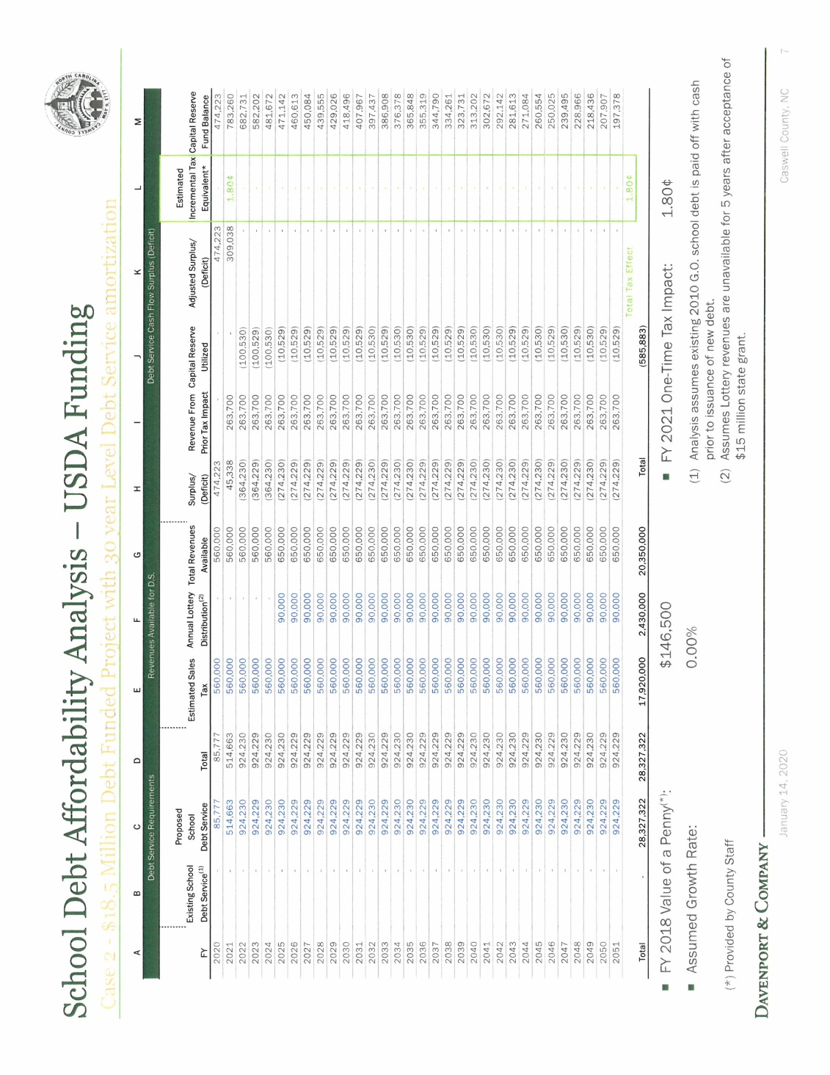
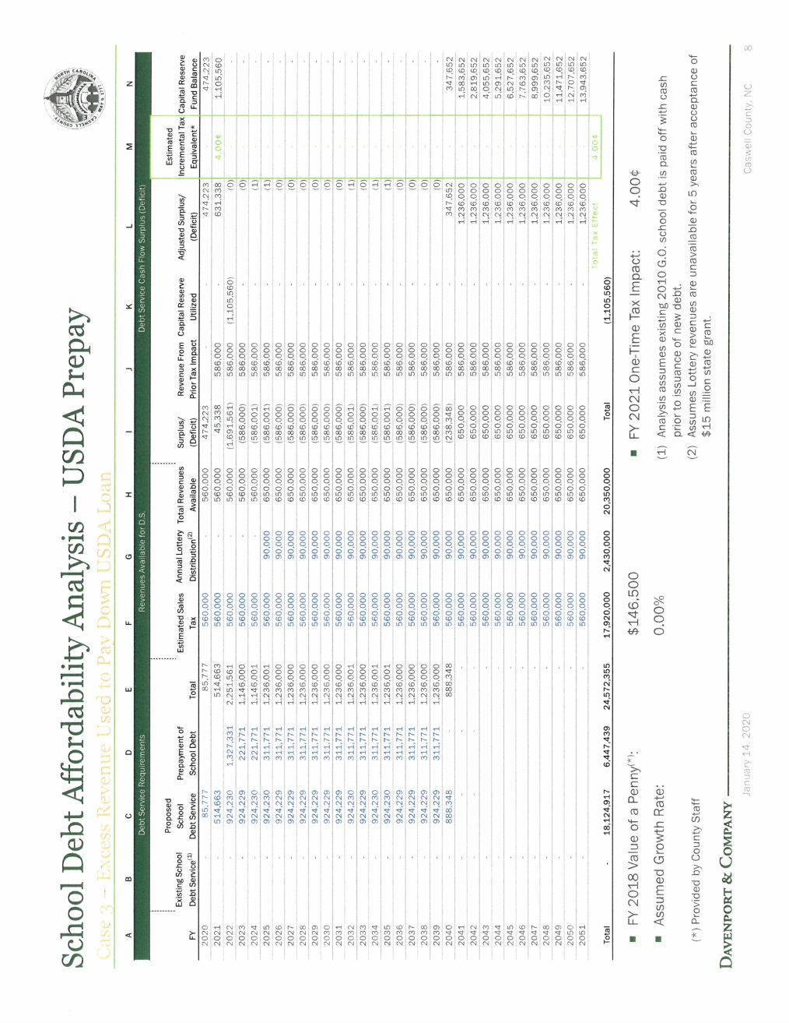
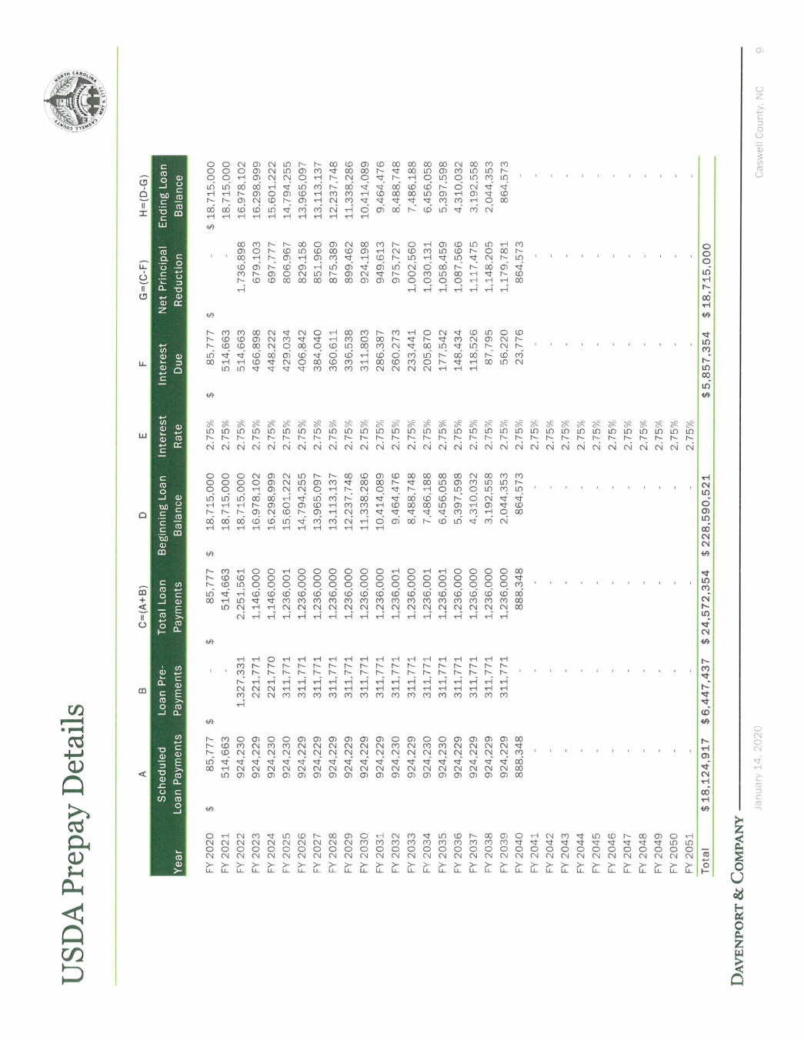

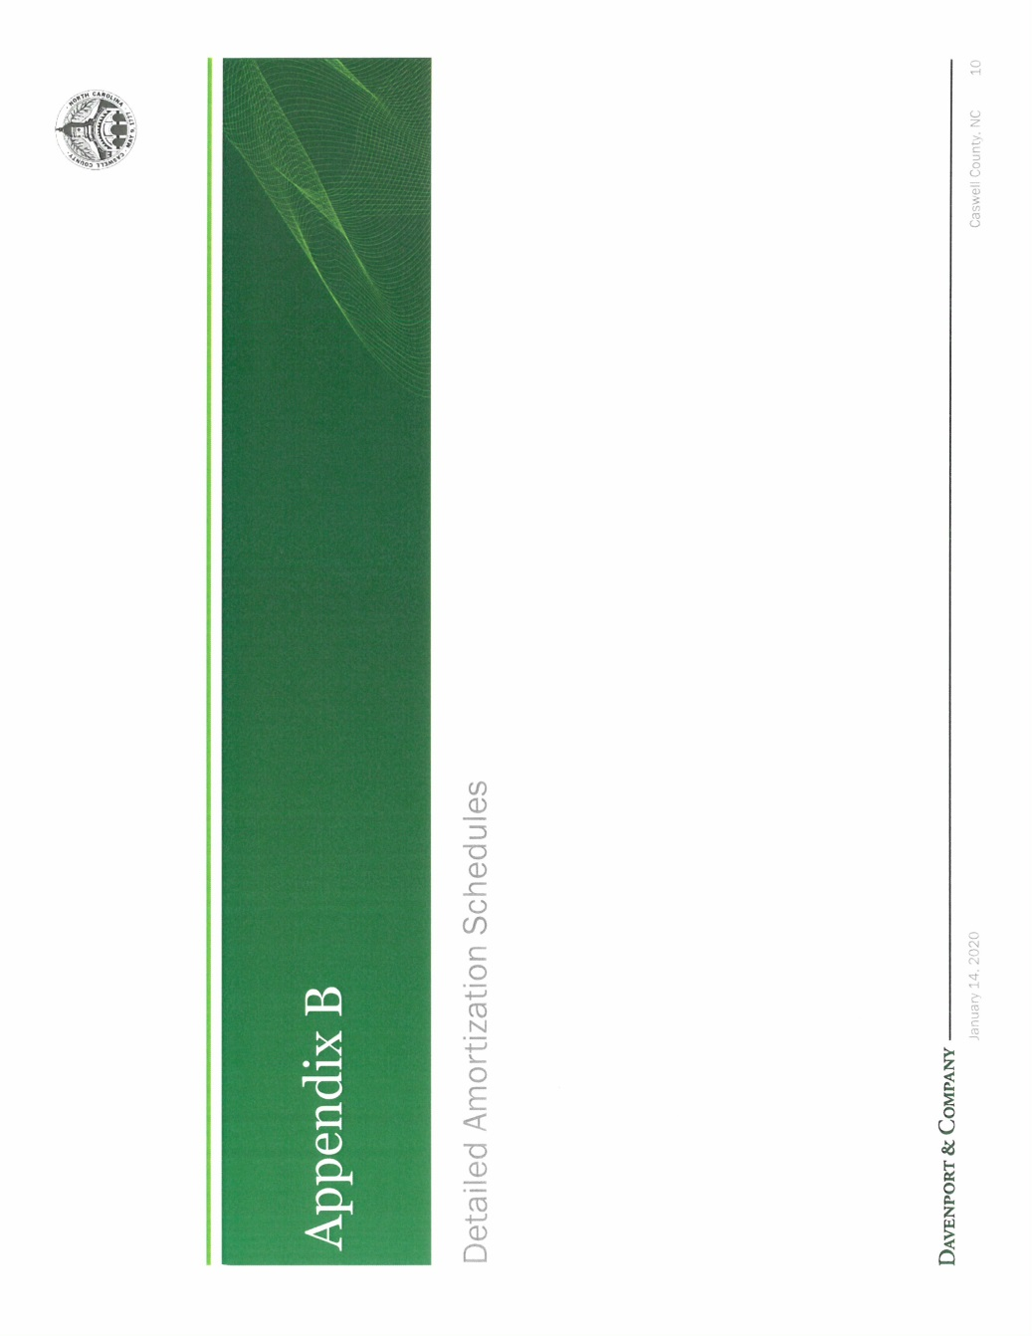

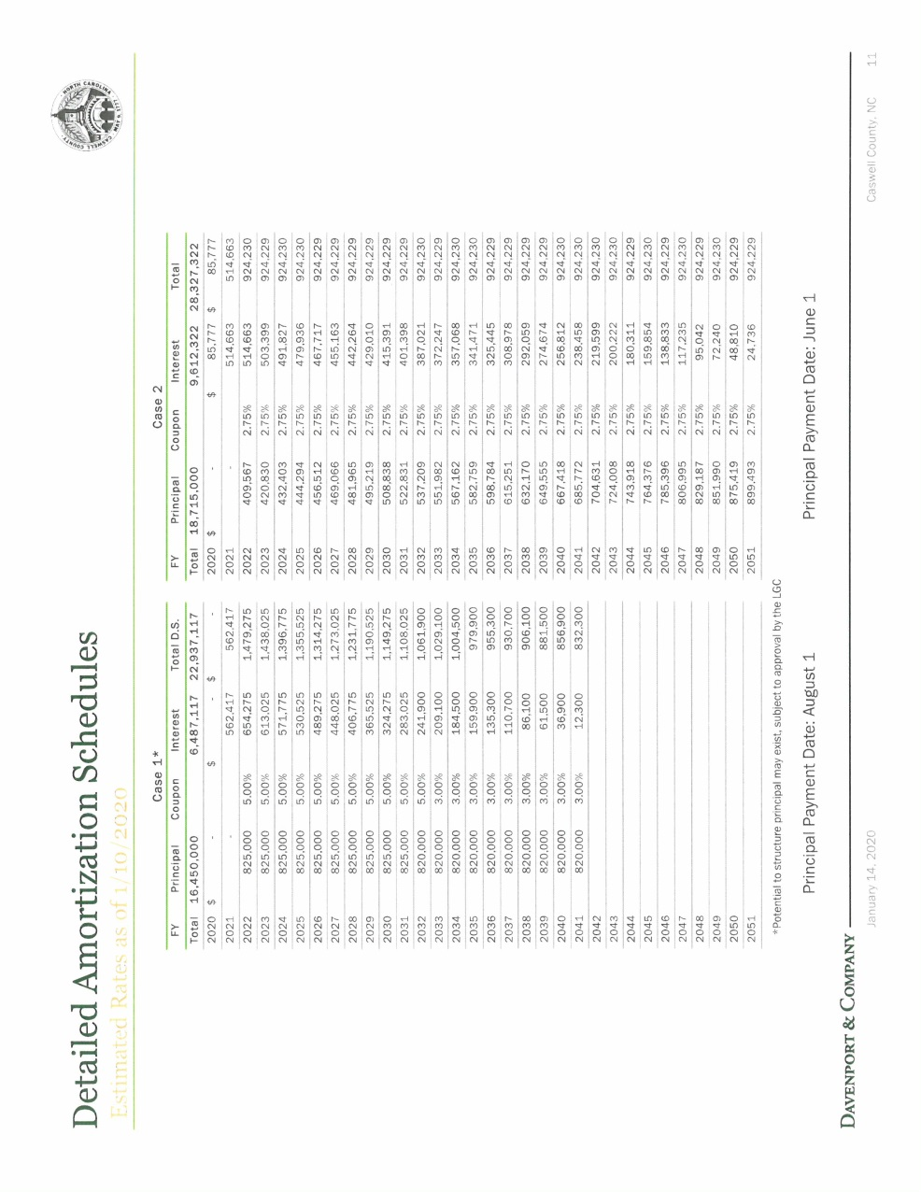

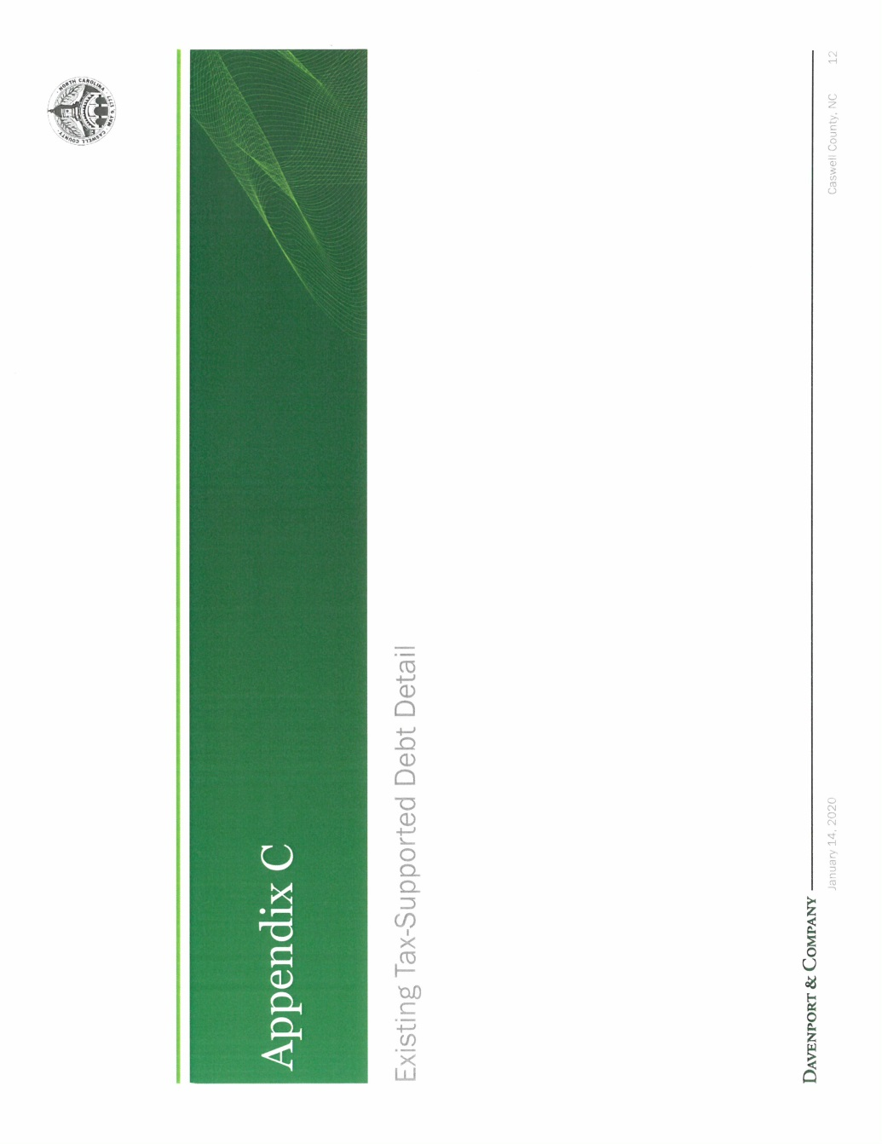

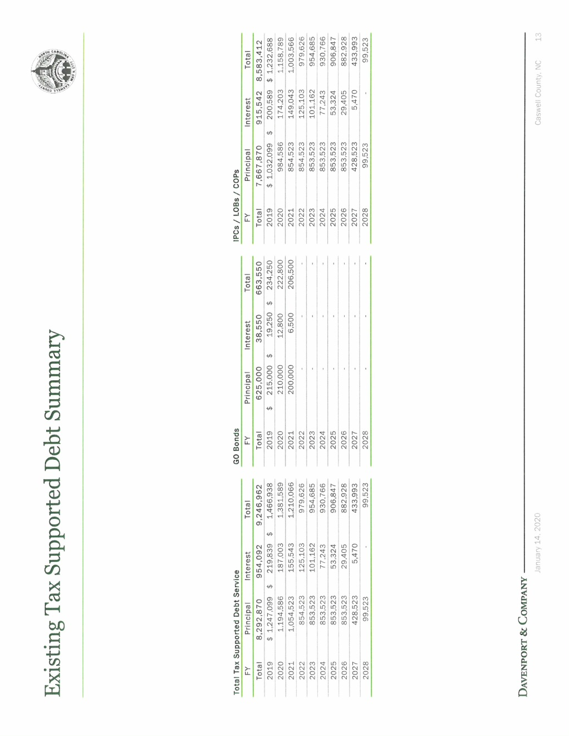

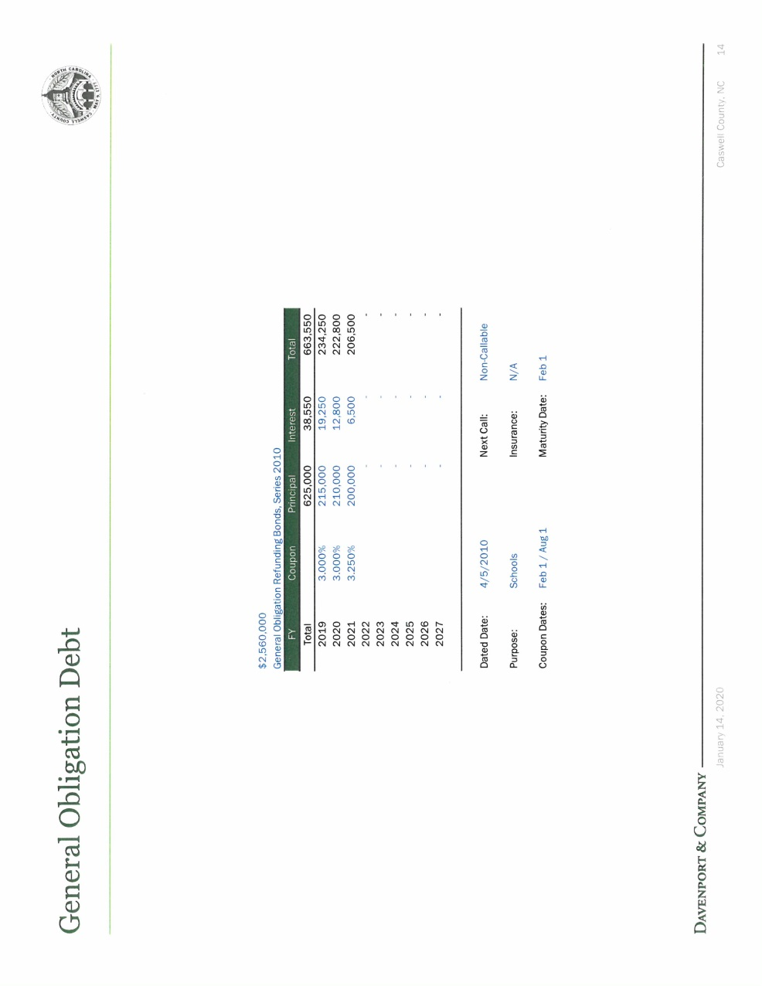

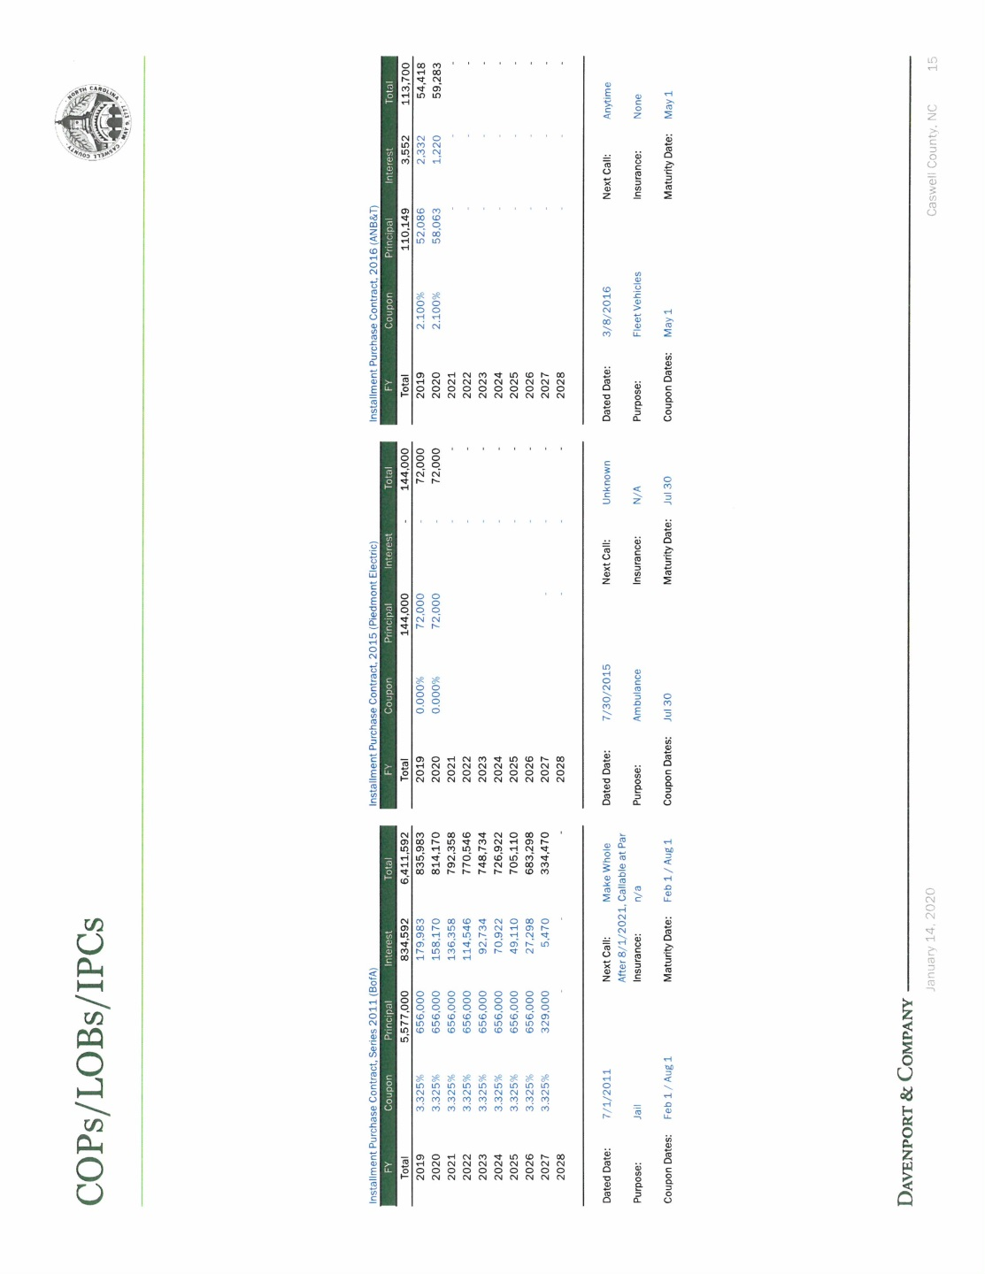
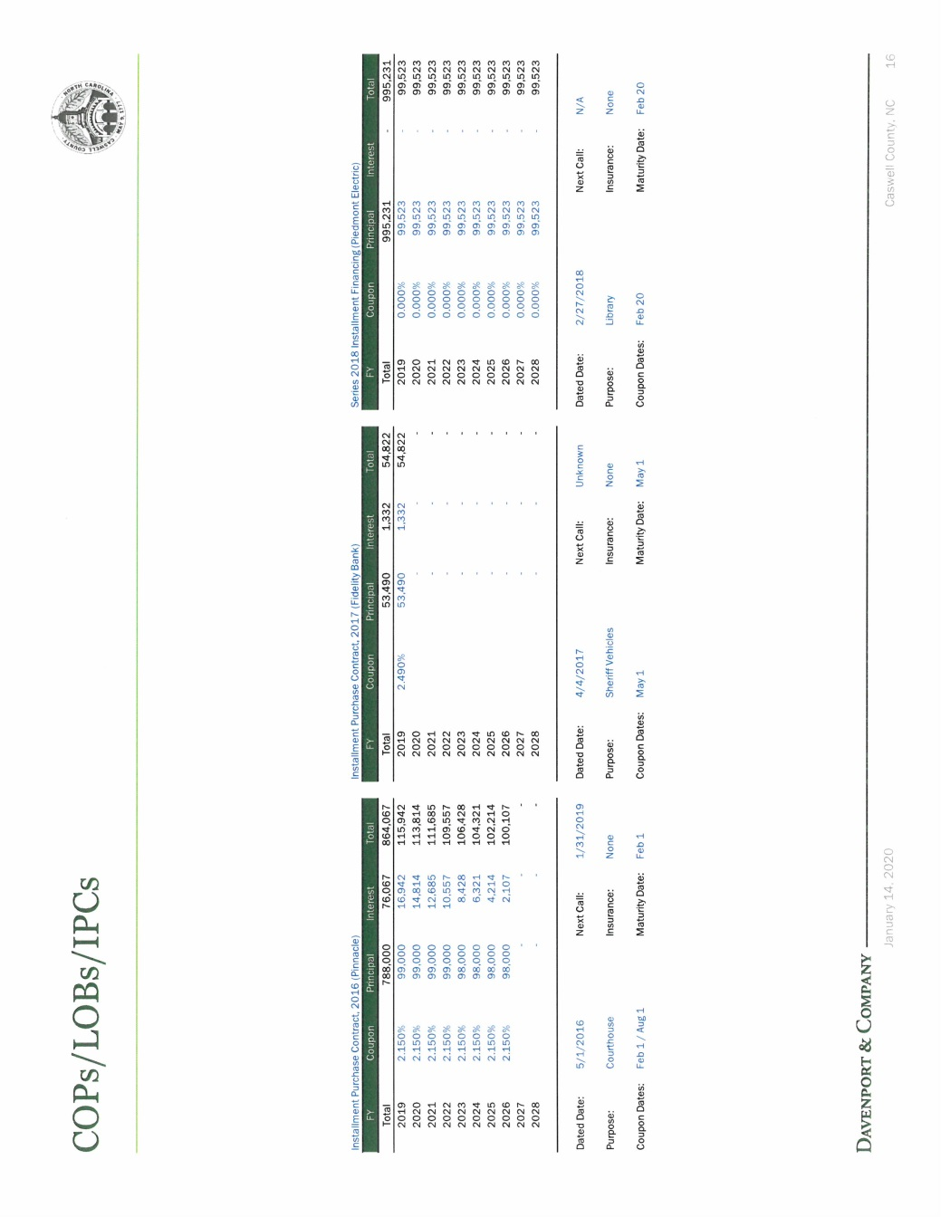

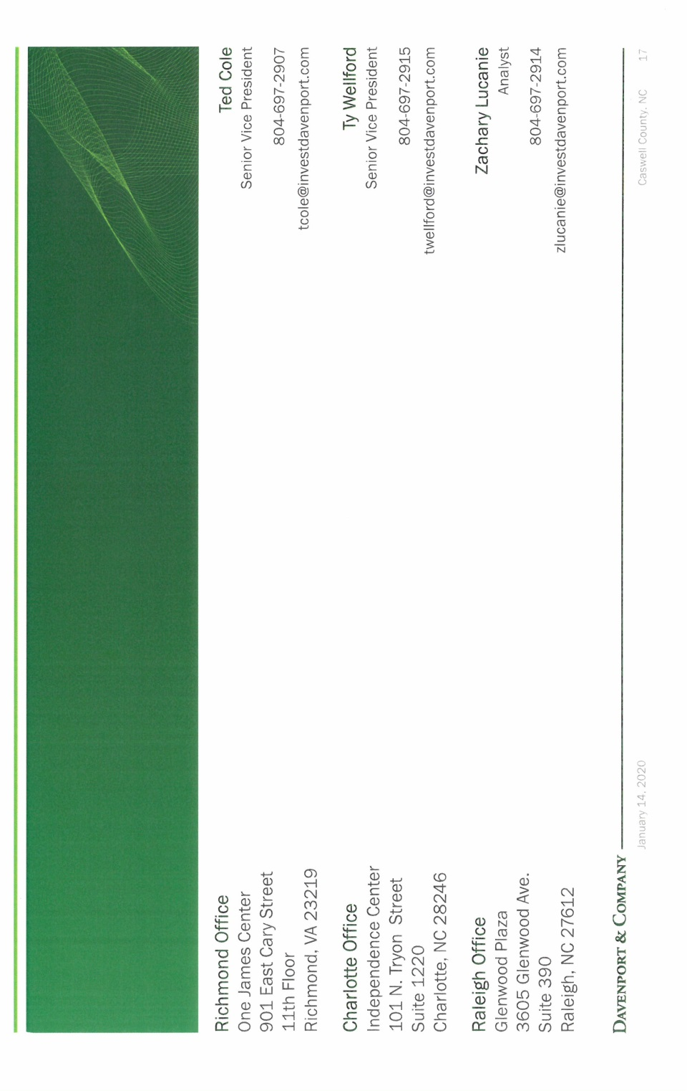
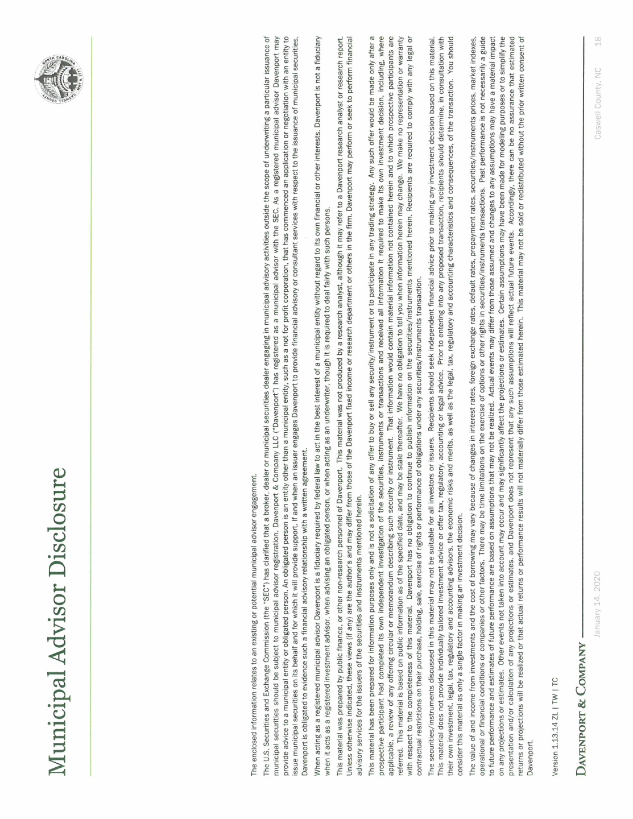

Mr. Wellford stated that public sale term is up to 20 years and USDA is up to 30 years. He added that the USDA is approved will be locked in at 2.75% but the public sale term would not be set until next spring when the construction begins. Ms. Wellford stated that with current market the life of the loan under the public sale option would be just shy of $23 million with a loan of $18 million and the rough property tax increase would be 4 pennies. He added that USDA allows for a longer repayment term and the rate will be 2.75% which was set at January 1. Mr. Wellford stated that if the Board agrees the USDA letter of conditions tonight the rate would be locked in for the full life of the loan, with the longer repayment term there would be additional debt service and it would be roughly $28.3 million which is about $5 million higher than the 20 year public sale option but it would be a lower tax rate which would be estimated at 1.8 pennies. He added that if the County wanted to reduce the amount of payments he ran a prepayment scenario in Option 3. Mr. Wellford stated that in this scenario the county would raise the tax rate 4 pennies and the County would have the option to prepay the loan off at any time and the total amount paid would be reduce the difference from $5 million to $1.5 million.

Commissioner W. Carter asked if the County could pay the loan off early. Mr. Wellford responded yes but the County would need to raise revenues to do so. Commissioner W. Carter stated that his biggest concern is the different between 1.8 pennies tax increase and 4 pennies tax increase. He added that this would be a big difference for the taxpayers and the Board does not know what the budget will present.

Commissioner Jefferies asked if double payments could be made to pay it off early especially if a year is good where the County could do this. Mr. Wellford responded absolutely this could be done. Commissioner Jefferies stated that if the fund balance is good the County could pay towards extra payments.

Mr. Tobais Fullwood stated that he is here on behalf of the N.C. Department of Agriculture Rural Development and included in the Board’s packet is the USDA’s Letter of Conditions. He added that the USDA is seeking a resolution to accept the Conditions to lock in the interest rate of 2.75% as well as to obligate the $18.5 million for the construction and renovation of Bartlett Yancey High School. Mr. Fullwood stated that if there are any monetary changes as well as construction changes that have not been approved by USDA before moving forward USDA has to review any plans as well as any monetary changes up or down. He added that included in the Conditions is the project budget that has been presented and approved by the USDA. Mr. Fullwood stated that the loan is for a 30 year term and there is no early pay-off penalty. He added that there would not be any payments due until the construction is complete but the USDA will allow one more year to collect the revenue before making a payment. Mr. Fullwood stated that another document that is included is the USDA would need authorization to draft the payment from the County’s account and 60 days prior to this date the USDA will send a letter to the County to remind it about the first payment. He added that when this project first started the interest rate was 4% and now it is down to 2.75% and when it is time to finance the rate will be locked in at 2.75%. Mr. Fullwood stated that if the interest rate increases the rate would be 2.75%, he added that if the interest rate drops the county could, at closing, take the lowest interest rate at closing. He talked about historic preservation, wetlands and endangered species.

Commissioner S. Carter asked “I guess what’s on my mind is, are we prepared to determine which course we are taking?” Chairman McVey responded “Yeah we need to do it tonight.”

Commissioner W. Carter moved, seconded by Commissioner Owen to approve the USDA 30 year loan term with 1.8 cents tax increase.

Commissioner Oestreicher asked what the total expense to the county would be. He added that case 1 would be $41.7 million. Mr. Wellford responded that this amount is not correct; under case 1 the County would make payments just shy of $23 million. He added that under the USDA scenario for 30 years is $28.3 million.

Upon a vote of the motion, the motion carried unanimously.

Mr. Ferrell stated that based on the Board’s vote in the Board’s packet there is a letter of intent to meet conditions that the USDA requires as well as a loan resolution, he added that he did not talk to bond counsel about the substance of the loan resolution. Mr. Ferrell stated that what he understood was the Board would execute the letter of intent. He then asked Mr. Fullwood if it would be possible to come back with the loan resolution at a later date. Mr. Fullwood responded that he did not see a problem but he wanted to know when the later date would be. Mr. Ferrell stated that the loan resolution could be on the next agenda for the Board which would be in two weeks. He just wanted to make sure there was no conflict. Mr. Ferrell stated that the Board would need to make a motion to approve the letter of intent to meet conditions.

Commissioner Hall moved, seconded by Commissioner Owen to approve the letter of intent to meet conditions.

Commissioner S. Carter stated “Just one item, this is in regards to this, these points that you made in the presentation today. On page 7 where it talks about Environmental Mitigation Measures in the second paragraph Historic Preservation, the last sentence says ‘The Catawba Indian Nation must be notified if Native American artifacts and / or human remains are located during the ground disturbance phase of this project.’ I just want to make the point that the Catawba Nation is near Charlotte and is not assigned to this area. Mr. Fullwood responded that according to his director they are assigned to this area. Commissioner S. Carter continued “I suggest that this would be looked into with the State Office of Archeology, it makes zero sense to me. They are a tribe on the border of North Carolina and South Carolina. We do have a state recognized tribe assigned to this county, the Occaneechi Tribe, so I don’t know if they would fall under that. Before I move on whether there is a difference in federal or state on Native American tribes but that definitely needs to be looked into for the final time comes if there are no other objections or if we want to continue with that in there.” Mr. Ferrell responded that this could be looked into but he did not think it would prohibit the Board from moving forward with accepting the letter of intent.

Upon a vote of the motion, the motion carried unanimously.

RECESS

The Board took a brief recess.

APPROVAL OF BARTLETT YANCEY HIGH SCHOOL PHASE 1 – TEMPORARY CLASSROOMS CONTRACT

Mr. Miller stated that this process began a couple of months ago. He added that the Board approved the contractor for the project, the low bid was $1,033,000 and tonight the Board has the contract in front of it. Mr. Miller stated that the contract has been reviewed by the county attorney and Dewberry has review the contract. He asked for approval from the Board based on AIA contract included in the agenda packet based on county attorney approval.

Commissioner Oestreicher asked the county manager this this part of the project would fall under the project manager or is it covered at all. Mr. Ferrell responded that there is an agreement for a project manager but he did not think that agreement has been signed yet. He added that the project manager is available on a contract basis what the boards would like for him to do.

Commissioner Owen recused himself from the vote on this project due to the fact that he has a son-in-law that is over this project. Mr. Ferrell responded to make a motion to this for the record.

Commissioner Hall asked if the contract the Board is voting on is the architect contract. Mr. Ferrell responded that this contract is for the actual contractor, Quality Construction.

Commissioner S. Carter moved, seconded by Commissioner Oestreicher to allow Commissioner Owen to recuse himself from this vote. The motion carried unanimously.

Commissioner S. Carter moved, seconded by Commissioner Hall to approve the AIA contract subject to county attorney final approval. The motion carried unanimously.

GATEWOOD INDUSTRIAL PARK – RELEASE OF RESTRICTIVE COVENANTS

Mr. Miller informed the Board that included in its agenda packet is the documents associated with the release of the restrictive covenants. He added that part of the restrictive covenants is that amendments can be made if 50% of the owners in land mass agree to amend the restrictive covenants and this was met with WS Construction and Cayman Investments so he asked the Board for approval to release the restrictive covenants as they apply to Gatewood Business Park.

Mr. Ferrell stated that the second part in this is to release the easement that was discussed at the Board’s last meeting.

Commissioner Oestreicher moved, seconded by Commissioner S. Carter to release Gatewood Industrial Park from the restrictive covenants as well as the easement. The motion carried unanimously.

TIMBER BIDS FOR PELHAM INDUSTRIAL PARK

Mr. Miller informed the Board that he received 3 bids for the timbering of the Pelham Industrial park and these 3 bids are for the sale of the south side which is where Project CEAD is planning to go. He added that bids for the north side have not been received. Mr. Miller stated that the high bid is for $41,800 and this is consistent with what the Board had received earlier as an estimate.

Commissioner W. Carter moved, seconded by Commissioner Owen to approve timber bid as presented by the county manager.

Commissioner Oestreicher asked about the timeline on this. Mr. Miller responded that it would be timbered as soon as possible.

Upon a vote of the motion, the motion carried unanimously.

RESOLUTION CALLING A PUBLIC HEARING ON WHETHER THE COUNTY OF CASWELL, NORTH CAROLINA SHOULD ACQUIRE CERTAIN PROPERTY INCLUDED IN A HIGH SCHOOL CONSTRUCTION PROJECT

Mr. Miller stated “Commissioners this is required for the Bartlett Yancey High School project as we move forward and basically what this does is direct myself and the clerk, the clerk specifically, to move forward with advertising a public hearing so that we could take ownership if requested of the Bartlett Yancey High School property for the purposes of receiving sales tax rebates throughout the project. If you will remember we’ve had several discussions surrounding this. It was discussed that the Board would need to obtain ownership of the property for us to be eligible for those sales tax rebates so this is just another step in the process so we would ask for approval of the resolution to call a public hearing to consider taking ownership of that property if requested by the Board of Education. We would set this at the next meeting.

Commissioner S. Carter stated “Just curious, is there a written resolution that was in the packet, for some reason I can’t find it in my packet.” Mr. Ferrell responded “There was a resolution in my packet, let me see if I can get a page number.” Commissioner S. Carter continued “I have a paper copy.” Mr. Miller responded “I can read it.” Mr. Miller read the resolution.

Commissioner Oestreicher asked “Should we not include in Section II. publication of this on the County website, does that make sense or County Facebook page?” Mr. Miller responded “So I think we would do that anyway regardless but we can include that if you would like to.” Commissioner Oestreicher continued “If it doesn’t slow things down.” Mr. Miller responded “Sure.”

Commissioner Hall asked “Once we acquire this property how long are we going to hold it?” Mr. Miller responded “Throughout construction.” Chairman McVey responded “Until the end of construction.” Commissioner Hall continued “And then we will have to do some similar action to turn it back over to the Board of Education.” Mr. Miller responded “That’s correct. During the term of construction we would be required to lease the property back to the Board of Education. Mr. Ferrell added “And there will be a spree of agreements about how all of that works, the conveyance in and the conveyance out and the lease in the interim. It’s a relatively common practice that the counties and school boards go through for projects of this type, this conveyance, so we are going to be relying on some of our counties that have done this in the past to give us some guidance on the documents that you will see to get this done. The School Board has to go through a similar public hearing process as well to ask the County to accept the property.”

Commissioner S. Carter moved, seconded by Commissioner Owen to accept the resolution to call for a public hearing. The motion carried unanimously.

RESOLUTION CALLING A PUBLIC HEARING ON WHETHER THE COUNTY OF CASWELL, NORTH CAROLINA SHOULD ACQUIRE CERTAIN PROPERTY INCLUDED IN A HIGH SCHOOL CONSTRUCTION PROJECT

WHEREAS, the County of Caswell, North Carolina (the "County") and the Caswell County Board of Education (the "Board of Education"), have determined to cooperate in a plan to finance the cost of a project which each has found to be necessary and desirable to provide for improved public school facilities and improved public education in the Caswell County School System, specifically the design, acquisition, construction, improvement, expansion, renovation and equipping of Bartlett Yancey High School located on a site that is to be conveyed by the Board of Education to the County (the "School Project"); and
WHEREAS, the County is authorized to acquire the fee or any lesser interest in the real and personal property included in the School Project for use by the Caswell County Schools System upon the request of the Board of Education and after a public hearing; and
WHEREAS, the Board of Education has made such request or is expected to make such request of the County; and
WHEREAS, it is necessary to call a public hearing on such proposed acquisition;
NOW, THEREFORE, BE IT RESOLVED by the Board of Commissioners for the County as follows:
Section 1. A public hearing shall be held at 9:00 a.m. on February 3, 2020 in the Historic Courthouse, 144 Court Square, Yanceyville, North Carolina for the purpose of considering whether the County of Caswell, North Carolina should acquire the fee or any lesser interest in the real and personal property included in the School Project for use by the Caswell County Schools System in order to proceed with a plan by the County and The Caswell County Board of Education for the financing of the cost of the School Project.
Section 2. The Clerk to the Board shall cause a notice of such public hearing to be published in the Caswell Messenger or another newspaper in accordance with law at least once prior to the date of the public hearing.
Section 3. This resolution shall take effect immediately upon its passage.
Commissioner Owen seconded the motion, and members of the Board voted as follows:

Ayes: S. Carter, W. Carter, Hall, Jefferies, McVey, Oestreicher and Owen.
Noes: None.
PROPOSED ZONING MEETINGS AND PUBLIC HEARINGS CALENDAR

Mr. Miller stated that at the last Board’s work session the Board was presented with a calendar that scheduled out all of the meetings that the Board had stated would occur in the moratorium and there were some conversations surrounding some of the dates that had been chosen so the Board had decided to discuss the calendar at tonight’s meeting. He informed the Chairman that he had received comments from at least one concerned citizen which has requested that there be two monthly community meetings instead of one so the community is well informed about the process.

Commissioner S. Carter stated “I also agree to advocate to have the community meetings before the public hearing. I think it would be suitable to have our first community meeting before the end of this month and to proceed with 2 in February, 2 in March, 2 in April, 2 in May, and that way they would be concluded in May when there is already a scheduled 1st public hearing.” Chairman McVey responded “Well we are getting pretty short in this month.” Commissioner S. Carter continued “I understand. So we need…Ms. Seamster how much notice do we need to have a community meeting…72?” Mr. Miller responded “There is not a notice provision; community meetings usually are not considered regularly scheduled meetings for the Board of Commissioners.” Mr. Ferrell added “Unless you show up in mass.” Mr. Miller responded “Unless everybody shows up. If everybody shows up we do need to advertise.”

Mr. Miller stated that he and the county planner are happy to move through this process as quickly as possible and hold two meetings a month. He added that the citizens do need to receive more than a week’s notice for the community meetings.

Commissioner W. Carter asked when the latest date would be to put this on the November ballot. Mr. Miller responded that the moratorium is a 12 month moratorium which began in January and will end in January of 2021 and during this time period the Board has to come to a decision on how to handle the issue that caused the moratorium. He added that if this issue is added to the ballot in November it would run short on time but the Board would have 1 ½ months to look at the data. Commissioner W. Carter stated that he has heard two different ways that the Board may go so he would like to put it on the ballot.

Commissioner S. Carter asked “Mr. Chairman, just a quick question, have we come to a consensus to pursue putting this on the ballot or can we even get it on the ballot at this point?” Commissioner Owen responded “Before we do that could we get this scheduled first?” Commissioner S. Carter continued “I did not mean to get off subject but…” Commissioner Owen responded “If you don’t mind, let’s get this schedule done and then if we want to discuss that at some time we can.” Commissioner S. Carter stated “Mr. Chairman I don’t see why we couldn’t have out first community meeting Wednesday or Thursday and this would give our citizens 9 days’ notice.” Chairman McVey responded “Next Thursday which would be the 30th?” Commissioner S. Carter continued “Correct.” Chairman McVey responded “I can’t make it.” Commissioner S. Carter asked “We are not required to attend those community meetings are we?” Mr. Miller responded “No.” Commissioner S. Carter continued “I’m only suggesting that we be finished in May having 2 meetings in each month after January and that would put us in line with having our first public hearing on the 18th of May.”

Commissioner Owen stated that his recommendation is to start in February to allow for sufficient time to get locations and then do 2 meetings each month.

Mr. Miller stated that whatever the Board requests can be done.

Chairman McVey asked “Can you do this any other day than Thursday?” Commissioner S. Carter responded “I just suggested that because the rest of the community meetings are scheduled on Thursdays, I do not have any problems with picking another day during the week.” Chairman McVey stated that he wanted to attend all of the community meetings but with the schedule it is going to be hard to him to attend all of the meetings. He added that he would like to hear what the citizens have to say at these meetings like he did with the fire tax meetings.

Commissioner S. Carter stated “I am still suggesting one next week, I can meet whatever date is decided.”

Commissioner Owen stated that he would like to wait until February because he wants to make sure to have ample time to get these dates out into the community.

Commissioner Jefferies stated to start the meeting in February.

Chairman McVey took a consensus of the Board and the consensus was to start the community meetings in February.

Commissioner S. Carter asked “So we have none scheduled in February currently can we select some dates?” Chairman McVey responded “We certainly can.”

Commissioner Owen suggested Thursday to keep it consistent. He asked about February 6th and 20th for community meetings. Mr. Miller responded that these dates would be fine.

Commissioner S. Carter stated “If we stick to the schedule it will probably be easy for the public. And for March we already have the 5th so do the second one on the 19th.

Mr. Miller informed the Board that the county planner has some prior obligations that he will have to attend to in April and May and may not be able to attend those meetings but he would be able to proceed with the meetings in April and May. Commissioner W. Carter suggested having a commissioner from that district to attend the meetings with the county manager.

Mr. Ferrell recommended noticing all the meetings just in case the commissioners show up.

Commissioner Owen stated that there is a community meeting on April 2nd and there is a special meeting on the 16th.

Commissioner S. Carter stated “We could do Yanceyville for that one.”

Mr. Miller stated that it may be wise to hold at least one meeting on a Saturday just so the people that work outside the county are able to attend and to hold it at the Historic Courthouse.

Commissioner Owen asked if the 16th meeting of April would be on the 18th. Commissioner S. Carter responded “You might want to make sure that is not Easter weekend.”

Commissioner S. Carter asked “So the 7th and the 21st of May?” Commissioner W. Carter did not think the Board should schedule that far out since things could change. Commissioner S. Carter continued “We are required to have all of these up until August to make sure that people are aware of what is going on.”

Commissioner Oestreicher asked if the meeting on April 18th could be changed to April 4th because he would like to attend the countywide meeting.

Commissioner Owen asked about the month of May and if the Board is considering having a public hearing on the 18th and a community meeting on the 21st.

Commissioner S. Carter stated “I don’t have a problem with moving April 18th to April 4th.” Commissioner Owen stated that it would be fine with him. Commissioner S. Carter continued “And then the last community meeting will be June 4th. I was just saying that last community meeting…there are 9 townships would be June 4th.

Commissioner W. Carter stated that he thought May and June should be left open for the budget.

Commissioner Owen stated that he is good with going with the community meetings through June and then the Board would be able to see where everything stands.

Commissioner S. Carter stated “Well as we have it currently, June is available other than the regular meeting on the 1st and the community meeting on the 4th.

Commissioner Owen stated that he hopes there are some budget meetings in May but the community meetings need to be held.

Commissioner S. Carter stated “Then in July we are still good for the 16th which would basically be a work session in conclusion of all the community meetings and that way the budget is over also during that time so we can evaluate where we are at.”

Commissioner S. Carter stated “I have another suggestion Mr. Chairman and I promise I won’t hold you any longer, after those community meetings are over with and we have that special meeting on July 16th I think it may be appropriate at that point we could possibly make changes based on what we’ve heard from the citizens. On that work session day the 16th would it be good to have and updated public hearing then to review what we’ve done up to this point on our regular meeting of July 20th at that night commissioners meeting to put a public hearing on that agenda because our next public hearing would not be until September. I am proposing to have a public hearing on July 20th and that way we will know where everybody is at as far as the public is concerned.”

Commissioner Owen asked if the public hearing was still necessary on May 18th. Commissioner S. Carter responded “Yes. I think that is fair, it is roughly in between all of those meetings and it gives people the opportunity to learn all of that to come and voice concerns maybe. If there were citizens that were not able to come on the preceding dates, that gives them an opportunity to come to our regular meeting, evening meeting, to address some concerns.”

Commissioner Oestreicher asked if the public hearing would be i/l/o of the public hearing on the 21st of September. Commissioner S. Carter responded “The 21st of September yes. I am of the opinion that rather soon versus in December we will know kind of where everybody stands on all of this.” Commissioner Oestreicher stated that this had better be done well before December. Commissioner S. Carter responded “That is what I am saying; I agree I think we should have this done before December.”

Commissioner W. Carter stated that the Board needs to decide if the Board is going to vote on this or if it is going to be put on the ballot. Commissioner Owen responded that the meetings needed to be scheduled first.

Commissioner Owen stated that nothing is scheduled for August. Chairman McVey responded that there is one meeting in August. Commissioner S. Carter responded “Well that is just a regular meeting.” Mr. Miller stated that the Board would discuss anything surrounding zoning at the August 3rd meeting and that would be it for August.

Commissioner S. Carter stated “That would be a follow up of the July 20th meeting. Remove all community meetings after that.” Commissioner Oestreicher stated that the meeting on the 3rd of September would be removed. Commissioner S. Carter continued “And the 1st of October. The only other thing we have left floating around is the special meeting on October 15th and another public hearing on December 21st and at this point I am thinking those are probably not necessary. Now that is speaking optimistically but we may want to put another special meeting in the midst of the first six months of the year to work on this.”

Chairman McVey took a consensus from the Board on the proposed meeting dates.

Commissioner S. Carter asked “So where are we with October 15th, are we taking that out?” Commissioner Owen responded that he thought these could be taken out and added back if needed. Commissioner S. Carter continued “Take out October 15th and December 21st. Do we need to list these so that everybody is kind of clear?” Chairman McVey responded “Yeah, after the meeting.” Commissioner S. Carter continued “After the meeting.” Chairman McVey responded “After the meeting. We need a motion now to approve the calendar.”

Commissioner S. Carter moved, seconded by Commissioner Owen to approve the proposed zoning meetings and public hearings calendar. The motion carried unanimously.

Chairman McVey stated “I think Mr. Carter if you and Ms. Seamster will get together and get calendars to those folks. I don’t know if she wants to do it tonight but if you two will get together.” Commissioner S. Carter responded “What is yet to be determined is where those specific locations will be.”

TAX DIRECTOR’S QUARTERLY UPDATE

Mr. Thomas Bernard, Tax Director, informed the Board that as of January 13, 2020 the collection rate is 1.2% ahead of the same time last year and he thinks this is a result of taxpayers entering into payment agreements and knowing they can break their bill down into multiple payments. He added that the Tax Office is in the process of receiving listing forms, applications for present use value programs, applications for senior citizens and disability exclusions, veterans’ exclusions, and land use exemptions. Mr. Bernard stated that the Tax office is working with the E-911 department on correcting addresses that are not correct throughout the county. He added that the tax office is also working with the state fire marshal on redrawing and recalculating all of the fire response districts from the original 6 mile fire response districts. Mr. Bernard stated that the IT Department has the new SQL server up and running and added that on January 7th Bi-Tek started extracting data from the AS400 to the new SKL server. He stated that the tax department is entering the present personal property listing on the AS400 and this need to be extracted to the SQL server. Mr. Bernard stated that hopefully in March collections will be up and running on the new system.

SCHOLARSHIP ALLOCATION MONEY

Mr. Miller stated that at the last work session the Board instructed him to have a conversation with the superintendent regarding monies allocated to the Board of Education and this discussion did take place. He stated that the superintendent expressed her willingness to work with the Board and to create better opportunities for the students graduating from Bartlett Yancey High School. Mr. Miller stated that in order to do this type of thing more research is needed to make sure that this can legally be entered into.

Commissioner Owen stated that he has shared this information with the Board before but he knows of at least one county in the state that pays for every student to do through a two year program at their community college. He added that he would get information so the Board will see how they are doing this and it may help the county with this endeavor.

Mr. Ferrell stated that the manager and he talked about this and as he gets a clearer focus on what the Board’s intent is with the scholarship fund I will be of further assistance.

Commissioner S. Carter asked “Mr. Chairman, I just have a general question to the group and to the staff, are we still confused on what the intent of this was?” Mr. Ferrell responded that he was not at the work session so the manager explained it to him and he asked if Commissioner Carter could give him some more information. Commissioner S. Carter continued “It was during the budget, during one of the last sessions, the idea was to come up with some way to recruit teachers for our school system and to focus more so on local students that are interested in going into education and the ones that stay the longest are the ones that are native to the county. The idea was that we would help with their tuition to an in state public university and not pay for all if they are out of state but there were discussions about how many students we may be able to impact, the more the merrier. As far as the legalities, there has not been any mention of it since then and we have not had a chance to meet. The original group was Commissioner Hall, myself, board member Wayne Owen and board member Tracy Stanley, and the manager and Dr. Carter. We attempted to get together one time and the Board of Education members something happened to their schedule and there was currently an email sent out about possibly meeting on Wednesday, January 29th or Thursday, January 30th at the school office at 10:00 on one of those days. I am not able to answer that just yet because of my work schedule. Mr. Hall has not seen that email notice yet but we are trying to get together again to meet about these issues and to iron out a program that would be more appropriate right now.” Mr. Ferrell responded that this was helpful and added that there are a number of districts that are engaged in recruitment and retention efforts for teachers. He added that there are a number of models that can assist with recruitment and retention. Mr. Ferrell stated that it sounded like the Board wanted to help with some type of assistance with tuition such as a teaching fellows program. Commissioner S. Carter stated “The intention was to be a local teaching program but he did not know if we were able to do something like that or not.” Mr. Ferrell responded that counties are only given the authority that the legislation gives them so the county needs to make sure it has the authority to create a fund to fund scholarships and Commissioner Owen made mention of some type of fund like this. He stated that he was not sure the county could create a foundation to fund a scholarship that is administered by itself is unique in his experience for county government. Commissioner S. Carter asked “What about a non-foundation sense?” Mr. Ferrell responded that public dollars must be used for a public purpose so this would need more research.

Commissioner Owen stated that what Commissioner Carter may not be aware of is the discussion during the planning meeting. Commissioner S. Carter responded “I read the minutes.” Commissioner Owen stated that he wanted to make sure because that is how this foundation deal came up because the Board was looking at employee needs in the county and not just teachers. Commissioner S. Carter responded “And I understand looking at other employees but I will try to continue to advocate first that this be used for teaching degrees.”

FINANCE SOFTWARE UPDATE

Ms. Gwen Vaughn, Finance Director, stated that Tyler Technology has assigned a project manager to Caswell County for the implementation of the new software project. She added that the project will be implemented in two phases: financial starting in January with plans to go live in October 2020 and human capital management starting in October with plans to go live in July 2021. Ms. Vaughn stated that on January 14th and 15th the finance, HR, and IT staff participating in the first project planning session. She added that throughout January and March, for the next 10 weeks, 3 departments will be involved in 7 remote training sessions over a period of 13 days. Ms. Vaughn stated that staff is excited and looking forward to a new venture and the opportunity to make the county more accessible and responsive to external and internal customer services and needs and more efficient in the operation through streamlining, automating and integrating business processes and practices to produce services in real time. She stated that she would keep the Board updated on the process.

COUNTY MANAGER’S UPDATES
Cooperative Extension Office

Mr. Miller informed the Board that substantial roof work has been completed to the Cooperative Extension office as approved in the budget and added that there are interior project underway such as plaster. He added that additional items are being found that were not noticeable before but he would keep the Board updated. Mr. Miller stated that if additional funds are needed he would come back before the Board before proceeding with the repairs.

Senior Center HVAC

Mr. Miller informed the Board that the Senior Center has experience significant problems with its heating and air conditioning system for the last several months. He added that a couple of quotes have been received and the quotes are not cheap. Mr. Miller stated that there are a couple of quote on replacing the system as well as a quote for a patch work option but the patch work will not last very long. He added that this may be on the next meeting agenda.

Chairman McVey asked how long this system had been in use. Mr. Miller responded that it has been in use for a little over 11 years and this is not uncommon for this type of system.

COMMISSIONER COMMENTS

Commissioner W. Carter stated that he did not get an answer on his question about putting zoning on whether the Board would decide or that it would be put on the ballot so he hoped to get an answer to his question some time down the road. He added that the thinks the Board needs to adopt the resolution for the second amendment rights. Commissioner W. Carter stated that he is 100% for the second amendment and he thought it would be a good gesture for the Board to adopt the resolution as presented. He suggested putting the resolution on the next agenda for approval. Chairman McVey responded that it has been suggested that it be put on the next agenda. He directed the clerk to put this resolution on the next agenda. Commissioner W. Carter stated that he hoped to get an answer on the zoning question soon. Mr. Ferrell responded that the manager has been discussing this option with the legislatures and his recollection is that the Board did vote to ask the legislature or local delegation at the legislature to place an advisory zoning question on the ballot. He added that the county manager has been directed to do this but it would be up to the legislature to make that decision. Mr. Miller added that he had spoken with local legislatures and if it is approved it will be placed on the ballot in November. Mr. Ferrell stated that this would be an advisory referendum and the residents would have the opportunity to express their intent on zoning but the Board would have to vote to implement zoning or not.

Commissioner Oestreicher stated that he received a bulleting from the Department of Homeland Security and he recommended that it be put on the county’s website and any other way to get out to the citizens. Commissioner W. Carter added that this bulletin was sent to every water supply facility and water treatment plants have been placed on high alert across the state of North Carolina.

Commissioner Hall stated “Mr. Chairman and fellow Commissioners I have three comments I want to bring to the Board, For the Record, regarding the meeting of January 6, 2020. First Comment. A public hearing was held at the beginning of the meeting to get citizen input for an ordinance to place a moratorium on polluting industries. Near the end of the meeting, after much discussion and several revisions, a motion was made to approve the ordinance. I’m going to refer to our Rules of Policies and Procedures. Rule 25. Introduction of Ordinances, Resolutions, and Orders. A proposed ordinance shall be deemed introduced at the first meeting at which it is on the agenda, regardless of whether it is actually considered by the Board, and its introduction shall be recorded in the minutes. Rule 26. Adoption, Amendment, or Repeal of Ordinance. To be adopted at the meeting where first introduced, an ordinance or any action with the effect of an ordinance, or any ordinance amending or repealing an existing ordinance (except the budget ordinance, a bond order, or another ordinance requiring a public hearing before adoption) must be approved by all members of the Board of Commissioners. If the proposed measure is approved by a majority of those voting, but not all the members of the Board, or if the measure is not voted on at the meeting where introduced, it shall be considered at the next regular meeting of the Board. If the proposal receives a majority of the votes cast at the next meeting or within one hundred days of being introduced, it is adopted. There were two problems: Problem 1 – The ordinance was never put on the agenda. Problem 2 – The ordinance was not approved by all members of the Board of Commissioners. My Second Comment. The FYE 2019 Audit was presented by Alan Thompson, CPA. The report that he gave us showed a decrease in our property tax valuation of roughly $57,107,000. When I asked him about the change he said that he didn’t know why and that he would give me an answer. In my opinion this is a significant amount. Our CPA should have noticed this change and been prepared to answer. In addition, our Tax Director should have advised the Board of the change and the reason why. It is my hope that this Board will request that the Tax Director explain the change in the property tax valuation. My Third Comment. Appointments to Boards and Committees – The Board voted to appoint five people to the Caswell County Cemeteries Board of Trustees. Before the vote I asked if the list we had was representative of the citizens of Caswell County in terms of race, ethnicity, etc. Commissioner Sterling Carter responded that these people had an interest in genealogy and history and he couldn’t help who applied and who did not apply Several years ago the Board instituted a policy requiring that vacancies on all boards and commissions be advertised before we voted to fill them. I found out after the meeting that these positions were not advertised. The first and third comments relates to Board policies and procedures. These procedures were just adopted in December at our new organizational meeting and then at our first meeting January we started the year violating it. I hope that the Board will reconsider the way we move forward on adopted policies and procedures. Thank you.”

Commissioner S. Carter stated “Three things. First is a follow up and this can be on the agenda for our next meeting. I just want to give you a report that the Cemeteries Board of Trustees had a meeting on January 16th, our organizational meeting was a very productive meeting. I made them aware of some new things in state statute required and they passed the bylaws and I will have those as requested by this Board at the next meeting agenda so that this Board can make final approval on those bylaws. The resolution that was presented to us this evening about the second amendment rights, I hesitate for us to pass a resolution at first glance, I hope that we can review this at minimum but possibly even a committee of one or two members of this Board to finalize the wording of the resolutions as we are the representatives of the County and our citizens. And third in reference to Boards and Committees last year and I don’t have the dates, times and whatnot available but I brought up the point of our subordinate advisory boards and commissions not having their minutes available to us. We don’t even see maybe two or three in a normal agenda packet and we have many, many boards and commissions. I talked to our clerk today first to see if there were any more minutes and bylaws in which this Board suggested that they submit and very few have complied with that. I did want to go over this list with you briefly and also for the sake of putting it in the minutes and I would suggest that after having sent out three notices last year asking for this information I would like to see this Board first of all ask for it again and to hold those boards and commissions accountable for that and secondly I would like to see those submit those minutes to us and that they be posted online. I think information from one person to another and us as elected officials, we should know what is going on and with these advisory boards you should definitely know what business has been transacted and I am ready to admit that as a commissioner I am not aware of what they are all doing mainly because first we can’t attend all meetings and you know that very easily and second there is no minutes to read. So we have several of these: the Planning Board submits its minutes, the E-911 Board does not, there is a question as to whether they may be under the state or county and whether they should submit minutes or not but I don’t see why we can’t ask and see. Agriculture Advisory Committee, they do. The Caswell County Oversight Committee does not. Board of Elections again another state but we could ask if we so desire to see those minutes. Board of Health does and it’s available on the website. The Economic Development Commission that is one for me was shocked that they did not submit minutes for what goes on. Adult Advisory Committee does. Emergency Planning Committee does not. CATS, the Transportation committee, they do and those are on the website. The Hunting and Wildlife has in the past but currently have not submitted minutes. Farmer Lake does and those are usually in our agenda packet and I thank them for being diligent with that. The Library Board does. The Heritage Cultural, whatever that group is does not and they are currently not meeting. The Human Relations Committee I am not even sure what that is. The Jury Commission does not. JCPC that groups does a lot in this county but they do not submit minutes. The PTRC Workforce Development which is currently constituted does not. The Person-Caswell Lake Authority does and they are very diligent in submitting those. The PCC Board of Trustees does not. Piedmont Conservation Council does not. The Recreation Commission does not. The Senior Center does, the Senior Center Advisory Committee does. Social Services Board yes they do. The TDA board of course is new but we hope they will submit those. The Cemeteries Board of Trustees will submit our minutes. You know one of these could have an issue and I can use a specific example where a citizen comes and asks me a question, do you know about this or that and the answer would be yes or no or well this took place at this meeting, you know, a subordinate board or advisory commission and I just feel like as a commissioner of this Board we should know what is going on and I would like to submit that to this group again and hope that you address what will be best not only for us but for the citizens that all of these minutes be submitted to us and published online so that everyone can keep up to date on what Caswell County is working on and that is all that I have.”

Commissioner Owen stated that he did not mind have all the minutes published but we only have a limited amount of space. He suggested that this be put in a separate online folder and put in our agenda or on the website. Commissioner Owen stated that he is working on ways to improve the relationships between the boards and the Board.

ANNOUNCEMENTS AND UPCOMING EVENTS

A. Caswell County Blood Drive – Wednesday, January 29, 2020 at 10:00 a.m. to
2:00 p.m. – Senior Center
B. Caswell County Board of Commissioners, Town of Yanceyville and Town of Milton
Joint Meeting – Thursday, February 13, 2020 at 6:00 p.m. – 911 Center.

CLOSED SESSION

Commissioner W. Carter moved, seconded by Commissioner Owen to go into closed session to consider the compensation, terms of appointment and performance of an individual public officer (NCGS 143-318.aa)a)(6)) and to prevent the disclosure of information that is privileged or confidential (NCGS 143-318.11(a)(1)). The motion carried unanimously.

REGULAR SESSION

Commissioner W. Carter moved, seconded by Commissioner Owen to go back into regular session.

Commissioner Owen moved, seconded by Commissioner W. Carter to release excerpts of the closed session minutes on the Drug Store project as per discussion. The motion carried unanimously.

ADJOURNMENT

At 9:30 p.m. Commissioner S. Carter moved, seconded by Commissioner Owen to adjourn. The motion carried unanimously.

________________________________ ___________________________
Paula P. Seamster Rick McVey
Clerk to the Board Chairman

******************************************************************************

