MINUTES – MAY 18, 2020

The Caswell County Board of Commissioners met in regular session at 9:00 a.m. on Monday, May 18, 2020. The meeting was held electronically using Zoom Webinar software. Members present: Rick McVey, Chairman, David J. Owen, Vice Chairman, Sterling Carter, William E. Carter, Nathaniel Hall, Jeremiah Jefferies and Steve Oestreicher. Also present: Bryan Miller, County Manager, Brian Ferrell, County Attorney, and Debra Ferrell representing The Caswell Messenger. Paula P. Seamster, Clerk to the Board, recorded the minutes.

WELCOME
MOMENT OF SILENT PRAYER

Chairman McVey opened the meeting with a moment of Silent Prayer.

PLEDGE OF ALLEGIANCE

The Board of Commissioners and all the guests in the attendance recited the Pledge of Allegiance.

(Some Board members experienced problems connecting to the meeting.)

(At 9:22 a.m. Commissioner S. Carter joined the meeting.)

PUBLIC COMMENTS

The Clerk informed the Board that she did not receive any public comments for this meeting.

RECOGNITIONS

Commissioner Owen stated that this week is EMS Week and he wanted to recognize the staff at EMS. He added that EMS is facing some of the most unique and challenging times of their careers. Commissioner Owen stated that he was asked by the EMS staff to thank the community as well as the county government and Board of Commissioners for the support that they have received. He thanked all the staff of the EMS for their service and for what they do for the citizens of Caswell County. EMS Week is May 17th through 23rd.

Commissioner S. Carter stated “Mr. Chairman, I would like to recognize Harriet Brandon who passed away on May 6th. She was a key figure in the county and in the town of Milton for many years and touched the lives of many citizens through her teaching as well. I hope at our next meeting you all would allow me to have a resolution prepared for her to honor her service to the county and to the town of Milton. I just wanted to let everyone know that she had passed away on May 6th right after our last meeting and I feel that it is suiting to honor her.”

Commissioner W. Carter recognized the EMS workers and first responders for the job they are doing in the county. He also recognized the Public Health staff for the job they are doing as well.

Commissioner Oestreicher seconded the comments that were made by Commissioner Owen and Commissioner W. Carter about the EMS and Health workers. He added that this pandemic is unfortunately something they have trained for but it is unfortunate that their training is being tested at the maximum and they are doing a wonderful job responding and it is highly appreciated.

Chairman McVey recognized and thanked everyone on the frontlines that are doing what they are doing at this time of need.

(At 9:30 a.m. Commissioner Hall joined the meeting.)

ACTION ITEMS
APPROVAL OF AGENDA

Commissioner Owen moved, seconded by Commissioner S. Carter to approve the agenda. After a roll call vote the motion carried unanimously.

APPROVAL OF CONSENT AGENDA

Commissioner W. Carter moved, seconded by Commissioner Owen to approve the consent agenda. After a roll call vote, the motion carried unanimously.

The following item was included on the Consent Agenda:

A. Approval of Minutes of May 4, 2020 Regular Meeting

(At 9:35 a.m. Commissioner Jefferies joined the meeting.)

RESOLUTION OF BOARD OF COMMISSIONERS OF CASWELL COUNTY, NORTH CAROLINA DECLARING ITS INTENTION TO REIMBURSE ITSELF FROM THE PROCEEDS OF ONE OR MORE TAX-EXEMPT FINANCINGS FOR CERTAIN EXPENDITURES MADE AND/OR TO BE MADE IN CONNECTION WITH THE ACQUISITION, CONSTRUCTION, EXPANSION, RENOVATION AND EQUIPPING OF A CASWELL COUNTY CAPITAL (CO-SQUARED) PROJECT

Mr. Miller stated that the resolution is designed for the County to be able to reimburse itself from grant funds and loan proceeds received for the Co-Square project.

(At 9:35 a.m. Commissioner Jefferies joined the meeting.)

Commissioner Owen moved, seconded by Commissioner S. Carter to approve the resolution. After a roll call vote, the motion carried unanimously.

RESOLUTION OF BOARD OF COMMISSIONERS OF CASWELL COUNTY, NORTH CAROLINA DECLARING ITS INTENTION TO REIMBURSE ITSELF FROM THE PROCEEDS OF ONE OR MORE TAX-EXEMPT FINANCINGS FOR CERTAIN EXPENDITURES MADE AND/OR TO BE MADE IN CONNECTION WITH THE ACQUISITION, CONSTRUCTION, EXPANSION, RENOVATION AND EQUIPPING OF A CASWELL COUNTY CAPITAL (CO-SQUARED) PROJECT

WHEREAS, Caswell County, North Carolina (the “Issuer”) is a political subdivision organized and existing under the laws of the State of North Carolina; and

WHEREAS, the Issuer has paid beginning no earlier than 60 days prior to the date of adoption of this resolution, and will pay, on and after the date hereof, certain expenditures (“Expenditures”) for the design, acquisition, construction, improvement, expansion, renovation and equipping of a Caswell County capital (Co-squared) project, further described on Exhibit A attached hereto (the “Project”); and

WHEREAS, the Board of Commissioners of the Issuer (the “Board”) has determined that those moneys previously advanced no earlier than 60 days prior to the date of adoption of this resolution and to be advanced on and after the date hereof to pay the Expenditures are available only for a temporary period and it is necessary to reimburse the Issuer for the Expenditures from the proceeds of one or more issues of tax-exempt financing (the “Financing”).

NOW, THEREFORE, BE IT RESOLVED BY THE BOARD AS FOLLOWS:

Section 1. The Board hereby declares the Issuer’s intent to reimburse the Issuer with the proceeds of the Financing for the Expenditures with respect to the Project made on and after the date referenced above. The Issuer reasonably expects on the date hereof that it will reimburse the Expenditures with the proceeds of the Financing.

Section 2. Each Expenditure was and will be either (a) of a type properly chargeable to capital account under general federal income tax principles (determined in each case as of the date of the Expenditures), (b) a cost of issuance with respect to the Financing, (c) a nonrecurring item that is not customarily payable from current revenues, or (d) a grant to a party that is not related to or an agent of the Issuer so long as such grant does not impose any obligation or condition (directly or indirectly) to repay any amount to or for the benefit of the Issuer.

Section 3. The maximum principal amount of the Financing expected to be issued for the Project is $100,000.

Section 4. The Issuer will make a reimbursement allocation, which is a written allocation by the Issuer that evidences the Issuer’s use of proceeds of the Financing to reimburse an Expenditure, no later than 18 months after the later of the date on which the Expenditure is paid or the Project is placed in service or abandoned, but in no event more than three years after the date on which the Expenditure is paid. The Issuer recognizes that exceptions are available for certain “preliminary expenditures,” costs of issuance, certain de minimis amounts, expenditures by “small issuers” (based on the year of issuance and not the year of expenditure) and expenditures for construction projects of at least 5 years.

Section 5. This resolution shall take effect immediately upon its passage.

BARTLETT YANCEY HIGH SCHOOL RENOVATION CONSTRUCTION
Lowest Responsive Bidder Award and Lowest Responsive Bidder Contract Award

Mr. Miller stated that recently a bid opening was held for the Bartlett Yancey High School renovation project. He stated that the recommendation and subsequent motion if the Board so desired was to reject the bid of Blair Construction for being non-responsive and to accept the architect’s recommendation to award the bid to C.T. Wilson Construction. Mr. Miller stated that the second item for the Board is to award the construction contract as presented by the architects subject to Local Government Commission approval of the project and the financing of the project, USDA approval of the project and the financing of the project, Local Government attorney and local Board of Education attorney approval.

Commissioner Oestreicher asked the county manager for the amount of the bid compared to the budget amount. Mr. Miller responded that the responsive bid amount was $23,250,685 and the project budgeted amount was $29,700,000. Commissioner Oestreicher stated that this was good news and he did not want it to go unnoticed.

Commissioner S. Carter stated “Mr. Chairman, for the sake of the record, Mr. Miller are you able to explain in case any members of the public are wondering why we are not accepting the lowest bid versus the second lowest bid.” Mr. Miller responded that the Board is approving the bid of the lowest responsive bidder. He added that the low bid that was received was deemed unresponsive. Commissioner S. Carter continued “Right.”

Commissioner S. Carter moved, seconded by Commissioner Hall to reject the bid of Blair Construction, Inc. for failure to respond and to accept the architect’s recommendation to accept the bid of C.T. Wilson Construction Company, Inc. and also to approve the construction contract as presented by the architect subject to Local Government Commission approval of the project and the financing, USDA approval of the project and the financing, and subject to final county attorney approval. After a roll call vote, the motion carried unanimously.

BARTLETT YANCEY HIGH SCHOOL RENOVATION CONSTRUCTION
FINANCIAL ANALYSIS
BYHS Renovation Construction Interim Financing Award

Mr. Ty Wellford stated that Davenport prepared a summary presentation for the Board. He asked Mr. Miller if there was anything that he wanted to say before he began the presentation. Mr. Miller expressed his appreciation to Davenport and to BB&T and Regions. He added that he thought the County received two very good options and he asked Mr. Wellford to go over those options.

Mr. Wellford stated that the County is securing interim financing for funding of the construction project and then USDA will be paying off this funding with long term financing at the end of construction. He added that the amount that is being used is $18,500,000 and this is the same funding that USDA has committed to and with the favorable bids that were received he would expect that number to come down. Ms. Wellford stated that he was pleased to see the bid amount come in about $6 million under budget. He added that the goal today is for the Board to select a bank to provide the interim financing. Mr. Wellford stated that Davenport received some great responses and narrowed them down to two really good options. He walked through the process with the Board. (The presentation is included below.)

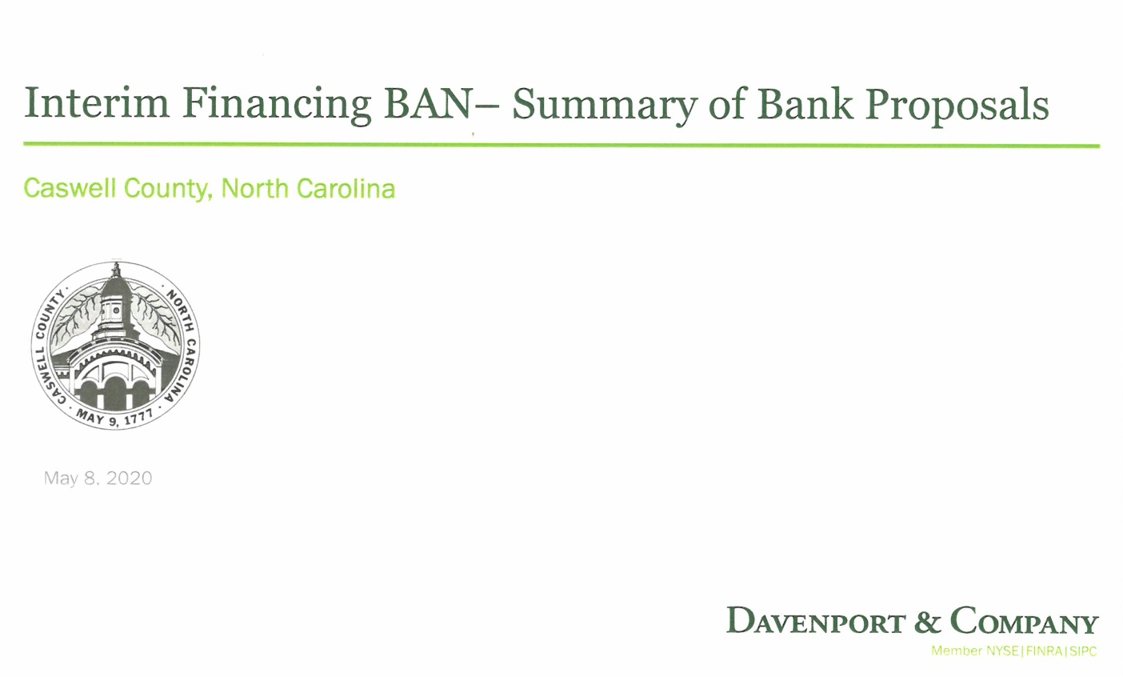
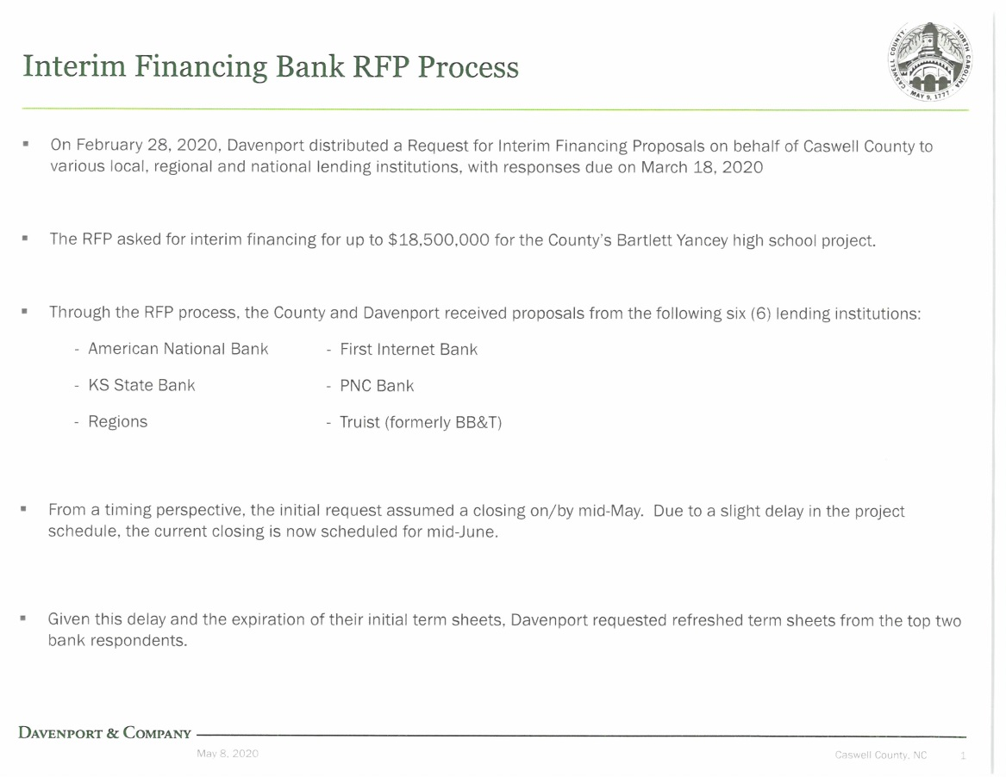

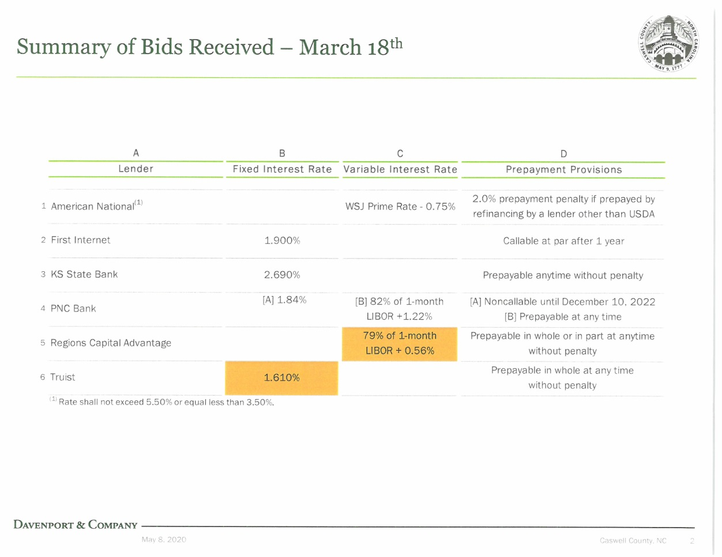
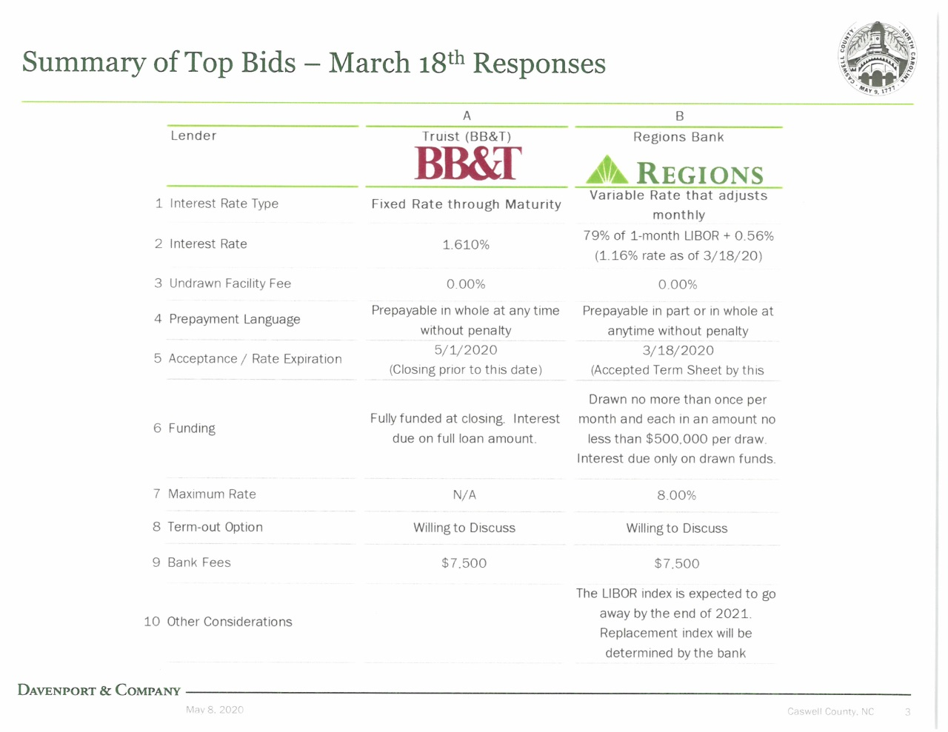

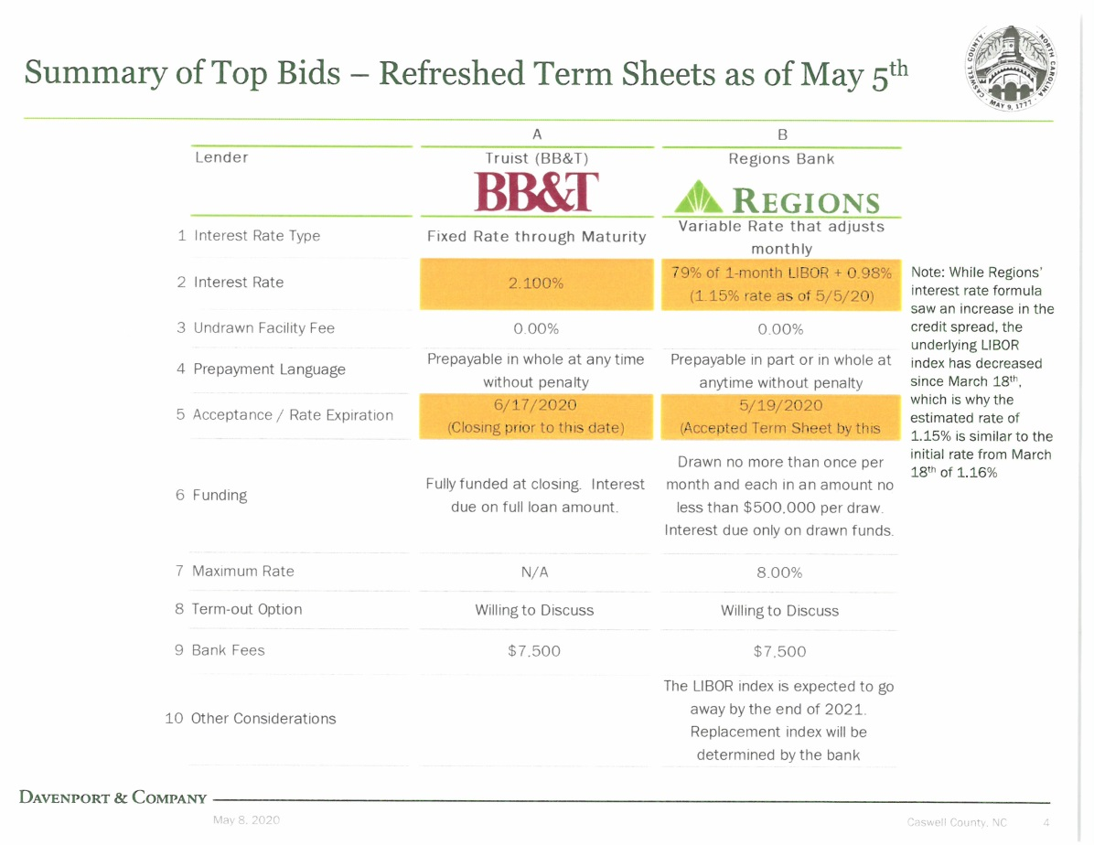
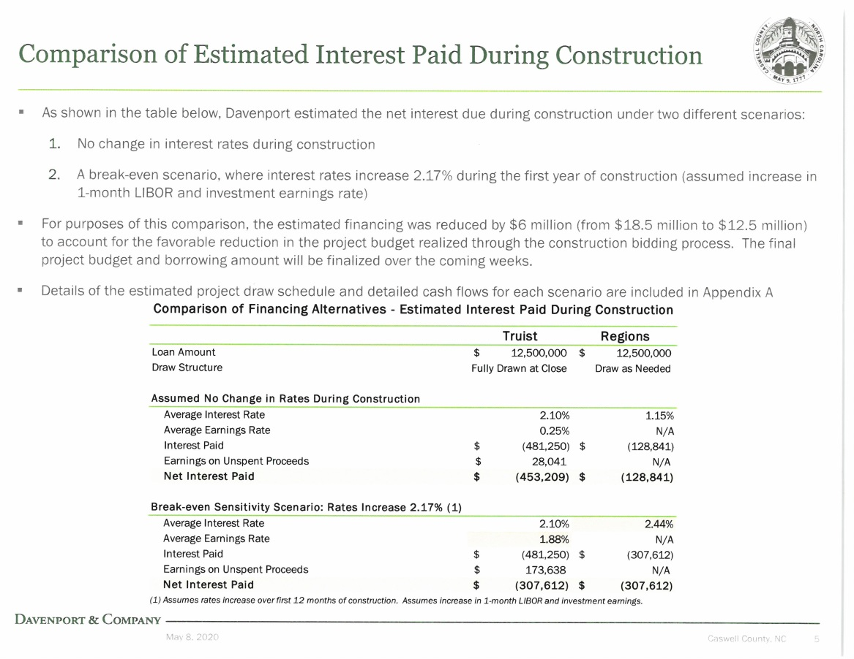

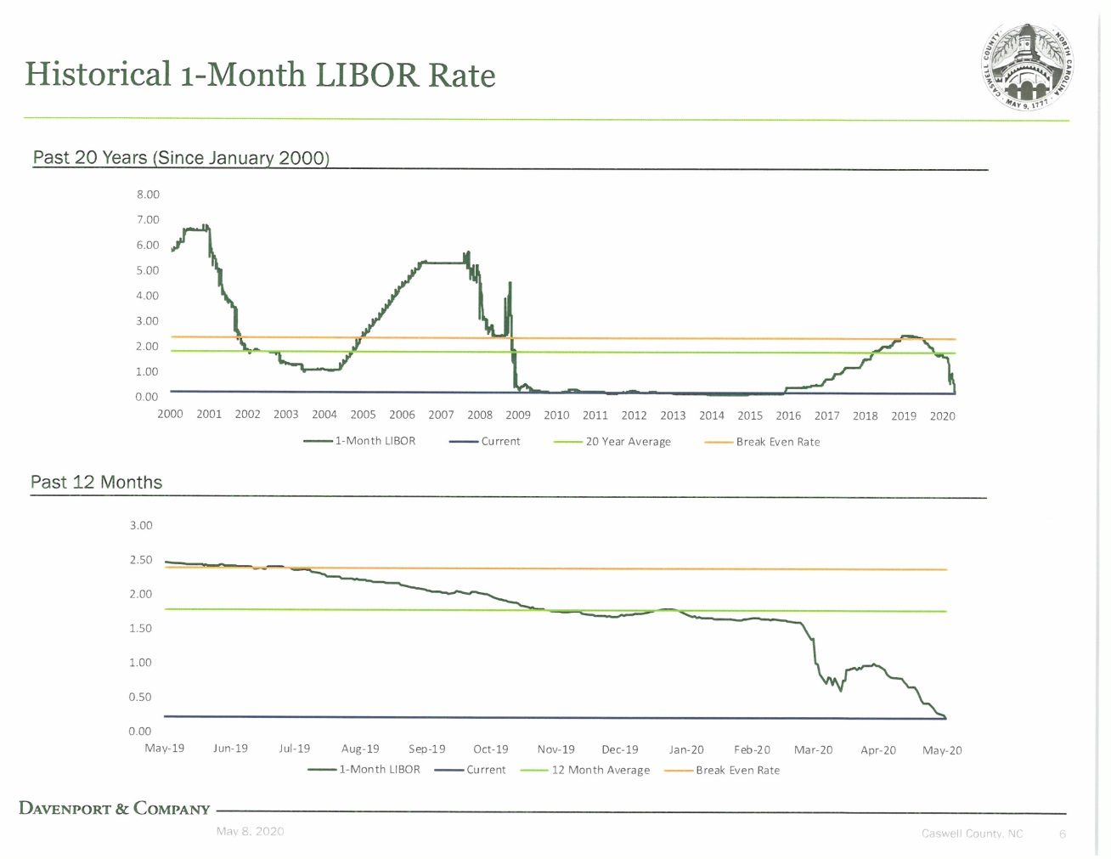
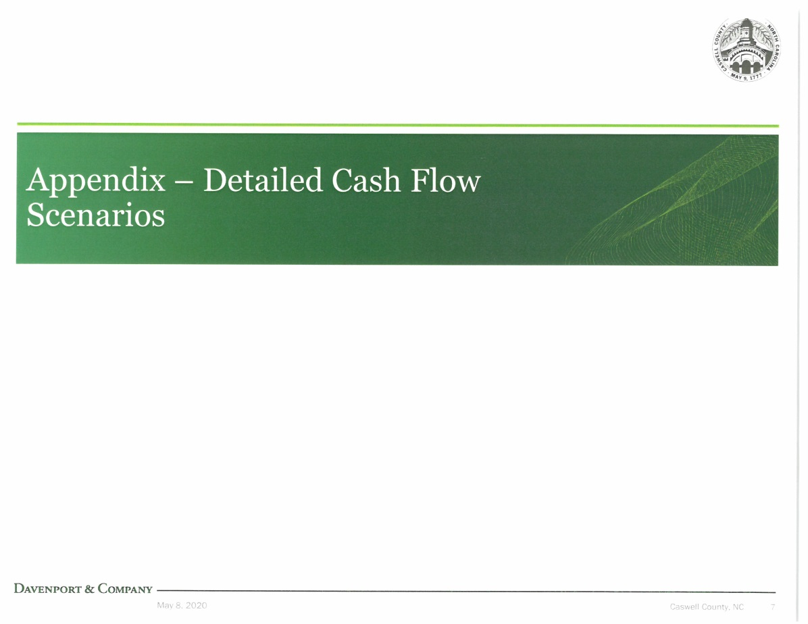

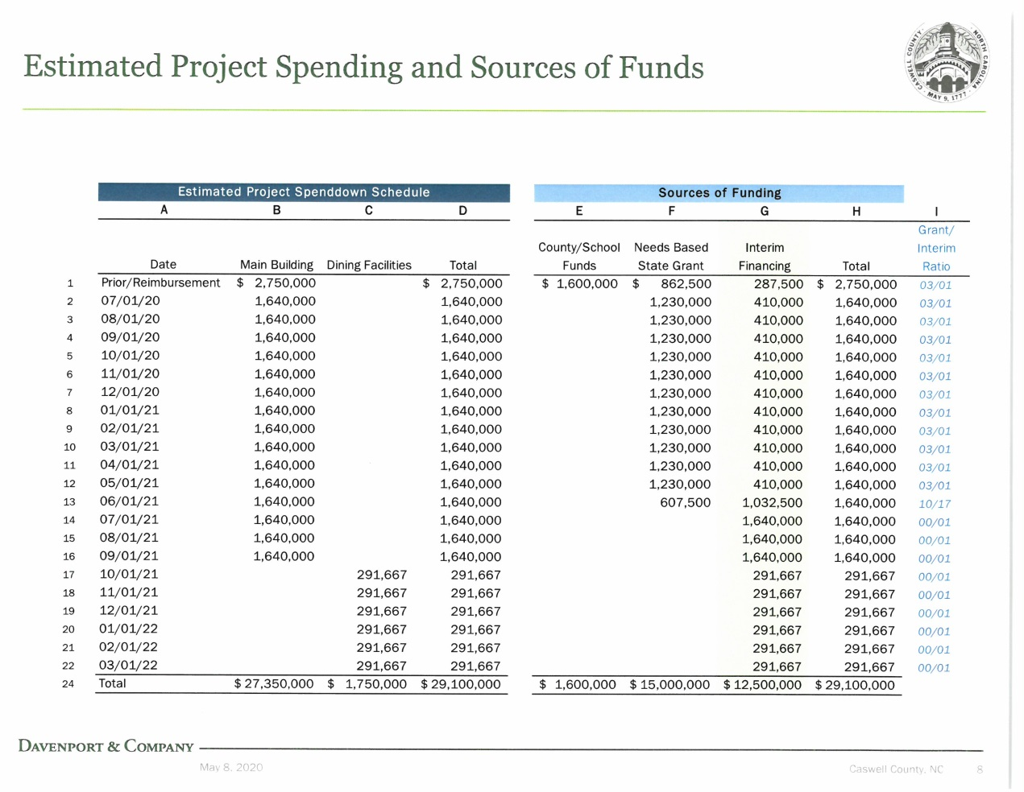
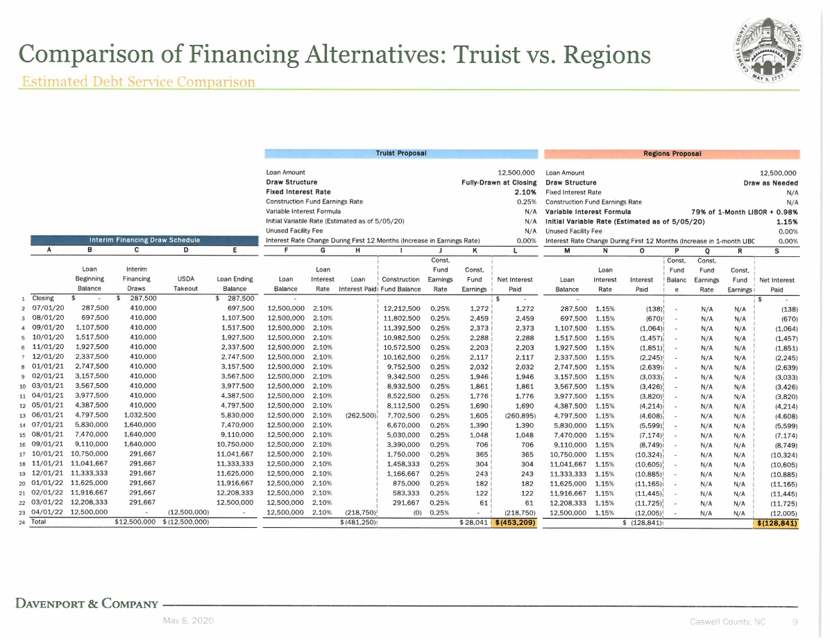

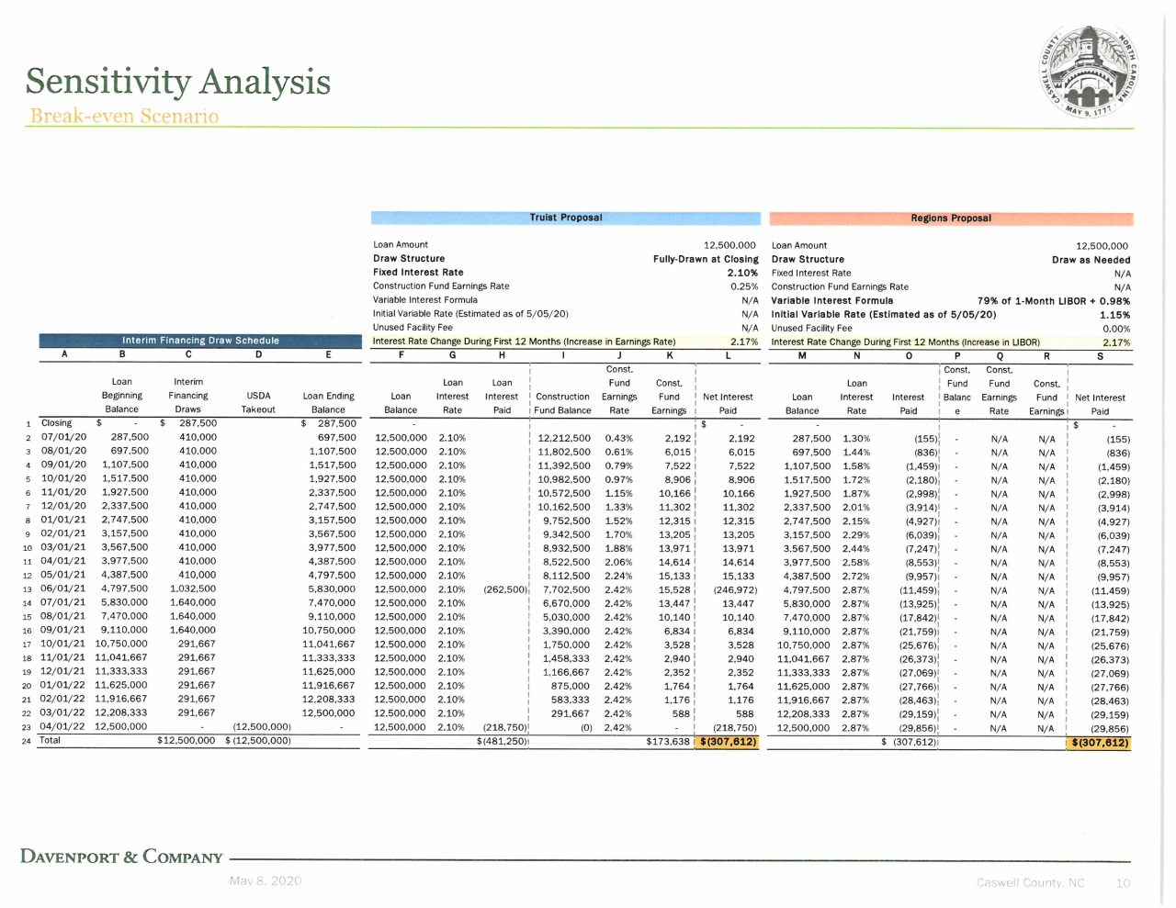
Mr. Wellford stated there are two great options here. If the Board wants certainty go with Truist but if the Board wants to start at a lower interest rate use Regions.

Commissioner Owen stated that he was concerned about where the tax rate will be and added that the county already has a high tax rate. He asked if it was better knowing what the tax rate will be or would it be better to take a chance and it go high and cost the citizens more money. Commissioner Oestreicher responded that it is not a huge advantage to go with a variable rate.

Mr. Wellford stated that the biggest factor in the entire equation is going to be the USDA long term financing at which the rate is already locked in and this is where the payments will come from. He added that the interim financing is only for about 18 months so the interest will be small in comparison to the USDA loan.

Commissioner Oestreicher stated that he agreed with Commissioner Owen.

Commissioner S. Carter stated “Mr. Chairman, I’m overwhelmingly in favor of the fixed.”

Commissioner W. Carter stated that he agreed with a fixed rate.

Commissioner Jefferies agreed with the fixed rate as well.

Mr. Paul Jacobson stated that the consensus has been expressed and the actual vote can take place during the next item on the agenda.

Commissioner S. Carter asked “Are we doing separate motions on those?” Mr. Jacobson responded that only one motion was needed.

RESOLUTION OF THE BOARD OF COMMISSIONERS OF CASWELL COUNTY, NORTH CAROLINA PROVIDING FOR THE ISSUANCE OF AN UP TO $18,500,000 GENERAL OBLIGATION BOND ANTICIPATION NOTE (SCHOOL PROJECT), SERIES 2020 OF CASWELL COUNTY, NORTH CAROLINA

Mr. Paul Jacobson, Sands Anderson Law Firm, stated that he was the county’s bond attorney for this specialized area. He stated that it sounds as if the consensus of the Board is to move forward with the Truist Bank/BB&T fixed rate interim financing. Mr. Jacobson stated that the annual interest rate would be 2.1% and the maturity date would be the end of December 2022. He added that the rest of the resolution talks about some of the specific terms getting to closing, the pay-off from the USDA, tax exempt covenants, as well as the form of the note itself. Mr. Jacobson stated that this should be in the LGC’s calendar for the June 2 meeting. He added that he thinks everything is on track with the LGC and USDA. Mr. Jacobson stated that the target date for interim financing closing is the middle of June.

Mr. Ty Wellford added that the maturity date in the resolution is December of 2022 is longer than the expectation of the project construction and this is on purpose just in case more time is needed.

Commissioner Oestreicher asked if the ownership of the school property was already in place. Mr. Jacobson responded that he believed that the county had already taken ownership of the school property. Mr. Ferrell stated that about a month ago the School Board met and voted to convey the school property and both deeds have been recorded.

Commissioner S. Carter asked “Mr. Chairman just a quick question, clarity, we are just motioning to approve this resolution and identifying the bank as BB&T with a fixed interest rate?” Mr. Jacobson responded that this was correct and added that it would be Truist Bank.

Commissioner S. Carter moved, seconded by Commissioner Hall to approve the resolution with Truist Bank for interim financing with a fixed interest rate. After a roll call vote, the motion carried unanimously.

Resolution No. 2020

Resolution of the Board of Commissioners of Caswell County, North Carolina Providing for the Issuance of an up to $18,500,000 General Obligation Bond Anticipation Note (School Project), Series 2020 of Caswell County, North Carolina

WHEREAS, Caswell County, North Carolina (the "County") is a political subdivision of the State of North Carolina;

WHEREAS, pursuant to the Local Government Bond Act (Article 4, Subchapter IV, Chapter 159, North Carolina General Statutes) (the "Act"), the County is authorized to issue general obligation bonds secured by the County's faith and credit, if approved by a majority vote of the qualified voters of the County voting on the question in accordance with the Act, and pursuant to North Carolina General Statues Section 159-61 the County is authorized to issue general obligation bond anticipation notes in anticipation of the receipt of the proceeds of the sale of such general obligation bonds;

WHEREAS, at a referendum held on November 6, 2018, a majority of the qualified voters of the County voting on the question approved a Bond Order (as defined below) that authorized the issuance of up to $36,500,000 of County general obligation bonds to pay costs of providing capital improvements to acquire, construct, improve, expand, renovate and equip County public school facilities;
WHEREAS, the County has submitted its application to the USDA (as defined below) for long-term financing of the School Project (as defined below), as authorized by the Bond Order, and the USDA has, subject to the fulfillment of certain conditions, indicated its willingness to provide financing for the School Project in the maximum amount of $18,500,000;

WHEREAS, no School Bonds (as defined below) have been issued, no notes have been issued in anticipation of the receipts of the sale of any School Bonds, and it is desirable at this time to make provision for the issuance of up to $18,500,000 of a general obligation bond anticipation note in anticipation of the issuance of the School Bonds;
WHEREAS, Truist Bank (formerly known as BB&T) has submitted a proposal for the purchase of such note, and the Board of Commissioners of the County has determined to accept such proposal; and

NOW, THEREFORE, BE IT RESOLVED by the Board of Commissioners of the County as follows:
Section 1. For purposes of this Resolution, the following words will have the meanings ascribed to them below:
“Bank" means Truist Bank.

"Board" means the Board of Commissioners of the County.

“Bond Order” means the bond order relating to the School Project authorizing the School Bonds adopted by the Board of Commissioners on June 18, 2018, and approved by the vote of a majority of the voters who voted thereon at a referendum in the County duly called and held on November 6, 2018.

“Code” means the Internal Revenue Code of 1986, as amended. Each reference to a section of the Code herein will be deemed to include the United States Treasury Regulations proposed or in effect with respect thereto.

“Federal Securities” means (a) direct obligations of the United States of America for the timely payment of which the full faith and credit of the United States of America is pledged or (b) obligations issued by any agency controlled or supervised by and acting as an instrumentality of the United States of America, the timely payment of the principal of and interest on which is fully guaranteed as full faith and credit obligations of the United States of America, which obligations, in either case, may be certificates representing ownership of United States Treasury bond principal at maturity or coupons for accrued periods of interest, which bonds or coupons are held in the capacity of custodian and independent of the seller of such certificates by a bank or trust company organized and existing under the laws of the United States of America or any of its states.

“LGC” means the Local Government Commission of North Carolina.

"Maturity Date" means December 31, 2022.

“Nonarbitrage and Tax Certificate” means the Nonarbitrage and Tax Certificate executed by the County related to the Note.

“Note” means the Caswell County, North Carolina General Obligation Bond Anticipation Note (School Project), Series 2020 issued in anticipation of long-term financing of the School Project represented by the School Bonds.

"School Bonds" means one or more general obligation bonds expected to be issued by the County to USDA, authorized by the Bond Order, in a principal amount not to exceed $18,500,000, for the long-term financing of the School Project.

“School Project” means the design, acquisition, construction, improvement, expansion, renovation and equipping of Bartlett Yancey High School in the County.

"USDA" shall mean the United States of America, acting by and through Rural Development, an agency of the United States Department of Agriculture.

Section 2. The County shall issue the Note in a principal amount not to exceed $18,500,000. The County’s full faith and credit are irrevocably pledged for the payment of the principal of and interest on the Note. In addition, the proceeds of the School Bonds are also pledged for the payment of the Note, and the Note shall be retired from the proceeds of the School Bonds as the first priority. The Board intends to issue the School Bonds to the USDA or other purchaser or purchasers of the School Bonds in an amount not less than sufficient to pay the outstanding principal amount of the Note in full.

Unless other funds are lawfully available and appropriated for timely payment of the Note, the Board will levy and collect an annual ad valorem tax, without restriction as to rate or amount, on all locally taxable property in the County sufficient to pay the principal of and interest on the Note as the same become due. The provisions of this Resolution shall constitute a contract between the County and the holders of the Note for so long as any portion of the Note and interest thereon are outstanding. The County accepts the Bank’s proposal dated May 5, 2020 for the purchase of the Note (the "Bank Proposal").

Section 3. The Note shall be dated as of its date of issuance and pay interest annually, on or about the anniversary date of its date of issuance, and on the Maturity Date. The Note is being issued to provide funds (a) to finance the capital costs of the School Project and (b) pay costs of issuing the Note, all pursuant to and in accordance with the Bond Order.

Section 4. The Board of Commissioners has ascertained and hereby determines that the average period of usefulness of the capital projects being financed by the proceeds of the Notes is not less than 30 years computed from the date of issuance of the Note.

Section 5. Subject to the provisions of this resolution, the County's Finance Officer is authorized and directed to determine the final principal amount of the Note to be issued and the principal and interest payment schedule for the Note. The Finance Officer will execute a certificate prior to the delivery of the Note determining such matters, and this certificate will be conclusive evidence of the Finance Officer's approval and determination of such matters. The Note shall bear interest on the outstanding principal amount computed on the basis of a 360-day year consisting of twelve 30-day months.

The final principal payment schedule shall be set forth in the Note and shall be conclusive. The Note in final form, however, must provide (i) for the principal amount of the Note to be not more than $18,500,000, (ii) for the Note to bear interest at an annual interest rate not to exceed 2.10% except in the case of default or an event of taxability, and (iii) for the maturity of the Note not to extend beyond the Maturity Date.

The Note shall bear interest from the Closing Date (as defined below). The principal of and interest on the Note shall be payable in any coin or currency of the United States of America which is legal tender for the payment of public and private debts on the respective dates of payment thereof.
Section 6. The Note is to be numbered “RA-1.”

Section 7. The Note is to be registered as to principal and interest, and the Finance Officer of the County is hereby appointed Registrar for the Note (the "Registrar") and directed to maintain the registration records with respect thereto. As Registrar, the Finance Officer will maintain appropriate books and records of the ownership of the Note. The County will treat the registered owner of the Note as the person exclusively entitled to payment of principal, premium, if any, and interest and the exercise of all rights and powers of the owner, except that interest payments will be made to the person shown as owner on the registration books on the 15th day of the month preceding each payment date.

Section 8. The Note will be issued initially in the form of a single fully-registered note, in substantially the form set out in Exhibit A, with such changes as may be in keeping with the Bank’s proposal and this resolution, and as the Finance Officer may approve. The Note will be dated the date of its initial delivery to the Bank (the “Closing Date”).

The Note must be signed by the manual or facsimile signature of the Chairman of the Board, Vice-Chairman of the Board, or the County Manager, must be countersigned by the manual or facsimile signature of the Clerk to the Board of Commissioners or any Assistant Clerk, and the County's seal must be affixed thereto or a facsimile thereof printed thereon. The Note will not be valid unless at least one of the signatures appearing on such Note (which may be the signature of the LGC’s representative required by law) is manually applied.

Section 9. Principal of the Note shall be paid in full on the Maturity Date. The principal amount of the Note is subject to redemption prior to the Maturity Date, at the option of the County, from any moneys that may be available for such purpose, in whole at any time, at a redemption price equal to 100% of the outstanding principal amount of the Note, plus accrued interest, if any, thereon to the redemption date.

At least fifteen (15) days prior to the redemption date of the principal amount of the Note, the Note Registrar shall cause a notice of any such redemption to be mailed, first class, postage prepaid, to the registered owner of the Note. A copy of such notice shall also be given by first class mail, postage prepaid, to the Local Government Commission; provided, however, that failure to give such notice to the Local Government Commission or any defect therein shall not affect the sufficiency of the proceedings for redemption.
Each such notice shall set forth the designation and date of the Note, the date fixed for redemption, the principal amount of the Note to be redeemed, the redemption price to be paid, the address and phone number of the Note Registrar and the date of the redemption notice. Any notice of redemption may state that the redemption to be effected is conditioned upon the receipt by the Note Registrar on or prior to the redemption date of moneys sufficient to pay the principal of and interest on the principal installments of the Note to be redeemed and that if such moneys are not so received, such notice shall be of no force or effect and such principal installments shall not be required to be redeemed. In the event that such notice contains such a condition and moneys sufficient to pay the principal of and interest on such principal installments of the Note to be redeemed are not received by the Note Registrar on or prior to the redemption date, the redemption shall not be made, and the Note Registrar shall within a reasonable time thereafter give notice, in the manner in which the notice of redemption was given, that such moneys were not so received.
The Finance Officer may determine to modify the terms for redemption of the Note prior to issuance of the Note to the extent the Finance Officer determines that such modification is in the best interest of the County.
If the County Manager determines that the County will not be in a position to issue the School Bonds and use proceeds of the School Bonds to pay the Note by the Maturity Date, the County Manager is authorized to negotiate an extension to the Maturity Date with the Bank. The County Manager, the Chairman of the Board, Vice-Chairman of the Board and other officers of the County each is authorized to execute and deliver any agreements or instruments, and to take any further actions, such officer finds to be appropriate and in the County's best interest to carry out any such modification to the Note to extend the Maturity Date. For any such modification, however, (a) there must be no increase in the outstanding principal amount of the Note, (b) there must be no increase in the interest rate payable on the Note, (c) there must be no change in the lender to which the Note is payable and (d) the Note must mature not more than three years from the original dated date of the Note. This authorization is not limited to one modification and extension, but includes as many modifications and extensions as the County Manager finds to be in the County's best interests.
Section 10. The Note and the provisions for the registration of the Note and for the approval of the Note by the Secretary of the LGC are to be in substantially the form set forth in Appendix A.

Section 11. The County covenants that it will not take or permit, or omit to take or cause to be taken, any action that would adversely affect the exclusion from gross income of the recipient thereof for federal income tax purposes of the interest on the Note, and, if it should take or permit, or omit to take or cause to be taken, any such action, the County will take or cause to be taken all lawful actions within its power necessary to rescind or correct such actions or omissions promptly upon having knowledge thereof. The County acknowledges that the continued exclusion of interest on the Note from the owner's gross income for federal income tax purposes depends, in part, on compliance with the arbitrage limitations imposed by Section 148 of the Code. The County covenants that it will comply with all the requirements of Section 148 of the Code, including the rebate requirements, and that it will not permit at any time any of the proceeds of the Note or other funds under its control be used, directly or indirectly, to acquire any asset or obligation, the acquisition of which would cause the Note to be “arbitrage bonds” for purposes of Section 148 of the Code. The Caswell County Board of Education in its Lease of the School Project has covenanted that it will not use or permit the use of the School Project in any manner that the Board of Education is advised by the County might result in the Note being a "private activity bond" within the meaning of Section 141 of the Code, or would otherwise cause the interest payments with respect to the Note to be included in the gross income of the owners or holders thereof for federal income tax purposes. The County Manager and Finance Officer are each hereby authorized to execute a Nonarbitrage and Tax Certificate with respect to the Note.

Section 12. The sale proceeds of the Note shall be utilized by the County to pay costs of the School Project and costs of issuance of the Note, and invested in accordance with the requirements of the Local Government Budget and Fiscal Control Act, Article 3 of Chapter 159, General Statutes of North Carolina, as amended. The Finance Officer is hereby directed to create and establish a special fund to be designated "County of Caswell, North Carolina General Obligation Bond Anticipation Note (School Project), Series 2020 Project Fund" (the "Project Fund") and shall track the expenditure of proceeds of the Note in the Project Fund related to the School Project. The Finance Officer shall deposit net proceeds from the sale of the Note in the Project Fund. The Finance Officer shall keep and maintain adequate records pertaining to the proceeds of the Note and all disbursements thereof so as to satisfy the requirements of the laws of the State of North Carolina and the requirements of the USDA in relation to issuance of the School Bonds, and shall properly allocate proceeds of the Note to the School Project in accordance with the limitations of the Bond Order and to assure that the County maintains its covenants with respect to the exclusion of the interest on the Note from gross income for purposes of federal income taxation.

Section 13. The County asks the LGC to sell the Note to the Bank at a private sale, substantially in accordance with the terms of this Resolution and the Bank’s proposal.

Section 14. The Chairman of the Board, the Vice Chairman of the Board, the County Manager, the County Finance Officer and the Clerk of the Board are hereby authorized and directed to cause the Note to be prepared and, when they shall have been duly approved by the LGC, to cause the Note to be executed and delivered to the Bank.

Section 15. The Chairman of the Board, the Vice Chairman of the Board, the County Manager, the County Finance Officer, the County Attorney and the Clerk of the Board are authorized and directed to execute and deliver for and on behalf of the County any and all additional certificates, agreements (including the Note Purchase Agreement or similar agreement with the Bank in the form presented to this meeting, with such changes and insertions deemed necessary by the officer executing it), instruments, documents, opinions or other papers and perform all other acts as may be required by the documents contemplated hereinabove or as may be deemed necessary or appropriate in order to implement and carry out the intent and purposes of this Resolution. All actions of the Chairman of the Board, the Vice Chairman of the Board, the County Manager, the Finance Officer, the Clerk of the Board, the County Attorney and their respective designees, whether previously or hereinafter taken, in effectuating the proposed financing and the issuance of the Note are hereby ratified, approved and authorized.

Section 16. This Resolution may be amended or supplemented, from time to time, without the consent of the owners of the Note if in the opinion of nationally recognized bond counsel, such amendment or supplement would not adversely affect the interests of the owners of the Note and would not cause the interest on the Note to be included in the gross income of a recipient thereof for federal income tax purposes. This Resolution may be amended or supplemented with the consent of the owners of a majority in aggregate principal amount of the outstanding Note, exclusive of any portion of the Note, if any, owned by the County, but a modification or amendment may not, without the express consent of any owner of the Note, reduce the principal amount of the Note, reduce the interest rate payable on it, extend its maturity or the times for paying interest, change the monetary medium in which principal and interest is payable, or reduce the percentage of consent required for amendment or modification.

Any act done pursuant to a modification or amendment consented to by the owners of the Note is binding on all owners of the Note and will not be deemed an infringement of any of the provisions of this Resolution, whatever the character of the act may be, and may be done and performed as fully and freely as if expressly permitted by the terms of this Resolution, and after consent has been given, no owner of the Note has any right or interest to object to the action, to question its propriety or to enjoin or restrain the County from taking any action pursuant to a modification or amendment.

Section 17. Nothing in this Resolution shall preclude (a) the payment of the Note from the proceeds of the School Bonds or any refunding bonds or notes or (b) the payment of the Note from any legally available funds.

If the County causes to be paid, or has made provisions to pay, on maturity or on redemption before maturity, to the owners of the Note the principal of the Note (including interest to become due thereon) and, premium, if any, on the Note, through setting aside trust funds or setting apart in a reserve fund or special trust account created pursuant to this Resolution or otherwise, or through the irrevocable segregation for that purpose in some sinking fund or other fund or trust account with an escrow agent or otherwise, moneys sufficient therefor, including, but not limited to, interest earned or to be earned on Federal Securities, the Note shall be considered to have been discharged and satisfied, and the principal of the Note (including premium, if any, and interest thereon) shall no longer be deemed to be outstanding and unpaid; provided, however, that nothing in this Resolution requires the deposit of more than such Federal Securities as may be sufficient, taking into account both the principal amount of such Federal Securities and the interest to become due thereon, to implement any such defeasance.

If such a defeasance occurs and after the County receives an opinion of a nationally recognized accounting firm that the segregated moneys or Federal Securities together with interest earnings thereon are sufficient to effect a defeasance, the County shall execute and deliver all such instruments as may be necessary to effect such a defeasance and desirable to evidence such release, discharge and satisfaction. Provisions shall be made by the County, for the mailing of a notice to the owners of the Note that such moneys are so available for such payment.

Section 18. If any one or more of the agreements or provisions herein contained is held contrary to any express provision of law or contrary to the policy of express law, though not expressly prohibited, or against public policy, or for any reason whatsoever is held invalid, then such covenants, agreements or provisions are null and void and separable from the remaining agreements and provisions and will in no way affect the validity of any of the other agreements and provisions hereof or of the Note authorized hereunder.

Section 19. The selection and retaining of Davenport & Company, LLC as financial advisor and Sands Anderson PC as bond counsel to the County is hereby confirmed and ratified.

Section 20. All resolutions or parts thereof of the Board of Commissioners in conflict with the provisions herein contained are, to the extent of such conflict, hereby superseded and repealed.

Section 21. This Resolution is effective on the date of its adoption.

Commissioner Oestreicher asked where the project manager fits into this project and when does this kick in. Mr. Miller responded that the project manager is currently on board and the Board approved his contract so Bill Powell is the project manager for the construction of the school project. He added that Mr. Powell is working closely with Brian Bradner the architect. Mr. Miller stated he would get Mr. Bill Powell scheduled to appear before the Board to discuss the project in more detail. Commissioner Oestreicher stated that this was exactly what he wanted to hear.

RECESS

The Board took a brief recess.

Mr. Ty Wellford and Mr. Paul Jacobson left the meeting.

COVID-19 UPDATE

Ms. Jennifer Eastwood, Health Director, stated that the county has 1 case come in around 7:30 so that bring the county to 42 cases and this was the first case in about 9 days. She stated that there is a little bit of a discrepancy between the State’s dashboard and the County’s numbers and they are trying to figure out where this is coming from but she believes that is coming from the offenders at the prison who have been transferred to other facilities. Ms. Eastwood stated that the county will find out Friday if it will be able to move into Phase 2. She stated that the goal from the State is for the County to test at least 5% of the county every month which about 266 a week. Ms. Eastwood stated that she is looking to the State for guidance since there may be a shortage on test kits. She added that the county is okay on test kits now but with the increase in testing there may be an issue. Ms. Eastwood stated that the Health department is having issues with finding isolation gowns and these are needed for staff when they are testing. She stated that regardless of what phase the state is going into she wanted to remind everyone that social distancing is not going away any time soon. Ms. Eastwood stated that she knew that there was a public awareness campaign being put together from the region covering social distancing and face coverings. She knew that efforts are going on to provide face masks and hand sanitizers to those who cannot afford it. Ms. Eastwood stated that she has gained more community partners since this started and added that the warden at the prison has been wonderful to work with. She added that the Senior Center allowed the Health Department to set up a testing facility for the correction center employees and she thanked them for that. Ms. Eastwood stated that she would be talking to the Boy Scout Camp today to see what this means for their summer program. She added that she is grateful for the teamwork in the county.

Commissioner S. Carter asked “Mr. Chairman, Ms. Eastwood could you remind us for the sake of anyone in the public that may be listening, the main differences between Phase 1 and Phase 2 and how that would affect them?” Ms. Eastwood responded that in Phase 1 the stay at home order is still in effect. She added that the only real change is that some outdoor facilities will open back up. Ms. Eastwood stated that in Phase 2 they may allow a larger group size and restaurants will still be closed. She did not think there would be a huge difference but Phase 2 will last about 4 to 6 weeks. Commissioner S. Carter continued “I’m also concerned with people who may be taking care of family members or like in my case I’m a caregiver and take care of an individual, we’ve had struggles getting masks and particularly gloves and I was wondering if we have any kind of effort in the works to work with people in the county when it comes to supplies. For example, we were told to go to, I think it was, Walgreens and Walmart and then you go there and they don’t have them and so you are stuck having to buy like off Amazon or EBay for $30 a box.” Ms. Eastwood stated that these are the things that the Health Department continues to struggle with as well so that we have the supplies for the frontline workers. She added that he could request those types of supplies for the county is not providing those types of supplies because the county needs to make sure it has enough for the Health Department staff and EMS staff. Commissioner S. Carter continued “Sure.”

Commissioner Owen stated that he would make a comment to this as well and added that there are many individuals in the county that are making masks that can be washed and reused. He stated that the ones that are purchased can only be used once. Commissioner Owen stated that these masks cost between $5 and $7 and he has heard that some can’t afford this but people will buy what they want to buy. He added that there are individuals that are giving these masks away and he could get some of these sources to Commissioner S. Carter if he is interested. Commissioner Owen stated that his wife has made face masks and they have an area that a filter can be put in it if the individual wants more protection. Commissioner S. Carter responded “Yeah, I think the main concern was we were shocked with the lack of supplies when it comes to gloves, latex or latex free, people use them all the time in healthcare and literally the only resource we could find was some price-gouged options online so that’s why I was asking if there were any coordinated efforts, you know, with working with home healthcare providers whether they are individuals or group homes or whatever. There are many of those in the county.”

Chairman McVey asked if there were any more questions for Ms. Eastwood.

Commissioner W. Carter asked Ms. Eastwood how many cases have recovered out of the 42 cases. Ms. Eastwood responded that there have been 12 that have recovered. She added that some are out of their isolation period but will have to be retested in order to go back to work. Ms. Eastwood stated that the Health Department did a drive through testing for about 50 correction employees and three tested positive but they did not live in Caswell County. She added that they are continuing to test prison employees as they develop symptoms or if they have been exposed to someone.

CASWELL COUNTY COMMUNITY HEALTH ASSESSMENT

Ms. Marcy Williams stated that the Community Health Assessment is required to be submitted at least every 4 years and the last Community Health Assessment was submitted in the spring of 2016. She stated that the process for this community health assessment began in the spring of 2017 and the final document was submitted in February of 2020. Ms. Williams stated that the survey for this assessment began in the fall of 2017 and 543 people completed that survey. She added that this data was compared to other outside sources. She stated that there were 9 listening sessions throughout the spring and summer of 2019 with over 100 participants. Ms. Williams stated that 14 key priorities emerged from these meetings and most of these issues related to the economy, community resources, and healthcare. She stated that these 14 issues were put on a priorities survey and 320 people participated in this survey. Ms. Williams stated that the top 5 priorities were: Improved local job opportunities, Structured positive activities for children and teens, Improved local school experiences for students regardless of their backgrounds and abilities, Improved race relations, and Access for affordable health care options. She stated that the Caswell Health Collaborative met and discussed these priorities and came up with 2 priorities to be worked on for the next couple of years and those were: Structured activities for youth and Improved race relations. Ms. Williams stated that the Community Health Assessment is available on the Health Department’s website. She gave a brief overview of the data collected.

Commissioner S. Carter stated “Mr. Chairman not a question per se just stressing a point, we talked about this briefly either last year or the year before last the community health concerns for 2016, mental health, substance abuse, and obesity I feel like, you know, the efforts that are being made are quite valuable and helpful but I’m seeing more of a stress like with…we are focusing on our employees which is great but I feel like we need to collaborate with other groups and the school system. I think this is kind of where I went with this last year because we have lack of data when it comes to like childhood obesity which everyone should be able to realize is a huge issue in Caswell County and especially noticeable in the last couple of decades in the school system. And then for mental health it mentions, you know, trainings and it focuses on substance abuse and then it just said if you are experiencing something call this number so I’m curious what services are that when it comes to mental health, they can call 911 or they can call this 1-800 number, were there any other resources?” Chairman McVey asked if there were any other questions for Ms. Williams. Commissioner S. Carter stated “I did not get an answer on my question, I am sorry.” Ms. Williams responded that with mental health there is a help line through Cardinal Innovations. Commissioner Owen added that through the County Wellness Program there have been several programs that were given that were made available to anybody concerning mental health. He agreed that in the area of mental health there has been a lack of resources from the federal government down. Commissioner Owen stated that the county has at least provided some workshops that were available to all people whether caregivers or individuals as well as county employees. Commissioner S. Carter continued “Right. Let me bring it back to this 800 number Ms. Williams, how do people have access to this number in Caswell County?” Mr. Miller responded that this number has been shared with all the local healthcare providers and the number is also available through the Health Department and the Department of Social Services. He added that Administration also has this number and will share with anyone that needs it. Mr. Miller asked the clerk if Cardinal’s number was listed on the county website. The clerk responded that this number is not on the county’s website but it could be added to the website. Commissioner S. Carter asked “Is that number, as far as you know, in the school system? Is that a number that children can call that may have a crisis, people that are not in social services for example?” Mr. Miller responded that the school system does have this number available. Commissioner S. Carter continued “That’s all I got.”

Commissioner Oestreicher stated that part of the survey questions was how did the people get their information and 45% of the people responded that they get their information through the internet and only 22% only consider the internet for their news regarding Caswell County services. He asked if there was a way to use this information to enhance or improve the ability for the county to get grants for better support from internet providers. Ms. Williams responded that the survey data is available to anyone or any agency to use. Mr. Miller responded yes providers could use this data to help support applications for internet services within the county. He added that most providers need adoption rates or how many people on a monthly basis would purchase this service. Mr. Miller stated that the county planner did a great job putting together a campaign and gathered a tremendous amount of data to help an ISP to secure a grant on behalf of Caswell County and it was one of the highest grants awarded in the state. He added that now the county is just waiting on the company, Open Broadband, LLC to move forward with their plans to provide some kind of wireless internet service within the county. Commissioner Oestreicher stated that maybe the action he was looking for is for Ms. Williams to develop a short statement that summarizes this information and focuses on the internet and the high probability of use of the internet by county residents for health-related issues and then the county planner could pass this information on to the ISP as part of the Connect 2020 initiative.

Commissioner Owen stated that he wanted to make a comment and did not want it to come across wrong but he did not want the citizens to look for health information on the internet because everyone has seen in the last two months how much information is out there from all kinds of sources that are not reputable. He added that he understood what Commissioner Oestreicher was saying and he understood where he was coming from. Commissioner Oestreicher responded that he thought it would be good if part of Ms. Williams’ statement would be recommendations on where to go for health related information within the county and added that this type of information is hard to get and it supports that residents want better internet and cell phone coverage.

Commissioner Oestreicher stated that the other number that bothered him was that 36% of the residents in Caswell County don’t even have a telephone and he did not know if this was a countywide percentage or if this number was accurate. Commissioner Owen asked if this was a house telephone or cell telephone. Commissioner Oestreicher stated that the answer was ‘I do not have a phone’. Ms. Williams responded that these numbers were transposed and this would be 1% do not have a phone.

Commissioner S. Carter stated “We have to keep in mind too that only 2% of our citizens filled out this survey.” Commissioner Oestreicher responded that he made that comment as well. Commissioner S. Carter continued “Right.” Commissioner Oestreicher responded that maybe this information should not be used.

Commissioner S. Carter stated “Mr. Chairman just a comment, I just wanted to acknowledge that a lot of hard work went into putting together the survey and administering it, collecting it and compiling the data and I just wanted to thank everybody at the Health Department and everybody else in County government and citizens and businesses that participated, we appreciate that.”

NEED FOR ACTION REGARDING COVID-19 SPREAD

Ms. Jennifer White, Chairperson of the Board of Health, stated that the county has had a very minor first wave of this epidemic but it is certainly not minor for the individuals that have contracted the disease but in terms of epidemiology the county has had a very minor first wave. She added that big cities got hit harder than rural areas however the second wave is expected to start in the fall through the winter and then perhaps a third wave may follow the pattern of the 1918 epidemic. Ms. White stated that she was very grateful that Caswell has not been hit as hard as other areas and added that the county does have the responsibility to protect and educate the citizens of the county. She stated that the Board of Health met virtually on the 5th and there was a very robust discussion about protecting the citizenry of Caswell. She added that there was some disagreement about how rules and regulations and out of this came the letter that was sent to the Board and included in the agenda requesting a resolution. Ms. White stated that on Friday afternoon she talked with Ms. Eastwood and Commissioner Hall and during this conversation there was a suggestion that she write a resolution. She stated that she sent the Board a resolution with the caveat that she had never written a resolution before. Ms. White asked the Board to approve this resolution to present to the community. (The resolution was put on the screen for all to see).

Chairman McVey stated that he had read the resolution and recommended to the Board and Board of Health that the county manager and Ms. Eastwood rewrite this resolution and to bring it back to the Board at the next meeting. He added that there are some issues in the resolution that need to be looked at by the county manager and Ms. Eastwood before approving. Ms. White responded that the letter from her was a group effort and she added that the resolution should also be a group effort but she did think there was some amount of urgency because as a nurse she is seeing very spotty measures that are taken place and as public safety she thought this should be release as soon as possible. She stated that he had no objections of this resolution being reviewed by Mr. Miller and Ms. Eastwood.

Commissioner Hall asked Chairman McVey if he could share his concerns with Ms. White. Chairman McVey responded that in number 3 it says ‘we are expecting compliance with these public safety measures, while at the same time recognizing that it is not possible to enforce them legally at this time.’ He had an issue with making everyone in the county to wear a mask because he thought the people in the county were smart enough to decide if they want to wear a mask or if they do not want to wear a mask. Chairman McVey stated that the second reason is the sheriff’s department is too busy right now to enforce this anyway. He stated that in number 5 it says ‘Model these public health measures personally to show our citizens that we take the safety and health of all our citizens seriously.’ He stated that he was not going to have anyone tell him that he has to wear a mask because he said it was his choice to wear a mask or not. Chairman McVey stated that these are some of the reasons he wanted the resolution to be sent to Mr. Miller and Ms. Eastwood to do a rewrite. He added that he was all for funding the creation and distribution of educational materials and he did not have a problem with encouraging citizens to wear a face mask but he would not require it. Commissioner Hall stated that the Board of Health had a serious discussion along that same line and added that from a medical standpoint the mask that individuals wear is for the protection of individuals around you and this is the standpoint that the Board of Health took several years ago about smoking. He added that there needs to be some consideration for friends, neighbors, and family. Commissioner Hall stated that he understood Chairman McVey’s position but this was the position that the Board of Health agreed upon to ask the Board of Commissioners to support the resolution.

Commissioner Owen stated that he had some reservations about the resolution in general because he was more than happy to encourage the citizens to wear face coverings, social distancing, avoiding large social gatherings, and washing hands. He stated that he was more than willing to do this through education. Commissioner Owen stated that his problem with the resolution is the county has been 9 days without a case and when you look at the overall percentage of citizens in Caswell County compared to the population it is way less than 1%. He added that he was not saying the disease is not serious but the county needs to have all the facts laid out for the citizens. Commissioner Owen stated that he did not think a resolution from the Board would carry a lot of weight with the citizens because there are policies that are enforced and citizens still do not follow them. He added that because of the way that people view government from the federal level down they do not trust the government very much and the county has not had a lot if any community spread so he has a problem with doing a resolution at this time. Commissioner Owen stated that the resolution only covers face coverings but does not cover social distancing and hand washing which are just as important if not more. He also had a problem with phrases such as ‘we expect citizens to comply’ because citizens in this county do not like those kinds of words by the government and he did not want to create a divide. Commissioner Owen stated that being told to wear a mask is creating problems in various areas of divide between people, violence between people, and there has been one person killed over this issue and he did not want to create that within the citizenry of Caswell. He asked if he were to go to Food Lion and not wear a mask and has the virus but shows no signs and someone else is wearing a mask and washes his or her hands after the visit what are the odds of that person getting the virus. Commissioner Hall responded that the odds are pretty high if social distancing is not practiced. He added that as far as a divide the county already has a divide because some individuals do not believe that certain rules apply to them. Commissioner Hall stated that it is not asking too much for an individual to wear a mask. He agreed that there were some things that were left out of the resolution and could be added. Commissioner Hall stated that Ms. Williams mentioned that 75% of the citizenry work outside the county and those 75% could bring something into the county from all over the region and the county needs to be prepared. He added that the county has been fortunate so far but this will not last long.

Ms. White stated that in number 2 it does say “to physically distance themselves from others by at least six feet” and she added that Commissioner Owen was right because she neglected to put in frequent and thorough hand washing. She added that she wrote this under pressure but she thought Commissioner Hall was right because everyone is their brother’s keeper and wearing a mask protecting the people around you. Ms. White stated that she did not have an objection with Mr. Miller and Ms. Eastwood rewriting this. She stated that she had been on the call since 9:00 and that she had to leave the meeting because she has an appointment in Burlington. Ms. White thanked everyone for their attention to the matter and she understood the objections.

Commissioner Owen stated to Ms. White before she left the meeting that this was not an attack on her resolution and added that he would not know how to write a resolution either and he thanked her for what she had done but he thought other things needed to be included in the resolution. Ms. White thanked Mr. Owen and agreed that other things needed to be included.

Chairman McVey also thanked Ms. White for writing the resolution and he understood that she had to do this at the last minute but he hopes she understood why he wanted to have Mr. Miller and Ms. Eastwood to rewrite it. Ms. White thanked Chairman McVey.

Commissioner Oestreicher stated that in the rewrite he thought the county should be accurate with what the county was recommending to be done because wearing a face mask improperly does not do a thing to help. He added that encourage individuals to protect other individuals is a good idea. Commissioner Oestreicher stated that the resolution needed some careful thought and he would like to see it in full compliance.

Commissioner S. Carter stated “Mr. Chairman, I understand both sides of this, we can recommend but not enforce, I agree with that mostly because enforcement of that is almost just not realistic even if we wanted to. Through this whole adventure we’ve had with COVID what bothers me most of all, you know, with the recommendations I see families with young children, masks are one thing, so they are not wearing masks but most importantly they are not practicing social distancing out and about and, you know, I have seen in other counties, maybe there are some here locally but I commend the business owners that are working hard to protect their employees and their patrons by requiring masks in their places of business. I personally understand that point of view, you know, from the prospective of the business owner and I commend them for that. Protecting family, friends, coworkers, all contributes to the greater good and whether that is here or out of county where our citizens are going, you know, our citizens travel all the time outside of the county so we never know what is coming in or going out. A resolution sounds good, you know we’ve done resolutions on all kinds of things but really at the end of the day how far does it go and I am not against the idea of a rewrite and doing something at the next meeting but even at that point where does it go, what do we do? I am sort of thinking that just pure education is the best way to address all of this but what steps do we take? Could we partner with local businesses in some way that’s collaborative to consolidate this effort, you know, to protect everyone? How can…it’s a matter of just expounding the recommendations of the CDC and the NCDHHS in this county, you know, that could serve its citizens well by leading by example but we need to come up with some concrete set of steps, initiatives or recommendations that we as a county government and hopefully in partnership with others commit to other than just words. It all sounds good and I am in favor of it, it just I feel like we need to come up with a more concrete plan.”

Commissioner Hall stated that in regard to what Commissioner S. Carter said the Piedmont Triad Regional Council has developed and educational tool and it was designed for businesses and the PTRC has committed to share that tool with Caswell County and with the county manager.

Commissioner Owen stated that the county’s EOC is already in the process of looking at an educational component and he stated that he has already seen some of what they are thinking about doing. He agreed that there needs to be some steps and he definitely supports a strong educational program about COVID-19 but he wants to make sure that factual information is being given out. Commissioner Owen stated that he did not want this to be a scare tactic. He added that information about the proper wearing of face coverings is very important as well as the dos and don’ts of face coverings.

Commissioner W. Carter stated that he agreed with Chairman McVey and Commissioner Owen on the public educational part. He added that encouraging people to wear face masks is better than requiring because it is about the wording. Commissioner W. Carter stated that he was in favor of the county manager and Ms. Eastwood rewriting the resolution.

Commissioner S. Carter asked “Mr. Chairman, just a question for Mr. Miller, to my point with can we partner and collaborate with local businesses and organizations, is that something that we are looking at or could look at?” Mr. Miller responded that conversations have already started and added that the county is already working on a public awareness campaign for COVID-19 and the campaign will highlight any issues addressed by the Board of Health in their letter as well as provide guidance for churches, create a video that will be published and distributed through social media, create yard signs for continued awareness for COVID-19. He added that the program will also include a mask campaign to provide masks, create t-shirts to promote awareness, radio public service announcements as well as provide a reopening program for local businesses and the county is partnering with the Chamber of Commerce to achieve that goal. Mr. Miller stated that as the reopening process the county will highly recommend that those businesses go through the PTRC training module that Commissioner Hall spoke of earlier. He added that hyper local Facebook awareness campaigns on COVID-19 will be created as well as Facebook communications to engage citizens. Commissioner S. Carter continued “Thank you. With all of what you just mentioned is any of this a budget concern or can some of this stuff be covered by the federal dollars that we may be getting?” Mr. Miller responded that the county believes with the partnerships that have been created with other organizations like the Caswell Family Medical Center, the Danville Regional Foundation, and the Community Foundation, will help to pay for this campaign as well as use some of the CARES Act money. Commissioner S. Carter continued “Thank you.”

Commissioner Oestreicher asked if it would be reasonable to have a public health bulletin coming from the Health Department on the virus because the credibility would be better and it would carry more weight than if it came from the county commissioners. Chairman McVey responded that this was the reason why he wanted to send it back to Ms. Eastwood and Mr. Miller. Commissioner Oestreicher suggested that the Board of Health issue the resolution rather than the county commissioners. Chairman McVey responded that he thought that Mr. Miller should be included as well. Commissioner Oestreicher stated that he would highly recommend that Mr. Miller and Ms. Eastwood work together on the resolution but the resolution would be better received if it were from the Health Department. Commissioner S. Carter responded “Very fair point.”

Commissioner Jefferies asked if the county manager and health department use the grant money to send out letters to the citizens to explain the virus before doing anything with the resolution. Mr. Miller responded that the county is working on a regional level to put together care packages for low income and vulnerable populations and in those care packages will be bulletins, best practices and guidance on how to wear a mask, social distancing guidelines, hand washing guidelines, etc. He added that the money that Commissioner Jefferies mentioned is the CARES Act money and the county will receive $617,000. Mr. Miller stated that in order to receive this money the county will have to submit a spending plan to the state by June 1st and the money has to be expended by December 30, 2020. He stated that Ms. Williams, Ms. Eastwood and the Emergency Management Director have been putting together a list for this plan. Mr. Miller stated that this money cannot be used as loss revenue in local government because there are specific guidelines on how this money can be used. He stated that some of things that this money can be used for would be to supplant employees’ salaries that have served in specific response roles to the pandemic, PPE supplies, sanitation supplies, etc. and this information will be submitted to the Board at its June 1st meeting for review and approval.

The Board came to the consensus to have the resolution reviewed by Mr. Miller and Ms. Eastwood.

FY 2020-2021 BUDGET MEETINGS CALENDAR

Mr. Miller informed the Board that the FY 2020-2021 budget presentation will be presented at the June 1st Board meeting and added that he would like to schedule the first budget meeting after the Board meeting on Monday, June 1st. He added that 2 to 3 budget meetings will occur per week after June 1st and he asked the Board if there were days that worked better than others to hold these meetings.

Commissioner S. Carter stated “Tuesdays and Thursdays are generally not good days for me to meet. Chairman McVey stated that he would be available anytime. Commissioner Oestreicher stated that he would try to work around his physical therapy appointments. Commissioner Owen suggested sending out a list of dates to the commissioners and let them reply. Mr. Miller responded that a Doodle Poll would be sent out with dates and times for the Board to reply to.

ZONING COMMUNITY MEETINGS

Mr. Miller informed the Board that the county plans to re-enter zoning community meetings soon after entering Phase 2. He stated that the county planner has created a video of Mr. Miller and Mr. Hoagland’s presentation to the department leaders and the video will be uploaded to the county’s website with Ms. Seamster’s help.

Commissioner Oestreicher asked if it would be possible to make this presentation over a Zoom meeting. Mr. Miller responded that it would be possible but with the lack of internet resources and the lack of adoption rate within the county that would not be the most effective way to do that and that is one of the reasons the presentation is being put online and it could be viewed at any time and not at a specific time of a Zoom meeting. Commissioner Oestreicher stated that he did not mean that it would be exclusive but it would be nice to schedule 1 or 2 Zoom meetings so there would be some interaction. Mr. Miller responded that he would look into holding a couple Zoom meeting but he did not want this to be the county’s only avenue.

FARMER LAKE FISHING PIER

Mr. Miller informed the Board that the Farmer Lake Fishing Pier has been reopened and 8 individuals can be on the pier at any given time.

Commissioner Hall stated that it is good that the county is starting to allow people on the fishing pier but he asked the Board if it would be permissible to allow people to fish from their personal property for about 6 months. Commissioner Owen responded that this would need to go before the Farmer Lake Board. He added that he did not see a problem with this for a short period of time but he would like to get some input from the Farmer Lake Board first to understand the reasoning behind not allowing that to begin with. Commissioner Hall asked the county manager to get some input from the Farmer Lake Board so this could be discussed at the next Board meeting. Mr. Miller responded that he would get input from the Farmer Lake Board and he would also get input from the county attorney to see if this is possible from a legal perspective. Commissioner Hall stated okay.

Commissioner S. Carter asked “Mr. Chairman, are y’all meeting between now and the next meeting, the Farmer Lake Board?” Chairman McVey responded that he has not received a recent update on when the Farmer Lake Board is going to meet again. He added that Mr. Watlington sent out a letter stating that there would not be a meeting when COVID first began but he would have the county manager to get in touch with Mr. Watlington to schedule a called meeting. Commissioner S. Carter continued “And I have a little bit more to add to all of that if you will allow me.” Chairman McVey responded “Yes sir.” Commissioner S. Carter continued “This is kind of holistically addressing meetings moving forward during this time and I’d had a brief discussion with the manager about this, I feel like we should do…well we should open up the option for our subordinate boards and committees to do these Zoom meetings and if they are not properly prepared to conduct those the county do some kind of training via email or over the phone to allow them the option to meet during this time because I know a lot of groups are up in the air about what to do about moving forward and this is just using the Farmer Lake Board as an example. I did not know how the Zoom subscription worked but apparently our other boards can use them as well and work with Mr. Norris on that as well so I am kind of throwing that out there as an idea, suggestion, moving forward that we continue to function as a county government even with our subordinate boards as well. And another concern of mine was is the Planning Board going to be meeting any time soon because I know there are concerns about individuals not being able to participate over Zoom but despite some minor troubles we have been doing quite well as this Board over Zoom. Does the manager have any thoughts on that?” Mr. Miller responded that he thought ultimately whether the Planning Board meets or not is up to the Planning Board chairman. He added that he knew that there have been some technical difficulties but he would help them to get through a Zoom meeting. Mr. Miller stated that he knew that the Planning Board has a lot of issues to discuss so he has express that the county is willing to help any way it can to do a Zoom meeting but it would be up to the Planning Board if they feel they can conduct a meeting in that fashion. He added that he thought that most of the boards that have a staff member are aware of the capabilities as far as using Zoom as a platform to provide a meeting space. Mr. Miller stated that after his conversation with Mr. Carter he realized that all of the boards may not be aware of this capability and added that he would reach out to those individuals and make them aware of the Zoom platform. Commissioner S. Carter stated “I guess that brings up a concern when it comes to the Planning Board with the issues that are very pressing that are pending for their agendas, do the commissioners not have the tools available to authorize them to proceed with meetings despite they not being so comfortable with meeting in this manner? Because with their issues a lot of that stuff is time sensitive so I don’t want us to just kind of kick the can down the road based on lack of experience with Zoom where we could be training them to do that.” Mr. Miller responded that he was not sure of the Board’s authority to compel a meeting of the Planning Board but he would research that and bring it back to the Board.

Commissioner Hall stated that in regards to Commissioner S. Carter’s question he thought the county manager was trying to be a little soft on the boards and added that he thought that the county was moving into an area of the new normal. He added that the Board has the authority to tell the boards that the Board expects them to meet and if they are not comfortable with this then the Board has the authority to replace them. Commissioner Hall stated that individuals that are older have a hard time with embracing technology but the Board embraced it and some of the Board is seniors and the Board needs to let the subordinate boards know that we expect them to meet or to at least try to meet. Commissioner S. Carter responded “Yeah, I did not want to come across as sounding harshly but my personal point on this is the Planning Board has no excuse not to meet in the month of May and I will say that and leave it at that.”

Commissioner W. Carter stated that the Planning Board is not scheduled to meet until the 4th Tuesday of this month. Commissioner S. Carter responded “So they do have a meeting scheduled." Commissioner W. Carter stated that he serves as the commissioner on the Planning Board but what he was saying was they meet on the 4th Tuesday of each month.

Commissioner S. Carter asked “What is everybody else’s thoughts on us working with them to accomplish a meeting on the 4th Tuesday of this month?” Commissioner W. Carter responded that this is the schedule to the meet but he had not received his agenda.

Commissioner Owen stated that he did not have a problem with the Board encouraging them to meet but he did not think that every board needed to meet unless there are time sensitive items to be discussed.

COUNTY MANAGER’S UPDATES
Project CEAD Interlocal Agreement

Mr. Miller informed the Board that the CEAD Interlocal Agreement is still being worked on. He added that they are trying to work on the agreement where it works for the county and Piedmont Community College as well as the allow PCC to start drawing down the funds from the NC Connect bond funds from the state. He hopes to have this on the next agenda at the next Board meeting.

G.A.R.E

Mr. Miller stated that the GARE group (Governmental Alliance on Race and Equity) did suspend training sessions during COVID-19 but the group is on track and will be rescheduling those meetings.

CODE RED SYSTEM

Mr. Miller informed the Board that the county has moved forward with upgrading the Code Red System and he hopes to roll out the new program over the next couple of week. He stated that this system will create groups and when citizens decide to enroll in Code Red groups they can choose which groups they want to receive messages from.

Commissioner Oestreicher asked if these calls would come as regular Code Red calls. Mr. Miller responded that yes it would be a call through the Code Red system but it would be structured a little bit differently. He added that there would most likely be separate numbers for each group. Commissioner Oestreicher asked if the call would show up say for example as Parks and Recreation. Mr. Miller responded that it would show up as Parks and Recreation if it is saved that way.

COMMISSIONER COMMENTS

Commissioner Owen stated that since the Board is getting ready for the budget he has read through all the legislation regarding the COVID-19 money and the county is scheduled to get about $617,000 but he had not found anywhere that this money can be used to make up revenue so he wanted to remind the Board about that when looking at the budget.

Commissioner S. Carter asked “Did Commissioner Hall or Commissioner Owen attend, by chance, the virtual meeting on the NCACC Steering Committees? It was kind of short notice when they sent it to me on my email to be able to participate in that Zoom meeting and I didn’t know if either of you had attended that and what kind of updates they may have presented.” Commissioner Hall responded that he did not participate. Commissioner Owen responded that he did attend and all of the subcommittees presented except or 1 or 2 and the Chairman gave updates and added that these updates were from prior committees meetings that had been held. He stated that there was a presentation by the U.S. Small Business Administration as well as updates from the Director of DHHS. Commissioner Owen stated that there were updates from the Department of Emergency Services. He stated that sales tax deficits were discussed and what the county manager discussed earlier about having the spending plan in for COVID-19 monies in by June 1st. Commissioner S. Carter continued “Appreciate it.” Commissioner Owen responded that County Assembly Day is this Wednesday, May 20th.

Commissioner Oestreicher asked the county manager if the county was moving through the 160D update well. Mr. Miller responded that he was pleased to announce that with having these work from options the county planner has moved through the 160D fairly quickly and he thought that the planner had codified most of 160D except for maybe one ordinance. He added that the planner will run through these changes with the Planning Board soon. Commissioner Oestreicher stated that this was excellent. He stated that at the last meeting the Board discussed the table of allowed uses for zoning and he requested to have a meeting to review a proposal on those allowed uses sooner rather than later. Mr. Miller responded that a date and time has not been set for that meeting but he could move forward with that if that is the wishes of the Board.

Commissioner S. Carter asked “Can we commit to that right after the budget?” Commissioner Oestreicher responded that what the Board discussed was putting together a small group to make a proposal but he was fine with the whole Board reviewing it. He stated that he wanted to make sure this was moving forward because it is the most important aspect of zoning.

Mr. Miller stated that he did not remember that conversation and asked if the Board had put together a group already. Commissioner Oestreicher responded that he suggested to put together a few people and added that he had volunteered to serve on the committee. Mr. Miller stated that he would put together a few people and work through the process and try to schedule a meeting before the end of budget. Commissioner Oestreicher responded that this would be great.

Commissioner S. Carter stated “I am willing to help with that as well.” Mr. Miller responded okay.

Commissioner Oestreicher stated that he would be pleased if Chairman McVey would sit on this committee as well. Chairman McVey responded that he would be glad to help out.

ANNOUNCEMENTS AND UPCOMING EVENTS

- County Assembly Day – Wednesday, May 20, 2020 – 9:30 a.m. – 12:00 p.m. – Virtual.
- District Coffee Talks – Thursday, June 4, 2020 – 10:00 a.m. – 11:00 a.m. – Virtual.
- 113th NCACC Annual Conference – August 13 – 15, 2020 – Cabarrus County
Concord Convention Center Update

Commissioner S. Carter asked “Did they not say that was still very unlikely, the conference?”
The Clerk responded that the Annual Conference will be held virtual at no cost to the counties.

CLOSED SESSION

Commissioner Owen moved, seconded by Commissioner S. Carter to go into closed session to consider the compensation, terms of appointment and performance of an individual public officer (NGS 143-318.11(a)(6)). After a roll call vote, the motion carried unanimously.

REGULAR SESSION

Commissioner S. Carter moved, seconded by Commissioner Owen to go back into regular session. After a roll call vote, the motion carried unanimously.

BONUSES FOR HEALTH DEPARTMENT AND EMS

Mr. Miller made a proposal to provide employees at the Health Department and EMS bonuses for their services directly related to COVID-19. He stated that these bonuses would apply to every employee at the Health Department and every employee at EMS. Mr. Miller stated that the bonuses are based specific on their response and dealing with individuals on a daily basis that either had or could have had COVID-19. He stated that the grand total for these bonuses is $67,375.

Commissioner S. Carter asked “I am sorry Mr. Miller was that 57 or 67?” Mr. Miller responded $67,375. Commissioner S. Carter continued “Got it, thank you.”

Chairman McVey asked Mr. Miller to explain where the money will come from. Mr. Miller responded that the money for this will come primarily from the CARES Act and is one of the allowable uses for the funds.

Commissioner Oestreicher asked if this was out of the $617 million. Mr. Miller responded that it is $617,000.

Commissioner S. Carter asked “And how much is each employee getting?” Mr. Miller responded that it is based on $1,000 per employee but the Health Department is a little bit different because some employees had a tremendous amount of direct contact with COVID-19 and some had less so those vary a little bit. He stated that full time employees would receive $1,000, part time employees or 50% employees would receive $500, and 75% employees would receive $750.

Commissioner Owen stated that he did not have a problem with this because he thought it was a good thing but he did not want to take action on it today because it was not on the action items. He added that he wanted to make sure that everyone is on the same page with this before voting but this would be up to the Board. Commissioner Owen stated that he would like to wait until the next meeting to actually take action on this item.

Mr. Ferrell stated that to Commissioner Owen’s point the Board has a rule of procedure that says that any expenditure at this level that is not budgeted cannot be acted upon at the meeting where it is first introduced so he said the Board could either hold this item over to the next meeting or suspend the rule on unbudgeted expenditures.

Chairman McVey stated that he was in favor of holding this item over to the next meeting and vote on it at that time.

Commissioner S. Carter stated “I also agree with that and I think it’s well deserved for our employees.” Chairman McVey agreed that it is deserve but it was just a matter of procedure.

Commissioner Oestreicher asked where the $1,000 amount came from and he also asked how it compared to other counties and places. Mr. Miller responded that it was in line with what other people in rural jurisdictions have done.

Commissioner W. Carter moved, seconded by Commissioner Jefferies to place this item on the next agenda. After a roll call vote, the motion carried unanimously.

ADJOURNMENT

At 12:30 p.m. Commissioner W. Carter moved, seconded by Commissioner Owen to adjourn. After a roll call vote, the motion carried unanimously.

________________________________ ___________________________
Paula P. Seamster Rick McVey
Clerk to the Board Chairman

******************************************************************************

