MINUTES – MAY 30, 2018

The Caswell County Board of Commissioners met in special session at the Caswell County Historic Courthouse in Yanceyville, North Carolina at 12:00 p.m. on Wednesday, May 30, 2018. Members present: Nathaniel Hall, Chairman, Rick McVey, Vice-Chairman, Sterling Carter, William E. Carter, David Owen and Kenneth D. Travis. Absent: Jeremiah Jefferies. Also present: Bryan Miller, County Manager and Gwen Vaughn, Finance Director. Paula P. Seamster, Clerk to the Board, recorded the minutes.

CALL TO ORDER

Chairman Hall called the special meeting to order to review the proposed FY 2018-2019 Budget.

PROPOSED FY 2018-2019 BUDGET

Chairman Hall stated that the Board had asked the Budget Officer to present a budget to the Board without a tax increase and with no fund balance use appropriation. He added that the Board received a list of capital items and personnel request that were not included in the proposed budget so the Board will need to decide if it is going to stay with the proposed budget as it is or to move forward with looking at the list of options the Budget Officer presented. He asked the Board how to proceed.

Commissioner Travis stated that the Board needed to go over the list and decide in favor of or not in favor of.

Commissioner Owen stated that he had a question about something that was included in the proposed budget.

Commissioner Travis asked if the Board could handle Commissioner Owen’s question and then go over the list of capital items and personnel requests.

Chairman Hall asked Commissioner Owen to ask his question.

Commissioner Owen asked if the $165,000 extra in the School System’s Expenditure Budget would come out of a special fund. Ms. Vaughn responded that this expenditure would come out of sales tax. Commissioner Owen stated that he knew it came from that fund last year but he wanted to know if it would come out of the same fund this year. Ms. Vaughn responded that the Board would have to decide that. Commissioner Owen stated that he wanted to make sure that this expenditure did not come out of the general fund.

Chairman Hall moved on the to the capital items and personnel requests list. He added that the Board would go through the list by departments, look at the total amount and then make a determination on the total amount to be included in the budget.

Mr. Miller went through the list of capital items with the Commissioners.
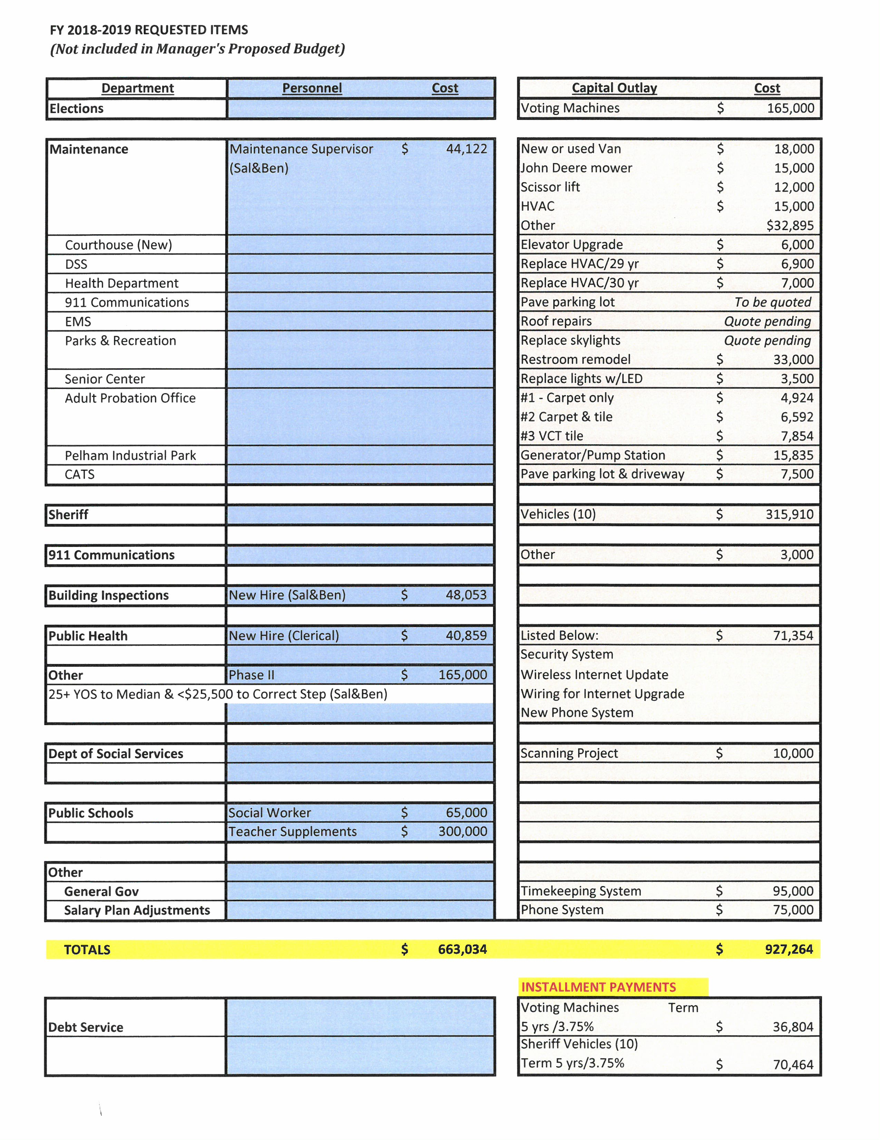
Mr. Miller stated the first item on the list is Voting Machines for Elections in the amount of $165,000. He added that this item may be pushed back a year but he would not know that information until Thursday. Mr. Miller stated that the Board could use fund balance to pay for the machines or they could be financed over a 5 year period.

Commissioner McVey stated they he would rather pay for the machines instead of financing them. Commissioner Travis agreed and added that the interest would be about $19,000.

Mr. Miller moved on to the Maintenance portion of the capital items. He stated that Maintenance needed a van because the one they have now has over 200,000 miles on it. There was a lot of discussion on whether it should be a new or used van. The next item was a new mower. Commissioner McVey asked how many mowers the county has. Mr. Miller responded that Maintenance has 3 mowers and Parks and Rec has 1 mower. Commissioner McVey asked for the hours on the mowers. Mr. Miller did not have that information.

Commissioner McVey asked the county manager to get the hours on the mowers and to get the cost of maintenance on Maintenance’s van.

Mr. Miller continued, the next item is the scissor lift. He stated that this is necessary to change the lights at the detention center and Parks and Rec but it may be cheaper to get a one man lift. Commissioner McVey stated that it may be cheaper just to rent one when it is needed. Commissioner Owen expressed his concern about the new floor at Parks and Rec with this type of equipment. Mr. Miller went on to the next item which is the HVAC at Guilford Mills. This unit is for the large portion where PCC and the Economic Developer are located. Commissioner Hall asked how old the unit is. Mr. Miller responded that most of the units that Maintenance has listed are between 20 and 30 years old. Commissioner Hall asked how many units in the county are 20 years or older. Mr. Miller responded that he would check on this. Commissioner Travis stated that the HVAC needed to be done but the scissor lift could wait. Commissioner W. Carter recommended handling the HVAC units in this year’s budget. Chairman Hall recommended getting someone to bid on all 3 units but it did not matter if it is this budget year or the next budget year.

Mr. Miller moved on to the paved parking lot. Commissioner Travis asked the county manager to go back to the miscellaneous capital. Mr. Miller could not remember what this was for. Mr. Miller continued with the elevator at the main courthouse. He stated that the repairman for the elevator stated that he needed to be upgraded. Mr. Miller added that the elevator is the only ADA access to the second floor. Mr. Miller stated the paving of the parking lot at 911 could wait. He added that the roof repairs at EMS are really not a capital expense and could be handled in the regular budget. Mr. Miller stated that the skylights at Parks and Rec need to be replaced because they are over 30 years old as well as the remodeling of the bathrooms. The Senior Center wants to replace the outside lights with LED lights. With Adult Probation there are 3 options for the floor replacement but this needed to be done because the county has received warning notices from the state on this item. Mr. Miller recommended going with the VCT tile at Adult Probation.

Chairman Hall recommended that staff contact the power company for the Senior Center to see if they will give the lights to the county. He added that all county buildings should go to LED lighting. Chairman Hall also stated that the utility bills needed to be looked at to see what the county is paying.

Mr. Miller moved to the next item which is a generator for the pump station at the Welcome Center. He asked the Board for the opportunity to work with the state on this item. Chairman Hall asked how long he needed to talk with the state. Mr. Miller responded that he would not be able to talk with the state until after July 1st.

Mr. Miller moved on to the next item, pave parking lot at CATS. Mr. Miller stated that this item could wait. The next item is 10 cars for the Sheriff’s Department. Commissioner Travis stated that this item needed to be talked about because the county cannot afford to buy 10 cars. Commissioner Owen recommended buying 5. Commissioner W. Carter stated 5 or 6. Commissioner Travis asked for a report on how much money was spent on the Sheriff’s cars over the last year and how much was spent at each garage location.

Mr. Miller moved to the next item, 911 needs $3,000 for different items. Public Health needs $71,354 for a security system, wireless internet update, wiring for internet update and a new telephone system. Chairman Hall stated that he did not know how this all could be done for this amount of money and he added that the telephone system is a nightmare.

Mr. Miller stated the next item is scanning for DSS and then the Timekeeping System for $95,000. He added that as far as the Phone System for $75,000 this could cover all county buildings and it would only be an increase of $8,000.

Commissioner Owen asked how much longer DSS would need to scan. Mr. Miller responded that he did not know but they are reimbursed most of this money from the state.

Commissioner W. Carter asked if the timekeeping system was Kronos. Mr. Miller responded no it is through ADS.

Chairman Hall stated that there is a greater need for scanning in the Health Department as well as a digitized type system.

Commissioner Owen stated that on the last list the county manager gave to the Board EMS has a request for turn out gear and he asked if this was included in the regular budget. Mr. Miller responded that he would check into this.

Commissioner Travis asked if the Board would be able to see the Fire Departments budgets before the budget is approved. He added that Vernon Massengill stated that the Board would be able to do this. Chairman Hall requested that the county manager request the general ledgers from the fire departments.

Chairman Hall asked how the Board wanted to proceed with the budget work sessions. Commissioner Owen recommended holding the next budget work session after the next regular scheduled commissioners meeting on June 4th.

Chairman Hall asked how the fire departments distribution was determined. Ms. Vaughn responded that the valuation for each district was used to determine the distribution. Commissioner Travis stated that each fire department should be receiving the same amount. Chairman Hall stated that the fire departments could be discussed at the next budget session.

RECESS

At 1:05 p.m. Commissioner S. Carter moved, seconded by Commissioner McVey to recess the FY 2018-2019 Budget Work Session until Monday, June 4, 2018 immediately following the regular Board meeting. The motion carried unanimously.

________________________________ ___________________________
Paula P. Seamster Nathaniel Hall
Clerk to the Board Chairman

******************************************************************************

