MINUTES – JUNE 29, 2020

The Caswell County Board of Commissioners reconvened in special session at 1:00 p.m. on Monday, June 29, 2020. The meeting was held electronically using Zoom Webinar software. Members present: Rick McVey, Chairman, David J. Owen, Vice Chairman, Sterling Carter, William E. Carter, Nathaniel Hall, Jeremiah Jefferies and Steve Oestreicher. Also present: Bryan Miller, County Manager and Gwen Vaughn, Finance Director. Paula P. Seamster, Clerk to the Board, recorded the minutes.

WELCOME

Chairman McVey reconvened the budget work session.

PROPOSED FY 2020-2021 BUDGET (cont’d)

Mr. Miller stated “Commissioners the finance director has put together a budget ordinance for you. But first does each commissioner have a copy of the budget ordinance?” The Commissioners responded yes. Mr. Miller continued “What I would like to do is just run down the budget ordinance or Gwen would you rather do this or would you rather me do this?” Ms. Vaughn responded “It is entirely up to you; you can move forward if you would like.” Mr. Miller continued “Okay, so Commissioners appropriated in the general fund are the following amounts, we have Revenues in the amount of $22,270,259. We have Expenditures in general government at $3,632,379; in Public Safety we have expenditures of $7,479,281; in Economic & Physical Development we have expenditures of $767,875; in Environmental Protection we have $119,256; in Human Services we have $873,220; Cultural & Recreational Services $353,933; for Regional Agencies we have $90,447; Special Appropriations total $227,466; Public Schools we have $3,120,000; Piedmont Community College we have $550,014; for Bond Payments you will see $724,395; School Bond & Private Placement we have $998,859; for Debt Services/Installments we have $221,209; Vehicle Lease Program $104,706 in expenditures; Transfers to Other Funds or Contributions to Other Funds we have $3,007,219 in expenditures. The Total General Fund Expenditures is $22,270,259. Point out additional revenues and expenditures. We have $4,338,417 of Revenues generated by the Department of Social Services; we have $4,338,417 worth of expenditures from the Department of Social Services. From Public Health we have $2,941,921 of Revenues and Expenditures. Library Fund we have $370,536 of Revenues and Expenditures. Family Services/Crisis Intervention Fund we have $202,438 in Revenues and Expenditures. Tourism Development Authority we’re budgeting $8,000 in Revenues and Expenditures. Section 8 Housing Authority Fund $1,055,836 in Revenues and Expenditures. For the Special Fire District Fund, we have $942,946 in Revenues and Expenditures. The Revaluation Fund $30,300 in Revenues and Expenditures. The Emergency Telephone System Fund $471,000 worth of Revenues and Expenditures. School Capital Reserve Fund $727,395 worth of Revenues and Expenditures. Solid Waste Management Fund $1,019,624 worth of Revenues and Expenditures. CATS Department we have $548,516 worth of Revenues and Expenditures. Special Separation Trust Fund $93,372 worth of Revenues and Expenditures. Total General Fund Budget $22,270,259. Our Total from Other Funds is $11,248,056. Our Total Enterprise Funds is $1,568,140. So the Total Caswell County Budget is $35,086,455. I am proud to announce Commissioners that with the budget ordinance that you see in front of your today that the tax rate remains constant at .7350 per one hundred dollars’ valuation which is a 0% increase in the tax rate through the leadership and strong physical guidance given by the Board of Commissioners we’re able to enter into this year’s budget without a tax increase of any kind. We have Ad Valorem Tax Collections of $11,263,358; Casville Special Fire District Tax $39,267; Fire Service District will yield $470,894; Solid Waste Management Fund $573,677. I do want to point out that the stipulations with the budget remain constant to what you’ve seen in previous years’ budget ordinances. I will tell you that we have added an additional section, the Coronavirus Aid, Relief and Economic Security (CARES) Act section. The CARES Act was signed into law on March 27, 2020. The law has provided relief funding for expenses related to and addressing the COVID-19 pandemic. This budget has been adopted based on speculation of down-turns in revenues, increased expenses, entitlements for eligible employees, as well as enforcement and/or directives by the state and federal government. The budget will be amended as needed during the uncertainty of the pandemic and those amendments will come before the Board for approval. I’m happy to answer any questions you have about the budget, the budget ordinance or anything contained in the budget.”

Commissioner S. Carter stated “I just want to get it clarified, in the budget we did raise the solid waste fee which is a tax by $1 other than that nothing else has been increased.” Mr. Miller responded “Yes you raised the solid waste fee $1.” Commissioner S. Carter continued “Correct.” Mr. Miller responded “Technically it is not a tax.”

Commissioner Owen stated “Just a question on appropriated fund balance, Gwen I assume that as in past years that there will be money that will come back into that fund balance.” Ms. Vaughn responded “That is my current projection that we will not use any of the fund balance that was appropriated in the current fiscal year and therefore we’ll end up, I’m projecting about a 28% almost 29% fund balance at the end of this fiscal year.”

Mr. Miller stated “And again Commissioners I’ll just reiterate to the fact that through the strong physical leadership of the Board of Commissioners even with the Bartlett Yancey High School renovation and construction project occurring this year we will have no tax increase this fiscal year.”

Commissioner S. Carter asked “What was the final fund balance number we appropriated?” Ms. Vaughn responded “$1,793,113.” Commissioner S. Carter continued “Is that in Transfers on this budget ordinance?” Ms. Vaughn responded “It is the…if you will look at the Revenues section at the top of the ordinance, where you see $22,270,259 just above that in Appropriated Fund Balance.” Commissioner S. Carter stated “Thank you.”

Commissioner Oestreicher stated “As usual I have a couple questions. On page 2 the Teacher Incentive Program at zero that is the $50,000 that was not spent this year and will go for next year, is that correct?” Ms. Vaughn responded “No, there was no appropriation made for this current fiscal year and the appropriation, I am sorry there was no appropriation made for the new fiscal year 20-21. The current fiscal year appropriation still remains in place because it has not been transferred to the school’s budget.” Commissioner Oestreicher continued “Right, okay, that was my assumption. On page 3 on the Vehicle Lease for the Sheriff $71,216, I just want to confirm that that is the lease for 4 new patrol cars.” Ms. Vaughn responded “That is the current lease and the new lease, it’s all combined. His current lease is in his budget at $36,000, I mean the new leases at $36,000 and this is the current lease.” Commissioner Oestreicher asked “So where is the 36, is that in here or not?” Ms. Vaughn responded “It’s included in the Sheriff’s total of $2,730,000.” Commissioner Oestreicher continued “Okay, alright, so that’s back on…” Ms. Vaughn responded “Page 1.” Commissioner Oestreicher continued “Page 1 of $2.7 million?” Ms. Vaughn responded “Yes.” Commissioner Oestreicher continued “Okay. Alright on page 5 please, on the Tourism Development Authority.” Ms. Vaughn responded “Yes.” Commissioner Oestreicher stated “This shows the Occupancy Tax at $8,000.” Ms. Vaughn responded “Yes.” Commissioner Oestreicher continued “They have a balance in the fund this year don’t they, in previous years?” Ms. Vaughn responded “Yes, the $8,000 is the projection only for 20-21. There is fund balance amount of…I can look at it but it is probably about $20,000 at this point so that is not appropriated because there is no spending, there is not appropriation for it, there’s no plan for it yet.” Commissioner Oestreicher asked “Does that show up in the restricted fund balance somewhere in this budget?” Ms. Vaughn responded “It is more in a restricted, it is not in an unrestricted because it’s only used for tourism.” Commissioner Oestreicher continued “I am sorry; you are exactly correct. But that does show up in the 20-21 budget in the fund balance in restricted?” Ms. Vaughn responded “It does, yes it does.” Commissioner Oestreicher stated “I’m almost done.” Ms. Vaughn responded “Okay.” Commissioner Oestreicher continued “I know everyone’s pleased. In fact, I am done. Thank you very much.”

Chairman McVey asked “Anymore questions.”

Commissioner Jefferies moved, seconded by Commissioner S. Carter to approve the budget ordinance as presented without any tax increase. After a roll call vote, the motion carried unanimously. (Commissioners S. Carter, W. Carter, Hall, Jefferies, McVey, Oestreicher and Owen vote yes.)

Chairman McVey stated “The budget has passed gentlemen.”

Commissioner S. Carter stated “Thank y’all for your hard work, Bryan and Gwen and Paula, everybody else that had any help on this budget, it’s been great.” Chairman McVey responded “Yes sir. Thank you a lot.” Mr. Miller stated “Gwen did an excellent job this year.” Ms. Vaughn responded “Thank you.”

Chairman McVey asked “Are there anymore comments or questions at this time?”

Commissioner W. Carter stated “I’ve got a couple comments. With the curfew being in effect Friday, I had several people call me and I didn’t know anything about it until I called the manager. One lady got pretty irked with me the other night. I told her ma’am as soon as I find out anything I will call you back. I think we need to have something in place that if something like that somebody needs to notify all the commissioners about. Commissioner Jefferies heard about it Saturday morning.” Commissioner Jefferies responded “Yeah I contacted the county manager and presented my concerns Mr. Carter. I think everyone should have been contacted because I had 4 or 5 people to call me about it and I didn’t know anything about it.” Chairman McVey stated “I had 200 calls to me. But anyway any more questions on the budget. If not can I get a motion to adjourn.”
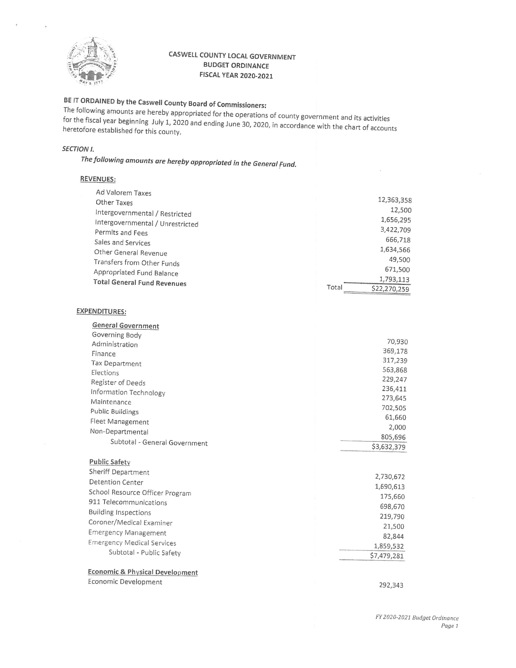

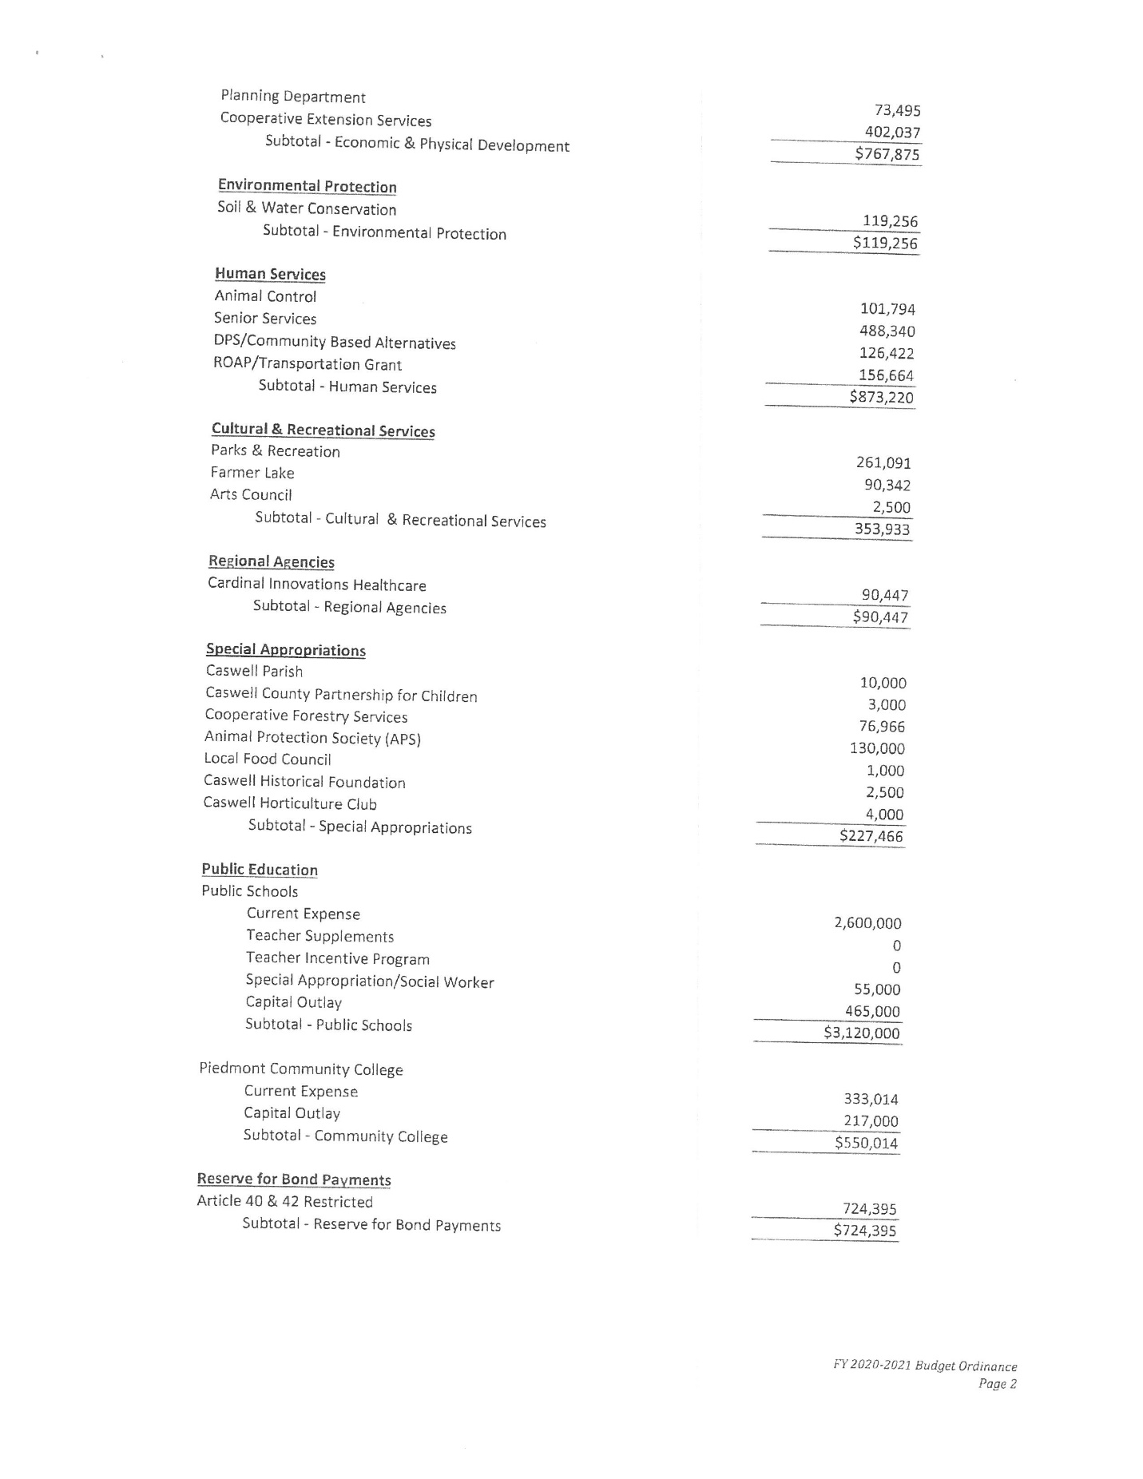

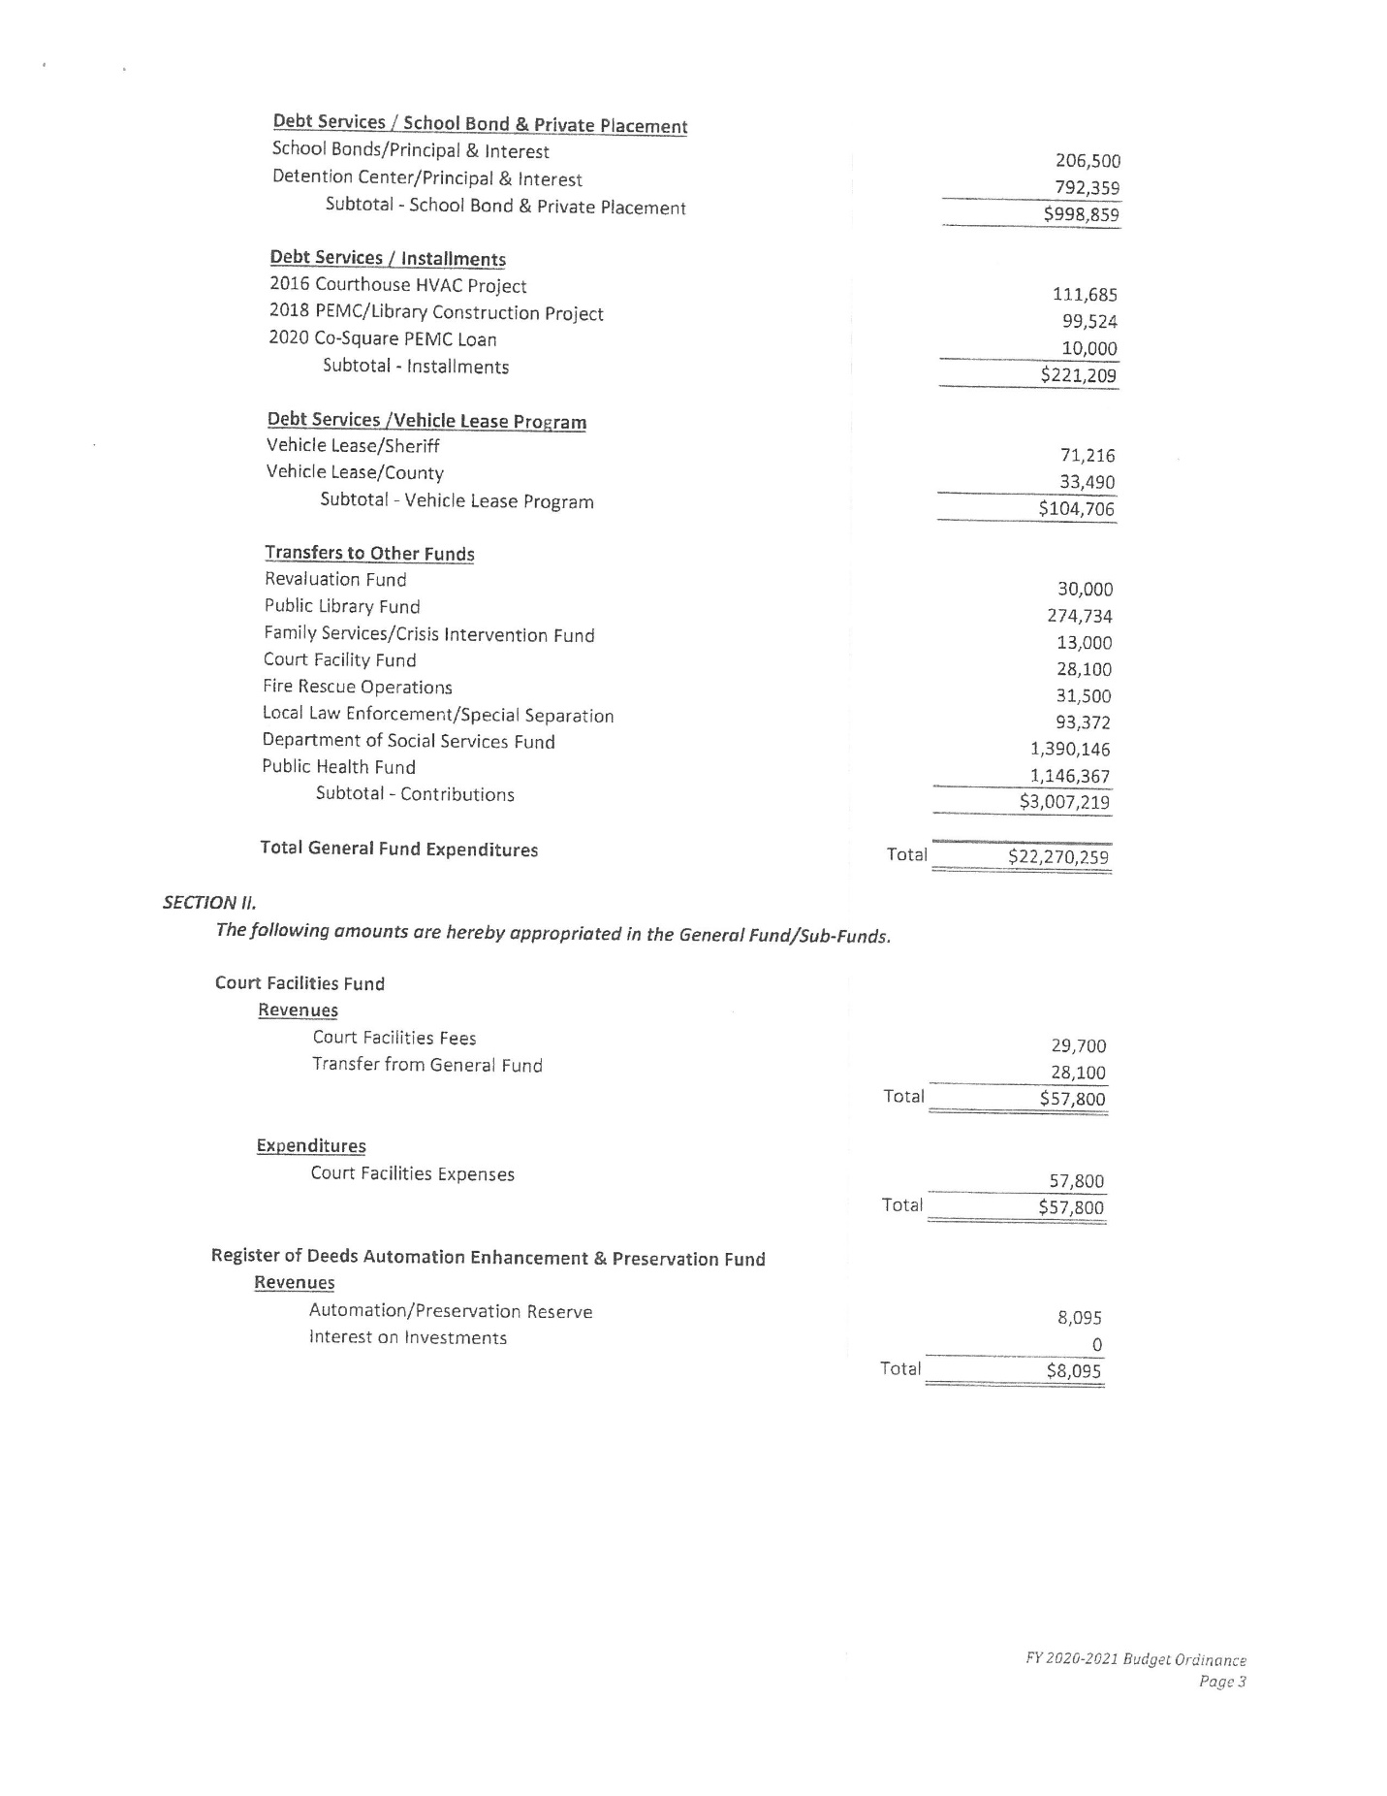

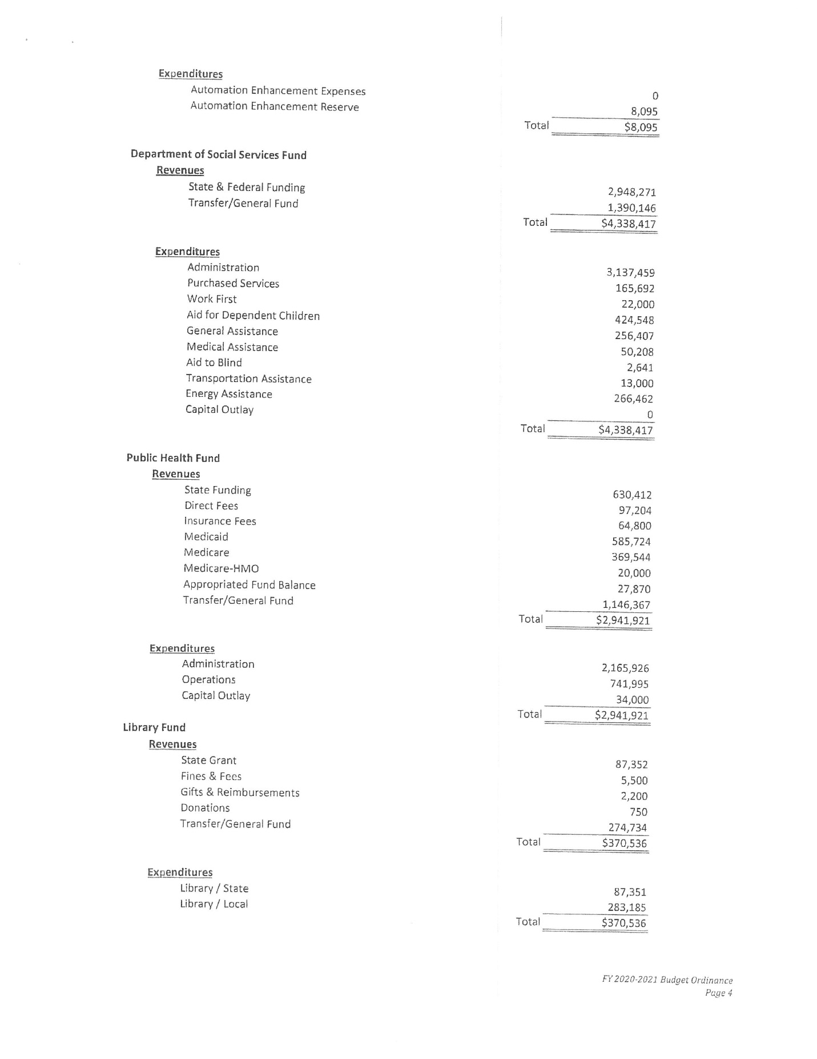

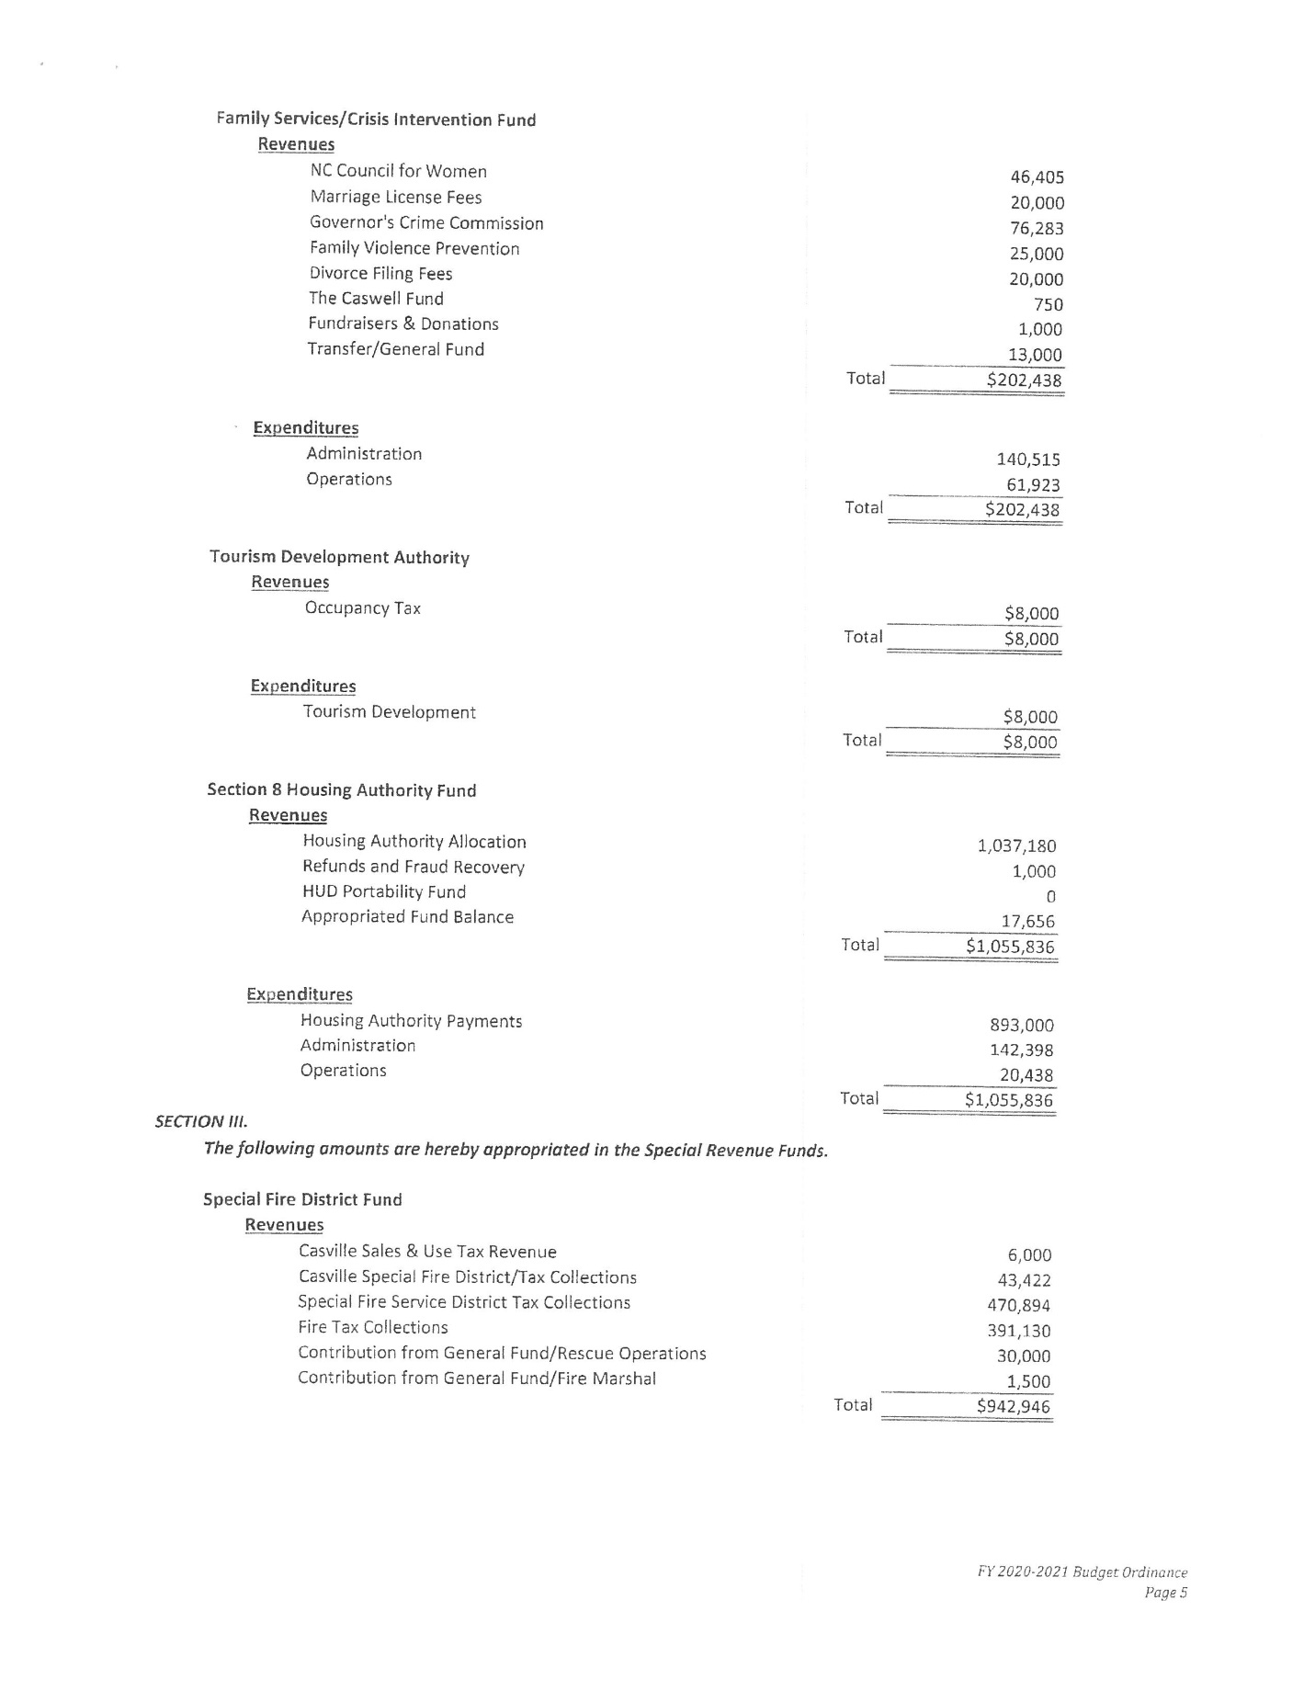

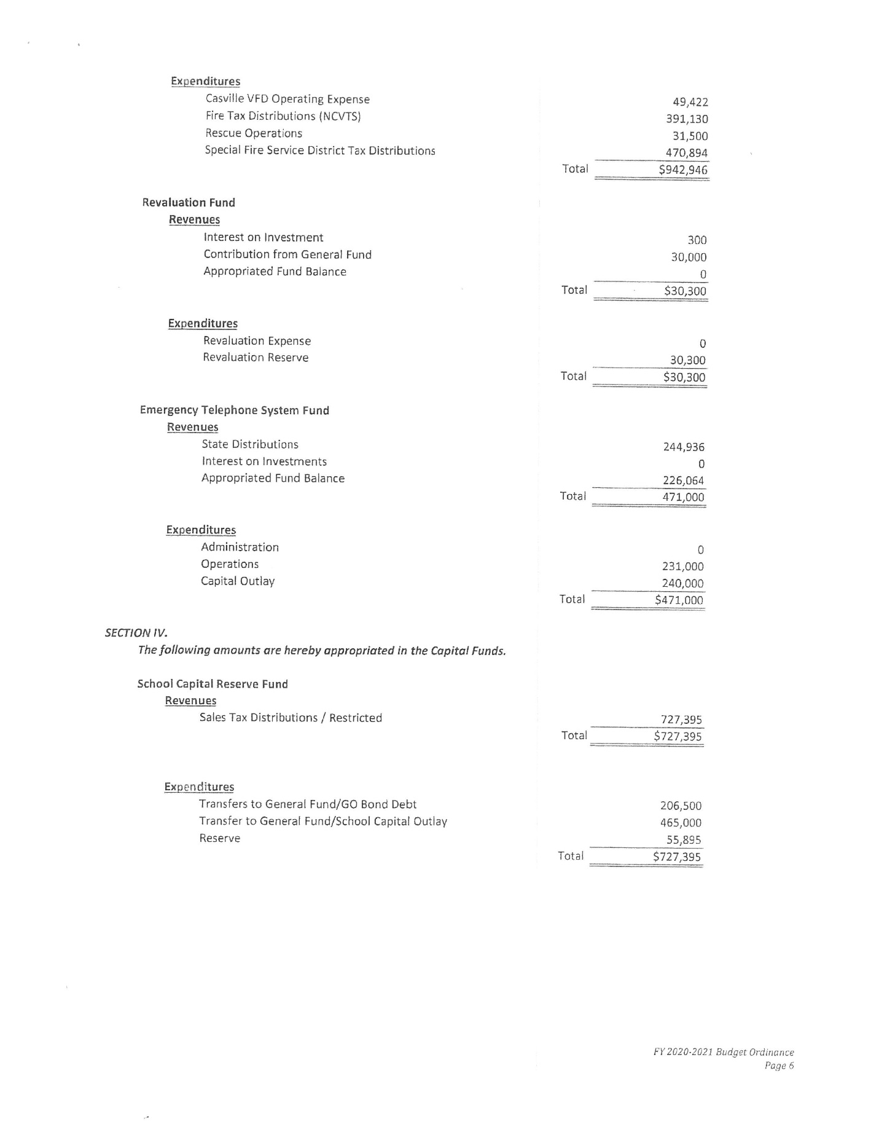

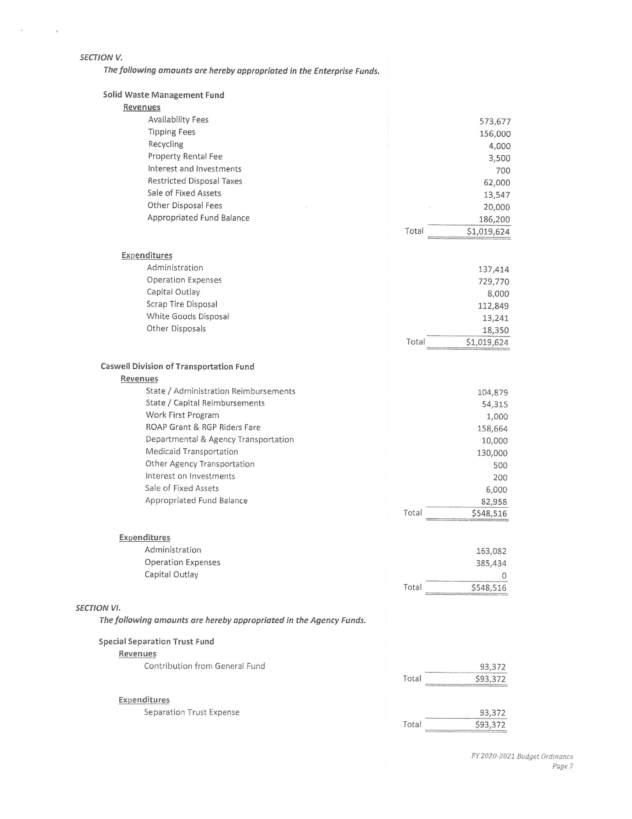

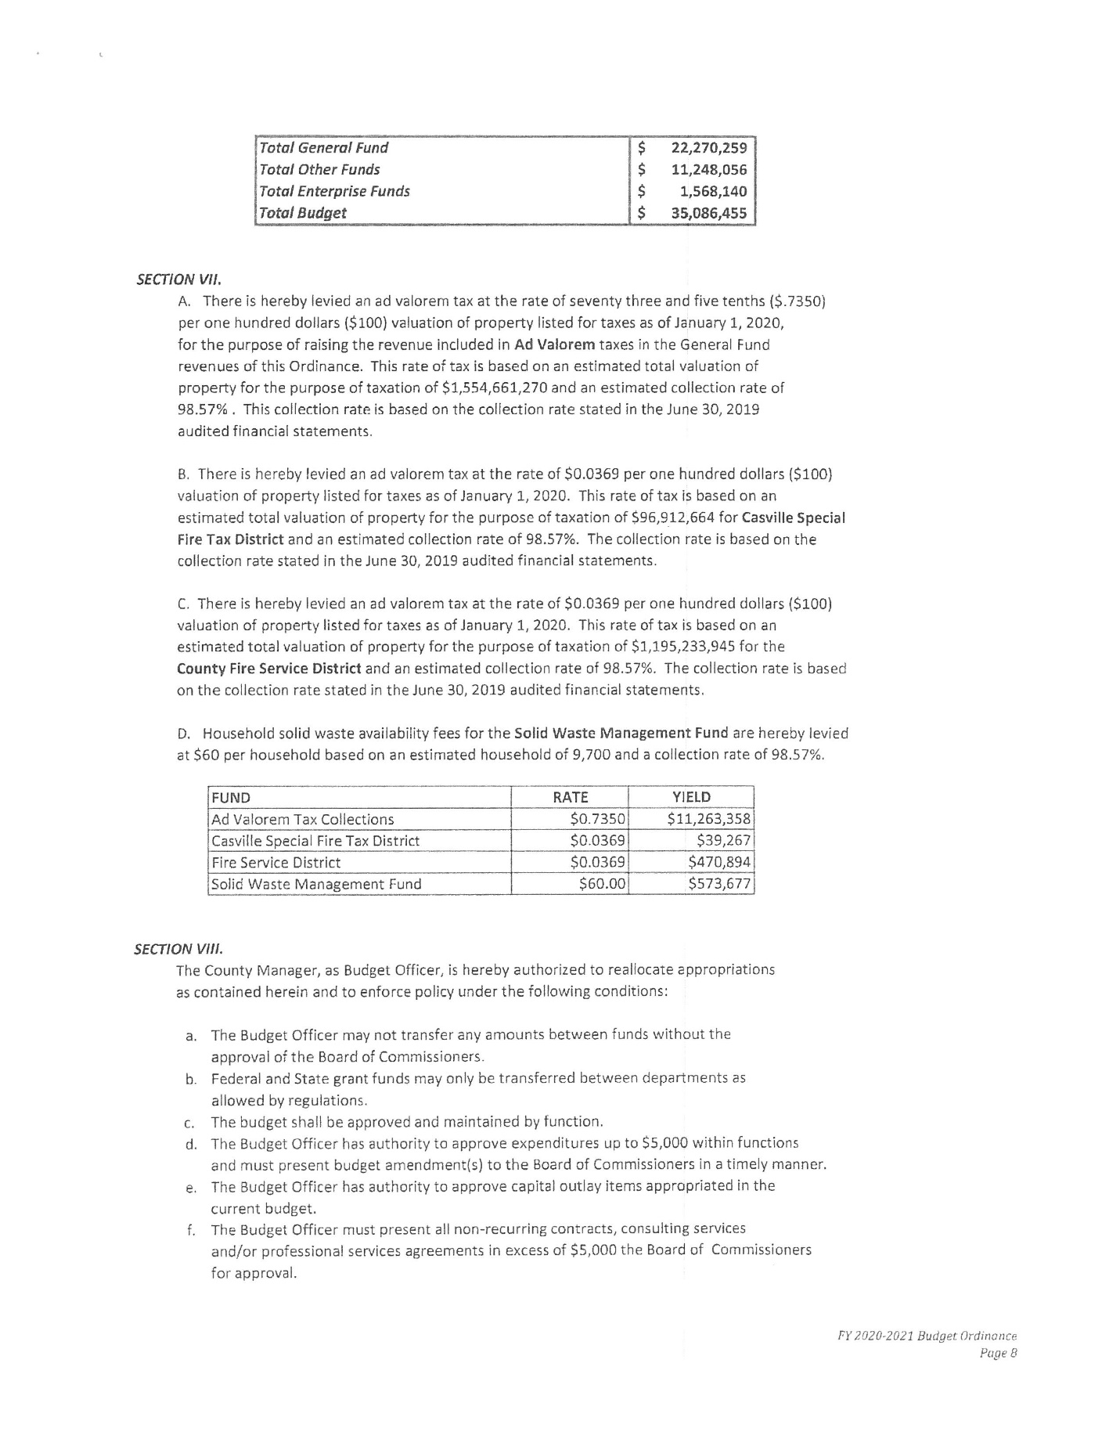

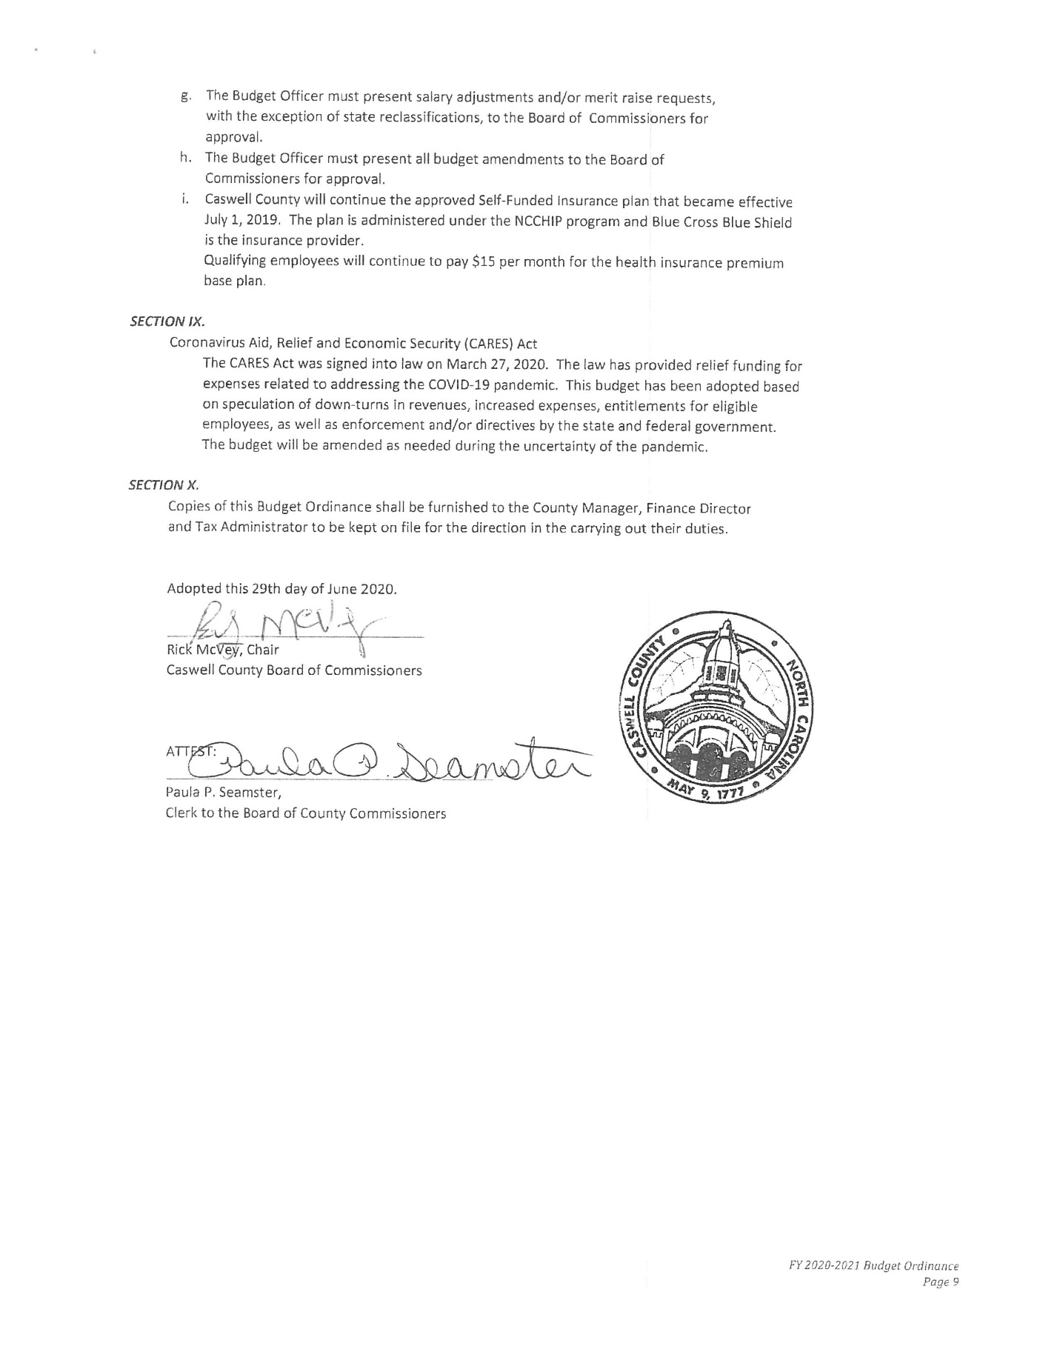

ADJOURNMENT

At 1:22 p.m. Commissioner Owen moved, seconded by Commissioner S. Carter to adjourn. After a roll call vote, the motion carried unanimously. (Commissioners S. Carter, W. Carter, Hall, Jefferies, McVey, Oestreicher and Owen vote yes.)

________________________________ ___________________________
Paula P. Seamster Rick McVey
Clerk to the Board Chairman

******************************************************************************

